Network Rail Infrastructure Limited Defendant’s Response to Freightliner Heavy Haul Limited Sole Submission to the Timetable Panel in connection with the offer of certain paths following a slot review and recast of the train service into Ratcliffe Power Station

Dispute Reference: TTP643

- DETAILS OF PARTIES
  - The names and addresses of the parties to the reference are as follows:-
    - Freightliner Heavy Haul Limited whose Registered Office is at 3rd Floor, The Podium, 1 Eversholt Street, London, NW1 2FL ("FHH") ("the Claimant"); and
    - Network Rail Infrastructure Limited whose Registered Office is at Kings Place, 90 York Way, London N1 9AG (“Network Rail” (“the Defendant”)).
    - Correspondence for Network Rail should be addressed as follows:
Matthew Allen
Network Rail
Willen Floor 2, Area E
The Quadrant MK
Elder Gate
Milton Keynes
MK9 1EN
[redacted]

  - Possible effected third parties:
    - DB Schenker Rail UK Limited
    - Colas Rail Limited
Both the above Timetable Participants operate services to/from Ratcliffe Power Station and were party to the resent recast of the slot plan and timetable. It is Network Rail’s understanding that both DB Schenker and Colas Rail are agreeable to the decisions made by Network Rail in connection with their Train Operator Variation Requests to recast the timetable plan for Ratcliffe Power Station.

- THE DEFENDANT’S RIGHT TO CONTEST THIS REFERENCE
  - This matter is referred to a Timetabling Panel ("the Panel") by Freightliner Heavy Haul Limited (FHH) for determination in accordance with Condition D3.3.9 and D5 of the Network Code.
  - Network Rail’s obligations in connection with making decisions on a ‘Train Operator Variation Request’ are summarised as:
    - Network Rail in responding to a Train Operator Variation Request shall:
i) be entitled to exercise Flexing Right
ii) can decide not to accept a Train Operator Variation Request if to do so would give rise to any conflict with a train slot already scheduled or ‘The Rules’
iii) use the Decision Criteria
- Notify its acceptance, rejection or modification of a Train Operator Variation Request within the timescales listed in condition 3.3.6
2.3 Supporting extracts from the Network Code:
“3.1.4 In considering or making any Timetable Variation, Network Rail shall be required and entitled to act in accordance with the duties and powers set out in Conditions D4.3 and D4.4.”
“3.3.6 Except in relation to a Train Operator Variation Request which includes a One Stop Shop Service which is dealt with in Condition D3.3.7, Network Rail shall notify its acceptance, rejection or modification of a Train Operator Variation Request, by the following latest times:
(a) as soon as reasonably practicable, where the request is to operate a Train Slot on day 1 or day 2.
(b) by 15:00 hours on day 1, where the request is to operate a Train Slot on day 3;
(c) by 10:00 hours on day 2, where the request is to operate a Train Slot on day 4;
(d) by 15:00 hours on day 2, where the request is to operate a Train Slot on day 5;
(e) by 15:00 hours on day 3, where the request is to operate a Train Slot on day 6;
(f) by 10:00 hours on day 4, where the request is to operate a Train Slot on day 7;
(g) where (a), (b), (c), (d), (e) or (f) do not apply, within five Working Days of receipt of the request”

“4.3.1 In responding to a Train Operator Variation Request, NetworkRail shall conduct itself as follows:
(a) it is entitled to exercise its Flexing Right;
(b) when exercising its power set out in Condition D3.3.3 Network Rail shall apply the Decision Criteria in accordance with Condition D4.6 except that it shall not accept a Train Operator Variation Request if to do so would give rise to any conflict with any Train Slot already scheduled in:
(i) the New Working Timetable after it is published at D-26 or the relevant Working Timetable, unless it is a Strategic Train Slot;
or
(ii) the Rules;
(c) where the Decision Criteria have been applied as set out in sub-paragraph (b) immediately above but two or more such requests would give rise to conflict were they to be accepted, they shall be prioritised in the order in which they were submitted and any conflict resolved accordingly.

- CONTENTS OF REFERENCE
This Sole Reference includes:-
    - The subject matter of the dispute in Section 4;
    - A summary of the issues in dispute in Section 5;
    - A detailed explanation of the issues in dispute in Section 6;
    - Any further issues raised by the respondent in Section 7;
    - In Section 8, the decisions of principle sought from the Panel in respect of
      - legal entitlement and
      - remedies;
    - Appendices and other supporting material.

- SUBJECT MATTER OF DISPUTE
  - The matter in dispute is Network Rail’s rejection of four train slots in the December 2013 timetable which FHH requested as part of a Train Operator Variation Request after D-26 in connection with the recast of the slot plan and timetable for Ratcliffe Power Station.
  - The train slots in question are:
    - The train slot which arrives Ratcliffe at 1510 ex Hunterston MSX & SO
    - The train slot which arrives Ratcliffe at 1650 – ex Kellingley SX & SO
    - The train slot which arrives Ratcliffe at 1835 – ex Immingham SX
    - The train slot which arrives Ratcliffe at 2015 – ex Kellingley SX & SO
  - Network Rail understands that it is FHHs view that Network Rail have failed in correctly exercising its flexing right, and that there is a link between the four new train slots being accepted or modified by Network Rail and the relinquished paths FHH proposed as part of the Ratcliffe Power Station recast plan.
  - Network Rail agrees with FHH that this request constitutes a Train Operator Variation Request in accordance with condition 3.3, and welcomes their understanding that the volume of alterations meant that Network Rail could not have provide a completed recast of the timetable plan into Ratcliffe Power Station within the 5 working day response period as set in the condition 3.3.3.
  - The Ratcliffe Power Station recast involved three Freight Operators and a combined total of 136 train slots (41 additional new trains slots, 24 amended train slots and 52 relinquished train slots – 19 additional train slots were rejected).

- SUMMARY OF DISPUTE
  - During the summer of 2013 EON the owner and operator of Ratcliffe Power Station began a project with Freight Operating Companies and Network Rail to explore the options for increasing the number of daily coal slots planned in the Working Timetable to arrive at the power station from 13 to 14 trains per day. Ratcliffe Power Station sought to implement the revised slot plan during September 2013.
  - As part of the review the number of primary locations serving Ratcliffe Power Station with coal was reduced to Immingham, Kellingley, Thoresby, Liverpool, Portbury and Hunterston – with minor tonnages coming in from Greenburn and North Blyth.
  - There were 3 FOCs involved – FHH, DB Schenker and Colas Rail. It was agreed with EON and the Freight Operators that they would submit one Train Operator Variation Request each for this work and that they had agreed a date with EON and Network Rail to submit these all at the same time, the preference being that one Network Rail planner should handle all three Train Operator Variation Requests as they are all interlinked. Network Rail understood that the Train Operator Variation Requests would be for new trains (with some currently running on a weekly basis as “Short Term Planning” Train Operator Variation Requests), amendments to existing services and removal of all other services from the old slot plan. The removed train slots would include existing slots from suppliers no longer serving Ratcliffe Power Station such as Daw Mill, Hatfield, Wolsingham, New Cumnock, Ravenstruther and Killoch.
  - The Train Operator Variation Requests from all three Freight Operators were received by Network Rail on the 23rd August 2013 the changes were sought for both the current working timetable (outside of this dispute) and the December 2013 Working Timetable.
  - In considering a Train Operator Variation Request after D-26
    - Network Rail is permitted to exercise its Flexing Right
    - Decisions on using Flexing Rights to accommodate the rejected train slots in this dispute could only be made with the consent of the other impacted Timetable Participants if this impacted an existing train slots currently within the New Working Timetable or the relevant working timetable
    - The use of the Decision Criteria is not applicable to the decisions being made in connection with the rejection of these train slots, as these requests are rejected due to the conflict with existing trains slots in the New Working Timetable
  - Network Rail confirms it believes all the material provide by FHH to support their Sole Submission relate to the circumstance in dispute.
  - Network Rail has no contract or process reasons which need resolution prior to agreeing that these issues be heard at dispute.
  - In particular response to FHH sole submission para 5.1 and the Hearing Chair’s directions letter, Network Rails understanding of the agreements made in July are:
- the number of train slots in the Power Station slot plan
- EONs allocation of the Power Station slots by Freight Operator and supply point
- agreement that all three Operators would coordinate their Timetable Variation Requests to Network Rail
- train slots from other coal supply points would be relinquished
- Network Rail would provide a dedicated timetable planning resource to deliver the Power Station recast plan
  - In particular response to the Hearing Chair’s directions letter and on what basis can Network Rail request an Operator to lose an existing train slot, Network Rail recognises that Freight Operators can only be asked to lose existing train slots from the timetable via:
- Part D, condition 3.3 (the Operator voluntarily surrendering a train slot via a Train Operator Variation Request)
- Part D, condition 2.1.6 (Prior Working Timetable) or
- Part D, condition 8.5 (Removal of a Train Slot obtained by a freight Train Operator that are not underpinned by access rights in the rights table)
Network Rail has taken on face value the FHHs Train Operator Variation Request to voluntarily remove a number of trains without restriction as listed in Annex M (FHH Sole Submission) and that condition 3.3 applies.

- EXPLANATION FROM THE DEFENDANT’S PERSPECTIVE OF EACH ISSUE IN DISPUTE
  - Issues where the Defendant Accepts the Claimant’s Case
    - In connection with train slots which arrive Ratcliffe at 1510 ex Hunterston MSX & SO, at 1650 – ex Kellingley SX & SO and at 1835 – ex Immingham SX Network Rail confirms that it has not exercised its flexing entitlement surrounding the inclusion of these trains into the New Working Timetable.
    - Network Rail as part of the overall Ratcliffe Power Station rewrite has used its Flexing Right on approximately 10 trains in the New Working Timetable. All were very minor changes and none helped with the four trains slots in dispute with FHH.

  - Issues where the Defendant qualifies or refutes the Claimant’s Case
The train slot which arrive Ratcliffe at 1510 ex Hunterston MSX
    - Originally it was hoped that this new train slot could be routed via Moorthorpe Jn, but this created a conflict with 1V56 SX 07:50 Glasgow Central - Plymouth. It was then verbally agreed with FHH that we should explore the options of a Y path option with an existing FHH Working Timetable slot, 6E76 MSX 01:41 Hunterston – West Burton 15:22 to Doncaster and then creating a new train slot between Doncaster and Ratcliffe.
    - This train slot between Doncaster and Ratcliffe Power Station conflicts with the below existing train slots in the New Working Timetable:
    - 2R69GZ SX 12:25 Sheffield – Scunthorpe (Northern)
    - 1S15GB SX 11:30 London Kings Cross – Edinburgh (East Coast)
    - 1D12GB SX 11:35 London Kings Cross – Leeds (East Coast)
    - 1W38GZ SX 12:41 Sheffield – Bridlington (Northern)
    - 1E11LB SX 07:52 Aberdeen - London Kings Cross (East Coast)
6.2.3 Network Rail upon reviewing the timings for this proposed train slot made the following observations at Doncaster between 13:05 – 13:13:
    - The proposed freight path arrives Doncaster and stops on the UF line at signal D294. The freight train is timed on a 60H66S20 timing load which amounts to 414 metres in length. Consequentially the train is blocking the path across Marshgate Junction for 2R69GZ SX 1225 Sheffield - Scunthorpe, which departs Doncaster towards Kirk Sandall at 13:08.
    - The paths of 1S15GB SX 11:30 London Kings Cross – Edinburgh and 1D12GB SX 11:35 London Kings Cross – Leeds, 1W38GZ SX 12:41 Sheffield – Bridlington prevent a compliant crossing move towards Swinton. Although there are no TPR listed junction margins from departing from the UF line, Network Rail has applied the junctions margins used from Platform 3B. In this instance a train crossing from Platform 3B to Sheffield followed by a train arriving from the Down Main/Slow should be separated by 5 minutes.
    - Departing the UF line 2 minutes after 1W38GZ SX 12:41 Sheffield – Bridlington arrives (13:14) would mean falling short on headway with 1E11LB SX 07:52 Aberdeen - London Kings Cross which would pass Doncaster 2 minutes after 6Mxx MSX 0141 Hunterston High Level - Ratcliffe departs the UF. The TPR required headway on LN600 is 4 minutes.
    - To achieve a TPR compliant passing move through Doncaster, there needs to be more time between 6Mxx MSX 0141 Hunterston High Level crossing to the Sheffield line and the class 1’s arriving from the Down ML direction.
    - The consequential retiming to facilitate a compliant crossing move at Doncaster would be as follow:
- 1S15 + (2) on approach to Doncaster – Arrives Platform 4 1310 for 2 minute T stop
- 1D12 + (2) on approach to Doncaster – Arrives Platform 8 13:13 for 3 minute T/K stop
- 1W38 + (2) on approach to Doncaster – Arrives Platform 4 13:16
- 1E32 + (2) on approach to Doncaster - Arrives Platform 8 13:19 ½, departs 13:21½
    - After adding additional time for all of the above, the amended 1E32 SX 09:40 Reading - Newcastle would fall non compliant with 2R82 SX 13:15 Adwick – Sheffiield which would arrive platform 8 2 ½ minutes after 1E32 SX 09:40 Reading - Newcastle departs. The Timetable Planning Rules compliant margin for this move is 5 minutes. In light of the above it is clear to see that any consequential retiming of any train at Doncaster, at this time of day, will spiral into a long list of impacted trains which Network Rail is not confident a compliant timetable solution could be found for. The level of change and the impact on passenger train arrival and departure times at Doncaster Station lead Network Rail into making the decision not to explore further its entitlement to exercise its Flexing right to accommodate this train slot in the New Working Timetable.
The train slot which arrives Ratcliffe at 1510 ex Hunterston SO
    - For the December 13 New Working Timetable FHH submitted timings for this train slot which was based around a Y path option with an existing FHH Working Timetable slot, 6E63 SO 02:05 Hunterston – Drax 14:05.
    - This proposed train slot between Doncaster and Ratcliffe Power Station conflicted with the below existing train slots in the New Working Timetable:
    - 2B18GB SO 13.26 Doncaster – Leeds (Northern)
    - 2B17GB SO 13:20 Leeds – Doncaster (Northern)
    - 5M30EA SO 13:05 Neville Hill - Nottingham (EMT)
    - 1W40GA SO 13:41 Sheffield – Bridlington (Northern)
    - 1E36GS SO 09:47 Southampton Central - Newcastle (Cross Country)
    - Network Rail, upon reviewing the timings, were unable to identify a path over South Kirkby Jn until 14:06. Pathed behind 6V66CR/DA 09:44/12:47 SO Redcar/Scunthorpe – Llanwern Exchange Sdgs (Y paths) between Swinton and Clay Cross North Jn. The arrival time at Ratcliffe Power Station would have been 15:56, the path was rejected as it was unable to meet booked arrival time at Ratcliffe Power Station.
    - Network Rail looked at the possibility of flexing existing paths in the New Working Timetable between Leeds and Barrow Hill, and found that the section between South Kirkby Jn was Swinton the key pinch point. Key problems:
- After Y’ing with 6E63 SO 02:05 Hunterston – Drax as far as Crofton West Jn, there were Timetable Planning Rules compliance issues passing South Kirkby Jn at 13:41, same time as 2B18GB SO 13:26 Doncaster – Leeds passing from the Doncaster direction. Timetable Planning Rules states that at South Kirkby Junction, a margin of 3 minutes should be applied whereby a train passing from the Doncaster direction is follow by a train passing towards Moorthorpe.
- Consequentially, adding 3 minutes pathing into 6Mxx SO 02:05 Hunterston High Level - Ratcliffe to achieve the required junction margin at South Kirkby Junction then means that 2B17GB SO 13:20 Leeds – Doncaster follows 6Mxx SO 02:05 Hunterston High Level - Ratcliffe over the junction on a reduced headway of 3 minutes. A possible flex to solve this conflict could be to move the <1> from Doncaster to South Kirkby to maintain the required 4 minute headway with 6Mxx SO 02:05 Hunterston High Level - Ratcliffe. This would then mean that 5M30EA SO 13:05 Neville Hill - Nottingham would also require an additional (1) to maintain headway with 2B17GB SO 13:20 Leeds – Doncaster. This could be achieved by removing (1) from the (6) allowance at Swinton. Although the above flexes would ensure compliancy of the all paths through South Kirkby a further stumbling block for the additional freight path occurs in the Swinton area. Passing Swinton at 13:56, 6Mxx SO 02:05 Hunterston High Level - Ratcliffe would fall non compliant with 1W40GA SO 13:41 Sheffield – Bridlington at Swinton which crosses towards Doncaster ½ a minute later. TPR states that a train passing from Moorthorpe followed by a train passing towards Doncaster requires a margin of 4 minutes to be given. A review of pathing allowances in the schedule of 1W40GA SO 13:41 Sheffield – Bridlington shows that it is viable to swap pathing time from Mexborough, Hexthorpe Jn & Doncaster to enable 1W40GA SO 13:41 Sheffield – Bridlington to pass Swinton 4 minutes after 6Mxx SO 02:05 Hunterston High Level - Ratcliffe passes.
- Consequentially, a review of 1E36 SO 09:47 Southampton Central - Newcastle would also have been required as this would be following the amended 1W40GA SO 13:41 Sheffield – Bridlington on non compliant headway. Again a review of the pathing allowances suggests that 1E36 SO 09:47 Southampton Central - Newcastle could be amended similarly to 1W40GA SO 13:41 Sheffield – Bridlington by amending pathing time allowances at Mexborough & Hexthorpe Jn to Swinton. Adding an additional 3 ½ minutes into the schedule of 1E36 SO 09:47 Southampton Central - Newcastle would then mean that 1E36 falls non compliant with 5M30 at Swinton with the amended 1E36 SO 09:47 Southampton Central - Newcastle crossing towards Doncaster ½ before 5M30EA SO 13:05 Neville Hill - Nottingham passes from Moorthorpe. From the above reasons Network decided not to explore entitlement to Flexing services to accommodate this train slot in the New Working Timetable.
The train slot which arrives Ratcliffe at 1650 – ex Kellingley SX
    - This proposed new train slot conflicted with the below existing train slots in the New Working Timetable:
    - 6E91GL MSX 03:55 Hunterston – Drax (DBSchenker)
    - 4D21/4R21 SX 14:35 Eggborough – Doncaster Down Decoy/Immingham HIT (Y Paths, GBRF)
    - Network Rail looked at the possible flexing of these trains to accommodate the new services, but the correct Timetable Planning Rules junction margins at Knottingley could not be maintained between this new train slot and 6E91 MSX 03:55 Hunterston – Drax in the Knottingley East to South area. The additional pathing required in both the proposed new train slot and 6E91 MSX 03:55 Hunterston – Drax, would have impacted on 4D21/4R21 SX 14:35 Eggborough – Doncaster Down Decoy/Immingham HIT and made this train slot non complaint with the Timetable Planning Rules headway margins between Knottingley and Drax Branch Jn.
    - Departing Kellingley at 13:54 was explored as an earlier alternative option; however the path could only be developed as far as Shaftholme Jn, arriving 14:48. No compliant crossing moves on to the ECML were identified due to conflicts with 1O40 SX 13:35 Newcastle - Guildford, 6H71GA SX 14:39 Doncaster Down Decoy FLHH – Drax AES, 6E84GA/GE MFO/TWThO 08:20 Middleton Towers – Drax AES, 6H88 SX 11:50 Daw Mill – Drax AES, 1N85 SX London Kings Cross – York before 4D21/4R21 SX 14:35 Eggborough – Doncaster Down Decoy/Immingham HIT (Y paths) arrives from Knottingley at 15:12. After evaluating the WTT graphs it was established that the next compliant path between Sudforth Lane & Knottingley would depart at 16:40.
The train slot which arrives Ratcliffe at 1650 – ex Kellingley SO
    - This proposed new train slot conflicted with the below existing train slots in the New Working Timetable in relation to Timetable Planning Rules headways between Sudforth Lane and Knottingley or junction margins departing from Sudforth Lane:
    - 6C59GD SO 13:57 Doncaster Down Decoy – Eggborough (GBRF)
    - 4N30GC SO 14:30 Eggborough – Tyne Coal Terminal (GBRF)
    - 4N30PD SO 14:27 Drax – Tyne Coal Terminal/Widdrington Exchange (Y paths, GBRF)
    - Similarly to the SX path, the SO path could not be planned Timetable Planning Rules compliantly between Sudforth Lane & Knottingley East Jn. A compliant path departing Kellingley could not be found until around 15:43. With all pathing & adjustment allowances removed from the schedule it was established that departing this late culminated in not achieving the 1650 arrival time at Ratcliffe Power Station required. Network Rail therefore made the decision to reject the proposal new train slot as the terminal arrival time at Ratcliffe could not be met.
The train slot which arrives Ratcliffe at 1835 – ex Immingham SX
    - For the December 13 New Working Timetable FHH submitted timings for this train slot which was based around a Y path option with an existing FHH Working Timetable slot, 6R16GL SX15:41 Immingham – Ferrybridge.
    - This train slot conflicted with the below existing train slot in the New Working Timetable between Lincoln and Ratcliffe Power Station:
    - 6V29DB SX 17:32 Lincoln Terrace CHS – Cardiff Tidal (DBSchenker)
From Barnetby the path of 6Mxx is required to be held at West Holmes Loop between 17:20 & 17:56 and then follow 6V29DB SX 17:32 Lincoln Terrace CHS – Cardiff Tidal (DBSchenker) owing to the fact that there are no compliant paths to, and over Newark Flat Crossing until departing West Holmes at 17:56
    - Following 6V29 to meet this path over Newark Flat Crossing means the additional Ratcliffe Power Station slot time of 1835 was unable to be achieved (Network Rail also looked at running in the path of 6V29, but this only achieved an arrival time into Ratcliffe Power Station of 19:10).
The train slot which arrive Ratcliffe at 2015 – ex Kellingley SX & SO
    - It is Network Rail’s view that FHH’s Train Operator Variation Request did not include a request for a train slot arriving at Ratcliffe 2015 – ex Kellingley SX & SO. Therefore Network Rail has not responded with a decision to accept, modify or reject this train.
Use of the Decision Criteria
    - None of the decisions to reject these four proposed new train slots in the Working Timetable were made using the Decision Criteria. The Decision Criteria is used to support decision making when the conflict is between train slots with the same priority and contractual right for inclusion in the timetable. Network Code Part D conditional 4.3.1 (b) states that:
“(b) when exercising its power set out in Condition D3.3.3 Network Rail shall apply the Decision Criteria in accordance with Condition D4.6 except that it shall not accept a Train Operator Variation Request if to do so would give rise to any conflict with any Train Slot already scheduled in:
(i) the New Working Timetable after it is published at D-26 or the relevant Working Timetable, unless it is a Strategic Train Slot;
or
(ii) the Rules;”
In this dispute all four of these proposed new train slots Network Rail has demonstrated that their inclusion in the New Working Timetable would conflict upon an existing train slot, and therefore the proposed new train slots does not have a priority high enough for including in the Working Timetable and the use of Decision Criteria is not applicable.

  - Issues not addressed by the Claimant that the Defendant considers should be taken into account as material to the determination
    - Network Rail confirms that a number of these train slots are successfully being planned on a weekly basis on the Short Notice Planning (STP) timescales. It is not always possible to replicate an STP train slot in the Working Timetable, the picture of the timetable plan on STP timescales can look different every week as the planning teams have sight of non running trains or other altered train slots for the applicable week which can help find path solutions.
    - The relinquishing of train slots was part of FHH Train Operator Variation Request for the recast Ratcliffe Power Station Plan and were not requested to Network Rail with a condition that these paths were only relinquished if all new or amended paths were accepted by Network Rail. It is Network Rail’s view that Part D condition 3.3 does not include the provision of a guarantee or a trading clause for a relinquished train slot to ensure that newly proposed train slots are included in the timetable. Other considerations in connection with FHH request to re-establish the relinquished paths:
    - A number of the trains are from Daw Mill Colliery which has now closed and it is no longer listed as a supplier of coal to Ratcliffe Power Station
    - Network Rail would need to revisit the decisions made in relation to the Colas Rail and DB Schenker Train Operator Variation Requests

  - Why the arguments raised in 6.1 to 6.3 taken together favour the position of the Defendant
    - In summary the points which Network Rail feel support the decisions that it has made are:
- The proposed new trains slots would conflict with trains in the existing New Working Timetable
- Network Rail is entitled to make exercise its Flexing Rights, but it is not compulsory that it does
- Part D condition 3.3 does not include the provision of a guarantee or a trading clause for a relinquished train slot to ensure that a newly proposed train slot is included in the timetable
- Partially attempting to re-establish the relinquished paths for FHH would mean unpicking the slot plan that had jointly been agreed with EON by the affected Timetable Participants
- The use of the Decision Criteria is not applicable in this dispute as the new train slots do have an equal priority or right with the train slots they conflict with in the existing timetable
- To have delivered an optimal recast of the slot plan at Ratcliffe Power Station it might have been of benefit to look at coordinating this with the development cycle of a New Working Timetable around a Principal or Subsidary Change Date

7 DECISION SOUGHT FROM THE PANEL
7.1 Network Rail seeks the following outcome from the Panel’s Determination:
That it has made the correct decisions in connection with the rejection of trains slots contained within a FHH Train Operator Variation Request after D-26 in connection with the recast of the Ratcliffe Power Station slot plan, specifically;
    - The train slot which arrives Ratcliffe at 1510 ex Hunterston MSX & SO
    - The train slot which arrives Ratcliffe at 1650 – ex Kellingley SX & SO
    - The train slot which arrives Ratcliffe at 1835 – ex Immingham SX
    - Uphold Network Rail’s view that FHH did not include their Train Operator Variation Request for the recast of Ratcliffe Power Station a train slot which arrived Ratcliffe at 2015 – ex Kellingley SX & SO
    - There are no other remedies or issues to be determined.

8 APPENDICES AND ANNEXES
Network Rail confirms that it has complied with Rule H21 of the Access Dispute Resolution Rules, which requires that
- the relevant extracts of contractual Documents containing the provision(s) under which the referral to the Timetabling Panel arises and/or provisions associated provision(s) associated with the substance of the dispute; and
- [the relevant extracts of] any other Documents referred to in the reference”. [Rule H21(b) (I)]
Annex “A” Doncaster Station TPR Extract
Annex “B” Swinton Jn TPR Extract
Annex “C” Knottinghley East Jn TRP Extract
Annex “D” LN882 Wakefield to Goole TPR Extract
Annex “E” TPS Graph LN600 Doncaster Station –
1300 to 1320
Annex “F” TPS Graph LN882 Wakefield to Goole SX -
1400 to 1500
Annex “G” TPS Graph LN882 Wakefield to Goole SO -
1400 to 1500
Annex “H” TPS Graph LN206 Lincoln to Newcark Castle SX -
1720 to 1840

9 SIGNATURE
For and on behalf of Network Rail Infrastructure Limited
Signed:
___________________________________
Print Name: Matt Allen
Position: Operational Planning Manager (National)

Annex A: Doncaster Station TPR Extract:
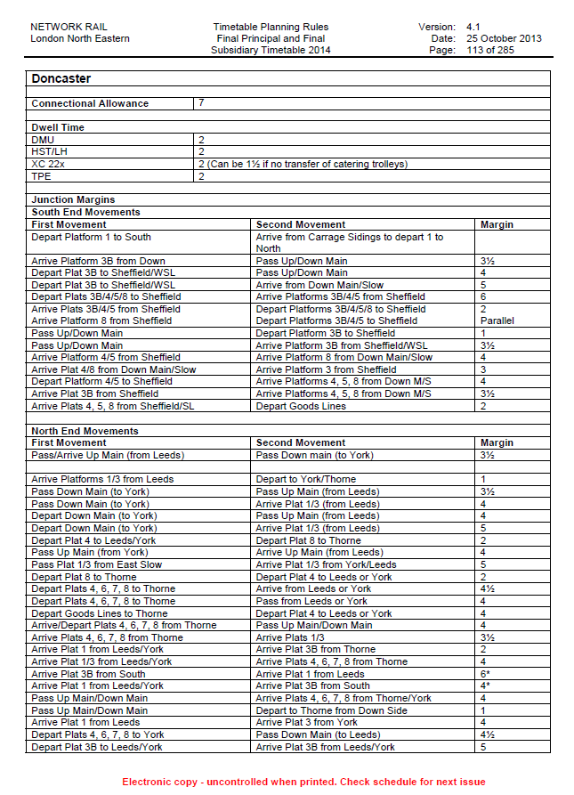
Annex B: Swinton Junction – TPR Extract

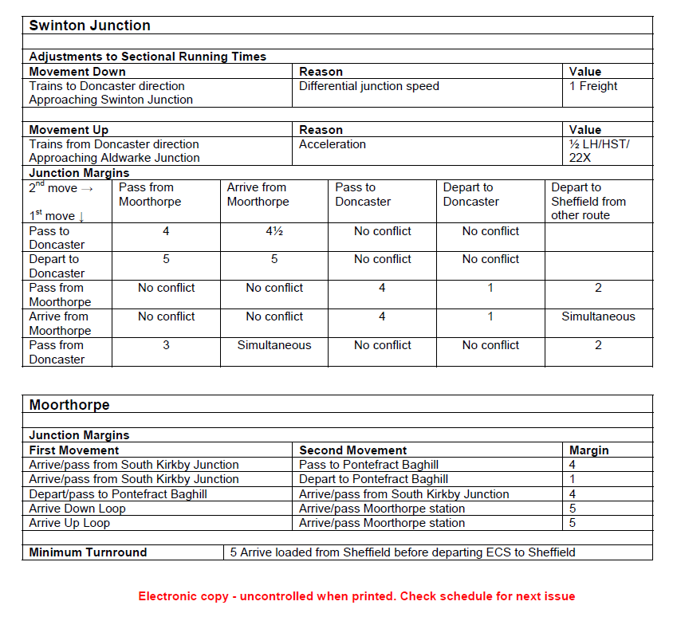
Annex C: Knottingley East Junction – TPR Extract
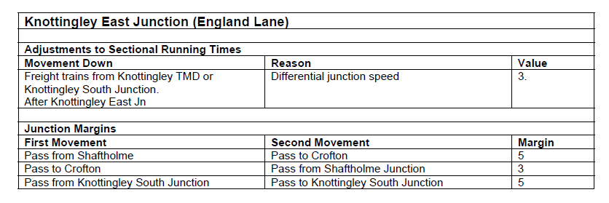

Annex D: LN882 Wakefield – Goole – TPR extract

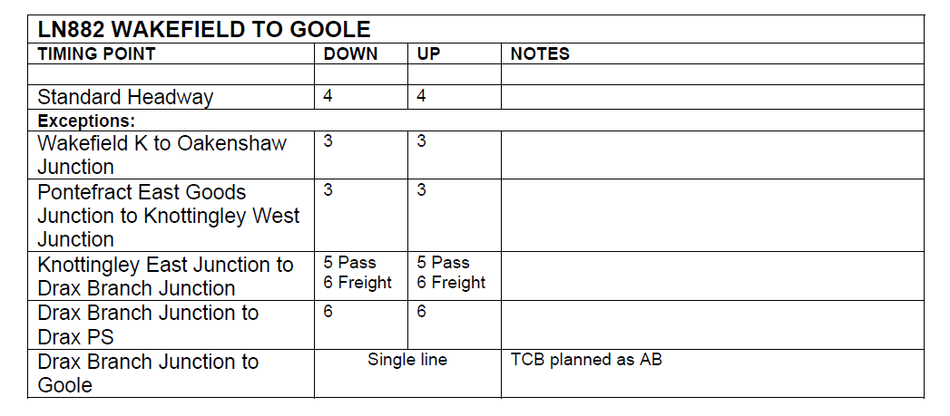

Annex E: TPS Graph LN600 –Doncaster Station Area – 1300 - 1320

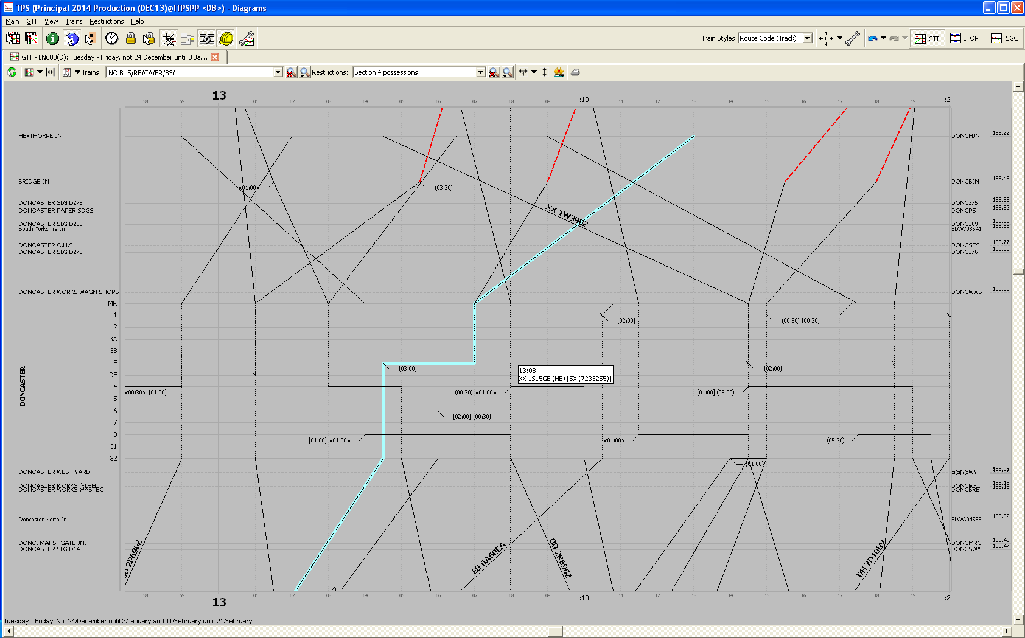
Annex F: TPS Graph LN882 – Wakefield – Goole - SX – 1400-1500

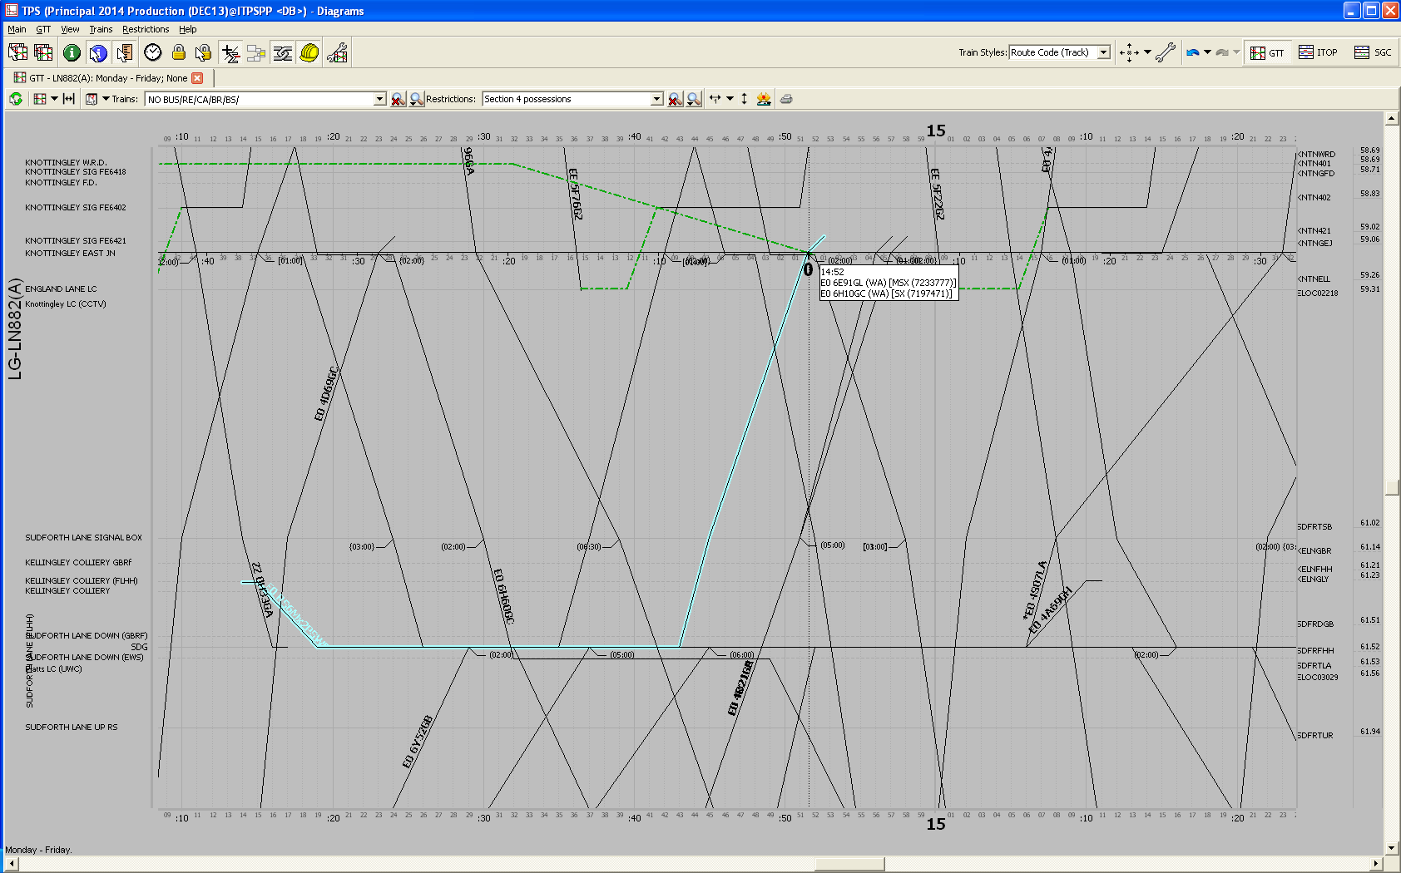
Annex G: TPS Graph LN882 –Wakefield – Goole – SO – 1400 - 1550

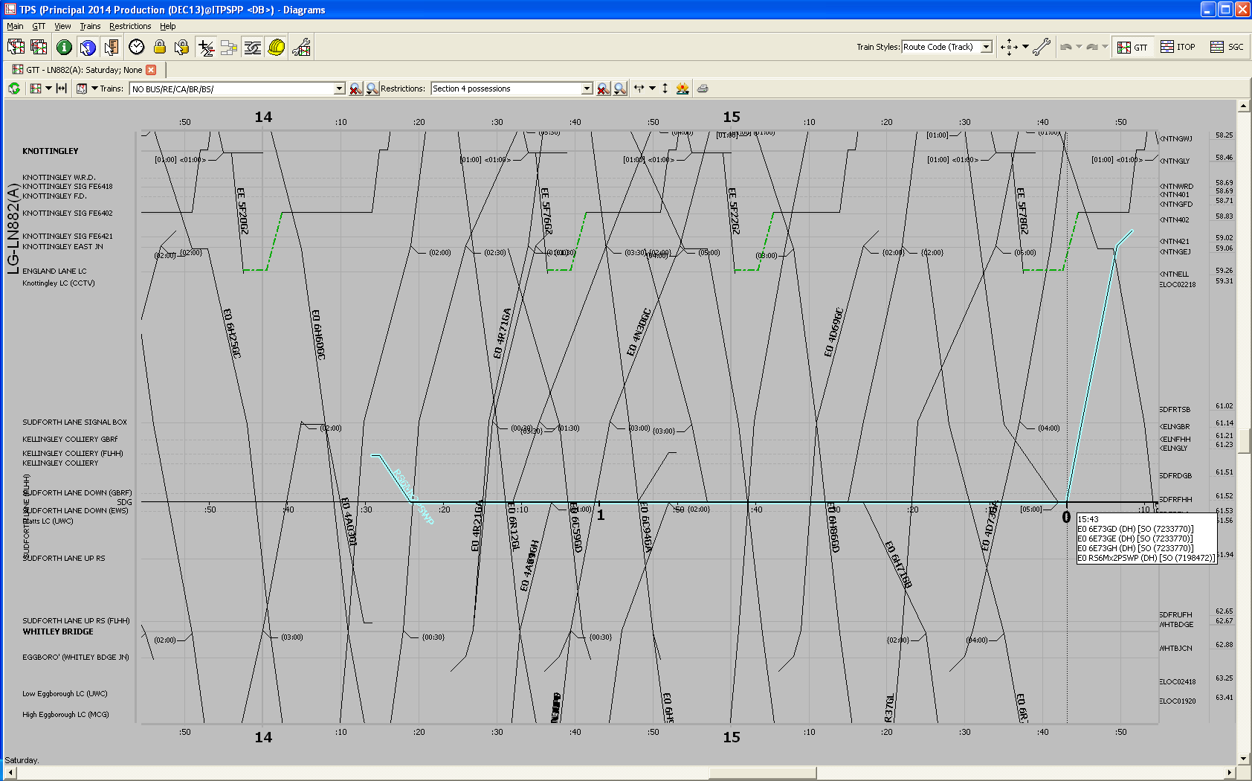
Annex H: TPS Graph LN206 – Lincoln – Newark Castle - SX – 1720 - 1840

