SOLE SUBMISSION TO TIMETABLING PANEL
By
WEST COAST TRAINS LIMITED

TTP Reference 434
(Decision Documentation – Notice LNW12-CE-03)

(Specific Restriction of Use – Decision Document –
ROU for Stockport Week 14 – 1st July 2012 )

8th February 2012

DETAILS OF PARTIES
  - The names and addresses of the parties to the reference are as follows:-
    - West Coast Trains Ltd. (Company number 3007940) whose Registered Office is at The School House, 50 Brook green, London W6 7RR (“WCTL” - "the Claimant"); and
    - WCTL contact details are Robert Hodgkinson, Commercial operations Manager, North Wing Offices, Euston Station, London, NW1 2HS

  - Third parties that may be affected by the Panel’s finding in any of the ways sought and determined under Section 8 are as follows:
    - Arriva Cross Country
    - Arriva Trains Wales
    - DB Schenker
    - First Keolis (TransPennine Express)
    - Freightliner Group
    - GBRf
    - Northern Rail

- THE PARTIES’ RIGHT TO BRING THIS REFERENCE
  - These matters are referred to a Timetabling Panel ("the TTP") for determination under those Conditions set out in accordance with Network Code D3.4 - Network Rail Variations with at least 12 weeks notice, (“....procedure for altering the engineering Access Statement other than through the twice yearly process....”). WCTL formally responded to Decision documentation (LNW-CE-03) published by Network Rail on 8th July 2011 in its response letter dated 22nd July 2011 - Annex “J” refers)., registering that this specific item was considered to be in dispute under section 3.4.1 of the National Rules of the Plan and Sections D3.5.4 & 5.1.2 of the Network Code, (as applicable to the July 2011 re-Issue - Annexes “A & B refer”).

- CONTENTS OF REFERENCE
3.1 “WCTL” has produced this sole reference and it includes:-
(a) The subject matter(s) of the dispute in Section 4;
(b) A summary of those issues in dispute in Section 5;
(c) A detailed explanation of those issues in dispute prepared by ‘WCTL’ in Section 6;
(d) Section 7 is not applicable;
(e) The decisions of principle sought from the Panel in respect of legal entitlement and remedies in Section 8;
(f) Appendices and other supporting material shown in summary in Section 9.

- SUBJECT MATTER OF DISPUTE
  - The issue relative to this WCTL vs. Network Rail dispute, is a single LNW Rules of the Route [ROTR] Restriction of Use (ROU) Section 7 item, proposed and decided upon by Network Rail’s Engineering Access Planning Unit under the auspices of the 2012 ROTR process, as directed under Network Code D3.4 and National Rules of the Plan 2012 (ROTP - Part 3.4.1). This was in the form of Decision document (LNW-CE-03), published on the 8th July 2011, thereby amending the final Version 2 Engineering Access Statement (EAS) for 2012 (which itself forms a totally independent dispute reference - TTP401).
  - This disputed item, originally part-proposed in the 2012 EAS to take place largely during the 2012 Easter Bank Holiday weekend in Week 2, was subsequently removed, being affectively re-proposed as an additional requirement during both the New Year Holiday Bank Holiday period (2011/12) and Week 14 (1st July) under LNW-CE-03; thus amending the original 2012, v.1 and final v.2 Engineering Access Statements.
  - Such dispute arises as a consequence of:
- Network Rail deciding to undertake engineering works between the hours of 0030 and 1630 on a single summer Sunday, (in the form of S&C Tamping), between Edgeley Jn No.2 (South of Stockport) and Slade Lane Jn (North of Stockport), at the beginning of July 2012. Such work requires the closure of Stockport station for a full 16 hour period, which by default has the affect of restricting access between Manchester and Macclesfield / Stoke. WCTL has requested that this work be preferably moved to the August Bank Holiday weekend where overall, WCML disruption to its Customers is less, (especially in comparison with earlier Bank Holidays this same year).
- Previously, we have proposed slightly more exigent alternatives, in either reducing possession times by approx 3½ hours, optimising the work into other Work-Banks throughout the year or other busier Bank Holiday Periods; all of which were rejected by Network Rail.
4.4 For clarity, the above item is NOT in dispute in terms of its relevance and conformity with due process, (i.e. the application of ROTR / ROTP); it is rather, Network Rail’s refusal to revise such Access opportunity to an alternative date, particularly in view of their lack of & contradictory reasoning.
4.5 We consider that the onus is on Network Rail to provide just reasoning and supportive evidence, as to how they have both weighted and applied, having had due regard to Decision Criteria, (Network Code D4.6 – see Annex “C“) their reasoning behind refusing WCTL’s request to move this additional proposal, first and foremost to the 2012 August Bank Holiday weekend.
4.6 Copies of relevant extracts of contractual Documentation containing those provision(s) under which this referral to the Timetabling Panel arises, and/or those provisions associated with the substance of the dispute, are referenced below under Annexes “A” through to “E”. Also attached below, and referenced accordingly throughout these sections 2 - 7, are Annexes “F” to “V”; all of which are indexed accordingly under section 9.
4.7 For clarity, it is proper to point out, that at the time of originally submitting this dispute item, and consequently the submission of our Notice of Dispute to the Secretary of the ADRC, that these were undertaken through the auspices of our then, current Track Access Agreement, which was due to expire on the 31st March 2012. This has subsequently been extended from 1st April 2012 until the 8th December 2012 inclusive.

- SUMMARY OF DISPUTE
  - WCTL is currently responsible for running a Very High Frequency timetable (VHF) along the whole of the West Coast Main Line (WCML) from London Euston to major conurbations / areas throughout the Home Counties, West Midlands, Liverpool, Manchester, Scotland, North Wales Coast and Lake District.
  - The VHF timetable is the output from a culmination of 10 years of Upgrade work and £8.9bn of expenditure, and represented, at its introduction, a 35% uplift in the number of services provided. Part of this uplift in service provision, was the introduction of three services an hour (3tp/h) to both Birmingham and Manchester, tailing off to hourly during both late night midweek and Saturday evening to Sunday lunchtime periods. Such an unprecedented level of service is provided in parallel with hourly services to Chester, Liverpool, Preston & Carlisle, as well as hourly vital Anglo-Scottish links to Glasgow and Edinburgh – See Map in Annex “V” for an overview of WCTL passenger flows.
  - WCTL VHF timetable obligations are enshrined both within its Passenger Service Level Commitments (Version 4 / Dec 2008) contained in WCTL Franchise Agreement with the Department for Transport (DfT); and within those Rights specified under Schedule 5 of its Track Access Contract (TAC – dated Dec 2008, and as previously advised, extended until 8th Dec 2012). (Extracts of these, relevant to those services affected, are shown for reference in Annexes “D” and “E”).
  - Such Rights, when considered in conjunction with those principles applied throughout the Industry under the 7-Day Railway model, (part of a regulatory requirement on Network Rail to increase Network Access through a 37% improvement in Engineering efficiency during Control Period 4 – See Annex “G”, alongside already established Enhanced Engineering Access (EEA) guidelines (See Annex “F”), are obviously significant in this dispute, but only to the point of highlighting the fact that we do have the Right, (subject to Network Rail requiring the taking of justifiable and reasoned ROU’s – Section 7.1 of Annex E refers), to operate such services over those routes, at those times and day, forming the subject matter of this dispute.
  - The concept of undertaking standard maintenance & renewal activities through ROUs finishing on Sunday lunchtime along the WCML, do however now form part of a well established set of principles, guiding Network Rail to, (excluding when necessary, Bank Holiday Sundays), providing improved access opportunities to travel, without major disruption on Sunday afternoon & evenings; critically for the increasing numbers of travelling weekend ‘returning’ passengers. Such principles are encapsulated as part of the Industry’s regulated ongoing 7-Day Railway Access improvement process, (itself encapsulated within our current Joint Network Availability Plan {JNAP} with Network Rail).
  - Network Rail has, in this particular circumstance, subsequently proposed a ROU that will hinder WCTL ability to operate its important London - Manchester services, which, as a result, will have a detrimental effect on its Customers as well as its business and operations.
5.7 The ROU to be undertaken in the Stockport area allows Network Rail to engage in S&C Tamping (Maintenance) activities until 1630 on one Sunday afternoon (1st July 2012). WCTL has specifically requested that this possession be transposed to a similar time frame (from Week 14 in July to August Bank Holiday Sunday {August 26th - Week 22}). Whilst highlighted in detail in Section 6 below, we have requested this preferably specific Bank Holiday, on the basis that the work:
a) Is not during the Olympic Games periods’ themselves (Main or Para-Olympic); although it must be highlighted that some disruptive works are taking place (patrolling work south of Rugby – at Castlethorpe and Bourne End – Annex “O1” refers), as well as work in Scotland that was proposed but thence rejected (Motherwell – Annex “O2” refers)
b) Is in a period when Network Rail is undertaking other Maintenance and Renewal activity (works at Stourbridge-Snow Hill, 2TTR south of Crewe to Ledburn Jn inc Stafford & Trent Valley - Annex “L2” for extracts refer), within those Olympic Delivery Authority (ODA) designated zones, (Zone 3 in this case – See Annex “T”), despite a categorical insistence, that they are not allowed to do so (again no evidence supplied); it should be noted that there is no contractual obligation as far as we are aware on either party to this dispute, about works not being able to take place in such period between the Games’:
c) Is on a weekend when Resources should be otherwise readily available, as aside from those works outlined in ‘b’ above, no major Renewal or Enhancement work is taking place over the August Bank Holiday (ABH) weekend across the LNW Route, (as there would have otherwise been, if the Olympics were not taking place) – Maps of past and planned heavy ABH works in 2011 & 2013 against the ‘light’ 2012 year, are attached herein - Annex “P” refers);
d) Is not a period which the ODA have stipulated (through any contractual obligation), that Train Operators must run additional Olympic services;
5.8 WCTL therefore provides below its full reasoning behind this dispute reference as hereby submitted, with a detailed explanation and supporting evidence / annexes, in Section 6 below; which is to be subsequently defended by Network Rail in its separate counter-response.

- EXPLANATION OF THE ISSUE(S) IN DISPUTE
  - WCTL operates a significant number of services to / from Manchester Piccadilly throughout the week, including most of the weekend. This comprises of three services an hour operating in each direction via Stockport with two services running via Macclesfield and Stoke-on-Trent (The ‘Potteries’); the other service running via Wilmslow and Crewe. Only one service of the two via Stoke-on-Trent calls at Macclesfield.
6.2 Such level of service represents those benefits associated with the introduction of the VHF timetable, which has seen weekend passenger growth increase by 36% in its first year, (this included a 37% rise in passenger numbers on the Manchester route alone (figures taken from the first year of VHF Dec 2008 to Dec 2009), making it the highest-used route out of all WCTL service groups. Continued growth in passenger journeys is approximately 9% per year, with the rail market share for Manchester to London being around two-thirds higher than all other transport modes.

6.3 On Sundays the level of service (i.e. 3tp/h) starts from approximately 1100 in the morning southbound (‘Up’) and from 1200 in the northbound direction (‘Down’). Such uplift in service provision is to cater for those numbers of passengers expecting to travel ‘out & back’ on a standard weekend, (outward on Friday ‘pm’ or Saturday ‘am’ and back on Sundays, essentially from lunchtime onwards; during Bank Holiday weekends, such travel patterns transpose to the next day in terms of passenger flows returning Monday afternoon / evening).
6.4 In v1 of the draft Engineering Access Statement (EAS) issued by Network Rail in October 2010, proposals for two independent closures over the Friday & Saturday of the 2012 Easter weekend (06/07th April) between Crewe & Wilmslow and Cheadle Hulme & Slade Lane Jn (via Stockport) were proposed. Such proposals were thence carried forward into the final v2 EAS¹ (issued on 4th February 2011), proposals which WCTL subsequently rejected (in line with Part D2.2 of the Network Code – TTP401 referred). Such rejection being primarily as a result of clashes with other engineering works North of Crewe, which would have resulted in no diversionary access for Anglo-Scot services, and of equal importance, both routes to Manchester via Stoke and Crewe.
6.5 WCTL rejection of such proposals was tempered by alternative suggestions for the above works to be undertaken during other lighter 2012 Bank Holiday periods, namely the 2011-12 New Year weekend and ABH in 2012. There then followed a period of Network Rail internal scrutiny following the finality of the EAS v.2 process, (although we have no formal evidence of any such scrutiny² undertaken by them, other than that e-mail correspondence provided for in the attached Annexes); which culminated in the publication of a ‘Proposal for Change to Engineering Access’ document on the 20th June 2011, containing numerous additional & amended ROU proposals (pertinent extract shown in Annex “H”). Such Proposal documentation, following review and comment by Train Operators, resulted, on the 8th July 2011, in a Decision document (LNW-CE-03), being published.
6.6 Such documentation (LNW-CE-03), clarified to both ourselves and other affected Operators, the fact that Network Rail had consequently moved those Manchester area ROU’s originally proposed at Easter (as set out in the 2012 EAS {v1 & v2} documentation) to other times of the year, with the Stockport work specifically being split to take place at the start of the year and on this hereby disputed Sunday, 1st July 2012 (Week 14).

¹ Due to the Olympics, the Industry agreed to only have two versions of the EAS to cover the period to December 2012.
² This incidentally also coincided rather confusingly, with the publication of an updated (but informal) v2.1 EAS being published, to which this dispute does not relate.
6.7 Part of Network Rail’s final decision making process with regards to this LNW-CE-03 notice, based upon those Industry comments received, obviously made the judgment to proceed with the work in the same form as that first proposed in June (in respect of this Week 14 item). WCTL received a response from Network Rail with regards to this decision documentation on the 29th July 2011, such extract shown in Annex “I”. Network Rail’s indifference to re-consider the transposition of this ROU based upon our contentions highlighted under Para 5.7, (and as originally challenged under Para 6.5), over the following five months, unfortunately means we have had no alternative but to progress this item to dispute – we explore this further below.
6.8 It is perhaps important at this juncture, to highlight the only two contributed reasons provided to us by Network Rail, as to why they continue to steadfastly refuse to move this item to the 2012 ABH weekend:
i) Firstly, as can be clearly seen in Network Rail’s response to WCTL (extract shown in Annex “I”), this element of work has been moved (in part) from Easter to early July, first and foremost on a ‘Precedent’ befitting a similar date, time, and location, to that which supported a previous Determination (TTP359) last year, which was subsequently found in Network Rail’s favour;
ii) Secondly, correspondence dated 22nd September 2011 between WCTL Production Director and Network Rail’s Customer Relationship Executive (see the e-mail under Annex “L1” refers), highlights a discussion surrounding work commitments, resource & disruption issues, relating to the transferral of such works to the 2012 ABH. Despite numerous verbal assurances from Network Rail that no works are permitted to take place during either the Olympic Games Period themselves or in between, this evidence
a) still does not prove (as far as we are aware at this juncture), that any contractual obligation exists upon Network Rail that stops them from undertaking such works in the period between the two Games’;
b) also confirms that other works are actually taking place over the ABH weekend, thus contradicting any stance previously indicated that no works are permitted (Annexes “L1 & L2 refer), as well as intimating that Resources are available for some works but not others,
The reasoning hitherto presented by Network Rail, (taking cognisance that the two items above are interrelated with each other) therefore appears to be unfounded, both on the basis of contractual entitlement and the application of their reasoning in supporting such actions (Decision criterion).

6.9 In relation to that Reasoning outlined under Para 6.8{i}
6.9.1 Whilst we recognise that Dispute resolution (TTP) proceedings culminate in Determinations that provide resolution for any explicitly discreet item or issue relative to that dispute only, as well as acknowledging, that in general terms, any Industry high-level principles set by such Determinations can be used going forward, for the purposes of giving direction & intention only, they do not specifically provide ‘Precedents’ upon which Parties can preside in order to make exclusive future decisions. This is fundamentally because every dispute / case is discrete, the content affecting differing Parties, over differing issues with differing characteristics.
6.9.2 This item is wholly different from last year in that it is fundamentally related to those circumstances surrounding the reasoning behind why (especially when considering Network Rail’s apparent non-application of Decision Criteria in reaching such conclusion) the re-dating of such ROU is not a viable proposition, rather than TTP359 ROU issues revolving around duration and timing around the clockface.
6.9.3 Whilst we acknowledge the outcome of such Determination following our Appeal to the ORR, we have obviously taken due cognisance of those previous factors drawn from TTP359; which demonstrated that Network Rail, in reaching its decision through the application of Decision Criteria, placed a greater weighting on the affect and outcome of customers journeys each Saturday night, rather than those on Sunday afternoons. Aspects associated with a Train Operator’s Access Rights and the inability to operate under the auspices of a 7-Day railway, (i.e. full operation from 1200 Sunday lunchtimes), not decisively being factored into Network Rail’s decision making processes at the time.
6.9.4 Whilst part of TTP359’s determination clearly endorses again, the need for Network Rail in making any decision, to weigh up all the facts and apply Decision Criteria throughout the process comprehensively, (from inception through to its decision - Para 10.3 of Annex “U” refers), the approach by Network Rail in this case, is inconsistent with such driven requirements. As we have highlighted above, Network Rail have not explained in detail, how, in view of those issues outlined above in Para 6.8, they can simply propose a ROU on the basis of a previous non principled Precedent? Furthermore there is no quantification of what criterion have been applied in reaching such decision(s), nor is there throughout this whole {LNW-CE-03} process, any systematic approach to applying such criterion during each assessment stage.
6.9.5 A number of Determinations (TTP271, TTP317 & TTP359) have in the past, elucidated in principle terms, that whilst the responsibility for the best use of the Network lies with Network Rail, it nonetheless must retain a duty to ensure that such responsibility does not unduly:
i) present a failure in the execution of procedure;
ii) present an unreasonable frustration of a specific right of a Train Operator;
iii) present an unreasonable placing of a Train Operator at a disadvantage;
iv) made any capricious decision(s) which did not take into account either the facts
of the case or the guidance embodied under Condition D6 (Decision Criteria).
(See extract from TTP359 – Annex “U” refers)
6.9.6 To provide further support on this matter, we have supplied a number of Annexes which offer here-in, some insight into the lack of clarity, detail and non-application of Decision Criteria, surrounding Network Rail’s reasoning. We hereby provide examples going back to the v.2 of the EAS and forward there-of, including:
i) An example of those general comments received from Network Rail in conjunction with the Section 7 Easter 2012 item from v.2 of the 2012 EAS. Annex “K” refers;
ii) The definitive comment received from Network Rail in relation to our rejection of LNW-CE-03 Decision documentation. Annex “I” {and “H”} refer;
iii) An extract from the notes of a meeting held on 27th September 2011, relating to discussions between WCTL and Network Rail, on outstanding disputed items from both the 2012 EAS (under a separate dispute reference TTP401) and any associated ROU’s resultant from the Decision documentation LNW-CE-03 including Stockport to which this dispute relates. Annex “M” refers
iv) An extract from meeting notes held at a recent Draft Period Possession Planning Meeting (DPPP) on 7th Dec 2011, relating to weeks 13 – 16 in 2012. Annex “N” refers
6.9.7 We would therefore advocate, in view of the nature under which such reasoning was presented to us (or not), that they have duly acted capriciously; i.e. without taking cognisance and relevance to those facts surrounding our quest for the work to take place in the ABH period, coupled with the fact that TTP359 cannot set a precedent upon which such application can be based, especially considering the differing specific events and Operators involved.
6.9.8 In summary, it has proved difficult for us to present a more exhaustive argument about Network Rail’s treatment and / or approach to the application of any specific Decision criterion, as they simply appear not to have been applied; what few conclusions were made, we consider have been made capriciously; and indeed, could also be deemed to satisfy those other elements highlighted above under Para 6.9.5 {i} {ii} {iii}.
6.10 In relation to that Reasoning outlined under Para 6.8{ii}
6.10.1 WCTL has, throughout the 2012 engineering planning process, worked closely with Network Rail to enable both parties to establish a programme of engineering work requirements, in conjunction with its 7-Day Railway objective, (including the application, where possible of EEA and JNAP principles), balanced alongside a continuation of our commitment to the Customer, for an increased, improved and reliable weekend train service. This has been even more essential this year due to the forthcoming Olympic & Para-Olympic Games and the perceived uplift in passenger travel requirements across the Country during each explicit period.
6.10.2 Setting aside those issues outlined above (6.9 refers) in terms of how Network Rail have arrived at their decision in relation to this work in July vs. August, the essence of this dispute centres around those reasons why, such maintenance work is not able to be carried out in a timeframe only 7 weeks later - this being on a comparative Sunday when perceived WCTL travel is expected to be lower than normal, due to the Bank Holiday.
6.10.3 There has been a consistent message underpinned through those constraints evidently placed upon them by the ODA & DfT, that Network Rail are not able to undertake, during the whole Olympic Games’ Period, (in this specific case, relevant to Zone 3 only – see Annex “Q”) any major engineering work, other than Section 4 scheduled & planned maintenance work, alongside normal inspection activities (Annex “R” refers); irrespective of the fact that disruptive engineering works have been and are proposed to take place during the Olympic Games themselves (Annexes “O1 & O2” refer);
6.10.4 So, whilst such constraints evidently apply explicitly to those durations when the Olympic & Para-Olympic Games are on, (although contradicting, as we have mentioned previously, those contentions expressed in Paras 5.7{a} and 6.10.3 above), there is NO such contractual stipulation that we are aware of, set by either the ODA or DfT on Network Rail, that would otherwise import similar restrictions in terms of engineering work for the period between the Games, (i.e. 13th to 28th August); the Bank Holiday being on Sunday 26th. Indeed, our own Olympic Service Delivery Plan purports in making no reference to any constraint on access (or service provision) in the period between the Games, (Annex “S” partly refers).
6.10.5 However, whilst it is apparent that the above condition hasn’t been acknowledged by Network Rail, another important specific message (tone) coming across from them, not only alludes to the fact that they aren’t supposedly able to undertake any works between the Games, but also that their inability to specifically undertake work in the Stockport area, (even if they deemed it legitimate?), is otherwise constrained by the fact that insufficient Resources are available to carry out such works during the ABH, (Annex “S” refers).
6.10.6 As can be seen from the Maps attached in Annexes “P”, prior and future ABH weekends witness significant volumes of both major Renewal and Enhancement work, alongside other key maintenance work activities – all these necessitating significant Resource requirements. How Network Rail can contend, during an engineering period (Period “F”) spanning 11 weeks (25th June to 14th September 2012) where no major or intensive work requiring significant Resource commitments are taking place, that one of the primary reasons (without any detailed explanation as to what those reasons are – see 6.9 above), is down to a lack of Resources?
6.11 It is also worth mentioning, that despite concerns from Network Rail about the impact of blocking Stockport on ABH Sunday due as a result of the expected high demand of Customers travelling, – (we have no evidence ourselves), the ODA’s forecast of additional passenger distribution is predicted to be only an additional 3% in the North-West area (Annex “T” refers), and this is only during the Olympics themselves – the 2012 ABH weekend is not during such Olympic Period. Therefore we are not envisaging any major uplift in demand for services other than that normally experienced on an average Bank Holiday Sunday; which as we have mentioned previously, is lower than that on a standard weekend Sunday.
6.12 We duly consider it helpful to therefore summarise, in support of our quest to identify those reasons why we dispute such proposal, (as illustrated in detail above), those important facets pertinent to our case, namely:
a) There has been no clear application throughout this process, of the use of Decision Criteria;
b) There has been an assumption that previous Determinations specifically permit a comparable application to be applied to future cases, even though the specifics of the case in terms of dispute reasoning, characteristics alongside affect, location & timing, all differ;
c) The lack of evidence and application has, in {a} & {b} above, rendered our ability to challenge and affect positive change with Network Rail, as impractical. We therefore contend that Network Rail have acted in a capricious manner that does not befit such an Industry reasoned process;
d) An inconsistency across the LNW & Scottish Routes in the application and approach to undertaking engineering works during this whole Period “F” Olympic Games period, whether this be either side of or in between the Games and / or during the Games’ themselves;
e) There is considerable dubiety over the availability of resources to carry out work in the period between the Olympics & Para-Olympics, especially during the August Bank Holiday;
f) The considerations by Network Rail regarding the volumes of likely affected passengers is significantly overstated.
g) The legal entitlement Network Rail has, to undertake non emergency engineering works, are those encapsulated under the Network Code and applicable Sections contained within a Train Operator’s Track Access Agreement (Part 5 & Schedule 5 {Part 7.1} – Annex “X” refers) in accordance with those obligations provided for under the Network Code, and in this specific case during the Olympic and Para-Olympic Games’ themselves. In other words there is no contractual obligation that we are aware of, that hinders Network Rail’s entitlement to undertake engineering works during the 2012 August Bank Holiday period.

7. ANY FURTHER ISSUES RAISED
7.1 WCTL has one item to raise under this Section 7.
7.1.1 In view of the discreet affiliation with this dispute and future 2013 Rules of the Route (v.1) proposals currently being consulted on & reviewed by the Industry, it appears that the same type of disruptive possession, (hereby replicated but under slightly more disruptive times of 0045 – 1645 Sun) has again been proposed for next year (works from Dec 2012, into 2013).
7.1.2 In view of this, we thought it prudent to highlight that this matter has and appears likely to become, a currently interminable issue that will result in similar disputes in the future. We thought it might benefit the Chairman and members of the Timetabling Committee to be aware of such ongoing concern.

- DECISION SOUGHT FROM THE PANEL
  - WCTL seeks the following outcome from the Panel’s Determination:
8.1.1 That Network Rail cancels the ROU at Stockport (PPS 1467966) in Week 14 (1st July 2012), and thence works jointly with WCTL (and other Industry Parties’), to securing a viable alternative during the preferable August 2012 Bank Holiday period, or as a fallback option, any later Bank Holiday period that may follow in the 2013 timetable year.
  - WCTL also seeks the following remedy:
8.2.1 That Network Rail does not use past and future Determinations as specific precedents for the planning of engineering work, specifically (but not necessarily restricted to), future proposals of ROU’s in the Stockport area.

- APPENDICES AND ANNEXES
The parties confirm that they have complied with Rule H.21 of the Access Dispute Resolution Rules, which requires:
- the relevant extracts of contractual Documents containing the provision(s) under which the referral to the Timetabling Panel arises and/or provisions associated with the substance of the dispute:
Annex “A” Extracts from applicable sections of the Network Code;
Annex “B” Extracts from applicable sections of the 2010 National Rules of the Plan (ROTP);
Annex “C” Relevant paragraphs relating to Network Code D.6 [Decision Criteria];
Annex “D” WCTL Service Level Commitments with the DfT (Extracts);
Annex “E” WCTL Contractual Firm Access Rights from Track Access Agreement (Extracts);
- [the relevant extracts of] any other Documents referred to in the reference”. (Rule H.21)
Annex “F” High Level Extracts from applicable sections of the SSSG and 7 Day Railway documentation;
Annex “G” High Level Extracts from relevant parts of the Network Availability Implementation Plan;
Annex “H” Notification of LNW-CE-03 Proposal inc Week 14 Extract
Annex “I” Notification of LNW-CE-03 Decision inc Week 14 Extract, plus Comments
Annex “J” Letter to Network Rail placing WCTL into Dispute regarding Week 14 1st July 2012
Annex “K” Network Response to EAS Responses to V1 & V2
Annex “L1” WCTL Director Response to Network Rail over 2012 ABH Works;
Annex “L2” Examples of Disruptive Works to be carried out South of Crewe during the 2012 August Bank Holiday weekend
Annex “M” Network Rail Meeting notes from 1:1 with WCTL in September 2011.
Annex “N” Background Extract –Meeting Notes from DPPP Meeting in December 2011
- APPENDICES AND ANNEXES CONT....
Annex “O1” Example of Disruptive Works to be carried out South of Rugby during the Olympic Games
Annex “O2” Example of Work originally proposed to be undertaken in Scotland during Olympic Games Period and other examples of work during the ABH Period
Annex “P” Maps of Previous, Past & Present August Bank Holiday Works
Annex “Q” Extract – Olympic Zones - Presentation to TOC’s by Network Rail in Feb 2011
Annex “R” Extract – Engineering Work Strategy during Olympics - Presentation to TOC’s by Network Rail in Feb 2011
Annex “S” ODA Schedule of Requirements for WCTL Olympic Delivery Plan
Annex “T” Predicted Passenger Distribution Flows during Olympics - Presentation to TOC’s by Network Rail in Feb 2011
Annex “U” Extract from TTP359 Determination Notes
Annex “V” Map of WCTL Services and Routes

10 SIGNATURES
The Claimant

For and on behalf of
West Coast Trains Limited (‘Virgin Trains’)
___________________________________
Signed

-----------------------------------------------------------
Robert Hodgkinson
___________________________________
Commercial Operations Manager

___________________________________

ANNEX “A”
Extracts from the Network Code – Parts 3.4, 3.5.4 & 5.1.
3.4 Network Rail Deviations with at least 12 Weeks Notice
3.4.1 The procedures described in this Condition D3.4 are designed to facilitate the planning of Network Rail Restrictions of Use at least 12 weeks prior to the start of each Timetable Week.
3.4.2 Network Rail shall be entitled to make a deviation to the Working Timetable provided that:
(a) The Network Rail Deviation is made only for the purpose of taking Restrictions of Use which are consistent with the the Rules; and
(b) Network Rail complies with the procedure set out in this Condition D3.4.
3.4.3 Network Rail shall include in the Rules a procedure to enable amendment of the Rules, following their finalisation in accordance with Condition D2.2. This amending power is without prejudice to the amending power referred to in Condition D2.2.7, and is to be utilised in order to facilitate changes which Network Rail considers necessary to take Restrictions of Use.
3.4.4 The procedure referred to in Condition D3.4.3:
(a) must require that no amendment to the Rules may be made unless Network Rail has consulted with all Timetable Participants likely to be affected by the amendment;
(b) must require that all decisions of Network Rail be made by application of the Decision Criteria in accordance with Condition D4.6;
(c) may authorise changes to the procedure.
3.4.5 All amendments to the Rules made pursuant to the procedure referred to in Condition D3.4.3 shall be subject to the appeal procedures in Condition D5 as if they were made pursuant to a procedure set out in this Part D.
3.4.6 Notwithstanding anything stated elsewhere in this Part D, where any amendment is made to the procedure referred to in Condition D3.4.3 by use of that procedure, the amendment shall not take effect until the determination of any appeal against the same.

ANNEX “A” Cont....
Extracts from the Network Code Cont – Parts 3.4, 3.5.4 & 5.1.
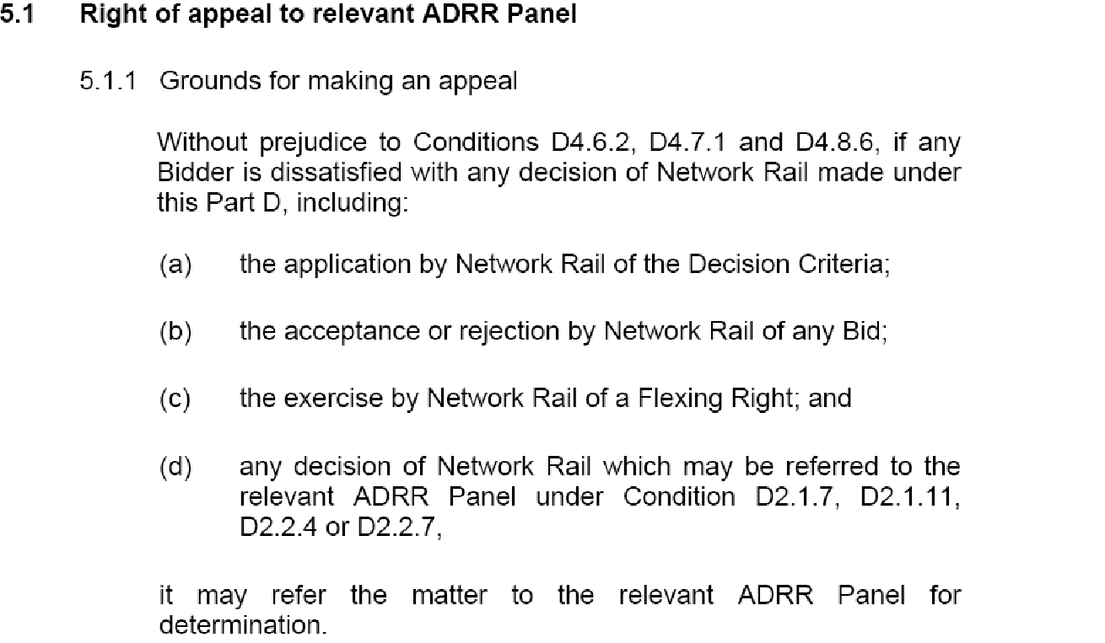
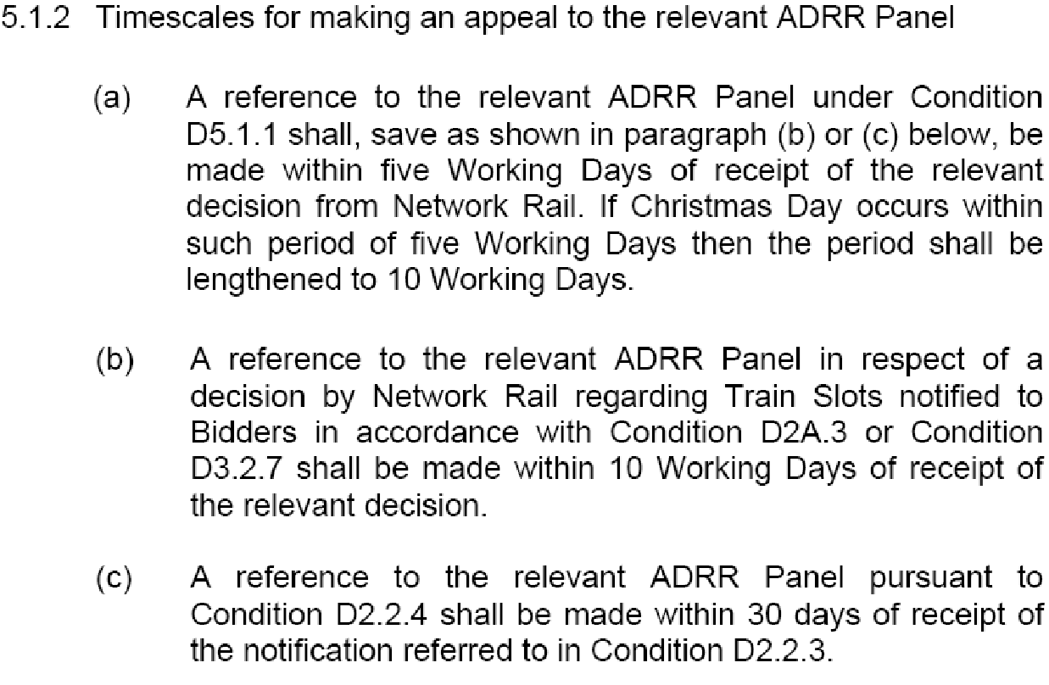

ANNEX “B”
Extract from the National Rules of the Plan – Section 3
Section 3 Procedure for Altering Rules of the Route or Rules of the Plan other than through the Twice-Yearly Process Having Effect from a Passenger Change Date

3.1. Introduction
3.1.1. This Procedure has been devised in accordance with Network Code Condition D 2.1.10 to provide a means of altering Rules of the Route and/or Rules of the Plan other than through the twice-yearly process having effect from the Passenger Change Dates. It supersedes the interim arrangements included within certain Train Operators’ Track Access Agreements and within certain Regional Rules of the Route and Rules of the Plan documents.

3.1.2. This procedure will be used by Network Rail to add, substitute or delete engineering access opportunities contained within Rules of the Route. All possessions so agreed will be regarded as being within Rules of the Route. Network Rail is committed to the achievement of the Informed Traveller deadlines resulting in details of amended train services being available 12 weeks before the date of operation, consequently, wherever possible, Network Rail will consult with Train Operators regarding possessions and other capacity restrictions which are disruptive to agreed train paths in sufficient time to allow details of those disruptive possessions to be included in a Confirmed Period Possessions Plan which will be published 26 weeks prior to the start of each 4-week period.

3.1.3. Where a need arises to amend Rules of the Route/Plan to cater for urgent safety requirements or other emergency situations, all parties concerned will co-operate in accelerating the normal timescales in this Procedure commensurate with the urgency of the circumstances.

3.2. Changes Initiated by Train Operators
3.2.1. A Train Operator may propose changes to any part of ROTR/P affecting or likely to affect that Train Operator.

3.2.2. The Train Operator shall submit a written statement of the proposed change and a concise explanation of the reasons for that change:

3.2.2.1. for ROTP, to its Network Rail lead Train Planning Manager who will acknowledge receipt and immediately copy the proposal to the Network Rail Train Planning Manager responsible for the relevant section of ROTP if not the lead TPM.

3.2.2.2. for ROTR, to the Network Access Unit Manager, who will acknowledge receipt.

3.2.3. Within 5 Working Days of receipt of the proposed change, Network Rail shall notify to all Train Operators affected details of the proposed change and Network Rail’s comments including concise reasons for the change and a statement as to whether Network Rail supports the proposal.

3.3. Changes Initiated by Network Rail
3.3.1. Network Rail may propose changes to any part of ROTR/P.

3.3.2. Network Rail shall notify to all Train Operators affected details of the proposed change including a concise explanation of its reasons. Proposed changes to ROTR arising before publication of the Draft Period Possessions Plan shall be notified by Network Rail in a single coordinated document to be issued each 4 weeks.

3.4. Response by Train Operators
3.4.1. Each Train Operator receiving notification of a proposed change in accordance with paragraphs 2.3 or 3.2 above will consider that proposal and respond to Network Rail within 10 Working Days from receipt of the notification, indicating:
3.4.1.1. its agreement to the proposed change or
3.4.1.2. details of a counter-proposal and an explanation of its reasons or
3.4.1.3. in the case of ROP items such as section running times, a request that a joint investigation is carried out.

3.4.2. Any Train Operator whose response is not received by Network Rail within 10 Working Days will be deemed to have agreed to the proposed change and will forfeit any right of Appeal.

ANNEX “B” Cont....
Extract from the National Rules of the Plan Cont. – Section 3
3.5. Decision by Network Rail
3.5.1. Network Rail shall give due consideration to responses received from Train Operators in accordance with paragraphs3.4.1 and 3.4.2 above and shall decide which changes, if any, should be made to ROR/P.

3.5.2. In reaching its decision, Network Rail shall have due regard to the Decision Criteria in Network Code Condition D6.

3.5.3. Network Rail will notify its decision to each affected Train Operator within 5 Working Days of the last date for receipt of responses under paragraph 3.4 above.

3.5.4. Any Train Operator, if it disputes Network Rail’s decision, may Appeal to a Timetabling Panel and any such Appeal will be dealt with as though it had been made in accordance with Network Code Condition D2.1.7. Any Appeal must be referred to the Access Disputes Secretary in accordance with the timescales shown in Condition D5.1.2 (i.e. within 5 Working Days of notification by Network Rail of its decision except at Christmas when the period is increased to 10 Working days.

ANNEX “C”
Extract from the Network Code Part “D” – Current Decision Criteria (D4.6) (19th July 2011)

“Where Network Rail is required to resolve any matter by applying the considerations in paragraphs (i)-(xv) below (“the Decision Criteria”) it must consider which of the Decision Criteria are relevant to the particular circumstances and apply those it has identified as relevant so as to reach a decision which is fair and not unduly discriminatory as between any individual affected Timetable Participants or as between any individual affected Timetable Participants and Network Rail. Where, in light of the particular circumstances, Network Rail considers that application of two or more of the relevant Decision Criteria will lead to a conflicting result then it must decide which is or are the most important Decision Criteria in the circumstances and when applying it or them, do so with appropriate weight”

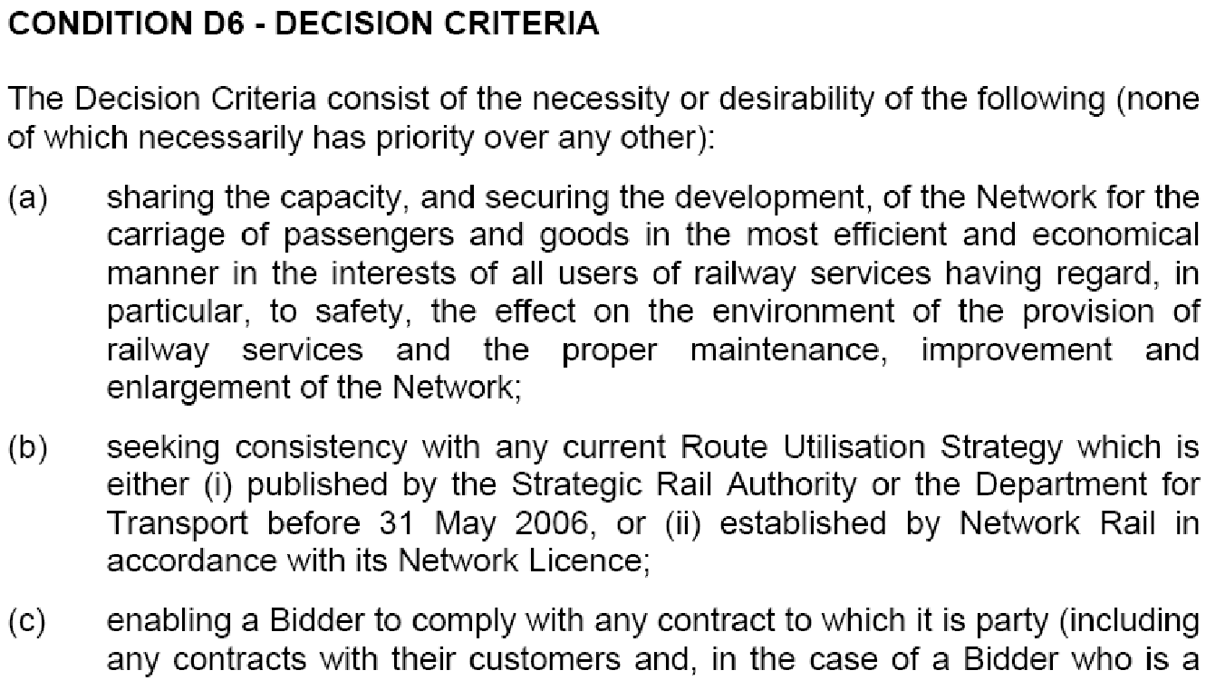

ANNEX “C”
Extract from the Network Code Part “D” Cont – Current Decision Criteria (D6) (18th July 2011)

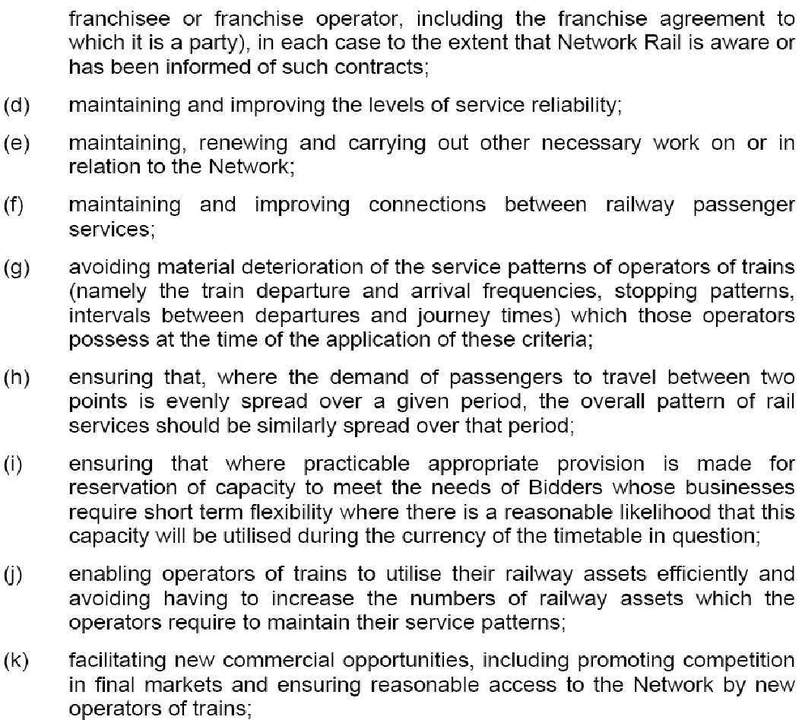
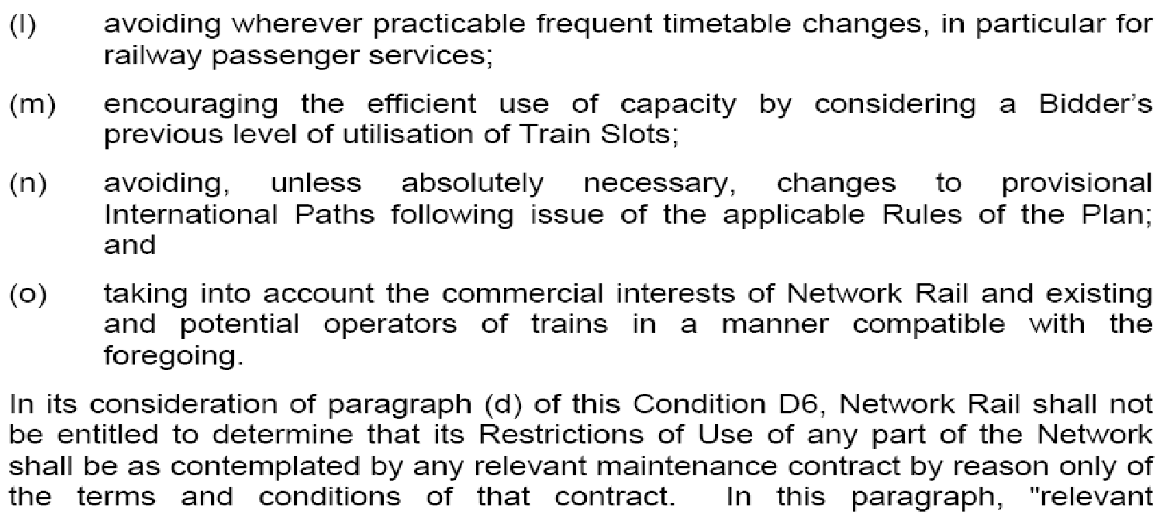

ANNEX “D”
Extract from the WCTL Service Level Agreement with DfT

WEST COAST FRANCHISE
Extracts Only

SERVICE LEVEL COMMITMENT v.4
(December 2008)

Version 2– 22/07/09 (updated for final December 20098 timetable)

Part 1
Service Level Commitment – General Provisions
1. Construction
The following provisions of this Part 1 shall apply in respect of the Service Level Commitment set out in Part 2, and these provisions shall be subject to flex rights contained within the Franchisee’s track access agreement.
2. Days and times of day
2.1 Except to the extent the context otherwise requires, references to a day mean the period commencing at 0200 on one day and ending at 0159 on the following day and references to particular days of the week shall be construed accordingly.
2.2 References to periods of times and periods of days include the times and days such periods start and finish.
  - All references to time are to the twenty-four hour clock.
3. Services
3.1 Except where expressly indicated to the contrary, references to services, all services or any part or any proportion of services are to be construed as references to the Passenger Services (or the relevant part or proportion thereof) required to be included by the Franchisee in its Timetable pursuant to paragraph 10.2 of Schedule 1.1 (Service Development) of the Terms and do not include such additional railway passenger services as the Franchisee may be permitted to provide from time to time under this Agreement.
3.2 Except where expressly indicated to the contrary, where an interval or frequency is specified for a service, such specification shall apply at the departure point for the relevant service.
  - Except where expressly indicated to the contrary, all services are to run in both directions and the requirements of the Service Level Commitment (including any interval between services, frequency of service or stopping pattern) are to apply in each direction.
  - Unless discretion is given in the wording of this Service Level Commitment, the Franchisee must not increase or decrease the number of services, nor decrease or cut short the stopping pattern of the services specified. Where discretion is allowed this will normally shown by using ‘may’ instead of ‘shall’ to describe the services.

ANNEX “D” Cont....
Extract from the WCTL Service Level Agreement with DfT Cont....

6 Bank Holidays
The level of service required to be included in the Timetable for the following days shall, except to the extent the Authority otherwise agrees, be as follows:
24 December: | Services may be wound down for close of service by 2000;
25th and 26th December | No services are required to be operated;
Weekdays falling between Christmas and New Year’s Eve: | Weekday service to operate. On the 27th December services may commence at 0800.
New Year’s Eve | Services may be wound down for close of service by 2000;
New Year (1st January): | Weekday service to operate, unless otherwise shown in the Service Level Commitment. Services may commence at 0800. A Sunday service may be provided for journeys to and from Scotland but there is no requirement for services to be extended to or originate from stations north of Edinburgh.
Other Bank Holidays: | Weekday service to operate.
December 2008 Onwards

Route C: London Euston to Manchester Piccadilly
- ROUTE DEFINITION
1.1 Services shall be provided between London Euston and Manchester Piccadilly via Stoke-on-Trent, calling at Stoke-on-Trent and Stockport and either of Milton Keynes Central and Macclesfield.
1.2 Services shall also be provided between London Euston and Manchester Piccadilly via Crewe, calling at Crewe, Wilmslow and Stockport.

4. SERVICE PATTERN - SUNDAYS
NORTHBOUND
  - Between and including the Early Service via Stoke-on-Trent and 1159, one train per hour shall be provided from London Euston to Manchester Piccadilly via Stoke on Trent, calling at the stations in Paragraph 1.1, including both Milton Keynes Central and Macclesfield.
  - Between 1200 and the Late Service via Stoke-on-Trent, two trains per hour shall be provided from London Euston to Manchester Piccadilly via Stoke-on-Trent, calling at the stations in Paragraph 1.1. These services shall alternately call at Milton Keynes Central or Macclesfield, to provide these stations with one service from London Euston to Manchester Piccadilly in each hour.
ANNEX “D” Cont...
Extract from the WCTL Service Level Agreement with DfT Cont....

  - Between 1200 and the Late Service via Crewe, one train per hour shall be provided from London Euston to Manchester Piccadilly via Crewe, calling at the stations in Paragraph 1.2.
  - NOT SHOWN
  - NOT SHOWN
SOUTHBOUND
  - NOTSHOWN
  - Between 1100 and the Late Service via Stoke-on-Trent, two services per hour shall be provided from Manchester Piccadilly to London Euston via Stoke-on-Trent, calling at the stations in Paragraph 1.1. These services shall alternately call at Milton Keynes Central or Macclesfield, to provide these stations with one service from London Euston to Manchester Piccadilly in each hour.
  - Between 1100 and the Late Service via Crewe, one train per hour shall be provided from Manchester Piccadilly to London Euston via Crewe, calling at the stations in Paragraph 1.2.
7. MAXIMUM JOURNEY TIMES
Route | Monday - Friday | Saturday | Sunday
London Euston – Manchester Piccadilly,  via Stoke-on-Trent | 2 hours 9 minutes, with 3 intermediate stops, with one exception of 2 hours 10 minutes and one exception of 2 hours 28 minutes | 2 hours 9 minutes, with 3 intermediate stops | 2 hours 14 minutes, with 3 intermediate stops
London Euston – Manchester Piccadilly,  via Crewe | 2 hrs 11 minutes with 3 intermediate stops | 2 hrs 11 minutes with 3 intermediate stops | 2 hrs 15 minutes with 3 intermediate stops
Manchester Piccadilly - London Euston,  via Stoke-on-Trent | 2 hours 8 minutes, with 3 intermediate stops | 2 hours 8 minutes, with 3 intermediate stops, with one exception of 2 hours and 10 minutes and one exception of 2 hours 19 minutes | 2 hours 12 minutes, with 3 intermediate stops, with one exception of 2 hours 13 minutes and two exceptions of 2 hours 19 minutes
Manchester Piccadilly - London Euston,  via Crewe | 2 hrs 9 minutes with 3 intermediate stops | 2 hrs 9 minutes with 3 intermediate stops | 2 hrs 14 minutes with 3 intermediate stops

ANNEX “E”
Extracts from the WCTL Track Access Agreement – Schedule 5

2 Passenger Train Slots
Table 2.1: Passenger Train Slots

Service Group 3: London Euston to Manchester Piccadilly
Service description |  |  |  |  | Passenger Train Slots
From | To | Via | Description | TSC | Weekday | Saturday | Sunday
London Euston | Manchester Piccadilly | Stoke-on-Trent | HF03.1 | 22108001 | 13 | 13 | 9
 |  | Stoke-on-Trent | HF03.2 | 22108001 | 14 | 12 | 8
 |  | Stoke-on-Trent | HF03.3 | 22108001 | 3 | 2 | 5
 |  | Wilmslow | HF03.4 | 22108001 | 14 | 14 | 10
 |  | Wilmslow | HF03.5 | 22108001 | 2² | 1 | N/A
 |  | Wilmslow | HF03.6 | 22108001 | 1 | N/A | 1
Manchester Piccadilly | London Euston | Stoke-on-Trent | HF03.7 ^{4th} | 22108001 | 14 | 16 | 14
 |  | Stoke-on-Trent | HF03.8 | 22108001 | 15 | 12 | 9
Manchester Piccadilly | London Euston | Wilmslow | HF03.10 | 22108001 | 15 | 15 | 10
 |  | Wilmslow | HF03.11 | 22108001 | 1 | N/A | N/A
 |  | Stockport | HF03.12 | 22108001 | 1 | N/A | N/A
Note to Table:

¹ See paragraph 2.3 of this Schedule.
² The first Service shall be Scheduled to start at Crewe

ANNEX “E”
Extracts from the WCTL Track Access Agreement Cont – Schedule 5

Table 3.2: Clockface Departures
1 |  |  |  |  | 2 | 3 | 4
Service Group 3: London Euston to Manchester Piccadilly
Service description |  |  |  |  | Station where Clockface Departure applies | Number of Clockface Departures per Period of 60 Minutes (which in this column means the period commencing at and ending immediately before the times specified in this column) | Provisos to the number of Clockface Departures per Period of 60 Minutes (as defined in column 3 of this Table)
From | To | Via | Description¹ | TSC |  | Sunday
London Euston | Manchester Piccadilly | Stoke-on-Trent/ Wilmslow | HF03.1  HF03.2  HF03.3  HF03.4 | 22108001 | London Euston | 1  between:  07:54 and 11:53 (inclusive)  3  between:  12:05 and 21:04 (inclusive) | In relation to the last Period of 60 Minutes, the number of Clockface Departures shall be two only and they shall be on pattern with the first and second Clockface Departures set earlier in the day.
Manchester Piccadilly | London Euston | Stoke-on-Trent/ Wilmslow | HF03.7  HF03.8  HF03.10 | 22108001 | Manchester Piccadilly | 3  between:  08:05 and 21:04 (inclusive)  1 Notwithstanding that more than one sub-Service Group may be listed under this column heading in relation to any particular row, the Train Operator’s Firm Rights to Clockface Departures in each Period of 60 Minutes (as that term may separately be defined for the purpose of each service description) shall not be more than the total aggregate number specified against each row in column 3. For greater clarity, the purpose of listing more than one sub-Service Group against a particular service description is to specify that quanta may be drawn from each of those sub-Service Groups when Scheduling repeat Clockface Departures during the Day or part of the Day specified in column 3. | In relation to the first two Periods of 60 Minutes, the number of Clockface Departures shall be one only in each such Period and they shall be on pattern with the first Clockface Departure in the subsequent Periods of 60 Minutes  In relation to the third Period of 60 Minutes, the number of Clockface Departures shall be two only and they shall be on pattern with the first and second Clockface Departure in the subsequent Periods of 60 Minutes  In relation to the first three Services, Network Rail may flex the departure of those Services by up to a further two minutes later giving a total departure time flex of five minutes for each of those Services  In relation to the last Period of 60 Minutes, the number of Clockface Departures shall be two only and they shall be on pattern with the first and third Clockface Departures in each preceding Period of 60 Minutes  In relation to the clockface pattern set to operate during the last Period of 60 Minutes, once this clockface pattern has been set, Network Rail may flex the departure of the first Service by up to a further two minutes later giving a total departure time flex of five minutes for this Service

ANNEX “E”
Extracts from the WCTL Track Access Agreement Cont – Schedule 5
Table 4.1: Calling Patterns
Service Group 3: London Euston to Manchester Piccadilly
Service description
From | To | Via | Description | TSC | Regular Calling Pattern | Additional stations
London Euston | Manchester Piccadilly | Stoke-on-Trent | HF03.1 | 22108001 | Milton Keynes Central, Stoke-on-Trent and Stockport | N/A
 |  |  | HF03.2 | 22108001 | Stoke-on-Trent, Macclesfield and Stockport | N/A
 |  |  | HF03.3 | 22108001 | Milton Keynes Central, Stoke-on-Trent, Macclesfield and Stockport | N/A
 |  | Wilmslow | HF03.4 | 22108001 | Crewe, Wilmslow and Stockport² | N/A
 |  |  | HF03.5 | 22108001 | Watford Junction, Crewe, Wilmslow and Stockport³ | N/A
 |  |  | HF03.6 | 22108001 | Milton Keynes Central, Rugby, Nuneaton, Tamworth Low Level, Lichfield Trent Valley, Stafford, Crewe and Stockport⁴ | N/A
Manchester Piccadilly | London Euston | Stoke-on-Trent | HF03.7 | 22108001 | Stockport, Macclesfield and Stoke-on-Trent⁵ | N/A
 |  |  | HF03.8 | 22108001 | Stockport, Stoke-on-Trent and Milton Keynes Central⁶ | N/A
 | London Euston | Wilmslow | HF03.10 | 22108001 | Stockport, Wilmslow and Crewe⁷ | N/A
Manchester Piccadilly | London Euston | Wilmslow | HF03.11 | 22108001 | Stockport, Crewe, Stafford, Nuneaton, Rugby and Milton Keynes Central | N/A
 |  | Stockport | HF03.12 | 22108001 | Stockport | N/A
Notes to Table:
² The first Service Scheduled to operate on each Sunday shall be Scheduled to call additionally at Milton Keynes Central. The last Service Scheduled to operate on each Sunday shall be Scheduled to call additionally at Stafford.
³ The first three Services Scheduled to operate on each Sunday shall be Scheduled to start at Crewe.
⁴ The Services Scheduled to operate on each Sunday shall not be Scheduled to call at either Tamworth Low Level or Lichfield Trent Valley.
⁵ The second, third and penultimate Services Scheduled to operate on each Sunday shall be Scheduled to call additionally at Milton Keynes Central.
⁶ The last Service Scheduled to operate on each Sunday shall be Scheduled to call additionally at Macclesfield and Watford Junction.
⁷ The first Service Scheduled to operate on each Sunday shall be Scheduled to call additionally at Stafford and Watford Junction. The second Service Scheduled to operate on each Sunday shall be Scheduled to call additionally at Watford Junction.
ANNEX “E”
Extracts from the WCTL Track Access Agreement Cont – Schedule 5
Table 6.3: Maximum Key Journey Times
Service Group 3: London Euston to Manchester Piccadilly
Service description |  |  |  |  | Sundays
From | To | Via | Description | TSC | Calling Pattern | Specified Equipment | Maximum Key Journey Time (minutes)
London Euston | Manchester Piccadilly | Stoke-on-Trent | HF03.1 | 22108001 | Milton Keynes Central, Stoke-on-Trent and Stockport | Class 390 (9 Car) (T) | 134
 |  |  | HF03.2 | 22108001 | Stoke-on-Trent, Macclesfield and Stockport | Class 390 (9 Car) (T) | 132
 |  |  | HF03.3 | 22108001 | Milton Keynes Central, Stoke-on-Trent, Macclesfield and Stockport | Class 390 (9 Car) (T) | 1 Service at 154  4 Services at 157
 |  | Wilmslow | HF03.4 | 22108001 | Crewe, Wilmslow and Stockport | Class 390 (9 Car) (T) | 135
 |  |  | HF03.4 | 22108001 | Milton Keynes Central, Crewe, Wilmslow and Stockport | Class 390 (9 Car) (T) | 166
 |  |  | HF03.4 | 22108001 | Stafford, Crewe, Wilmslow and Stockport | Class 390 (9 Car) (T) | 139
 |  |  | HF03.6 | 22108001 | Milton Keynes Central, Rugby, Nuneaton, Stafford, Crewe and Stockport | Class 390 (9 Car) (T) | 167
Manchester Piccadilly | London Euston | Stoke-on-Trent | HF03.7 | 22108001 | Stockport, Macclesfield and Stoke-on-Trent | Class 390 (9 Car) (T) | 8 Services at 132  1 Service at 139
 |  |  | HF03.7 | 22108001 | Stockport, Macclesfield, Stoke-on-Trent, Milton Keynes Central | Class 390 (9 Car) (T) | 1 Service at 141  2 Services at 153
ANNEX “E”
Extracts from the WCTL Track Access Agreement Cont – Schedule 5
Table 6.3: Maximum Key Journey Times
Service Group 3: London Euston to Manchester Piccadilly
Service description |  |  |  |  | Sundays
From | To | Via | Description | TSC | Calling Pattern | Specified Equipment | Maximum Key Journey Time (minutes)
Manchester Piccadilly | London Euston | Stoke-on-Trent | HF03.7 | 22108001 | Stockport, Macclesfield, Stoke-on-Trent and Watford Junction | Class 390 (9 Car) (T) | 153
 |  |  | HF03.8 | 22108001 | Stockport, Macclesfield, Stoke-on-Trent, Milton Keynes Central and Watford Junction | Class 390 (9 Car) (T) | 172
 |  |  | HF03.8 | 22108001 | Stockport, Stoke-on-Trent and Milton Keynes Central | Class 390 (9 Car) (T) | 7 Services at 132  1 Service at 133  1 Service at 139
 |  | Wilmslow | HF03.10 | 22108001 | Stockport, Wilmslow and Crewe | Class 390 (9 Car) (T) | 134
 |  |  | HF03.10 | 22108001 | Stockport, Wilmslow, Crewe, Stafford and Watford Junction | Class 390 (9 Car) (T) | 173
 |  |  | HF03.10 | 22108001 | Stockport, Wilmslow, Crewe and Watford Junction | Class 390 (9 Car) (T) | 154

Maximum Key Journey Time
6.7 Subject to paragraph 6.8, in respect of each of the Services specified in column 1 of Table 6.3, the Train Operator has Firm Rights to a Journey Time in the Weekday, Saturday and Sunday Working Timetables not exceeding the corresponding Maximum Key Journey Time in column 4.

ANNEX “E”
Extracts from the WCTL Track Access Agreement Cont – Schedule 5
7.1 In relation to the Applicable Engineering Access Statement and the Applicable Timetable Planning Rules:
(a) Network Rail shall not propose or agree to any amendments to the Applicable Engineering Access Statement or the Applicable Timetable Planning Rules which would prevent it from Scheduling a Journey Time in the Weekday, Saturday and Sunday Working Timetables:
(i) which is equal to or less than the Fastest Key Journey Time specified for at least one Passenger Train Slot for each of the Key Journeys specified in Table 6.2 in respect of each Weekday; and
(ii) which is equal to or less than the relevant Maximum Key Journey Time specified for every Passenger Train Slot consistent with each Key Journey of the type specified in Table 6.3;
(b) paragraph 7.1(a) shall not apply in relation to any such amendment which is proposed by the Train Operator or effected pursuant to the order of an appeal body under Part D of the Network Code or any other competent tribunal; and
(c) Network Rail shall not be in breach of paragraph 7.1(a) to the extent that the failure to Schedule any Journey Time in accordance with paragraph 7.1(a)(i) or (ii) is the result of any Network Rail Restriction of Use, Competent Authority Restriction of Use or Operator Restriction of Use (as these terms are defined in or for the purposes of Part 3 of Schedule 4).

Extract - Section 5 templated Front-End part of a Track Access Contract
5 PERMISSION TO USE
5.1 Permission to use the Routes
Network Rail grants the Train Operator permission to use the Routes.
5.2 Meaning
References in this contract to permission to use the Routes shall, except where the context otherwise requires, be construed to mean permission:
(a) to use the track comprised in the Routes for the provision of the Services using the Specified Equipment;
(b) to use the track comprised in the Network in order to implement any plan established under Part H of the Network Code;
(c) to make Ancillary Movements;
(d) to Stable, which shall be treated, for the purposes of Part D of the Network Code, as the use of a Train Slot;
(e) for the Train Operator and its associates to enter upon that part of the Network comprising the Routes, with or without vehicles; and
(f) for the Train Operator and its associates to bring things onto that part of the Network comprising the Routes and keep them there,
and such permission is subject, in each case and in all respects to:
(i) the Network Code;
(ii) the Applicable Engineering Access Statement; and
(iii) the Applicable Timetable Planning Rules.
ANNEX “F”
Extracts from Network Rail’s SBP in conjunction with EEA

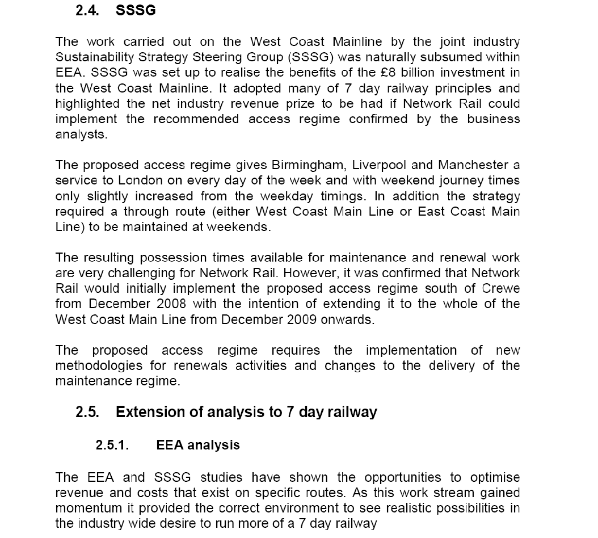

ANNEX “F”
Extracts from Network Rail’s Strategic Business Plan in conjunction with EEA Cont...
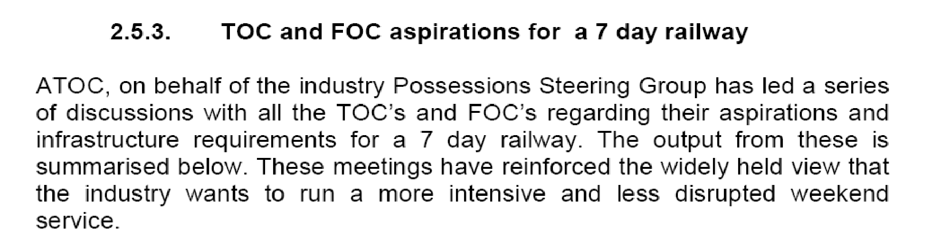
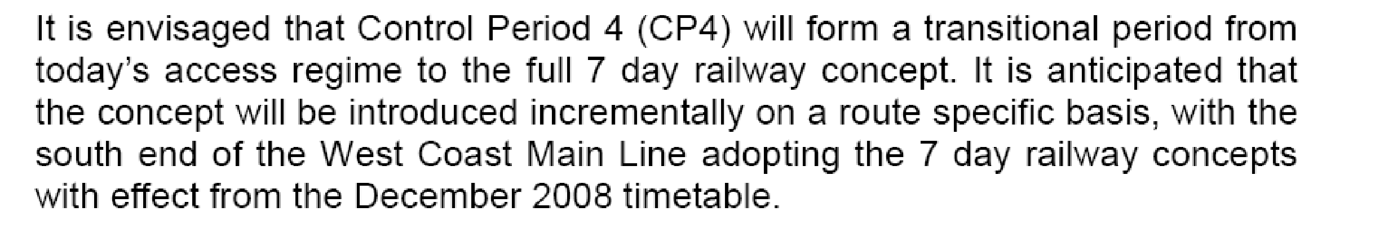

Demand
The following key conclusions have been reached from our analysis with operators of the potential demand:

• there is strong evidence of suppressed demand at weekends, especially on Sundays;

• weekend revenues affected by disrupted services (25-50% loss);

• there is additional demand late evening and on specialist flows such as airports traffic;

• TOCs (and passengers) do not like bus substitution (especially at weekends), and the costs of putting on a bus replacement service are high. Bus substitution is suppressing demand as passengers are deterred from using trains on the weekend from fear of being put on a bus for part of their journey;

ANNEX “G”

Extracts from Network Rail’s CP4 Delivery Plan

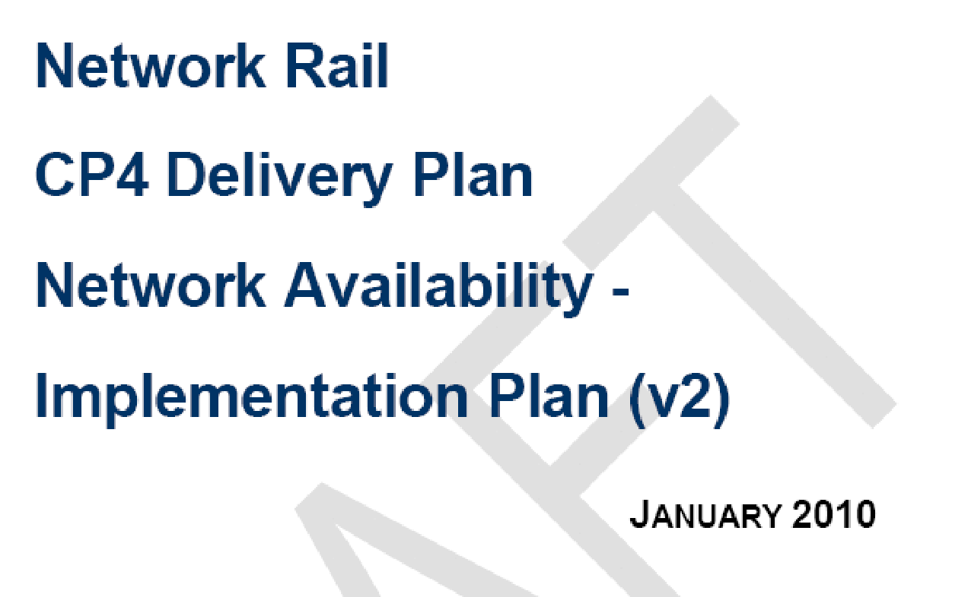

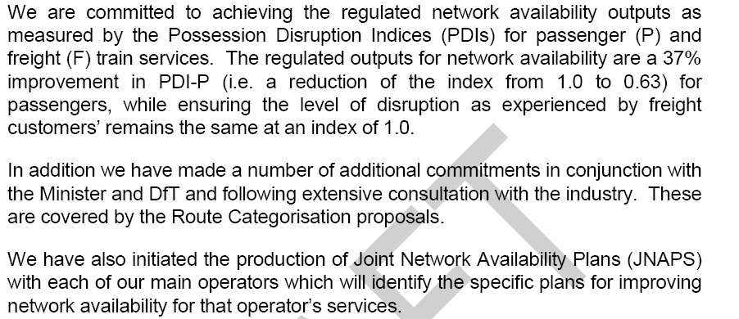

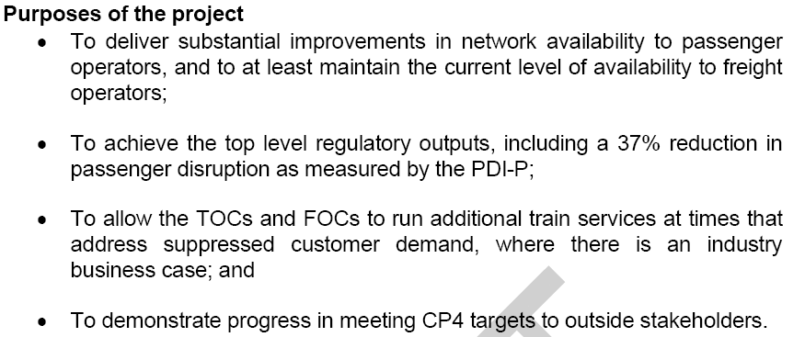
ANNEX “H”

Notification of LNW-CE-03 Proposal inc Week 14 Extract

From: Fredriksson Daniel
Sent: 20 June 2011 13:56
To: Warr Joe; EXTL: Dellard Chris; 'Richard Roberts CR'; 'David McConnochie'; 'Richard Lewis'; EXTL: Barrett s; EXTL: Hassall Chris; FSR: Claire Scougall; EXTL: Ian Kapur; Iqbal Mehtar; 'Janet Jones'; 'Matthew.Chappell; 'Peter Warhurst'; EXTL: Peter Latham; EXTL: Richard Sawyer; 'Roger Orpin'; 'Tim Jenkinson'; 'Tony Vigor'; TPE: David Langton; 'Stuart.Morris; Nichol, Susan; 'DBS: Graham White'; 'XC: John Cherrington'; 'Phil Dunlop'; Kevin.Waplington
Cc: Lamond Davina; Bates Gareth; Monk Justin; Ferguson Matthew; Evans Gary; Parsons David
Subject: REQUEST: LNW12-CE-03 AMENDMENT TO LONDON NORTH WESTERN ENGINEERING ACCESS STATEMENT 2012 - post Version 2 Section 7.

REQUEST: AMENDMENT TO LONDON NORTH WESTERN ENGINEERING ACCESS STATEMENT 2012

EAP Reference: LNW12-CE-03

Dear All,

Please find attached proposed amendments to London North Western Section 7 post Version 2 Engineering Access Statement 2012 for LNW North, LNW South (combined) and Merseyrail.

I look forward to receiving your formal response to the above proposal by Monday 4th July 2011. Earlier responses would be appreciated in order to capture any requested amendments to these possessions before the data freeze for EAS version 2.1.

This email is in accordance with Access Condition D2.1.10 and relates to Section 3.1 of National Timetable Planning Rules being the Procedure for Altering Engineering Access Statement or Timetable Planning Rules other than through the Twice-Yearly Process Having Effect from a Passenger Change

Kind Regards,

Daniel Fredriksson
Access Planning Specialist

The content of this email (and any attachment) is confidential. It may also be legally privileged or otherwise protected from disclosure. This email should not be used by anyone who is not an original intended recipient, nor may it be copied or disclosed to anyone who is not an original intended recipient. If you have received this email by mistake please notify us by emailing the sender, and then delete the email and any copies from your system. Liability cannot be accepted for statements made which are clearly the senders own and not made on behalf of Network Rail. Network Rail Infrastructure Limited registered in England and Wales No. 2904587, registered office Kings Place, 90 York Way London N1 9AG

ANNEX “H”

Notification of LNW-CE-03 Proposal inc Week 14 Extract cont...

LNW-CE-03 - Original Proposal

Week 14
NW5001
New possession required for S&C tamping Stockport No.2

Sunday 1 July
PPS Ref: P2012/1467966
At/Between: Heaton Norris Jn and Denton Jn
Lines: All Lines (Possession (T3))
Times: 0030 Sun to 1630 Sun
and
At/Between: Edgeley Jn No.2 Sb and Slade Lane Jn
Lines: All Lines (Possession (T3))
Times: 0030 Sun to 1630 Sun

Traffic Remarks: TRAINS TO DIVERT VIA CREWE AND STYAL. NO ACCESS TO STOCKPORT. RAIL REPLACEMENT ROAD SERVICES TO OPERATE. HOPE VALLEY SERVICES TO DIVERT VIA ROMILEY AND ASHBURYS TO MANCHESTER PICCADILLY.

ANNEX “I”

Notification of LNW-CE-03 Decision inc unchanged Week 14 Extract, plus Comments
From: Warr Joe
Sent: 08 July 2011 15:09
To: Fredriksson Daniel; EXTL: Dellard Chris; 'Richard Roberts CR'; 'David McConnochie'; 'Richard Lewis'; EXTL: Barrett s; EXTL: Hassall Chris; FSR: Claire Scougall; EXTL: Ian Kapur; Iqbal Mehtar; 'Janet Jones'; 'Matthew.Chappell; 'Peter Warhurst'; EXTL: Peter Latham; EXTL: Richard Sawyer; 'Roger Orpin'; 'Tim Jenkinson'; 'Tony Vigor'; TPE: David Langton; 'Stuart.Morris; Nichol, Susan; 'DBS: Graham White'; 'XC: John Cherrington'; 'Phil Dunlop'; Kevin.Waplington
Cc: Lamond Davina; Bates Gareth; Monk Justin; Ferguson Matthew; Evans Gary; Parsons David; McBride Helen
Subject: DECISION: : LNW12-CE-03 AMENDMENT TO LONDON NORTH WESTERN ENGINEERING ACCESS STATEMENT 2012 - post Version 2 Section 7.

DECISION: AMENDMENT TO LONDON NORTH WESTERN ENGINEERING ACCESS STATEMENT 2012

EAP Reference: LNW12-CE-03

Dear All,

Further to Daniel Fredriksson’s e-mail of 20/06/2011 please find attached Network Rail’s decision on the amendments to London North Western Section 7 post Version 2 Engineering Access Statement 2012 for LNW North, LNW South (combined) and Merseyrail. You will note that we are issuing this decision after Version 2.1, rather than allowing V2.1 to act as a contractual decision. This is because V2.1 is a rules update to show easements and agreed changes, whereas this document is the contractual decision. If you have any more queries, please give me a ring and I will talk you through it.

This email is in accordance with Access Condition D2.1.10 and relates to Section 3.1 of National Timetable Planning Rules being the Procedure for Altering Engineering Access Statement or Timetable Planning Rules other than through the Twice-Yearly Process Having Effect from a Passenger Change

Kind Regards

Joe Warr
Lead Access Planner LNW
Engineering Access Planning, Network Rail

ANNEX “I”

Notification of LNW-CE-03 Decision inc unchanged Week 14 Extract, plus Comment Cont...

Week 14
NW5001
New possession required for S&C tamping Stockport No.2

Sunday 1 July
PPS Ref: P2012/1467966
At/Between: Heaton Norris Jn and Denton Jn
Lines: All Lines (Possession (T3))
Times: 0030 Sun to 1630 Sun
and
At/Between: Edgeley Jn No.2 Sb and Slade Lane Jn
Lines: All Lines (Possession (T3))
Times: 0030 Sun to 1630 Sun

Traffic Remarks: TRAINS TO DIVERT VIA CREWE AND STYAL. NO ACCESS TO STOCKPORT. RAIL REPLACEMENT ROAD SERVICES TO OPERATE. HOPE VALLEY SERVICES TO DIVERT VIA ROMILEY AND ASHBURYS TO MANCHESTER PICCADILLY.

WCTL DECLINE THIS PROPOSAL Completely unacceptable. This has moved from a Bank Holiday into a normal weekend. VT have suggested on numerous weekends that this would fit better on August Bank Holiday, other operators have also suggested this as it is better for customers and NR Resources.
EAP response: this work has been moved as part of the redating the work at Stockport from week 2 in order to create a more workable access plan in that weekend. On the basis of the ADC and ORR determinations on the 2011 access in this location we have sought to date this work at a similar time of year with the same duration and timing of the blocks. As you know we are currently reviewing this work with a view to seeing if the tamp can be split or done in a different way – we will pass the results of this review onto Virgin Trains once we have them.

ANNEX “J”

Letter to Network Rail placing WCTL into Dispute regarding Week 14 1st July 2012

To:
Mr T. Skilton
Committee Secretary for the ADC
8th Floor
1 Eversholt Street
London
NW1 2DN

cc.
Mr. M. Allen
Mr. J. Warr
Mr. I. Leigh

22nd July 2011

Ref. ROTR2012- LNW12-CE03/RH/Res

Dear Tony

WCTL Response to Network Rail’s 2012 Amendment to the Engineering Access Statement - Ref LNW12-CE-03 decision Document, published on 08th July 2011.

With reference to the above documentation, proposed in accordance with Network Code D3.4 Network Rail Variations with at least 12 weeks notice, (but actually proposed incorrectly under the old D2.1.10 “....procedure for altering the engineering Access Statement other than through the twice yearly process....”,), received from Network Rail in e-mail format on 8th July 2011, (as proposed under section D3.4.3 of the Network Code and Section 3.1 of the National Rules of the Plan), WCTL hereby formally responds outlining those items that are considered to be in dispute, as required under section 3.4.1 of the National Rules of the Plan and Sections D3.5.4 & 5.1.2 of the Network Code.
WCTL primary objective with regards to all those possession proposals contained within this amendment to the 2012 ‘Rules’, is to seek to reduce those levels of operational disruption to our Very High Frequency timetable (VHF), introduced during 2009. With the overall average growth increase in business and leisure travel (‘journeys’) still continuing, any degradation in service levels especially at weekends is wholly unacceptable.

The introduction of these further disruptive Section 7 items as outlined here-in, (falling both within Bank Holiday Periods or unacceptable standard weekends, and in conflict with general EEA and route categorisation policies), will significantly further reduce our ability to operate a full VHF timetable; thus exacerbating the affect on both WCTL business and operations. In view of the Industry’s exigency to move towards 7-Day Railway access, such disruption to services is unacceptable.
ANNEX “J”

Letter to Network Rail placing WCTL into Dispute regarding Week 14 1st July 2012 Cont.

For simplicity, we separately attach an Annex “A”, encompassing all the aforementioned Decision Proposal Documentation, indicating what is in dispute and why, and what is duly accepted: WCTL will, nonetheless, seek to reduce such number of possessions in dispute, and will continue to work diligently with Network Rail to do this.

This letter, to be read in conjunction with our Notice of Dispute and Annex “A”, is presented to the Secretary of the ADRC without prejudice to the fact that, as from 1st April 2012 (and thus encompassing ⅔ of the remaining ‘Rules’ period), the current incumbent (“WCTL”) is presently negotiating a Contract extension to its current franchise Agreement for a further 8 months up until the 9th December 2012, (those same timescales relevant to this set of proposals). In the eventuality that any change to Operator status occurs, then the contents of this letter continue to stand for the replacement Operator.

In consideration of the above:

a) WCTL submits this response under Network Code conditions D3.4.5 and D5.1.2 to the Disputes Secretary of the Access Disputes Timetable Panel for determination at his discretion;

Yours Sincerely

Robert Hodgkinson
Commercial Operations Manager
West Coast Trains Ltd.
ANNEX “K”

Extract – Network Response to EAS Responses to V1 & V2.
Version 1 EAS response

Version 2 EAS Response

From: Warr Joe
Sent: 29 July 2011 17:20
To: Nichol, Susan
Cc: Lamond Davina; Monk Justin; Bates Gareth; Ferguson Matthew; Evans Gary; Fredriksson Daniel; Parsons David
Subject: NR reply to VT 2012 EAS ADC referral

Susan

Please see attached Network Rail’s reply to your 2012 EAS ADC referral. We’ll discuss outstanding issues more when we both return from leave, I hope we can resolve as much as possible.

As discussed on the phone, I apologise that we weren’t able to discuss this with you in more depth before we issued our decision.

Regards

Joe
Joe Warr, Lead Access Planner LNW, EAP, Network Rail

Addendum
The above highlights that in V.1 Network Rail initially considered the original Cheadle Hulme- Slade Lane item as being viable for implementation during a Bank Holiday Period, but this was not enacted upon in totality (i.e part went to May SBH, the other to Week 14).

ANNEX “L1”

WCTL Director Response to Network Rail over 2012 ABH Works

From: Bearpark, Phil
Sent: 22 September 2011 09:12
To: Joyce Michelle
Cc: Gibb, Chris; Dunster, Jonathan; Hodgkinson, Rob
Subject: RE: Aug BH 2012 planned work

Michelle

Thanks for this. I appreciate that you have done this research, however, I do not agree with the findings. How is it possible that Engineering resources are stretched on a Bank Holiday weekend where there is “no” engineering. As we have always said, customer numbers are much lower on Bank Holiday Sundays and we prefer to have disruption on those Sundays rather than on normal weekend Sundays.

I will instruct my team to prepare a submission to ADRC panel.

Phil

Phil Bearpark
Production Director
Virgin Trains
Tel - [redacted]

P.A. Tina Cranley

From: Joyce Michelle
Sent: 22 September 2011 08:25
To: Bearpark, Phil
Subject: Aug BH 2012 planned work

Phil

Further to discussion at DL today, I can summarise the Aug 2012 weekend works as follows -

S& C Tamping has been agreed at Norton Bridge
P2012/1394371
Whitehouse Jn and Basford Hall Jn 2130 Sat to 1300 Sun Down and Up Fast
Whitehouse Jn and Basford Hall Jn SB Slow Lines 2345 Sat to 0930 Sun
Penkridge and Trent Valley No 1 2345 Sat to 0930 Sun

The Norton Bridge tamping access still provides a route for service groups from Euston to Scotland and Euston to Manchester. It also provides a route between Birmingham/West Mids and Manchester (albeit missing the call at Stoke). There are still services between Stoke and Manchester on Euston to Manchester services.

The main service groups are still catered for by taking this block at these times, so minimal impact on the travelling public. It is low risk as the adjacent lines are open to traffic. This is why the work was permitted in this weekend. Our preference would be to avoid dating of this work on a Bank Holiday weekend when engineering resource is stretched, but unfortunately the journey time restrictions on Anglo Scottish passenger services between 1145 Sun and 1300 Sun don’t permit this work to be dated on a non Bank Holiday weekend.
ANNEX “L1”

WCTL Director Response to Network Rail over 2012 ABH Works Cont...

It would be a great deal more disruptive for travellers in the North West if we had a reduced service level diverted via the Styal lines to avoid Stockport. Further the Stockport job requires a 16 hour block of all lines 0030 Sun to 1630 Sun.

Additionally we would also encounter resource issues if Stockport was to take place in the same weekend. However, the main decision factor was the more disruptive impact of the Stockport works in this weekend.

Michelle

Michelle Joyce
Customer Relationship Executive [Virgin Trains]
Phone: [redacted]

Regards
Michelle

Michelle Joyce
Customer Relationship Executive [Virgin Trains]
Phone: [redacted]

The content of this email (and any attachment) is confidential. It may also be legally privileged or otherwise protected from disclosure. This email should not be used by anyone who is not an original intended recipient, nor may it be copied or disclosed to anyone who is not an original intended recipient. If you have received this email by mistake please notify us by emailing the sender, and then delete the email and any copies from your system. Liability cannot be accepted for statements made which are clearly the senders own and not made on behalf of Network Rail. Network Rail Infrastructure Limited registered in England and Wales No. 2904587, registered office Kings Place, 90 York Way London N1 9AG

ANNEX “L2”

Examples of Works taking place during the ABH Period

SATURDAY 25 to SUNDAY 26 AUGUST
Ref. No. P2012/1397654 Possession Manager Network Operations West Coast South

Item | Hillmorton Jn | Down Fast | 2215 | to | 1200
 | and | Possession | SAT |  | SUN
 |  | Down Slow | 2215 | to | 1200
 |  | Possession | SAT |  | SUN
 |  | Down Northampton/Coventry | 2215 | to | 1200
 |  | Possession | SAT |  | SUN
 | Trent Valley Jn | Down Coventry | 2215 | to | 2350
 | and | Possession | SAT |  | SAT
 | Long Lawford Jn
 | Rugby | Platform 3/Engine Siding | 2215 | to | 1200
 |  | Possession | SAT |  | SUN
 | Trent Valley Jn | Single | 2215 | to | 1200
 | and | Possession | SAT |  | SUN
 | Trent Valley Jn | All Lines | 2215 | to | 0850
 | and | Possession | SAT |  | SUN
 | Trent Valley Jn | Down and Up Coventry | 2350 | to | 0850
 | and | Possession | SAT |  | SUN
 | Brandon HABD
 | Trent Valley Jn | Up Fast | 2350 | to | 0850
 | and | Possession | SAT |  | SUN
 | Hillmorton Jn
 |  | Up Slow/Up Northampton | 2350 | to | 0850
 |  | Possession | SAT |  | SUN
 | Trent Valley Jn | Up Goods | 2350 | to | 0850
 | and | Possession | SAT |  | SUN
 |  | Up & Down Through Sidings | 2350 | to | 0850
 |  | Possession | SAT |  | SUN
 | Weedon | Down and Up Main | 2350 | to | 0850
 | and | Possession | SAT |  | SUN
 | Trent Valley Jn | Down Coventry | 0850 | to | 1200
 | and | Possession | SUN |  | SUN
 | Long Lawford Jn
 | Trent Valley Jn | Down Trent Valley Fast | 0850 | to | 1200
 | and | Possession | SUN |  | SUN
 | Brinklow Jn
 |  | Down Trent Valley Slow | 0850 | to | 1200
 |  | Possession | SUN |  | SUN

ANNEX “L2”

Examples of Works taking place during the ABH Period Cont...

SATURDAY 25 to SUNDAY 26 AUGUST

Ref. No. P2012/1394371 Possession Manager Network Operations West Coast South

Item | Whitehouse Jn | Down and Up Fast | 2130 | to | 1300
 | and | Possession | SAT |  | SUN
 | Basford Hall Jn SB (BH)
 | Norton Bridge North Jn | Down and Up Main | 2130 | to | 1300
 | and | Possession | SAT |  | SUN
 | Whitehouse Jn | Down and Up Slow | 2345 | to | 0930
 | and | Possession | SAT |  | SUN
 | Basford Hall Jn SB (BH)
 | Penkridge | All Lines | 2345 | to | 0930
 | and | Possession | SAT |  | SUN
 | Trent Valley Jn No.1
 | Stafford No.4 SB (SD4) | Up & Down Platform | 2345 | to | 0930
 | and | Possession | SAT |  | SUN
 |  | Up & Down Goods | 2345 | to | 0930
 |  | Possession | SAT |  | SUN

S&C Tamping
3m 57ch and 3m 0ch
W2012/3170488[U]

Other E&P Work
133m 0ch and 134m 20ch
W2012/3132130[U]

2130 SAT TO 2345 SAT AND 0930 SUN TO 1300 SUN
TRAINS TO TRAVEL OVER SLOW LINES. TRAINS TO DIVERT VIA CREWE AND CHEADLE HULME. RAIL REPLACEMENT ROAD SERVICE TO OPERATE.

ANNEX “L2”

Examples of Works taking place during the ABH Period Cont...

SATURDAY 25 to MONDAY 27 AUGUST

Ref. No. P2012/1562268 Possession Manager Network Operations West Coast South

Item | Ledburn Jn (inc.) | Down and Up Slow | 2000 | to | 1200
 | and | Possession | SAT |  | SUN
 | Hanslope South Jn
 | Milton Keynes Central | Reversible Slow | 2000 | to | 1200
 |  | Possession | SAT |  | SUN
 |  | Bay Platform 2A | 2000 | to | 1200
 |  | Possession | SAT |  | SUN
 | Bletchley | Down and Up Goods | 2000 | to | 1200
 | and | Possession | SAT |  | SUN
 | Bletchley | Bletchley C.S | 2000 | to | 1200
 |  | Sidings Possession | SAT |  | SUN
 |  | Bletchley C.S | 2000 | to | 1115
 |  | BLOCKED To A/C Electric Trains | SAT |  | SUN
 |  | TMD | 2000 | to | 0330
 |  | BLOCKED To A/C Electric Trains | SAT |  | MON
 | Wolverton | Sidings | 2000 | to | 1115
 |  | BLOCKED To A/C Electric Trains | SAT |  | SUN
 | Bletchley Jn | Down Slow/Cambridge and Up Cambridge/Slow | 2300 | to | 0430
 | and | Possession | SAT |  | MON
 | Bletchley | Arrival Line | 2300 | to | 1200
 |  | Possession | SAT |  | SUN
 | Swanbourne Siding Stop Block | Up & Down Oxford/Up Oxford/Down Flyover | 2300 | to | 0430
 | and | Possession | SAT |  | MON
 |  | Up Flyover/Down Oxford/Up & Down Oxford | 2300 | to | 0430
 |  | Possession | SAT |  | MON
 | Flyover Jn Summit | Down and Up Cambridge Flyover | 2300 | to | 0430
 | and | Possession | SAT |  | MON
 | Fenny Stratford
 | Bletchley | TMD | 2300 | to | 0430
 |  | Sidings Possession | SAT |  | MON
 |  | Cambridge Sidings | 2300 | to | 0430
 |  | Sidings Possession | SAT |  | MON
 |  | Field Sidings | 2300 | to | 0430
 |  | Sidings Possession | SAT |  | MON
 |  | Shunting Neck | 2300 | to | 1200
 |  | Sidings Possession | SAT |  | SUN
 | Ledburn Jn (inc.) | Down and Up Fast | 0130 | to | 0800
 | and | Possession | SUN |  | SUN
 | Hanslope South Jn
 | Milton Keynes Central | Reversible Fast | 0130 | to | 0800
 |  | Possession | SUN |  | SUN
 | Bletchley | Parcels Bay | 0130 | to | 0800
 |  | Sidings Possession | SUN |  | SUN
 |  | Parcels Bay | 0130 | to | 0705
 |  | BLOCKED To A/C Electric Trains | SUN |  | SUN
 | Ledburn Jn | Down and Up Slow | 2100 | to | 0430
 | and | Possession | SUN |  | MON
 | Hanslope South Jn
 | Milton Keynes Central | Reversible Slow | 2100 | to | 0430
 |  | Possession | SUN |  | MON
 |  | Bay Platform 2A | 2100 | to | 0430
 |  | Possession | SUN |  | MON
 | Bletchley | Arrival Line | 2100 | to | 0430
 |  | Possession | SUN |  | MON
 |  | Shunting Neck | 2100 | to | 0430
 |  | Sidings Possession | SUN |  | MON
 |  | Bletchley C.S | 2100 | to | 0430
 |  | Sidings Possession | SUN |  | MON
 |  | Bletchley C.S | 2100 | to | 0330
 |  | BLOCKED To A/C Electric Trains | SUN |  | MON
 | Wolverton | Sidings | 2100 | to | 0330
 |  | BLOCKED To A/C Electric Trains | SUN |  | MON

ANNEX “M”

Network Rail Meeting notes from 1:1 with WCTL in September 2011.

From: Warr Joe
Sent: 28 September 2011 07:39
To: Nichol, Susan; Parsons David; Fredriksson Daniel; Lamond Davina; Monk Justin; Bates Gareth; Evans Gary; Ferguson Matthew
Cc: Allen Matthew; Joyce Michelle; Leigh Ian
Subject: VT-NR 2012 EAS dispute resolution meeting notes 270911

All

Please see below notes of a meeting held between Susan Nichol of Virgin Trains and myself to review the outstanding 2012 TT year access disputes between NR and VT.

Summary notes:
Stockport S&C tamp 16 hours week 14: the negotiation process for 2012 has now been exhausted and this item will go to an ADC hearing. SN requested that the access in 2013 (currently proposed in week 26 0045 Sun to 1645 Sun) is reviewed to see if the tamp can be resourced in a Bank Holiday. VT are willing to consider Saturday access and BH Monday access up to as late as 1200 Mon to get this access moved away from a normal weekend. JW suggested a joint VT/NR workshop to review the Stockport area S&C tamps to see if a future access strategy could be agreed between the two companies without prejudice to the 2012 ADC dispute.
Hearing required

Items likely to go to ADC:
Stockport S&C tamp week 14 (hearing date to be confirmed)
Shap S&C late request weeks 41 and 42 (hearing date confirmed) Hearing held – access withdrawn, to be reproposed in less disruptive form, with job left incomplete
Acton Grange late request week 46 (hearing date confirmed) Access cancelled and dispute withdrawn. Work to be reproposed in week 6 following indication that signalling TNC can be extended.

Just leaves Stockport for dispute if you are ok with the progress of all other items.

Regards

Joe Warr
Lead Access Planner LNW
Engineering Access Planning, Network Rail

The content of this email (and any attachment) is confidential. It may also be legally privileged or otherwise protected from disclosure. This email should not be used by anyone who is not an original intended recipient, nor may it be copied or disclosed to anyone who is not an original intended recipient. If you have received this email by mistake please notify us by emailing the sender, and then delete the email and any copies from your system. Liability cannot be accepted for statements made which are clearly the senders own and not made on behalf of Network Rail. Network Rail Infrastructure Limited registered in England and Wales No. 2904587, registered office Kings Place, 90 York Way London N1 9AG

ANNEX “N”

Extract –Meeting Notes from DPPP Meeting in December 2011.
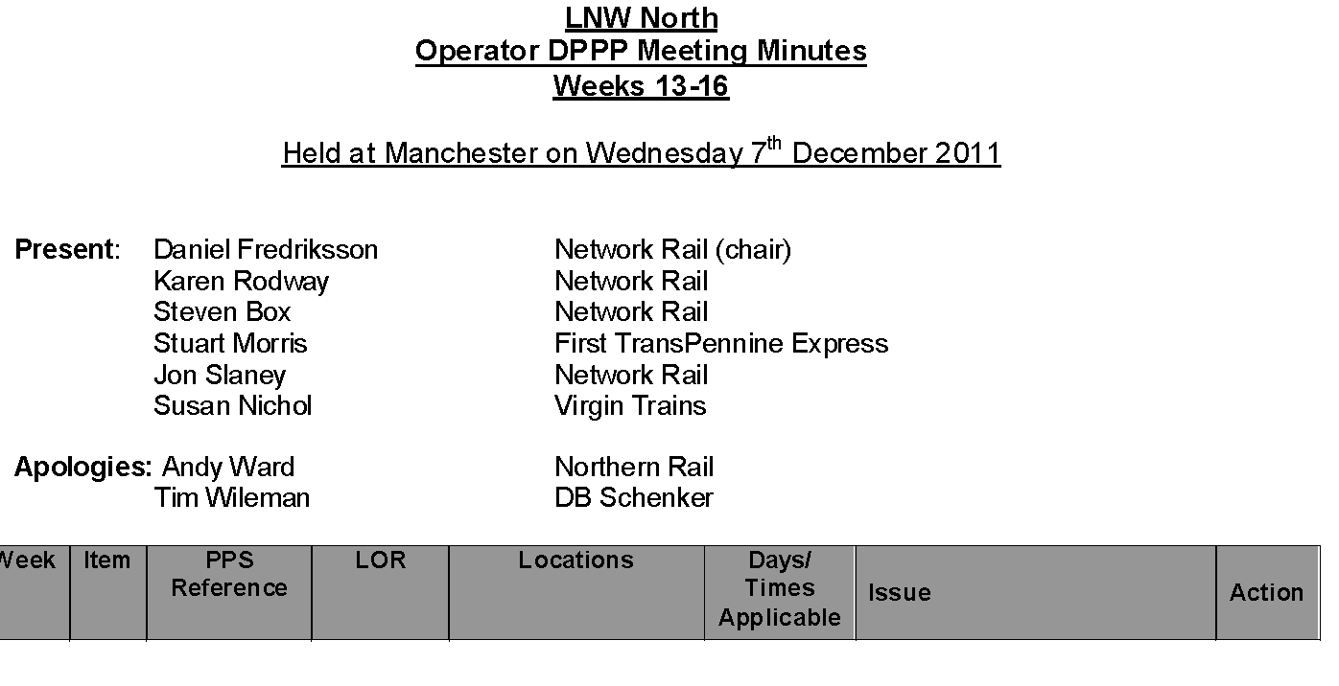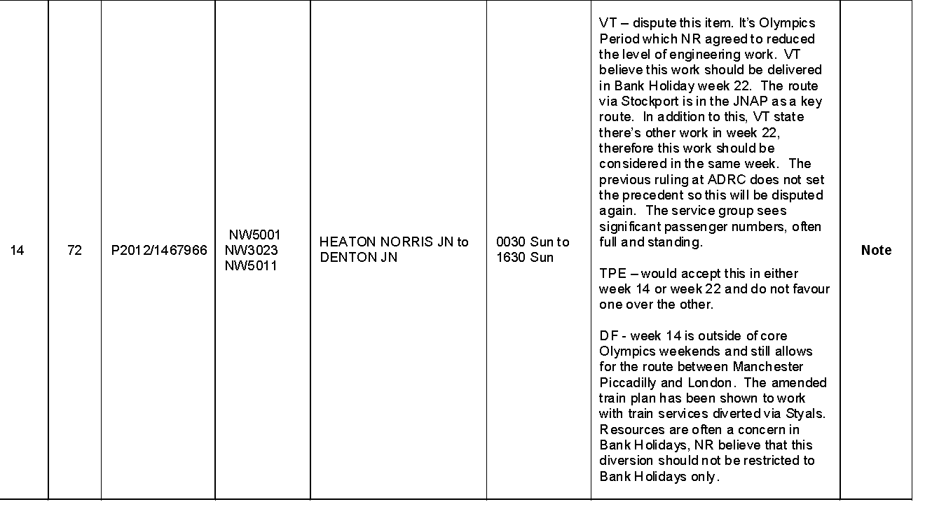

ANNEX “O1”

An Example of Disruptive Works to be carried out south of Rugby during the Olympic Games

-----Original Message-----
From: Warr Joe
Sent: 08 June 2011 12:35
To: Nichol, Susan
Cc: Allen Matthew; Spinks Martin; Swain Ian; Farms Ken; Lamond Davina
Subject: Olympic trains and Friday patrols

Susan

As I mentioned yesterday we are looking at retiming certain Olympic services in the early hours of Saturday morning to allow the Maintainer to carry out an essential track patrol of the Fasts between Bourne End and Hanslope Jns. This block will be timed 0105 Sat (after the passage of 1H81 0030 EUS-MAN) to 0605 Sat and will affect the following services:

1F77 0100 EUS-LIV req. SLs Bourne End-Hanslope and Whitehouse-Crewe Sth

1G85 0110 EUS-BHM req. SLs Bourne End-Hanslope

1H82 0130 EUS-MAN via SOT req. SLs Bourne End-Hanslope.

We also have an issue with the Fast line patrols between Whitehouse and Crewe, hence the request to amend 1F77 and we would also need to retime 1F76:

1F76 2345 EUS-MAN via CRE req. SLs Whitehouse-Crewe Sth.

We are working to ensure that this change is captured in the Olympic database to ensure that passengers are not given any confusing information about train times.

Sorry for the short notice alteration, but our original intention in ROTR was to keep the Friday night patrolling blocks in their entirety and that is what is shown in V2. We have by and large cancelled access to make the Olympic train plan work but we still need these essential patrolling blocks.

Joe
****************************************************************************************************************************************************************

The content of this email (and any attachment) is confidential. It may also be legally privileged or otherwise protected from disclosure. This email should not be used by anyone who is not an original intended recipient, nor may it be copied or disclosed to anyone who is not an original intended recipient. If you have received this email by mistake please notify us by emailing the sender, and then delete the email and any copies from your system. Liability cannot be accepted for statements made which are clearly the senders own and not made on behalf of Network Rail. Network Rail Infrastructure Limited registered in England and Wales No. 2904587, registered office Kings Place, 90 York Way London N1 9AG

ANNEX “O2”

Example of Works proposed to be carried out in Scotland.

From: Nichol, Susan
Sent: 26 September 2011 12:42
To: [operators’ addresses redacted]
Cc: Informed Traveller Scotland STP; NDS Scotland ARPCR; Freight - MK; DB Schenker - Leeds; Blunt Christopher; Ratcliffe Andrew; NDS Development Planning (Scotland); Dalrymple Charlie; Dunster, Jonathan; Hodgkinson, Rob
Subject: RE: REQUEST - D0072SC - WKS 20 - 22 - SC001 GRETNA JN TO GLASGOW CENTRAL (VIA BEATTOCK)

Chris

As this possession would result in retimings on VT trains this possession is declined as reservations are now open for these trains.

Regards

Susan

From: King Christopher
Sent: 26 September 2011 12:01
To: [operators’ addresses redacted]
Cc: Informed Traveller Scotland STP; NDS Scotland ARPCR; Freight - MK; DB Schenker - Leeds; Blunt Christopher; Ratcliffe Andrew; NDS Development Planning (Scotland); Dalrymple Charlie
Subject: REQUEST - D0072SC - WKS 20 - 22 - SC001 GRETNA JN TO GLASGOW CENTRAL (VIA BEATTOCK)

Possessions applied for after the T-4 Draft WON has been published, should be treated as disruptive. This email is to provide notification or request section 4 possession blocks within T-4 timescales.

REQUEST - WEEKS 20 to 22 – GRAVEYARD PLTR
Ref: D0072SC

Dear all,

Please find below, details of 3no DISRUPTIVE requests for access between Motherwell and Uddingston. This work is requested due to deteriorating track conditions, making it no longer efficiently maintainable. Station stops are unaffected and suitable diversionary routes are available.

ANNEX “O2”

Example of Works proposed to be carried out in Scotland Cont....

SC001 GRETNA JN TO GLASGOW CENTRAL (VIA BEATTOCK)

WEEK 20 – SATURDAY 11 AUGUST TO MONDAY 13 AUGUST 2012

PPS Ref: P2012/1541574

At/Between: Motherwell and Uddingston Jn
Lines: All Lines - Possession
Times: 2330 SAT to 0420 MON

ISOLATION OF ELECTRICAL SECTIONS
GN3D, GN4A 2330 Sat to 0420 Mon

PROTECTION LIMITS
Down: Beyond M177A pts# to Approach M42B pts#
Up: Beyond M43 pts# to Approach M176 pts#

TRAFFIC REMARKS
SUBJECT TO TOC/FOC AGREEMENT (DAF)

GENERAL REMARKS
ENGINEERING TRAIN(S) IN POSSESSION
TRAIN MOVEMENTS OVER LOGAN'S ROAD CCTV PROTECTING SIGNALS M399 ON THE DOWN LINE AND M386 ON THE UP LINE.

WEEK 21 – SATURDAY 18 AUGUST TO MONDAY 20 AUGUST 2012

PPS Ref: P2012/1541583

At/Between: Motherwell and Uddingston Jn
Lines: All Lines - Possession
Times: 2330 SAT to 0420 MON

ISOLATION OF ELECTRICAL SECTIONS
GN3D, GN4A 2330 Sat to 0420 Mon

PROTECTION LIMITS
Down: Beyond M177A pts# to Approach M42B pts#
Up: Beyond M43 pts# to Approach M176 pts#

TRAFFIC REMARKS
SUBJECT TO TOC/FOC AGREEMENT (DAF)

GENERAL REMARKS
ENGINEERING TRAIN(S) IN POSSESSION
POSSESSION TAKEN AROUND THE FOLLOWING TRAIN(S):-
6K05 AT SIGNAL M381 ON THE DOWN LINE

WEEK 22 – SATURDAY 25 AUGUST TO MONDAY 27 AUGUST 2012

PPS Ref: P2012/1541592
At/Between: Motherwell and Uddingston Jn
Lines: All Lines - Possession
Times: 2330 SAT to 0420 MON
ANNEX “O”

Example of Works being carried out in Scotland Cont....

ISOLATION OF ELECTRICAL SECTIONS
GN3D, GN4A 2330 Sat to 0420 Mon

PROTECTION LIMITS
Down: Beyond M177A pts# to Approach M42B pts#
Up: Beyond M43 pts# to Approach M176 pts#

TRAFFIC REMARKS
SUBJECT TO TOC/FOC AGREEMENT (DAF)

GENERAL REMARKS
ENGINEERING TRAIN(S) IN POSSESSION
POSSESSION TAKEN AROUND THE FOLLOWING TRAIN(S):-
6K05 AT SIGNAL M381 ON THE DOWN

I look forward to receiving your formal response to the above proposal by 10th October.

Best regards

Chris

Chris King
Access Planner (Scotland)
500 Station House, Eldergate
Milton Keynes Central
MK9 1BB
Tel [redacted]

This email is in accordance with Access Condition D3.4.3 and relates to Section 3.1 of National Timetable Planning Rules being the Procedure for Altering Engineering Access Statement or Timetable Planning Rules other than through the Twice-Yearly Process Having Effect from a Passenger Change

The content of this email (and any attachment) is confidential. It may also be legally privileged or otherwise protected from disclosure. This email should not be used by anyone who is not an original intended recipient, nor may it be copied or disclosed to anyone who is not an original intended recipient. If you have received this email by mistake please notify us by emailing the sender, and then delete the email and any copies from your system. Liability cannot be accepted for statements made which are clearly the senders own and not made on behalf of Network Rail. Network Rail Infrastructure Limited registered in England and Wales No. 2904587, registered office Kings Place, 90 York Way London N1 9AG

ANNEX “P”

Maps of Previous, Past & Present August Bank Holiday Works .

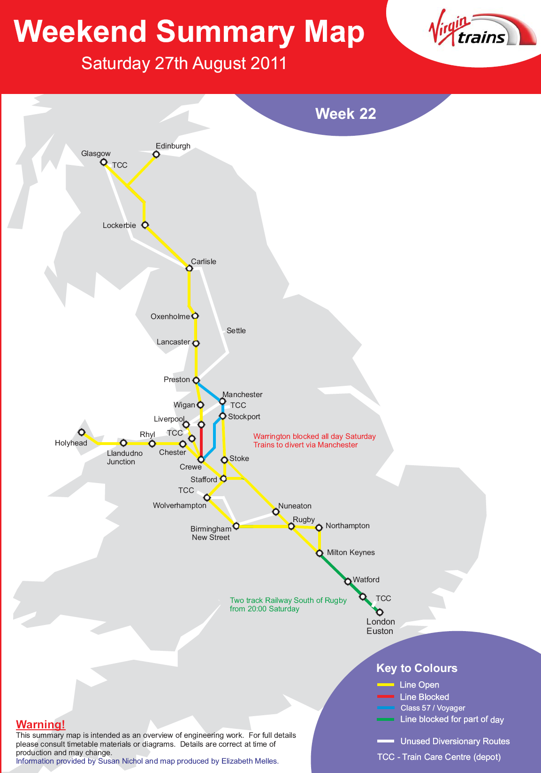
ANNEX “P”

Maps of Previous, Past & Present August Bank Holiday Works Cont.
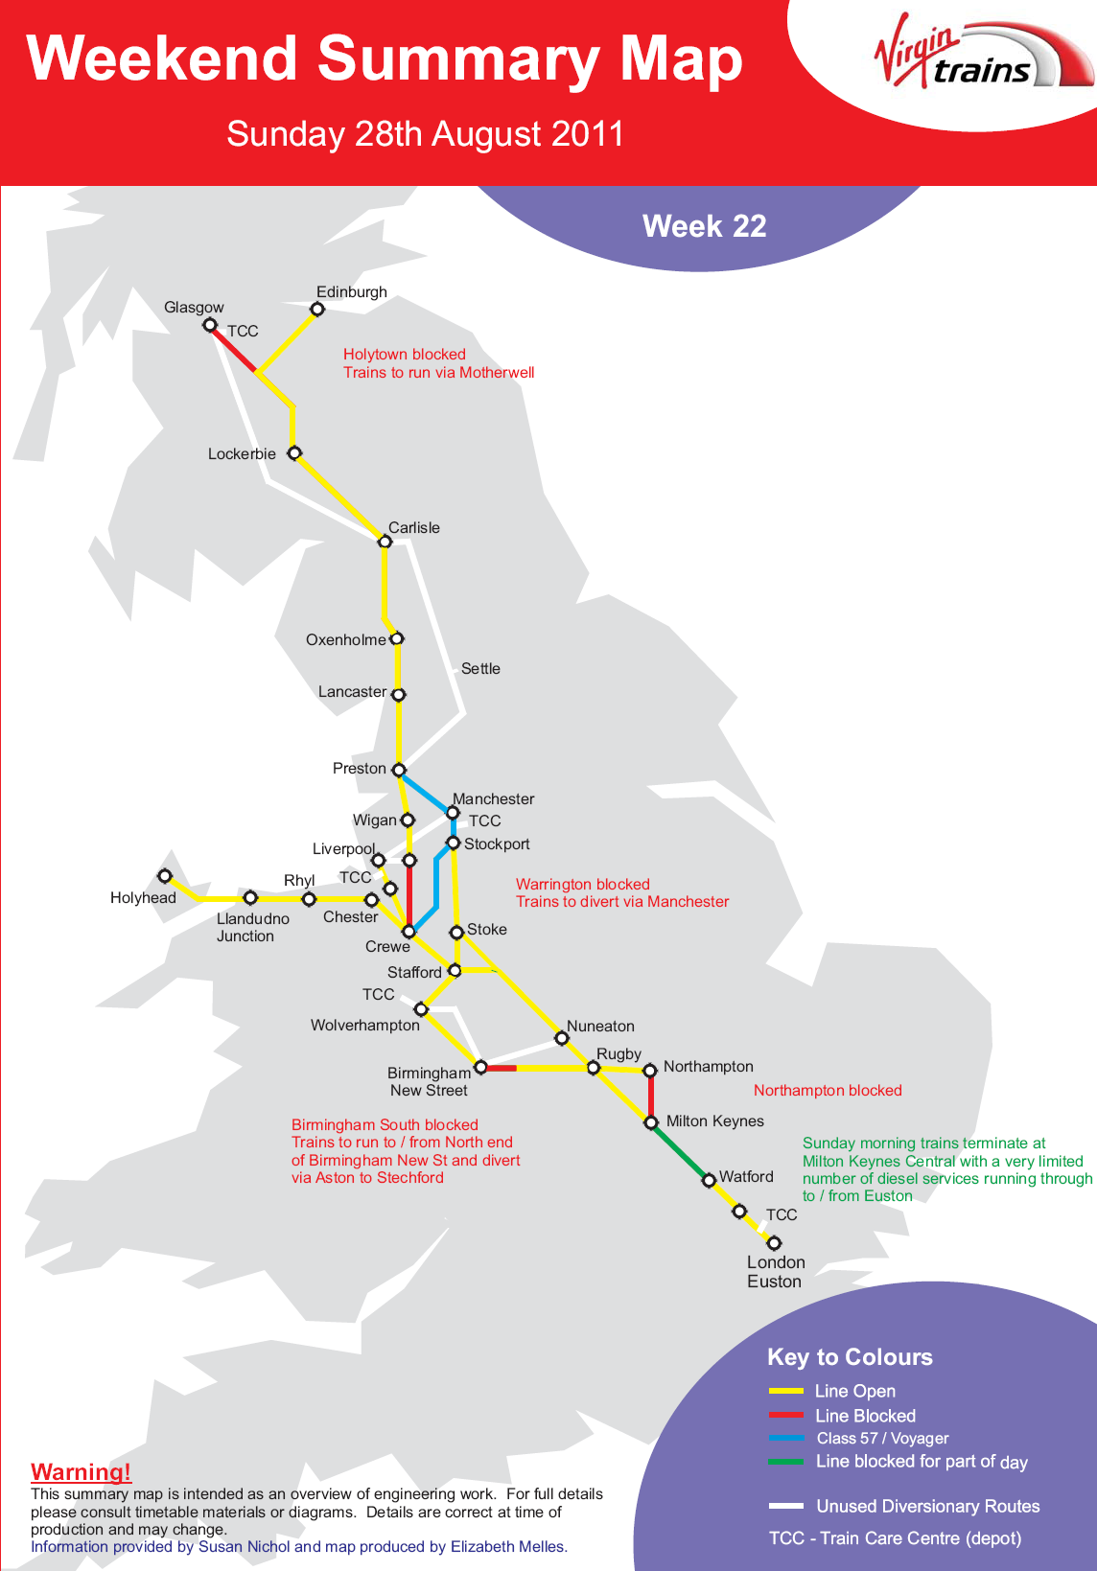
ANNEX “P”

Maps of Previous, Past & Present August Bank Holiday Works .
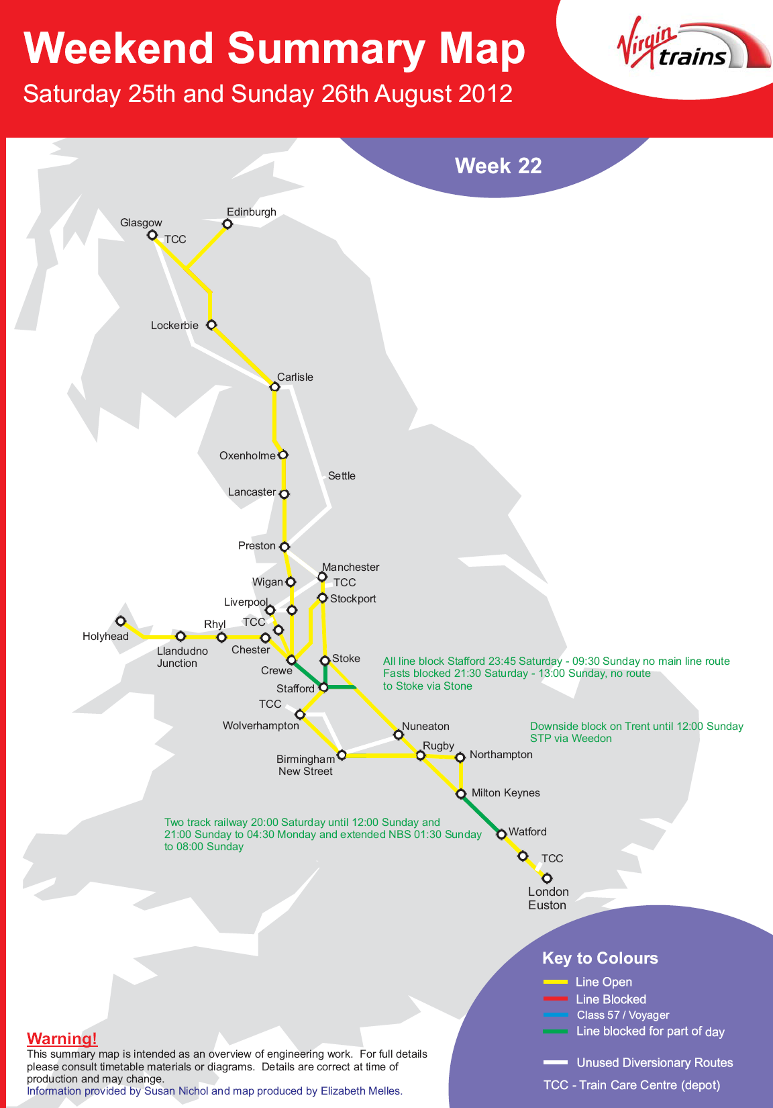

ANNEX “P”

Maps of Previous, Past & Present August Bank Holiday Works

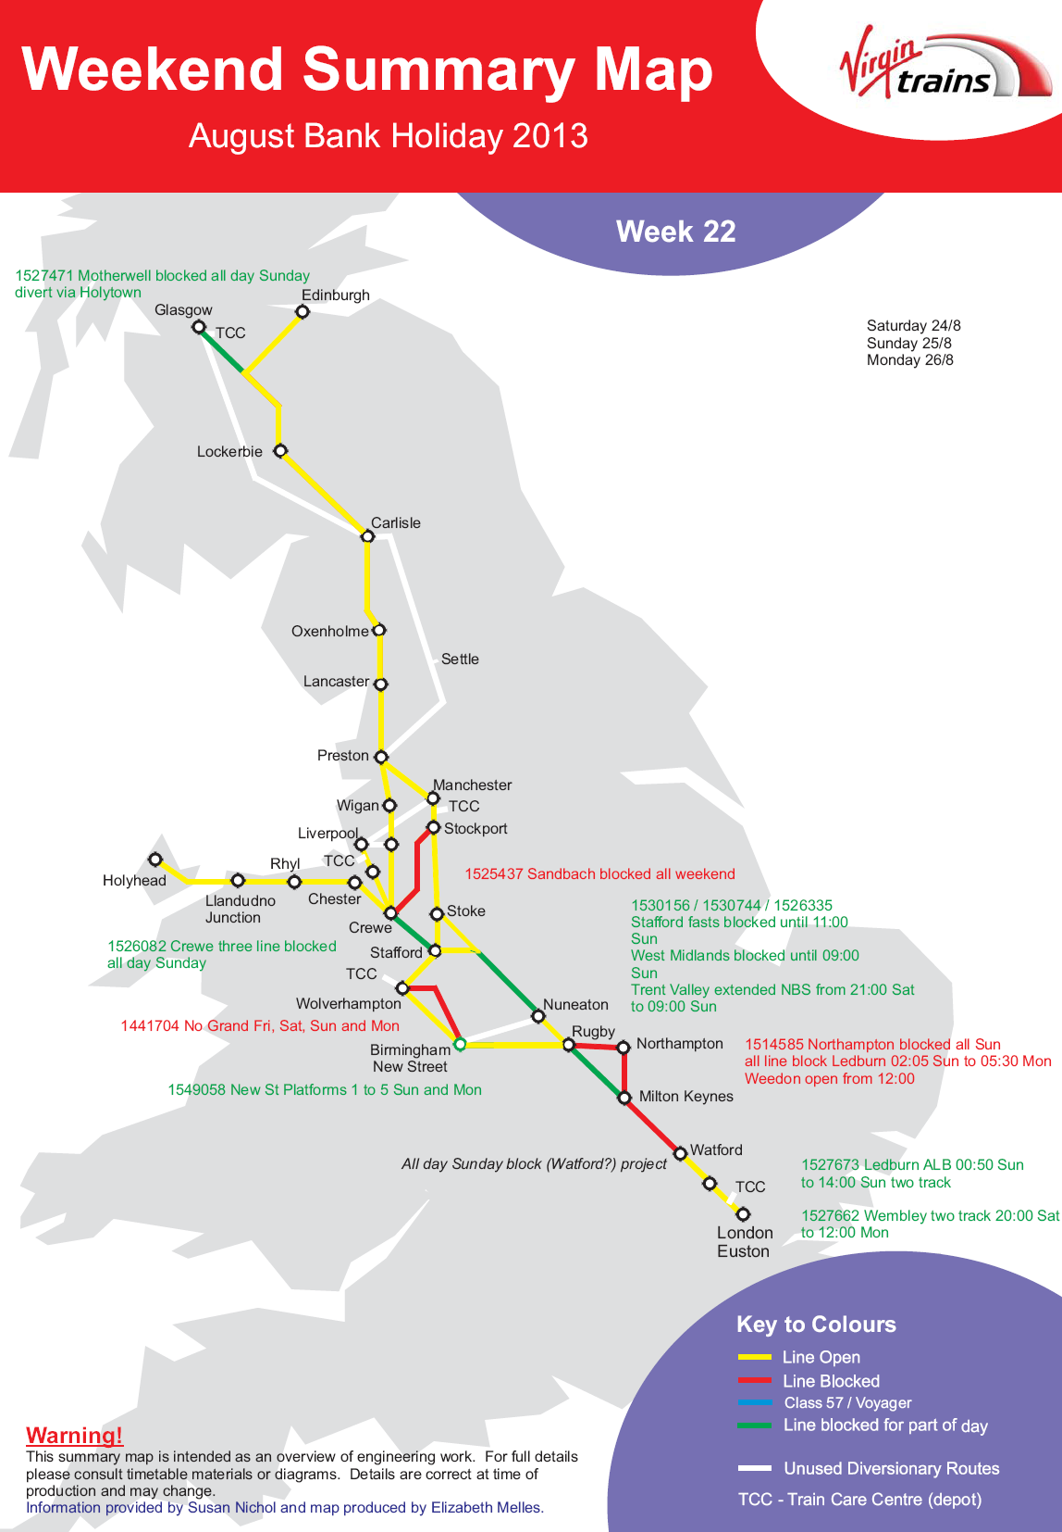

ANNEX “Q”

Extract – Olympic Zones - Presentation to TOC’s by Network Rail in Feb 2011

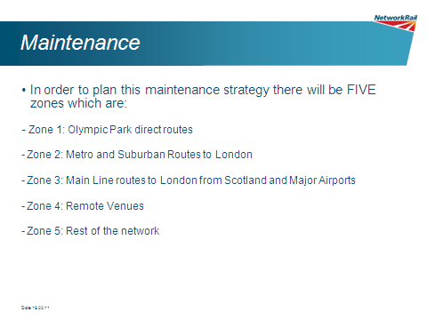
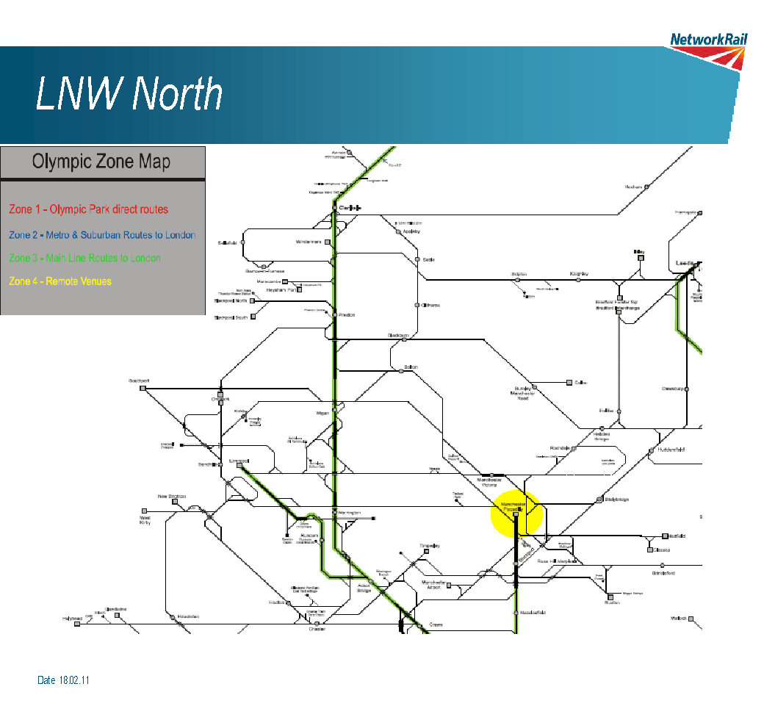

ANNEX “R”

Extract – Engineering Work Strategy during Olympics - Presentation to TOC’s by Network Rail in Feb 2011

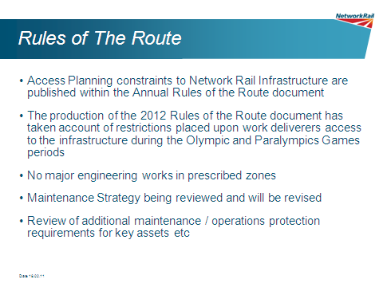

ANNEX “R”

Extract – Engineering Work Strategy during Olympics - Presentation to TOC’s by Network Rail in Feb 2011 Cont....

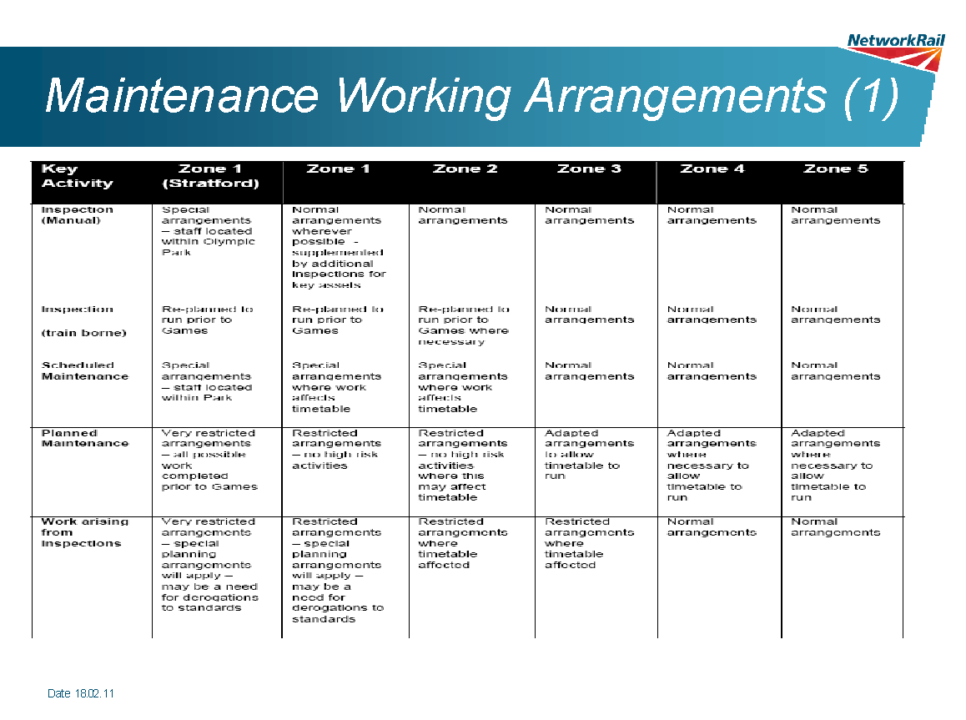

ANNEX “S”

Extracts – ODA Schedule of Requirements for WCTL Olympic Delivery Plan .
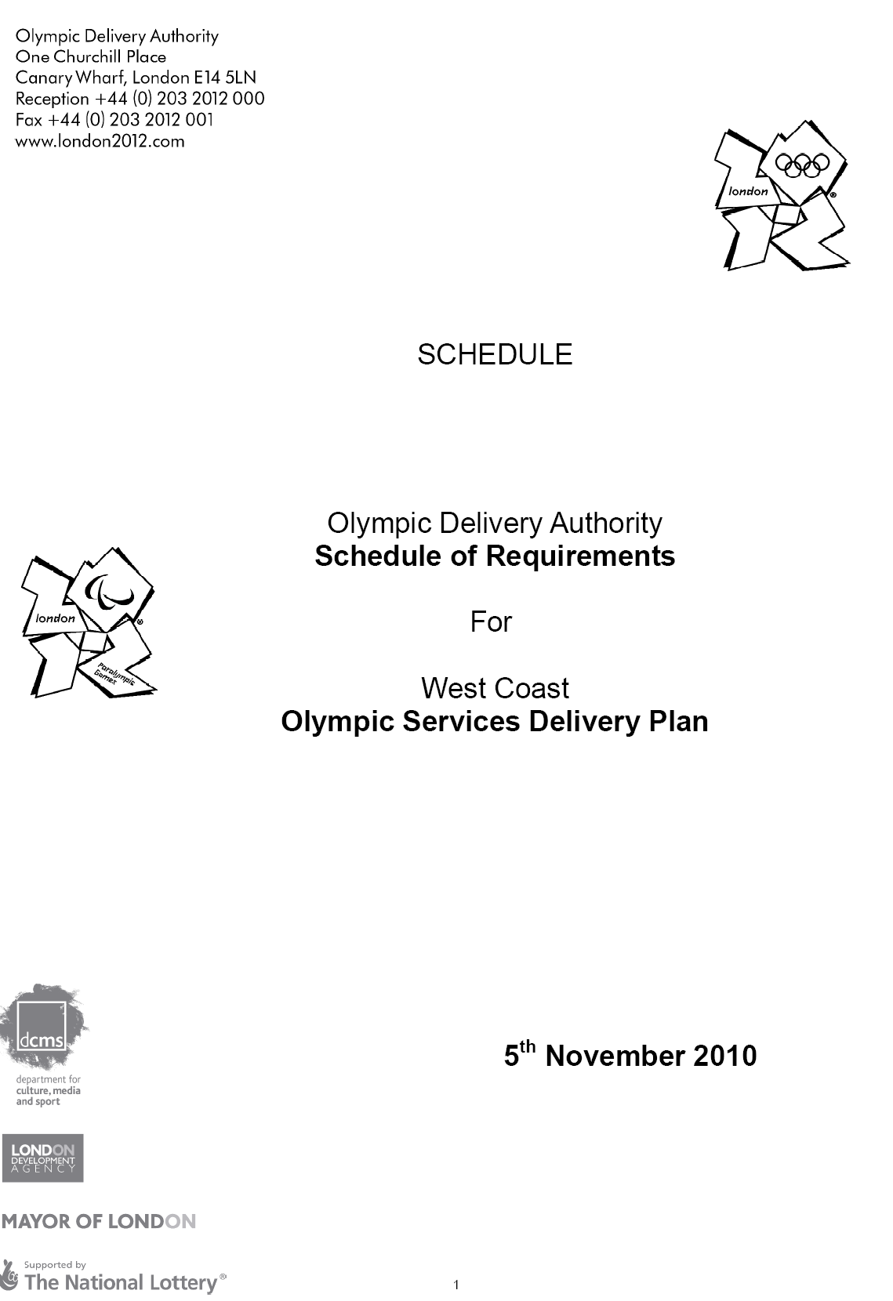

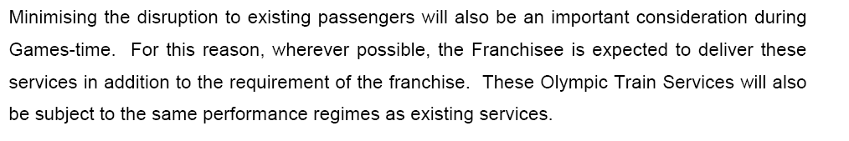
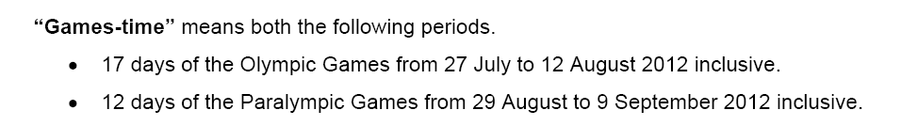

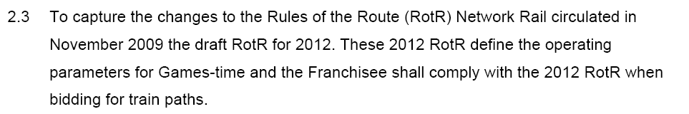
ANNEX “T”

Extract – Predicted Passenger Distribution Rates during Olympics - Presentation to TOC’s by Network Rail in Feb 2011
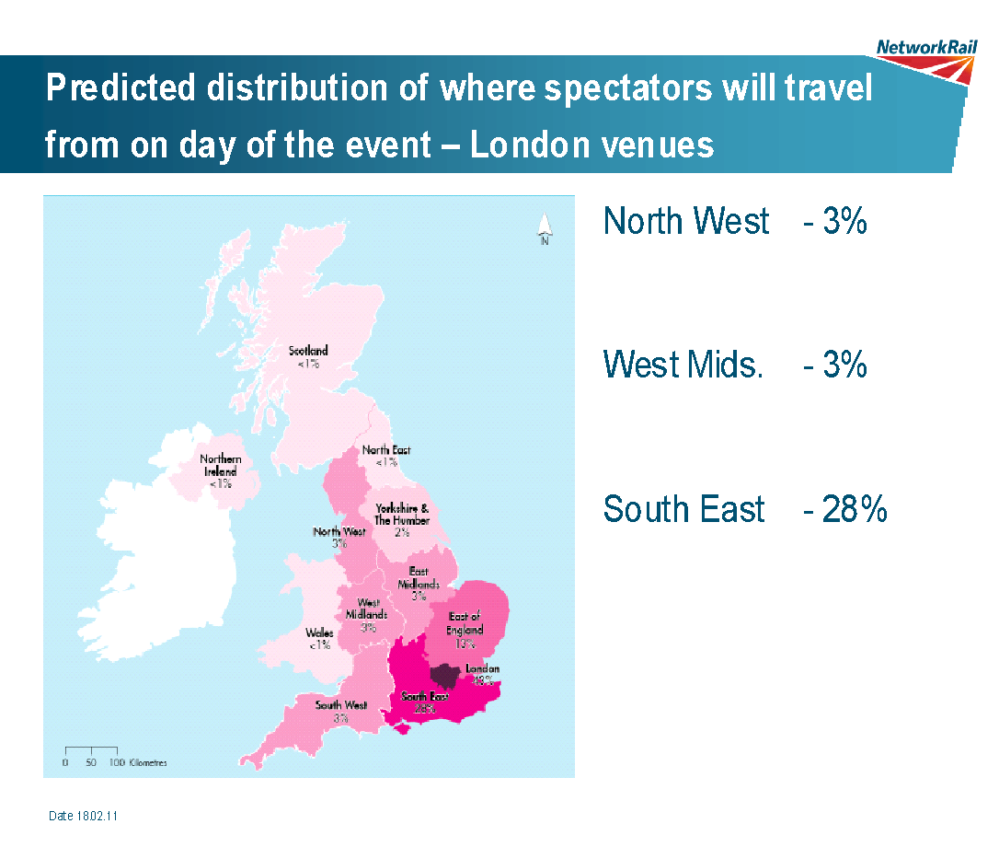

ANNEX “U”

Extract – TTP359 Determination Notes

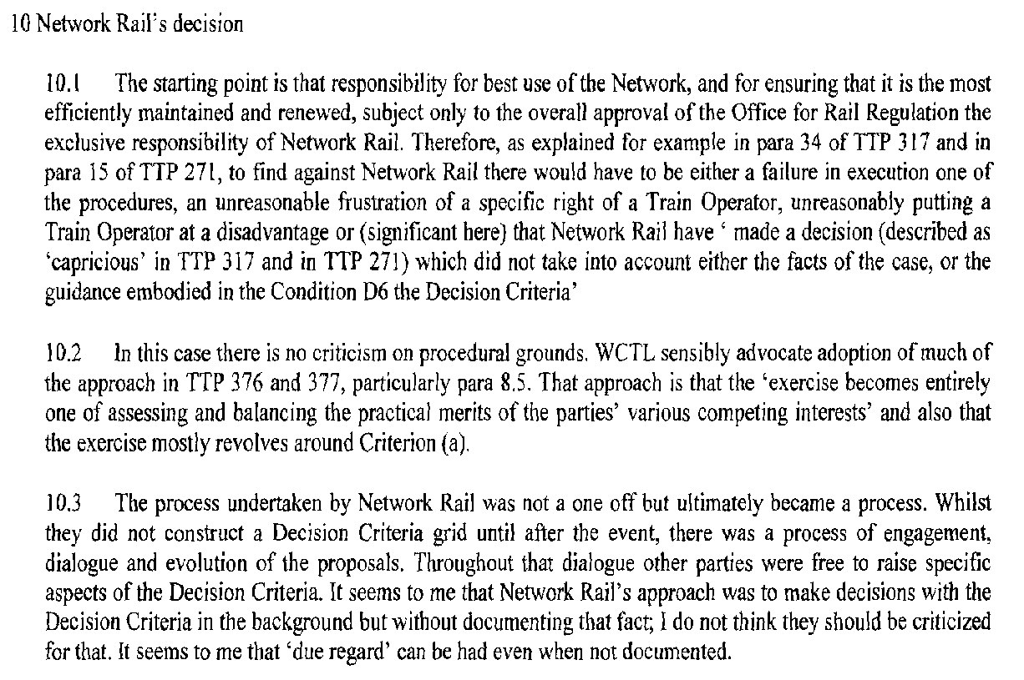
ANNEX “V”

Background Extracts – Map of Virgin Network .

