SOLE SUBMISSION TO TIMETABLING PANEL
By
NETWORK RAIL INFRASTRUCTURE LIMITED

TTP Reference 434
(Decision Documentation – Notice LNW12-CE-03)

(Specific Restriction of Use – Decision Document –
ROU for Stockport Week 14 – 1st July 2012)

17th February 2012

DETAILS OF PARTIES
1.1 The names and addresses of the parties to the reference are as follows:-
    - West Coast Trains Ltd. (Company number 3007940) whose Registered Office is at The school house, 50 brook green, London W6 7RR (“WCTL” - "the Claimant"); and
    - Network Rail Infrastructure Limited (Company number 2904597) whose Registered Office is at [‘Kings Place’, 90 York Way, London N1 9AG ("Network Rail” - "the Defendant").
    - WCTL contact details are Robert Hodgkinson, Commercial operations Manager, North Wing Offices, Euston Station, London, NW1 2HS
    - Network Rail contact details are Joe Warr, Lead Access Planner LNW, Engineering Access Planning, 500 Station House, Elder Gate, Milton Keynes Central MK9 1BB
  - Third parties that may be affected by the Panel’s finding in any of the ways sought and determined under Section 8 are as follows:
    - Arriva Cross Country (XC)
    - Arriva Trains Wales (ATW)
    - DB Schenker (DBS)
    - First Keolis (TransPennine Express - TPE)
    - Freightliner Group
    - GBRf
    - Northern Rail
    - East Midlands Trains (EMT)
- THE DEFENDANT’S RIGHT TO CONTEST THIS REFERENCE
2.1 This matter is referred to a Timetabling Panel ("the Panel") for determination in accordance with Condition D3.4 and D5 of the Network Code.
2.2 The contractual provisions which entitle Network Rail to facilitate this Restriction of Use in week 14 at Stockport are detailed in Network Code Part D, clause 3.4 and Section 3 of the National Timetable Planning Rules ‘Procedure for Altering the Engineering Access Statement or Timetable Planning Rules other than through the Twice-Yearly Process’.
2.3 Network Code Part D clause D3.4.16 allows for any Timetable Participant that is dissatisfied with Network Rail’s decision to appeal in accordance with Network Code Part D, clause D5. Network Rail accepts that West Coast Trains Limited is entitled to raise this dispute.

- CONTENTS OF REFERENCE
3.1 This Response to the Claimant’s Sole Reference includes:-
    - The subject matter of the dispute in Section 4;
    - A summary of the issues in dispute in Section 5;
    - A detailed explanation of those issues in dispute prepared by the claimant in Section 6;
    - In Section 7, the decision sought from the Panel;
    - Appendices and other supporting material.

- SUBJECT MATTER OF DISPUTE
  - The matter in dispute is Network Rail’s decision to plan a 16 hour possession between Edgeley No.2 SB and Slade Lane Jn in week 14 of 2012 in order to carry out S&C maintenance tamping of Stockport No. 2 Jn. Details of this possession can be found in Annex “B”.
  - This work was originally proposed (in Version 1 of the 2012 Engineering Access Statement) to be carried out during the Easter Bank Holiday (week 2), as part of more disruptive access in the Stockport area (56 hour access between Cheadle Hulme and Slade Lane Jn – see Annex “A” for more details). A number of Train and Freight Operators disputed this proposal and as a result Network Rail amended this access in Version 2.1 of the 2012 Engineering Access Statement such that the disruption is limited to the route between Sandbach and Wilmslow and redated to Saturday and Sunday. Network Rail also issued new proposals to carry out the work at Stockport, including the week 14 access.
  - Network Rail notes that WCTL are not disputing Network Rail’s application of the Network Code, Part D, in terms of its compliance with Part D clause 3.4. We also note that WCTL are not disputing the timing of the possession, which was exhaustively discussed in TPP337 / 359. The Panel and subsequently the ORR ruled in Network Rail’s favour in respect of TPP337 / 359.
  - The focus of WCTL’s dispute appears to be Network Rail’s refusal to redate the access in line with WCTL’s wishes. Therefore the dispute centres on Network Rail’s application of the Decision Criteria (Network Code, Part D clause D4.6).

- SUMMARY OF DISPUTE
  - During development of the 2012 Engineering Access Statement (subsequently referred to as ‘Rules’), Network Rail identified a requirement to carry out a maintenance S&C tamp of Stockport No. 2 Junction. This is part of a series of S&C tamps which require to be undertaken on the junctions in the Stockport area over a 3 year cycle. This work was originally planned to take place under cover of 56 hour access proposed in Version 1 of the 2012 Rules – the main work activity being an S&C renewal and plain line reballasting.
  - The 56 hour access was dated in week 2 (Easter Bank Holiday) 0001 Friday to 0800 Sun, all lines blocked between Cheadle Hulme Jn and Slade Lane Jn, associated with access at similar times between Crewe North Jn and Wilmslow. Most affected Operators including WCTL rejected this access during the Rules consultation process as it was deemed to be too disruptive, especially on Good Friday. It also had the affect of forcing possessions on the route between Crewe and Preston via Weaver Jn to finish on Tuesday morning which was felt to be detrimental to Anglo-Scottish traffic on the Monday afternoon.
  - As a result of customer responses to Network Rail’s proposals, the week 2 access in the Stockport area was cancelled in Version 2.1 of the Rules and the work replanned. The S&C renewal and reballasting work was redated to week 40 (New Year) at the request of WCTL to match access at Stoke. The S&C tamp could not be resourced in this week as not enough tampers were available. Therefore Network Rail proposed the Stockport No 2 Jn S&C tamp in week 14.
  - Several factors informed Network Rail’s decision to propose the access in week 14 with times of 0030 Sun to 1630 Sun. These were:
      - The requirement to carry out the work during 2012 in order to avoid points failures or speed restrictions;
      - The lack of suitable tamping resource in the week 40 Bank Holiday;
      - The disruptive access on the West Coast Main Line north of Weaver Jn in weeks 6 and 10 (May and Spring/Jubilee Bank Holidays respectively);
      - Internal company policy not to permit any significantly disruptive access in week 22 (August Bank Holiday) due to the Olympic Games;
      - The ADC and ORR determination of TTP 337 / 359;
      - Efficient Engineering Access (EEA) and Network Rail’s 7-Day Railway commitment to the ORR.
      - Route Categorisation principles applicable to the route concerned.
  - WCTL responded to Network Rail’s consultation on this access with a suggestion that the work should be dated in week 22. This was rejected on the grounds that Network Rail have decided as a matter of internal policy not to permit any significantly disruptive access on main routes in the August Bank Holiday. We have proposed work in the Stafford area (Norton Bridge S&C tamp) and in the Milton Keynes and Rugby area which blocks 2 lines on a 4 line railway up to 1200 Sun (1300 Sun in the case of Norton Bridge), which is disruptive but still allows trains to run with minor retiming. Therefore the access we have published in week 22 is of minimal impact to the train service and will not affect most users of the WCML. If we had proposed the Stockport S&C tamp in week 22, it would be more disruptive than any other access we have proposed in week 22, as it would require trains to start/terminate at Stoke or Macclesfield and divert via Alsager, Crewe and Styal (or via Romiley in the case of Northern, TPE and EMT Hope Valley services). Network Rail have decided, as expressed a number of times both verbally and in writing to WCTL, that significant disruption is not acceptable on August Bank Holiday because of the number of visitors in the country due to the Olympic and Paralympic Games and the potential impact on the reputation of the railway industry if we carry out engineering work requiring diversions and rail replacement road services at this time. It is worthy of note that the Sunday of the August Bank Holiday (26/08/2012) is three days from the start of the Paralympic Games (29/08/2012).
  - In discussions with us WCTL did not give us any concrete evidence from recent experience as to the impact of this access on their passengers in a normal weekend. This is surprising because in weeks 13 to 15 of 2011 the route was blocked between Cheadle Hulme Jn and Slade Lane Jn between 0030 Sun to 1630 Sun as a result of ADC / ORR determination TTP359. This would have given WCTL ample opportunity to gauge the passenger impact and passenger management implications of this access and present these to Network Rail to support their argument to move this access to a Bank Holiday.
  - Other affected customers have indicated to Network Rail informally that they would not accept this access in week 22 due to the number of events and festivals taking place in the North West on August Bank Holiday, such as Cream Fields, the Matthew Street Festival, Manchester Pride and others for which they anticipate a significant additional demand for rail travel in the area. We are also expecting a significant number of passengers in the Greater Manchester area to wish to travel into Manchester for day trips on the Sunday. It is worth noting that all the other Operators affected have agreed to the week 14 access, despite the fact that is causes significant disruption to CrossCountry, TPE, EMT and Northern.
  - The ADC determination on TTP 337 / 359 influenced Network Rail’s decision-making in this case in terms of the times of the possession (0030 Sun to 1630 Sun as opposed to 2130 Sat to 1330 Sun, as WCTL had sought in TTP 337 / 359) and its dating, as the determination permitted Network Rail to carry out this work in 3 non-Bank Holiday weekends. While a previous determination cannot be used as a precedent for future access proposals, common sense dictates that Network Rail will use these determinations to guide its thinking when planning similar access.
  - As part of our deliberations surrounding this access, Network Rail requested colleagues in the Stockport Delivery Unit to conduct a review of the Stockport No. 2 Jn S&C tamping requirements to see if the access could be split up to either allow trains to run past the site of work or split it into shorter-duration possessions which would be less disruptive. Unfortunately due to the nature of the layout at Stockport No. 2 Jn this is not possible. The S&C is spread across all 4 lines at the north end of Stockport station and partly on Stockport viaduct. The turnouts are close together and share common bearers across the layout. This requires 4 tampers to tamp the layout in tandem, without the ability to complete discrete elements of the tamp and open lines up to traffic. It is not possible, for example to tamp the Up and Down Fast first and then tamp the Up and Down Slow due to the common bearers across all four lines. See the diagram in Annex “C” for more details.
  - Network Rail strives wherever possible to deliver access with the least disruption possible balanced against reasonable cost. On main line routes such as Stoke/Crewe to Manchester via Stockport we have significantly reduced the level of disruptive access regularly proposed, even in Bank Holidays. We are guided by the principles of Efficient Engineering Access (EEA), Route Categorisation, 7 Day Railway and Joint Network Access Plans (JNAPs) agreed with Operators however none of these places a contractual obligation on Network Rail as far as individual possessions are concerned. Provided that Network Rail complies with the provisions of the Network Code, EEA, the 7-day railway, TACs, SLCs etc are factors for consideration which inform Network Rail’s decisions rather than contractual obligations. In Annex “F” I have inserted details of the ORR Determination of WCTL’s appeal against TTP 337 / 359 / 382 which discusses this issue at some length. Access affecting Stoke-Manchester services is typically taken in 16 hour blocks with times of 0030 Sun to 1630 Sun, although EEA as reviewed with industry partners on 12/03/2009 permits 29 hour blocks of the route between Cheadle Hulme and Slade Lane as long as diversions via Styal are possible – the last time we took access of this duration in a normal weekend was 2010.
  - In train planning terms this access requires WCTL to divert up to 3 trains per hour via Styal (journey time impact 0 minutes). The actual train plan depends on what WCTL can actual resource in terms of train crew and sets – in the 2011 access they diverted 1 train per hour booked via Crewe to travel via Crewe, Wilmslow and Styal and 1 train per hour booked via Stoke to travel via Stafford, Crewe, Wilmslow and Styal. The third service travelled via Stoke and terminated at Macclesfield. It would have been possible for at least one service to travel via Stoke, Alsager, Crewe, Wilmslow and Styal but WCTL did not take up this option. The key impact, we assume (in light of no concrete information from WCTL as to how it actually worked) was on passengers at Stoke, Macclesfield and Stockport who required to travel to London or Manchester. Stoke passengers would be able to catch 2 trains per hour to London and 1 WCTL train per hour to Manchester or 1 XC train per hour to Manchester (2 trains per hour in total). Macclesfield passengers could use 1 train per hour to London and a rail replacement road service to access Stockport and Manchester. Stockport passengers would have had to use a rail replacement road service (or a Metrolink tram) to access Manchester and a rail replacement road service to access stations south. In passenger handling terms we believe this is manageable in a non-Bank Holiday weekend.
  - In contrast, Northern will have to cancel its Manchester-Chester services; cancel Manchester-Buxton services; cancel Manchester-Stoke services; divert Manchester-Crewe services via Styal and divert Manchester-Sheffield services via Romiley, all of which requires a significant bus operation to replace cancelled services and station calls which cannot be made due to diversions. This level of disruption, in our view, is best timed on a Sunday but not a Sunday when there are significant events in the Greater Manchester area and when there is likely to be significant demand to travel.

- EXPLANATION FROM THE DEFENDANT’S PERSPECTIVE OF EACH ISSUE IN DISPUTE
6.1 Issues where the Defendant Accepts the Claimant’s Case
6.1.1 Network Rail accepts the claim by West Coast Trains Ltd (WCTL sole submission clause 6.3) that passenger numbers increase on long-distance services after 1200 on a Sunday. However throughout the access which Network Rail has published in week 14 a route between London and Manchester is consistently available: via Crewe, Wilmslow and Styal. A route is also available throughout between Stoke and Manchester via Alsager and Crewe. The only stations served by WCTL from which a direct train service to Manchester is not possible are Macclesfield and Stockport. Experience in 2011 suggests that a viable train service can be operated which transports the vast majority of passengers on the London-Manchester route by train without significant delay. A rail replacement road service is capable of handling the passengers which require to travel between Macclesfield, Stockport and Manchester and vice-versa.
6.2 Issues where the Defendant qualifies or refutes the Claimant’s Case
6.2.1 Network Rail does not accept the claims by West Coast Trains Ltd (WCTL sole submission clause 6.9.7) regarding the ‘capricious’ nature of Network Rail’s decision-making to date the Stockport S&C tamp in week 14 rather than week 22. We have on several occasions explained our reasoning to WCTL both verbally and in writing, as WCTL’s own submission shows (see for example WCTL Sole Submission Annex “N”). Although we have not articulated our application of the Decision Criteria explicitly, we have applied them throughout the process. The determination of TTP359 states:
(paragraph 10.3) “It seems to me that Network Rail’s approach was to make decisions with the Decision Criteria in the background but without documenting that fact; I do not think they should be criticised for that. It seems to me that ‘due regard’ can be had even when not documented.”
Whilst obviously prioritising criterion (e), we have also placed importance on criteria (a), (g) and (i), in that we have made a judgement which prioritises the availability of capacity ‘in the interests of all users of railway services’ (criterion (a)); ‘avoids material deterioration of the service patterns of operators of trains’ (criterion (g)); and ‘ensures that …appropriate provision is made for reservation of capacity to meet the needs of Timetable Participants whose businesses require short term flexibility…’ (criterion (i)). Network Rail has made a conscious decision to keep the August Bank Holiday substantially clear of major disruption on main routes – all the access referred to by WCTL in WCTL Sole Submission Annex “L2” on main line routes requires a block of 2 lines where 4 lines are available and it is of relatively short duration. This is because Network Rail has made a substantial sacrifice in its 2012 access plan by not carrying out work in week 22 – typically this Bank Holiday would contain a number of major S&C and Plain Line track renewals; signalling work; bridge reconstructions etc. This has all been removed in 2012 in order to support the country’s transport needs during a period of high visitor numbers and intense scrutiny of the success of UK plc’s public transport system. By and large we have worked very effectively with our Train and Freight Operator colleagues to plan work outside of week 22, in the main in other Bank Holidays, although not exclusively. We have prioritised access which is significantly disruptive, for example 29 hour all line block access requiring extensive diversions to be moved to other Bank Holidays. The Stockport S&C tamp, while significantly disruptive is not of the same order of disruption as (for example) a 29 or 54 hour block of the WCML north of Weaver Junction. It is also worth stating that if week 22 had been available to plan significant disruption we would have proposed as a priority 54 hour-type all lines blocked access on the WCML north of Weaver Jn, given the high volume of plain line and S&C renewals we require to undertake on this route. An S&C tamp at Stockport would not have been planned in week 22 as it would have clashed with the WCML access and it would have caused significant disruption to local Greater Manchester traffic which we try to avoid (along with major disruption in Merseyside) on the August Bank Holiday for the reasons outlined in para. 5.7.
6.2.2 In response to the claims by West Coast Trains Ltd (WCTL sole submission clauses 6.9.1, 6.9.2), Network Rail accepts that individual determinations do not form a precedent and that each case should be considered on its merits. However, we do strongly feel that it would be perverse not to take previous ADC and ORR determinations into account. In TTP359, the hearing centred on Network Rail’s alleged failure to apply the Decision Criteria ‘correctly’ (i.e. not in favour of WCTL). Both the ADC and the ORR confirmed Network Rail’s approach in terms of the timing of the access – i.e. the application of the Decision Criteria in favour of Northern Rail. Further, in this current case, WCTL have recognised implicitly that there is de facto precedent to time the access c. 0030 Sun to 1630 Sun (WCTL para. 6.9.3 is the closest we get to explicit recognition). Network Rail’s thinking behind dating the Stockport S&C tamp in week 14 did take TTP359 into account in that we had recently won a dispute (confirmed at ORR appeal) which allowed Network Rail to take ROUs at this time period in 2011. However this was not the only consideration, as outlined in para. 5.4 above. Network Rail does not think that it is unreasonable to propose access of 16 hour duration at Stockport outside of a Bank Holiday for a low number of weekends in each year. In 2012 it happens that we only need 1 weekend of disruption; in future years we are likely to require up to a maximum of 3 or 4 weekends of this type of access – a level of work we simply could not accommodate in Bank Holidays.
6.2.3 In response to the comments by West Coast Trains Ltd (WCTL sole submission para. 7) regarding Network Rail’s 2013 proposals: we have proposed 0045 Sun to 1645 Sun access for an S&C tamp of Stockport No. 1 Jn in week 26. Clearly this is not a Bank Holiday weekend – the work requires 4 S&C tampers which we have already allocated to higher priority Bank Holiday access in 2013, therefore we have proposed this tamp in a normal weekend. WCTL’s objection to this proposal appears to be centred on the fact that we have not proposed the access in WCTL’s preferred times (2100 Sat to 1300 Sun – the subject of TTP359) and we have not dated it in a Bank Holiday. WCTL intimate that they are likely to refer all similar access to the ADC: “…this matter has and appears likely to become, a currently interminable issue that will result in similar disputes in the future.” (WCTL submission para. 7.1.2). Verbally WCTL have advised Network Rail that regardless of any ADC or ORR determinations, they have taken a strategic decision at a senior level within the company to refer this access to the ADC whenever Network Rail proposes it outside a Bank Holiday. There is no particular contractual requirement driving this decision – in that sense it could be described as being ‘capricious’ just as WCTL characterise Network Rail’s wish to avoid significant disruption in the August Bank Holiday of 2012. Obviously Network Rail will work with its customers to deliver an access plan which supports their business requirements as far as possible; however we reserve the right, as enshrined in the Network Code, Part D and in our Track Access Agreements with our customers to propose access as we see fit through agreed industry processes. In this particular case we have an ongoing requirement to deliver S&C tamps of the following junctions in the Stockport area: Heaton Norris Jn, Stockport No 1 Jn, Stockport No 2 Jn, Edgeley No 1 Jn, Edgeley No 2 J, Cheadle Hulme Jn – all of which require 16 hour access with inflexible layouts which do not lend themselves to running trains past site whilst tamping is carried out. Given that many of these locations require 4 S&C tampers we cannot justify utilising Bank Holiday access solely for this work as outlined above. WCTL frequently object that Network Rail does not have enough S&C tampers to deliver all the work required at Bank Holidays. Network Rail’s view is that to keep a high number of S&C tampers merely to work for 6 weekends a year is not an efficient or affordable use of resources; in Bank Holidays we do maximise the available resources by transferring tampers between different areas and spot-hiring tampers, which is expensive. A tamper costs in the region of £1m per machine per annum to lease from our suppliers and a parallel tamp such as Stockport requires 4 such machines. If we acquired 4 additional tampers to ensure that we could consistently carry out tamps in the Stockport area at Bank Holidays, that would introduce an additional cost to Network Rail of £4m per annum or £666k per Bank Holiday. In a period when industry costs are under considerable scrutiny with a view to maximising efficiencies and reducing the dependency of the industry on government support (not to mention Network Rail’s CP4 licensing obligation to improve cost efficiency), it would be indefensible and unjustifiable to acquire tampers simply to use on Bank Holidays. Network Rail would appeal any determination which sought to limit Network Rail’s ability to take disruptive access in the Stockport area to Bank Holidays alone, although it would be surprising if any Panel were to reach such a determination. It is likely therefore, that this type of access will indeed be the subject of future ADC hearings as we will continue to propose it in normal weekends, subject to the Maintenance requirements of the infrastructure. In parallel we will of course, as we have done consistently with access-hungry disciplines, seek to reduce the necessary access footprint by investigating the use of new technology and novel delivery methods.
6.3 Issues not addressed by the Claimant that the Defendant considers should be taken into account as material to the determination
6.3.1 Network Rail does not have any such issues.
6.4 Why the arguments raised in 6.1 to 6.3 taken together favour the position of the Defendant
6.4.1 Network Rail has balanced its application of the Decision Criteria to support disrupting its customers at the start of the Olympic period, well before the Olympic Games and Paralympic Games. (Sunday of week 14 (01/07/2012 is 26 days before the start of the Olympic Games (27/07/2012)). This is because it believes that all-line block access is not acceptable on main routes during the week 22 August Bank Holiday weekend, the Sunday of which is three days from the start of the Paralympic Games. In doing so it has prioritised Decision Criteria (a), (g) and (i).
6.4.2 Network Rail’s decision to publish the Stockport No. 2 Jn S&C tamp in week 14 reflects its view that outside weeks close to the Olympic Games and the Paralympic Games it is acceptable to propose 16 hour all-line block access in the Stockport area. TTP359 did not discuss the dating of this type of access but implicit throughout was the assumption that it was acceptable to plan such access in a non-Bank Holiday weekend. Network Rail took from TTP359 a level of confidence that if future access were proposed of similar dating and timing, it would not be an unreasonable proposal. Whilst accepting that ADC determinations do not represent a precedent for future hearings, our belief is that they can be used, in combination with other factors, to support our decision-making.
6.4.3 It is Network Rail’s view that it would be unreasonable of WCTL to constrain 16 hour disruption in the Stockport area to Bank Holidays alone. Resources are at a premium in Bank Holidays and we would always seek to prioritise access which causes the most disruption to the industry over 16 hour access with a diversionary route offering near equivalent journey times (such as the route via Styal).
- DECISION SOUGHT FROM THE PANEL
  - Network Rail seeks the following outcome from the Panel’s Determination:
    - That Network Rail has correctly applied the Decision Criteria in regard to the decision taken to include the week 14 Stockport Restriction of Use in the respective timetable week.
    - There are no other remedies or issues to be determined.

- APPENDICES AND ANNEXES
Network Rail confirms that it has complied with Rule H21 of the Access Dispute Resolution Rules, which requires that
- the relevant extracts of contractual Documents containing the provision(s) under which the referral to the Timetabling Panel arises and/or provisions associated provision(s) associated with the substance of the dispute; and
- [the relevant extracts of] any other Documents referred to in the reference”. [Rule H21(b) (I)]
Annex “A” EAS 2012 Version 1 & Version 2 – access in the Stockport area in week 2
Annex “B” Proposal and Decision documents for week 14
Annex “C” Tamping plan for Stockport No. 2 Jn
Annex “D” Extract from the Efficient Engineering Access Documentation
Annex “E” Extract from the LNW Route Categorisation document
Annex “F” Extract from ORR determination of WCTL appeal of TTP TTP 337 / 359 / 382

- SIGNATURES

The Defendant
For and on behalf of
Network Rail Infrastructure Limited ___________________________________
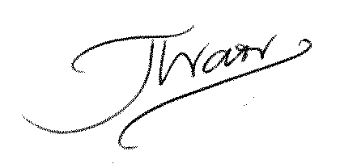
Signed

-----------------------------------------------------------
Print Name
Joe Warr
___________________________________
Position
Lead Access Planner LNW, Network Rail
___________________________________
ANNEX “A” EAS 2012 Version 1 & Version 2 – access in the Stockport area in week 2
Week 2 access as shown in Version 1:
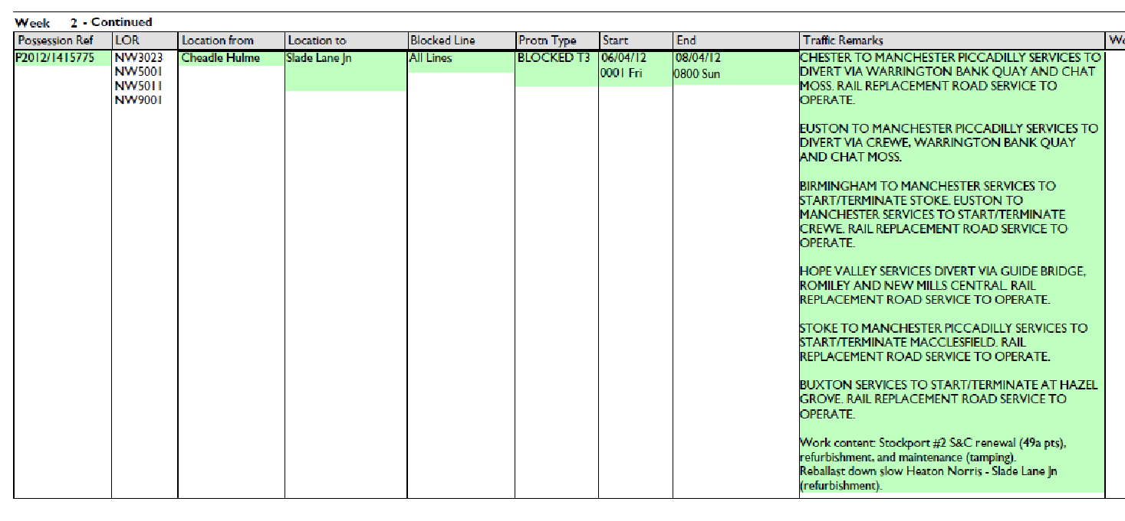
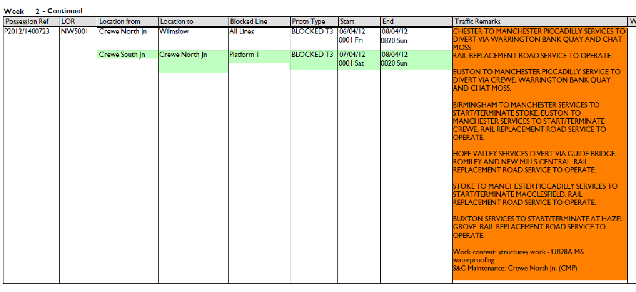
ANNEX “A” EAS 2012 Version 1 & Version 2 – access in the Stockport area in week 2 (cont.)
Week 2 access as shown in Version 2:
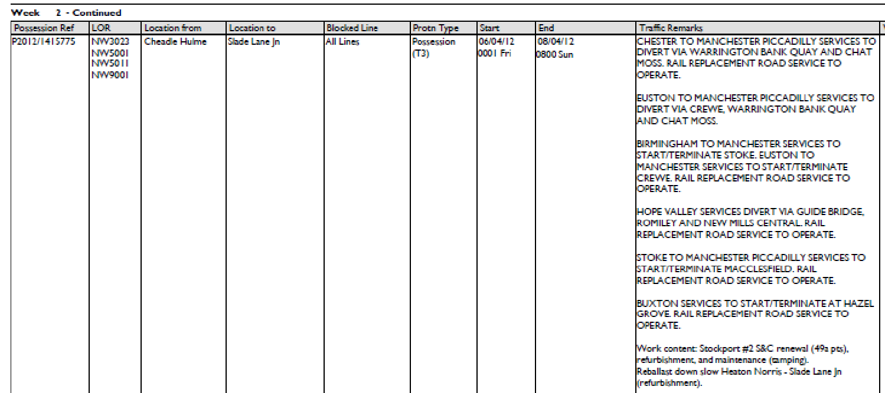
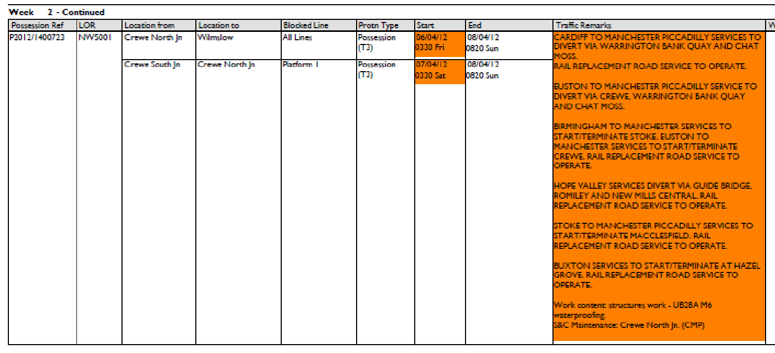
ANNEX “B” Proposal and Decision documents for week 14
REQUEST: AMENDMENT TO LONDON NORTH WESTERN ENGINEERING ACCESS STATEMENT 2012

EAP Reference: LNW12-CE-03

Dear All,

Please find attached proposed amendments to London North Western Section 7 post Version 2 Engineering Access Statement 2012 for LNW North, LNW South (combined) and Merseyrail.

I look forward to receiving your formal response to the above proposal by Monday 4th July 2011. Earlier responses would be appreciated in order to capture any requested amendments to these possessions before the data freeze for EAS version 2.1.

This email is in accordance with Access Condition D2.1.10 and relates to Section 3.1 of National Timetable Planning Rules being the Procedure for Altering Engineering Access Statement or Timetable Planning Rules other than through the Twice-Yearly Process Having Effect from a Passenger Change

Kind Regards,

Daniel Fredriksson
Access Planning Specialist
[redacted]

Extract from attached proposal document:
Week 14

NW5001
New possession required for S&C tamping Stockport No.2

Sunday 1 July
PPS Ref: P2012/1467966
At/Between: Heaton Norris Jn and Denton Jn
Lines: All Lines (Possession (T3))
Times: 0030 Sun to 1630 Sun
and
At/Between: Edgeley Jn No.2 Sb and Slade Lane Jn
Lines: All Lines (Possession (T3))
Times: 0030 Sun to 1630 Sun

Traffic Remarks: TRAINS TO DIVERT VIA CREWE AND STYAL. NO ACCESS TO STOCKPORT. RAIL REPLACEMENT ROAD SERVICES TO OPERATE.
HOPE VALLEY SERVICES TO DIVERT VIA ROMILEY AND ASHBURYS TO MANCHESTER PICCADILLY.
ANNEX “B” Proposal and Decision documents for week 14 (cont.)
DECISION: AMENDMENT TO LONDON NORTH WESTERN ENGINEERING ACCESS STATEMENT 2012

EAP Reference: LNW12-CE-03

Dear All,

Further to Daniel Fredriksson’s e-mail of 20/06/2011 please find attached Network Rail’s decision on the amendments to London North Western Section 7 post Version 2 Engineering Access Statement 2012 for LNW North, LNW South (combined) and Merseyrail. You will note that we are issuing this decision after Version 2.1, rather than allowing V2.1 to act as a contractual decision. This is because V2.1 is a rules update to show easements and agreed changes, whereas this document is the contractual decision. If you have any more queries, please give me a ring and I will talk you through it.

This email is in accordance with Access Condition D2.1.10 and relates to Section 3.1 of National Timetable Planning Rules being the Procedure for Altering Engineering Access Statement or Timetable Planning Rules other than through the Twice-Yearly Process Having Effect from a Passenger Change

Kind Regards

Joe Warr
Lead Access Planner LNW
Engineering Access Planning, Network Rail

Extract from attached decision document:
Week 14

NW5001
New possession required for S&C tamping Stockport No.2

Sunday 1 July
PPS Ref: P2012/1467966
At/Between: Heaton Norris Jn and Denton Jn
Lines: All Lines (Possession (T3))
Times: 0030 Sun to 1630 Sun
and
At/Between: Edgeley Jn No.2 Sb and Slade Lane Jn
Lines: All Lines (Possession (T3))
Times: 0030 Sun to 1630 Sun

Traffic Remarks: TRAINS TO DIVERT VIA CREWE AND STYAL. NO ACCESS TO STOCKPORT. RAIL REPLACEMENT ROAD SERVICES TO OPERATE.
HOPE VALLEY SERVICES TO DIVERT VIA ROMILEY AND ASHBURYS TO MANCHESTER PICCADILLY.

ANNEX “C” Tamping plan for Stockport No. 2 Jn
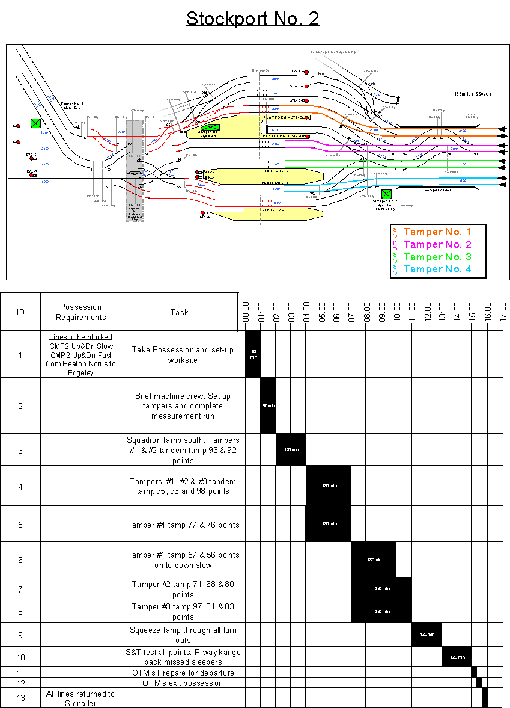
ANNEX “D” Extract from the Efficient Engineering Access Documentation
Relevant part highlighted in bold
NETWORK RAIL

EEA on West Coast Main Line from December 2008

This document summarises the agreed position between Network Rail and the Department for Transport with respect to the possession regime applying on the WCML from December 2008. This regime is known as EEA (Efficient Engineering Access). All Network Rail departments must plan engineering work on WCML in accordance with this.

The rationale for introducing this regime is that the passenger revenue which our industry will earn from running the extra trains made possible by shorter possession hours will more than compensate for the extra costs arising from carrying out engineering work within the constraints of EEA.

- From December 2008

A1. EEA will apply to Euston-Birmingham-Wolverhampton (though on Birmingham-Wolverhampton not until 1st April 2009), Euston-Stoke-Manchester and Euston-Crewe-Manchester. The ROTR possession hours will be:

Euston-Rugby
Sun/Mon to Fri/Sat nights: 8hr, 2 tracks open
Sat 2000 to Sun 1200: 2 tracks open. Also, within that block, will be a 7hr all-lines block.

Rugby-Crewe via Trent Valley
Mon/Tue to Fri/Sat nights: 8hr, 2 tracks open
Sat 2100 to Sun 0800: All lines blocked Rugby-Stafford
Sun 0800 to Mon 0600: 2 tracks open

Colwich-Slade Lane via Stoke and/or Crewe
Mon/Tue to Fri/Sat nights: 5.5hr, 2 lines (via either Stoke or Crewe) blocked
Sat to Mon: 32 hr, 2 lines (via either Stoke or Crewe) blocked
Rugby-Birmingham
Sun/Mon to Fri/Sat nights: 5hr, both lines blocked
Sat/Sun night: 9hr, both lines blocked

Birmingham-Wolverhampton (from April 2009)
Mon/Tue to Fri/Sat nights: 5hr, both lines blocked*
Sat to Mon: 30hr, both lines blocked*
*Alternatively, possessions can be taken ‘via Bescot’, leaving the Stour Valley open.

A2. Midweek nights SLW ROTR possessions between Preston-Carstairs will cease.
Annex “E” Extract from the LNW Route Categorisation document
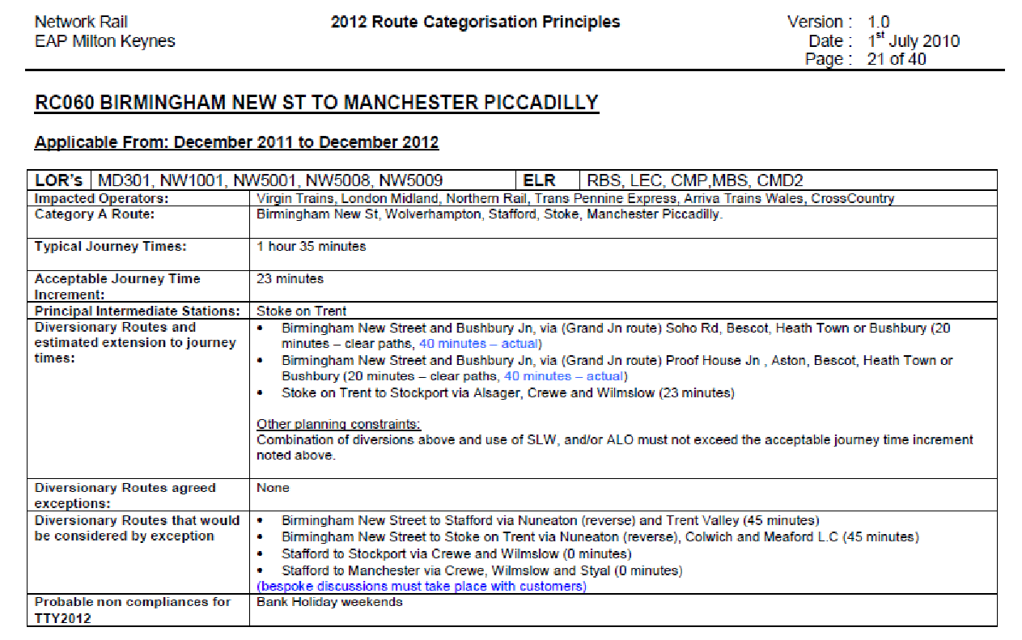
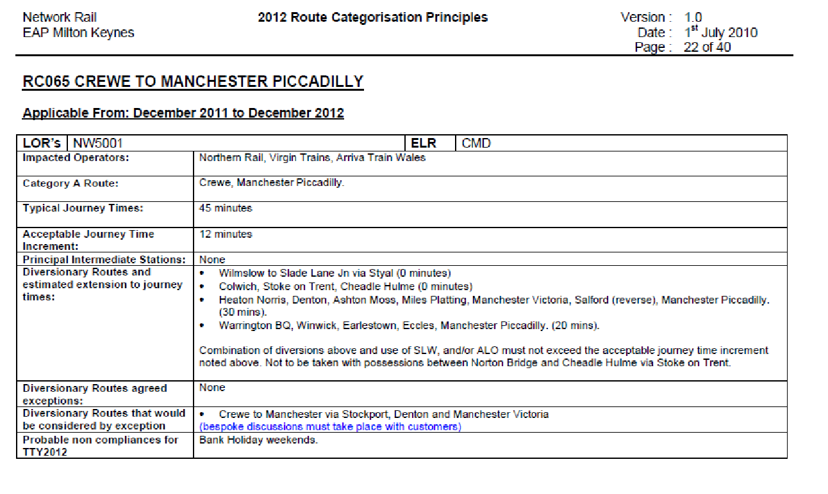

Annex “F” Extract from ORR determination of WCTL appeal of TTP TTP 337 / 359 / 382
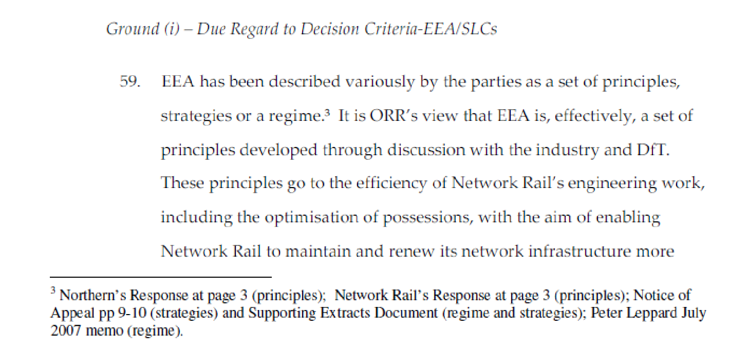
Annex “F” Extract from ORR determination of WCTL appeal of TTP TTP 337 / 359 / 382 (cont.)

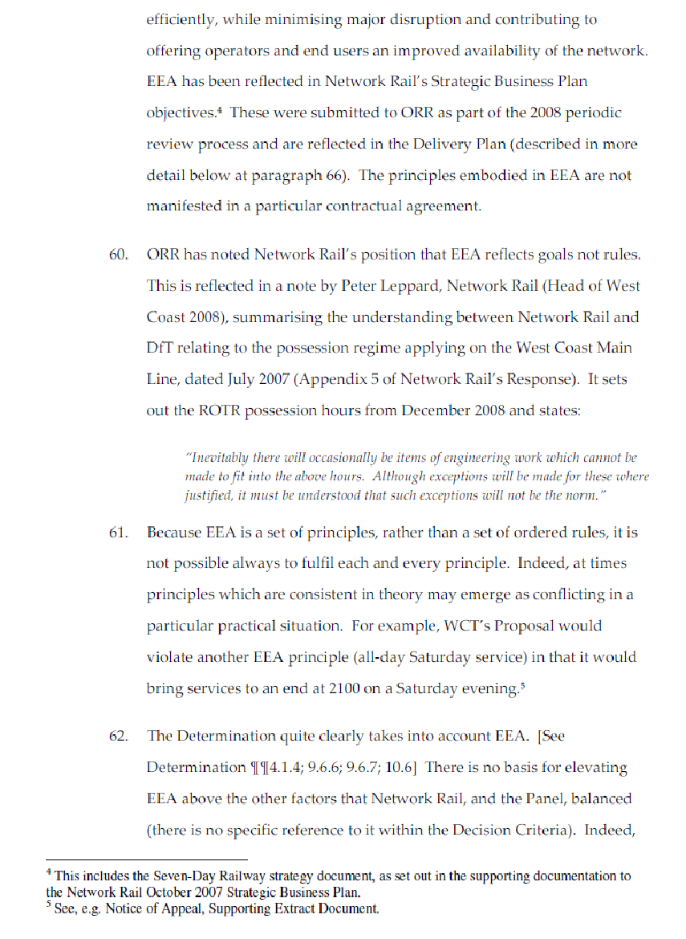
Annex “F” Extract from ORR determination of WCTL appeal of TTP TTP 337 / 359 / 382 (cont.)
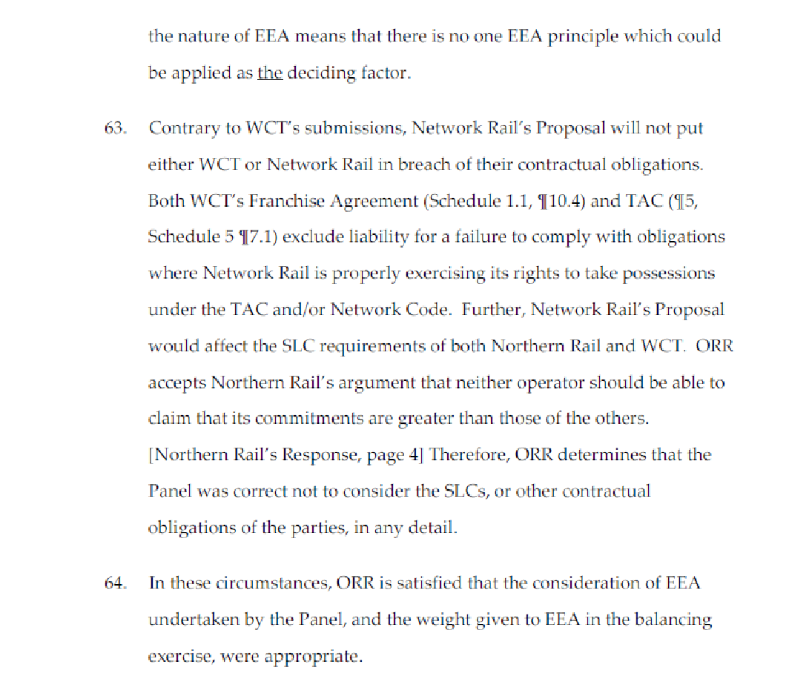

I accept that the ORR has placed a licence obligation on Network Rail to deliver its Possession Disruption Index CP4 target, but this does not refer specifically to possessions in the Stockport area.
I note that ‘due regard’ is not a feature of the version of the Network Code applicable during the 2012 Rules process (Oct 2010), Network Rail being merely required to ‘apply’ the Decision Criteria, although the principle is the same.

