Timetabling Panel Submission
By
Northern Rail Ltd

TTP Reference 337 (Preliminary ROTR Version 2)
and
TTP Reference 359 (Subsidiary ROTR* Version 4)
and
TTP Reference 382 (CPPP Weeks 13-15)

- DETAILS OF PARTIES

The names and addresses of the parties to the reference are as follows:-

a) Northern Rail Limited whose Registered Office is at Serco House, 16 Bartley Wood Business Park, Bartley Way, Hook, Hampshire RG27 9UY ("Northern") ("the Respondent");

b) Network Rail Infrastructure Limited (Company number 2904597) whose Registered Office is at [‘Kings Place’, 90 York Way, London N1 9AG ("Network Rail” - "the Respondent").

c) West Coast Trains Ltd. (Company number 3007940) whose Registered Office is at The school house, 50 brook green, London W6 7RR (“WCTL” - "the Claimant").

d) Northern contact: Helen Bold, Track Access Support
Tel: 01618221085
Email: [redacted]

e) Network Rail contact details are Joe Warr, Lead Access Planner LNW, Engineering Access Planning, 500 Station House, Elder Gate, Milton Keynes Central MK9 1BB

f) WCTL contact details are Robert Hodgkinson, Commercial operations Manager, North Wing Offices, Euston Station, London, NW1 2HS

- THE DEFENDANT’S RIGHT TO CONTEST THIS REFERENCE

This matter is referred to a Timetabling Panel] ("the Panel") for determination in accordance with Condition D2.2.8 and D5.1 of the Network Code.

- CONTENTS OF REFERENCE

This Response to the Claimant’s Sole Reference includes:-

a) The subject matter of the dispute is as set out in Section 4

b) A summary of those issues in dispute in Section 5

c) A detailed explanation of the Defendant’s arguments in support of its position on those issues where it disagrees with the Claimant’s Reference as set out in Section 6.1

d) Any further related issues not raised by the Claimant, but which the Defendant considers fall to be determined as part of the dispute as set out in Section 6.2

e) The decisions of principle sought from the Panel in respect of
legal entitlement and remedies in Section 7

f) Appendices and other supporting material shown in summary in Section 8
- SUBJECT MATTER OF DISPUTE

4.1 This submission is raised as a result of the timetable dispute brought by West Coast Trains Limited, (WCTL) against Network Rail Infrastructure Limited, (Network Rail), as referenced in the joint submission Reference, dated 12th January 2011.

4.2 The issues relative to this dispute are three LNW Route Rules of the Route [ROTR] as issued on 5th February 2010 (TTP337), issued on 9th July 2010 (TTP359) and further subsequent changes under Network Code D2.1.10 and ROTP Part 3.5 have also occurred during 13th December 2010 (see under TTP382).

4.3 The dispute arises as a consequence of a request by WCTL change in the timing of the ROUs to commence at 21.00 on the relevant Saturday and finish at around 1300 on each of the relevant Sundays on weeks 13 to 15, (25th June to 15th July) and relate to route between Wilmslow / Cheadle Hulme and Slade Lane Jn via Stockport.

4.4 Copies of relevant extracts of the documents referred to in this paragraph are included in the joint submission by West Coast Trains Limited (WCTL) and Network Rail Infrastructure Limited, (Network Rail), dated 12th January 2011.

- SUMMARY OF DISPUTE

5.1 The Manchester Piccadilly to Stockport corridor is a key artery in the Northern Rail service provision south on Manchester with a significant number of services operating to / from Manchester Piccadilly via Stockport. Annex A details Northern Rail’s contractual rights on this route and is include for completeness but also to assist the panel in understanding the complexity of the service provision and the stopping pattern which needs to be replicated by bus services. In summary Northern rail has rights to operate 226 services on a Saturday and 99 services on a Sunday.

5.2 The nature of a ROU is that each train operating company on the restricted route is prevented from fulfilling its obligations under its Service Level Commitments, (SLC). Annex B includes the relevant extracts from Northern Rail Ltd’s SLC under its Franchise Agreement. This highlights the difference in the commitments in terms of Saturday services compared with the Sunday provision.

5.3 Northern Rail’ s position in this dispute results from extensive experience in managing blocks during the West Coast Main Line upgrade and the understanding gained as a result, in optimising the train /bus service provision. A key issue, in restrictions in the Manchester area, has been the management of the bus operations at Manchester Piccadilly.

  - WCTL has provided a copy of Network Rail’s Seven Day Railway strategy and Network Availability Implementation Plan as supporting information for its claim. Northern Rail believes that these documents have no contractual basis and therefore are not relevant to this hearing.

- EXPLANATION FROM THE DEFENDANT’S PERSPECTIVE OF EACH ISSUE IN DISPUTE

The underlying premise of the WCTL claim, (as reflected in paragraph 4.5 of the joint submission), is the weighting and application of the Decision Criteria (Network Code D4.6). Northern Rail addresses the specific issues raised in relation to the application of the decision criteria in this section.

6.1 Issues where the Defendant qualifies or refutes the Claimant’s Case

    - Joint Submission – Paragraph 6.1.8

- WCTL has questioned the impact of its request on local services to/from Manchester. This statement is based on the assumption that rail replacement services, (buses), will only be required between Stockport and Manchester. This assumption is incorrect. Northern Rail’s service provision for restrictions on use at Stockport, would likely to be as follows:-

Route | Train  Service | Bus  Service
 |  |  | Max  Mileage  Bus | Journey Time
Manchester- Macclesfield |  | Throughout | 21 m | 1 hour
Manchester - Stoke |  | Throughout | 44 m | 2.5 hours
Manchester – Alderley Edge |  | Throughout | 15m | 1 hour
Manchester - Crewe | Manchester - Crewe | Intermediate stations between Manchester and Wilmslow. | 9 miles | 1 hour
Manchester - Buxton | Hazel Grove –  Buxton | Manchester – Hazel Grove | 14 miles | 1 hour
Chester - Manchester |  | Throughout | 45 miles | 2.5 hours

Please note that the table above is based on the assumption that suitable paths will be available on the Styal line. If this is not the case, a bus service would be required for the entire Manchester – Crewe route.

- A tram service is available form Altrincham as stated, which will provide an alternative service for Manchester-Altrincham, but will not benefit passengers travelling to stations between Manchester and Altrincham and on to Chester. Although not relevant to this dispute, it should be noted that there is no tram service available to New Mills Central.

- WCTL also refer to the consideration of civil disorder during the decision process. As stated above Northern Rail will need to use buses for considerable distances (up to 45 miles) with journey times of between 20 minutes and 2.5 hours. There is the additional issue in that there is no standing provision on buses. All these factors have a potential impact on law and order. WCTL has provided no evidence to support its statement that civil disorder tends to occur after 23.30. Northern Rail’s last Saturday train service leaves Manchester Piccadilly at 23.37. In Northern Rail’s own experience, civil disorder is not limited to the period after 23.30. Northern Rail’s assertion is supported by the statement provided by the British Transport Police, (Annex C).

  - ISSUES NOT ADDRESSED BY THE CLAIMANT THAT THE DEFENDANT CONSIDERS SHOULD BE TAKEN INTO ACCOUNT AS MATERIAL TO THE DETERMINATION

6.2.1 Joint Submission – Paragraph 6.1.9

Northern Rail confirms that the statement made by Network Rail in paragraph 6.1.15a of the joint submission that 26 Northern Rail services will be affected by the re-timing of the ROU to 21.00 on Saturdays. The implication to passengers in terms of bus services are shown in paragraph 6.1.1 of this submission.

6.2.2 Joint Submission – Paragraph 6.1.10

- WCTL has stated that the number of passengers affected by Network Rail’s ROU requirement is significantly higher than the number of passengers that would be affected under its proposal. Decision Criteria D4.6.1 (a) states that the interests all users should be considered in the evaluation. Given that the data supporting this paragraph has been redacted, Northern Rail is unable to comment on the passenger loading data for all users. We note however, that details of Northern Rail’s passenger loadings, where available, are included in Annex Q of the joint submission. Northern Rail passengers loadings (where available) for the applicable Sunday services, have been included in Annex D of this submission, for further consideration.

- The WCTL concern in this paragraph in relation to the potential to civil disorder has been made without an understanding of Northern Rail’s bus requirements for the period between 21.00 and 23.30 on Saturdays The current estimation is a requirement of 43 buses to cover the services affected. Northern Rail experience suggests that the risk of public order issues is greater for services leaving Manchester on a Saturday night than would be experienced on a Sunday afternoon for in-bound services to Manchester. In addition, Northern has public order concerns regarding the need for passengers travelling from Manchester to stations between Wilmslow and Crewe, to change at Wilmslow. The risk is believed to be, again lower, on a Sunday afternoon. There is a similar issue for Buxton passengers changing at Hazel Grove.

6.2.3 Joint Submission – Paragraph 6.1.12

WCTL refer to the overriding criterion used in the decision process for this disputed ROU. Northern Rail Ltd recognises the importance of criterion D4.6.1(a) in trying to achieve a balance between competing interests (TTP376/377 Part 8.5.7). Northern believes that Network Rail’s decision in relation to the timing of these ROUs, has been made following an assessment of the full requirements of this decision criterion, which, requires Network rail to have “___regard, in particular, to safety” in reaching a decision. Evidence for this point is shown in the table in paragraph 6.1.20 of the joint submission, in particular bullet point number 6.

  - Why the arguments raised in 6.1 to 6,3 taken together favour the position of the Defendant

Northern Rail believes that WCTL’s questioning of the weighting and application of the decision criteria in relation to these ROUs, has been based on incomplete information. The table included in paragraph 6.1.20 demonstrates that in publishing the CPPP on 13th December, Network Rail has assessed the implications for all users on the route and has considered all the requirements of the Decision Criteria restrictions, including criteria (a) (h) and (g).

7. DECISION SOUGHT FROM THE PANEL

Northern Rail Ltd seeks the following outcome from the Panel’s Determination

That Network Rail has correctly applied the Decision Criteria and that therefore the published access should remain unchanged under condition D5.3.1 of the Network Code.

8. APPENDICES AND ANNEXES

Northern Rail Ltd Defendant confirms that it has complied with Rule H21 of the Access Dispute Resolution Rules., which requires that

“Copies of the following documents shall also be annexed and cross referenced to the reference:

- Annex A –Northern Rail Ltd’s Contractual Firm Access Rights (Extracts from the Track Access Agreement.
- Annex B – Northern Rail Ltd’s Service Level Commitments (Extracts)
- Annex C – BT Police Statement On Bus Replacement Services.
- Annex D – Northern Rail Passenger Counts – Sunday pm

9. SIGNATURES
The Defendant
For and on behalf of
Northern Rail Ltd

___________________________________
Signed
-----------------------------------------------------
Print Name
Helen E Bold
___________________________________
Position
Track Access Support
___________________________________

Nor Used
Annex A
Northern Rail Ltd
Track Access Agreement (Extracts)
Dated 6th January 2010
Service Group ED10 - South Manchester
2 Passenger Train Slots
Table 2.1: Passenger Train Slots
1 |  |  |  |  | 2
Service Group ED10
Service Description: South Manchester |  |  |  |  | Passenger Train Slots
From | To | Via | Description | TSC | Total Weekday | Peak times1 |  | Off-Peak times2 | Saturday | Sunday
 |  |  |  |  |  | Morning Peak | Evening Peak
Manchester Piccadilly | Sheffield
 |  | Stockport | ED10.5.2 |  | 1 | 0 | 0 | 1 | 1 | 1
Sheffield | Manchester Piccadilly | Stockport | ED10.5.2 |  | 1 | 0 | 0 | 1 | 1 | 1
Manchester Piccadilly | Hazel Grove |  | ED10.6.1 | 12228110 | 13 | 0 | 3 | 10 | 13 | 0
Hazel Grove | Manchester Piccadilly |  |  |  | 12 | 5 | 0 | 7 | 12 | 0
Manchester Piccadilly | Buxton |  | ED10.7.1 | 12228820 | 20 | 0 | 4 | 16 | 18 | 14
Buxton | Manchester Piccadilly |  |  |  | 15 | 6 | 0 | 18 | 19 | 15
Manchester Piccadilly | Chester | Altrincham | ED10.8.1 | 12229820 | 18 | 0 | 4 | 14 | 18 | 7
Stockport |  |  |  |  | 2 | 0 | 2 | 0 | 0 | 0
Chester | Manchester Piccadilly |  |  |  | 17 | 3 | 0 | 14 | 17 | 9
 | Stockport |  |  |  | 2 | 2 | 0 | 0 | 0 | 0
 |  | Direct |  |  | 7 | 0 | 0 | 7 | 0 | 0
Deansgate | Stoke-on-Trent | Macclesfield | ED10.10.1 | 12231820 | 1 | 0 | 1 | 0 | 0 | 0
Manchester Piccadilly |  |  |  |  | 16 | 0 | 5 | 11 | 16 | 3
Manchester Piccadilly | Macclesfield | Direct |  |  | 2 | 0 | 0 | 2 | 2 | 0
Macclesfield | Stoke-on-Trent |  |  |  | 1 | 0 | 0 | 1 | 1 | 0
Stoke-on-Trent | Manchester Piccadilly | Macclesfield |  |  | 17 | 3 | 0 | 14 | 16 | 3
Macclesfield |  | Direct |  |  | 3 | 3 | 0 | 0 | 0 | 0
Manchester Piccadilly | Crewe | Stockport | ED10.11.1 | 12232820 | 20 | 0 | 5 | 15 | 18 | 7
 | Alderley Edge |  |  |  | 12 | 0 | 4 | 8 | 14 | 8
Crewe | Manchester Oxford Road |  |  |  | 1 | 1 | 0 | 0 | 0 | 0
 | Manchester Piccadilly |  |  |  | 18 | 4 | 0 | 14 | 17 | 7
Alderley Edge | Manchester Piccadilly | Stockport | ED10.11.1 | 12232820 | 12 | 3 | 0 | 9 | 12 | 8
Manchester Oxford Road |  |  | ED10.12.2 |  | 31 | 0 | 8 | 23 | 31 | 16
Stockport | Stalybridge | Guide Bridge | ED10.14.1 | 22227820 | 1 | 0 | 0 | 1 | 0 | 0

3 Intervals
Table 3.1: Service Intervals
1 |  |  |  |  | 2 | 3 |  |  | 4
Service Group ED10
Service Description: South Manchester |  |  |  |  | Station where interval applies | Interval (minutes) |  |  | Maximum variation  (+/- minutes)
Between | And | Via | Description | TSC |  | Weekday | Saturday | Sunday | Weekday | Saturday | Sunday
Manchester Piccadilly
 | Hazel Grove | Stockport | ED10.6.1 ED10.7.1 | 12228110 |  | 30 (0552-2026)  60 (2027-2331) | 30 (0552-2026) 60 (2027-2331) | 60 (0847-2331) | 5 | 5 | 5
 | Chester | Altrincham | ED10.8.1 | 12229820 |  | 60 (0612-0005) | 60 (0612-0005) | 120 (0917-2238) | 5 | 5 | 5
Deansgate | Stoke-on-Trent | Macclesfield | ED10.10.1 | 12231820 |  | 60 (0643-2300) | 60 (0643-2300) | N/A | 5 | 5 | N/A
Manchester Oxford Road | Alderley Edge | Stockport | ED10.11.1 | 12232820 |  | 30 (0628-1939)  60 (1940-2317) | 30 (0628-1939) 60 (1940-2317) | 60 (0857-2356) | 5 | 5 | 5

Table 3.1a: Morning Peak Service Intervals and frequency
1 |  |  |  |  | 2 |  |  |  | 3
Service Group ED10
Service Description: South Manchester |  |  |  |  | Minimum number of Passenger Train Slots arriving at Manchester Piccadilly in each Period of 60 Minutes of the morning peak with a maximum variation of +/-5 minutes |  |  |  | Minimum interval between Passenger Train Slots arriving at Manchester Piccadilly in each Period of 60 Minutes of the morning peak with a maximum variation of 5 minutes
From | To | Via | Description | TSC | 06:00-06:59 | 07:00-07:59 | 08:00-08:59 | 09:00-09:59 | 06:00-06:59 | 07:00-07:59 | 08:00-08:59 | 09:00-09:59
 | Manchester Piccadilly
Hazel Grove |  | Stockport | ED10.6.1  ED10.7.1 | 12228110  12228820 | N/A | 4 | 4 | 2 | N/A | 15 | 15 | 30
Chester |  | Altrincham | ED10.8.1 | 12229820 | N/A | 2 | 2 | 1 | N/A | 30 | 30 | N/A
Macclesfield |  | Direct | ED10.10.1 | 12231820 | N/A | 2 | 3 | 1 | N/A | 30 | 20 | N/A
Alderley Edge |  | Stockport | ED10.11.1 | 12232820 | N/A | 3 | 2 | 2 | N/A | 20 | 30 | 30
Notes to Table:
1.Where application of the permitted variation shown in columns 2 and 3 above causes a Passenger Train Slot to fall within another defined hour or immediately before or immediately after the first and last times respectively shown above, the Train Operator’s Firm Rights under paragraphs 3.1 and 3.2 shall be deemed to have been met.
Table 3.1b: Evening Peak Service Intervals and frequency
1 |  |  |  |  | 2 |  |  |  | 3
Service Group ED10
Service Description: South Manchester |  |  |  |  | Minimum number of Passenger Train Slots departing from Manchester Piccadilly in each Period of 60 Minutes of the evening peak with a maximum variation of +/-5 minutes |  |  |  | Minimum interval between Passenger Train Slots departing from Manchester Piccadilly in each Period of 60 Minutes of the evening peak with a maximum variation of 5 minutes
From | To | Via | Description | TSC | 15:00-15:59 | 16:00-16:59 | 17:00-17:59 | 18:00-18:59 | 15:00-15:59 | 16:00-16:59 | 17:00-1759 | 18:00-18:59
Manchester Piccadilly
 | Chester | Altrincham | ED10.7.1 | 12229820 | 1 | 2 | 2 | 1 | N/A | 30 | 30 | N/A
 | Stoke-on-Trent | Macclesfield | ED10.10.1 | 12231820 | 1 | 1 | 2 | 1 | N/A | N/A | 30 | N/A
Notes to Table:
1 Where application of the permitted variation shown in columns 2 and 3 above causes a Passenger Train Slot to fall within another defined hour or immediately before or immediately after the first and last times respectively shown above, the Train Operator’s Firm Rights under paragraphs 3.1 and 3.2 shall be deemed to have been met.
Table 3.3: Earliest and latest Passenger Train Slots
1 |  |  |  |  | 2
Service Group ED10 |  |  |  |  | Earliest and latest Passenger Train Slots (PTS)
Service Description: South Manchester |  |  |  |  | Weekdays |  | Saturdays |  | Sundays
From | To | Via | Description | TSC | earliest PTS no later than | latest PTS no earlier than | earliest PTS no later than | latest PTS no earlier than | earliest PTS no later than | latest PTS no earlier than
Manchester Piccadilly | Sheffield
 |  | Stockport | ED10.5.2 |  | 0555 | - | 0555 | - | - | -
Sheffield | Manchester Piccadilly
 |  | Stockport | ED10.5.2 |  | - | 2242 | - | 2219 | - | 2212
Hazel Grove | Manchester Piccadilly |  | ED10.6.1 | 12228110 | - | - | 0737 | - | - | -
Manchester Piccadilly | Buxton |  | ED10.7.1 | 12228820 | 0654 | 2305 | 0654 | 2305 | 0900 | 2247
Buxton | Manchester Piccadilly |  |  |  | 0604 | 2251 | 0604 | 2251 | 0828 | 2222
Manchester Piccadilly | Chester | Altrincham | ED10.8.1 | 12229820 | 0623 | 2312 | 0623 | 2312 | 0928 | 2117
Chester | Manchester Piccadilly | Altrincham | ED10.8.1 | 12229820 | 0610 | 2243 | 0610 | 2244 | 0911 | 2103
Manchester Piccadilly | Stoke-on-Trent | Macclesfield | ED10.10.1 | 12231820 | 0637 | 2143 | 0647 | 2144 | - | -
 | Macclesfield | Direct |  |  | - | 2309 | - | 2309 | - | -
Macclesfield | Stoke-on-Trent |  |  |  | 0608 | - | 0608 | - | - | -
Stoke-on-Trent | Manchester Piccadilly | Macclesfield |  |  | 0635 | 2213 | 0702 | 2213 | - | -
Macclesfield |  | Direct |  |  | 0627 | - | - | - | - | -
Manchester Piccadilly | Crewe | Stockport | ED10.11.1 | 12232820 | 0611 | 2333 | 0611 | 2259 | 0905 | 2059
 | Alderley Edge |  |  |  | - | - | - | - | - | 2259
Crewe | Manchester Piccadilly |  |  |  | 0555 | 2306 | 0654 | 2307 | 1107 | -
Alderley Edge |  |  |  |  | - | - | 0654 | - | 0931 | 2214

4 Calling Patterns
Table 4.1: Calling Patterns
1 |  |  |  |  | 2 | 3
Service Group ED10
Service Description: South Manchester
Between | And | Via | Description | TSC | Regular Calling Pattern | Additional stations
Manchester Piccadilly | Sheffield
 |  | Stockport | ED10.5.2 |  | Stockport, Hazel Grove, Chinley, Edale, Hope, Bamford, Hathersage, Grindleford, Dore
 | Hazel Grove |  | ED10.6.1 | 12228110 | Levenshulme, Heaton Chapel, Stockport, Davenport, Woodsmoor
 | Buxton |  | ED10.7.1 | 12228820 | Levenshulme, Heaton Chapel, Stockport, Davenport, Woodsmoor, Hazel Grove, Middlewood, Disley, New Mills Newtown, Furness Vale, Whaley Bridge, Chapel-en-le Frith, Dove Holes
 | Chester | Altrincham | ED10.8.1 | 12229820 | Stockport, Navigation Road, Altrincham, Hale, Ashley, Mobberley, Knutsford, Plumley, Lostock Gralam, Northwich, Greenbank, Cuddington, Delamere, Mouldsworth
 | Glossop | Hadfield | ED10.9.3 |  | Ashburys, Gorton, Guide Bridge, Flowery Field, Newton for Hyde, Godley, Hattersley, Broadbottom, Dinting, Hadfield
Deansgate | Stoke-on-Trent | Macclesfield | ED10.10.1 | 12231820 | Manchester Oxford Road (limited to 1 SX call in the direction of Stoke-on-Trent), Manchester Piccadilly, Levenshulme, Heaton Chapel, Stockport, Cheadle Hulme, Bramhall, Poynton, Adlington, Prestbury, Macclesfield, Congleton, Kidsgrove, Longport (limited to 2 SX calls in the direction of Manchester Piccadilly) | Manchester United Football Ground
Manchester Oxford Road | Crewe | Stockport | ED10.11.1 | 12232820 | Manchester Piccadilly, Levenshulme, Heaton Chapel, Stockport, Cheadle Hulme, Handforth, Wilmslow, Alderley Edge, Chelford, Goostrey, Holmes Chapel, Sandbach | Not applicable
Manchester Oxford Road | Manchester Airport | Direct | ED10.12.1 | 12233110 | Manchester Piccadilly, Mauldeth Road, Burnage, East Didsbury, Gatley, Heald Green
 |  |  | ED10.12.2 |  | Manchester Piccadilly, East Didsbury (limited to 1 SX call in the direction of Manchester Airport)
Manchester Piccadilly | Crewe | Manchester Airport | ED10.13.1 | 12233820 | Mauldeth Road, Burnage, East Didsbury, Gatley, Heald Green, Manchester Airport, Styal, Wilmslow, Alderley Edge, Holmes Chapel, Sandbach
Stockport | Stalybridge | Guide Bridge | ED10.14.1 | 22227820 | Reddish South, Denton, Guide Bridge

5 Specified Equipment
Table 5.1: Specified Equipment
1 |  |  |  |  | 2 | 3
Service Group ED10
Service Description: South Manchester
Between | And | Via | Description | TSC | Standard Specified Equipment1 | Additional Specified Equipment1
Manchester Piccadilly
 | Sheffield
 |  | Stockport | ED10.5.2 | 12226820 | Class 142 | Class 144, 150, 153, 155, 156, 158
 | Hazel Grove | Stockport | ED10.6.1 | 12228110 | Class 142 | Class 144, 150, 153, 155 156, 158, 180, 323
 | Buxton | Stockport | ED10.7.1 | 12228820 | Class 156 | Class 142, 144, 150, 153, 155, 158
 | Chester | Altrincham | ED10.8.1 | 12229820 | Class 142 | Class 144, 150, 153, 155, 156, 158
Deansgate | Stoke-on-Trent | Macclesfield | ED10.10.1 | 12231820 | Class 323 | Class 142, 144, 150, 153, 155 156, 158
Manchester Oxford Road | Crewe | Stockport | ED10.11.1 | 12232820 | Class 323 | Class 142, 144, 150, 153, 155 156, 158
Stockport | Stalybridge | Guide Bridge | ED10.14.1 | 22227820 | Class 150 | Class 142, 144, 153, 155, 156, 158
Notes to Table:
1 Any Standard Specified Equipment or Additional Specified Equipment included in this Table 5.1 may not be used until and unless the necessary route clearance has been obtained.
6 Journey Times
Table 6.1: Maximum Journey Times
1 |  |  |  |  | 2 | 3 | 4
Service Group ED10
Service Description: South Manchester
From | To | Via | Description | TSC | Calling Pattern | Specified Equipment | Maximum Journey Time (minutes)
Manchester Piccadilly | Sheffield
 |  | Stockport | ED10.5.2 |  | Regular Calling Pattern |  | Monday to Saturday: 79  Sunday: 79
Sheffield | Manchester Piccadilly
 |  | Stockport | ED10.5.2 |  | Regular Calling Pattern |  | Monday to Saturday: 79  Sunday: 79
Manchester Piccadilly | Hazel Grove |  | ED10.6.1 | 12228110 |  |  | Monday to Saturday: 30
Hazel Grove | Manchester Piccadilly |  |  |  |  |  | Monday to Saturday: 21
Manchester Piccadilly | Buxton |  | ED10.7.1 | 12228820 |  | Class 156 | Monday to Saturday: 64  Sunday: 60
Buxton | Manchester Piccadilly | Stockport | ED10.7.1 | 12228820 | Regular Calling Pattern | Class 156 | Monday to Saturday: 61  Sunday: 60 with up to 3 journeys of up to 61
Manchester Piccadilly | Chester | Altrincham | ED10.8.1 | 12229820 |  | Class 142 | Monday to Saturday: 91  Sunday: 91
Chester | Manchester Piccadilly |  |  |  |  |  | Monday to Saturday: 91  Sunday: 91
Deansgate | Stoke-on-Trent | Macclesfield | ED10.10.1 | 12231820 |  |  | Monday to Friday: 60
 |  |  |  |  | Regular Calling Pattern except Manchester Oxford Road |  | Monday to Saturday: 54  Sunday: 67
Stoke-on-Trent | Deansgate |  |  |  | Regular Calling Pattern |  | Monday to Friday: 60
Stoke-on-Trent | Deansgate | Macclesfield | ED10.10.1 | 12231820 | Regular Calling Pattern except Longport, Manchester Oxford Road | Class 323 | Monday to Saurday: 58  Sunday: 58
Manchester Oxford Road | Crewe | Stockport | ED10.11.1 |  | Regular Calling Pattern |  | Monday to Saturday: 74  Sunday: 63
Crewe | Manchester Oxford Road |  |  |  |  |  | Monday to Saturday: 75  Sunday: 66

Annex B

Extracts From Northern Rail Service Level Commitment

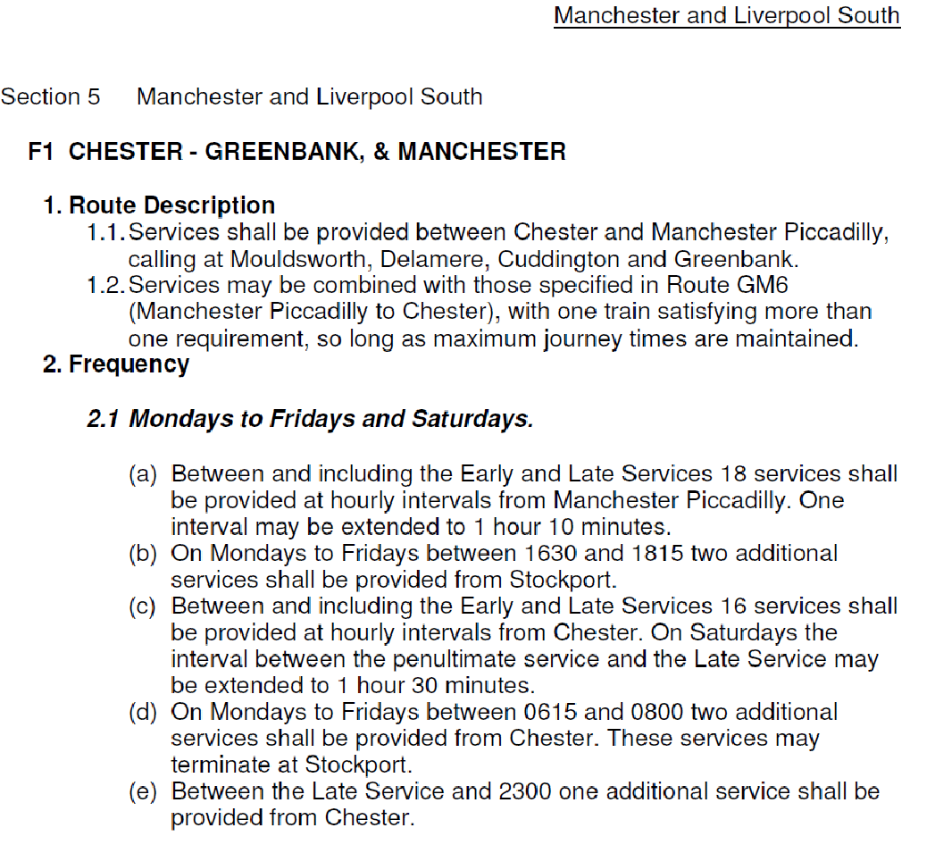

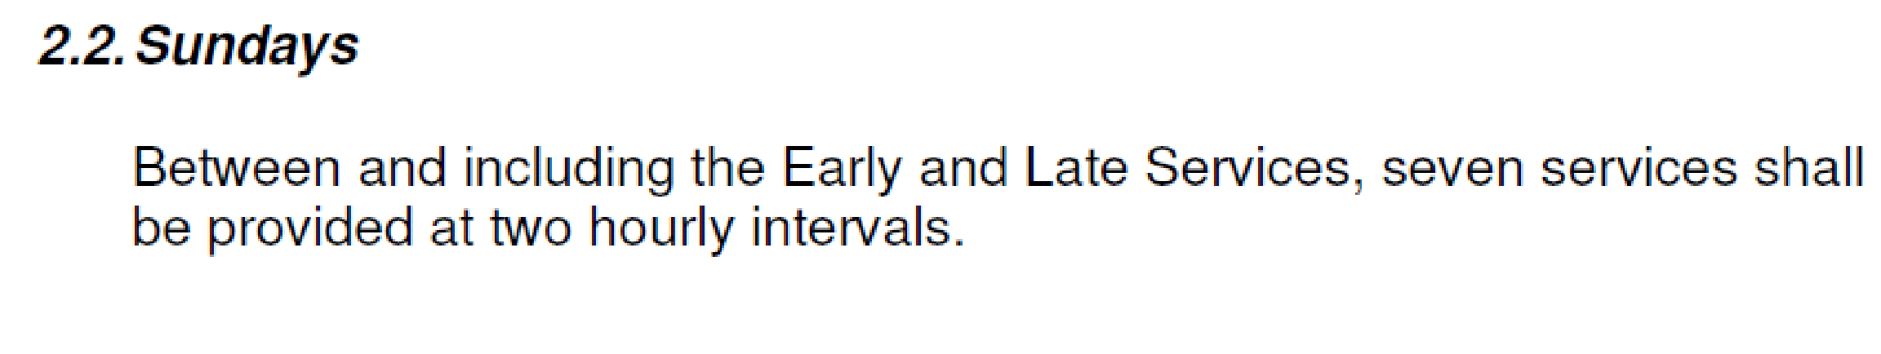

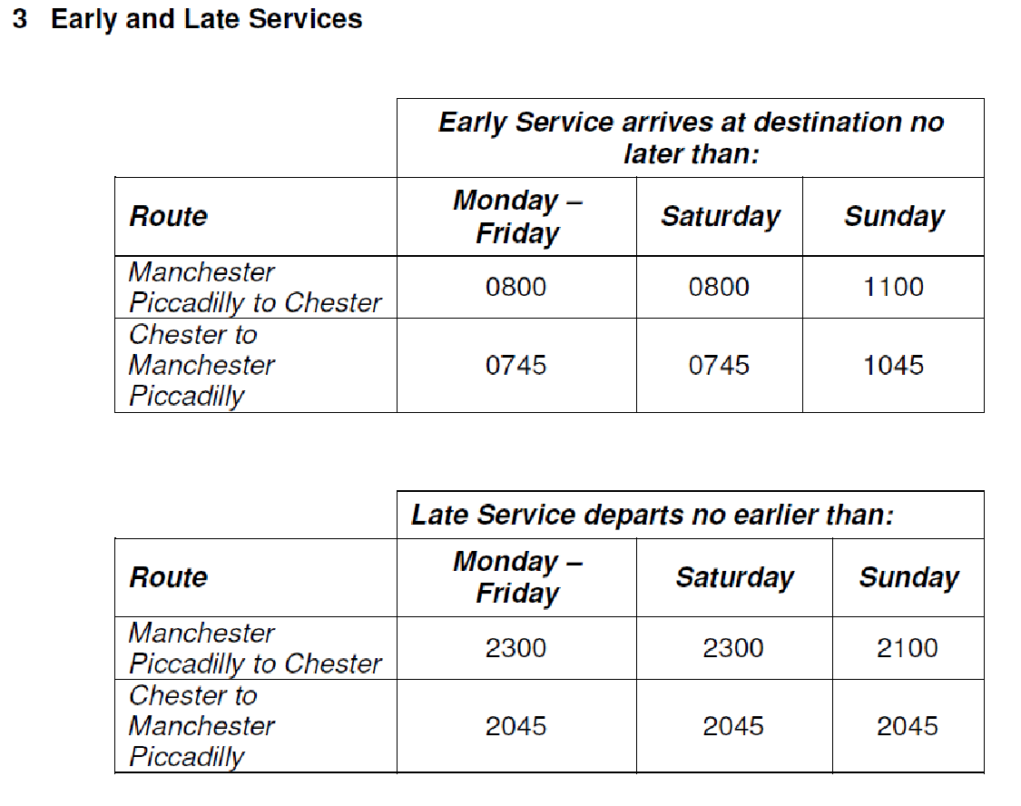

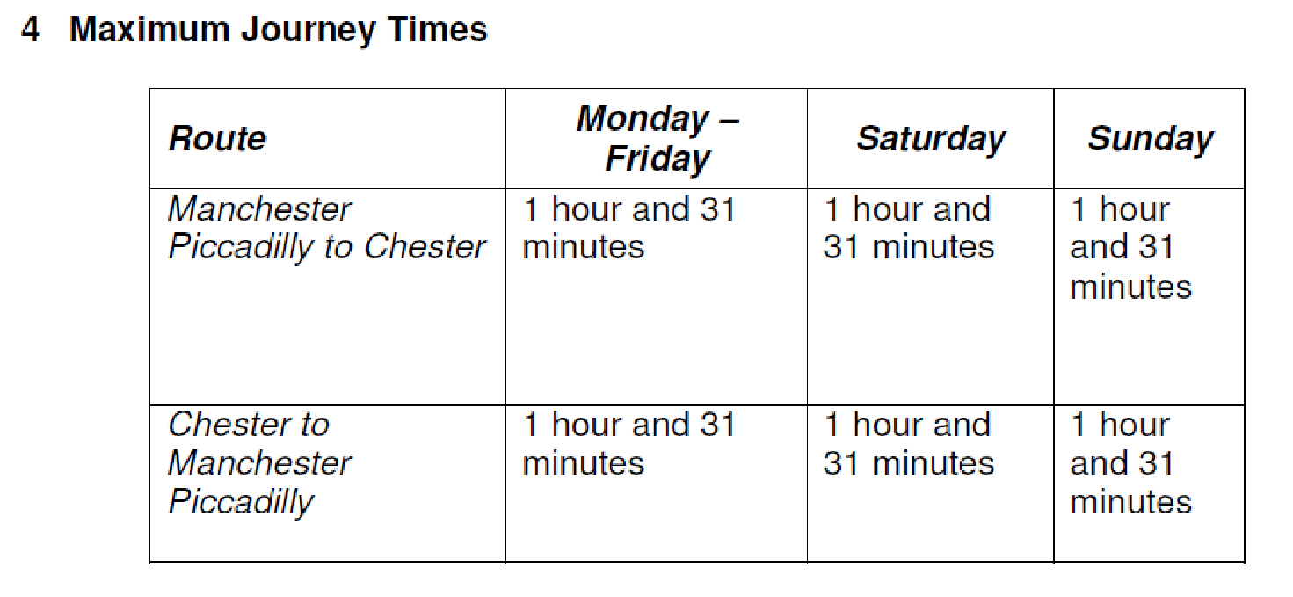

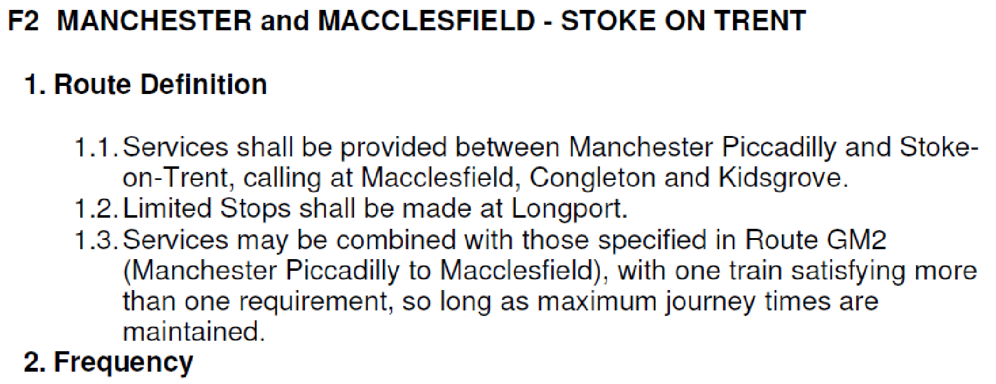
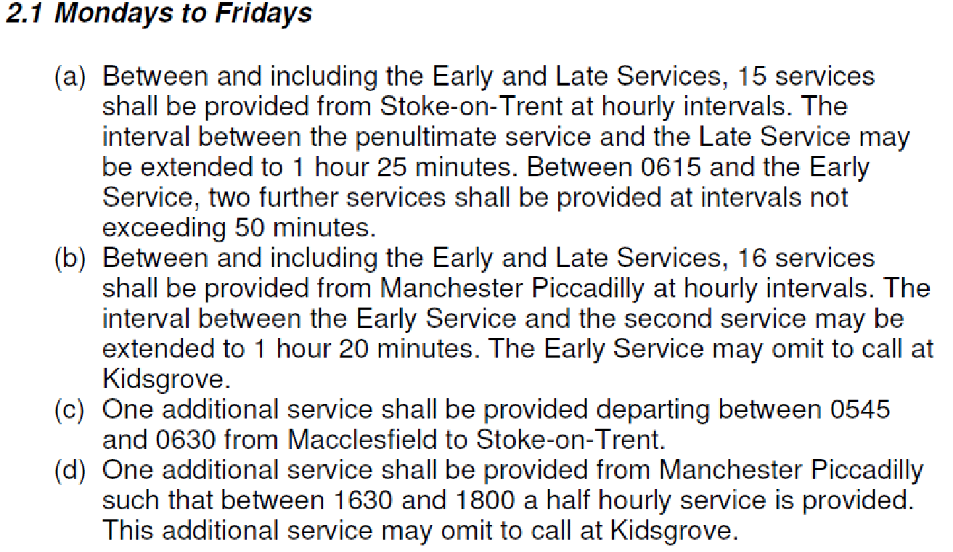
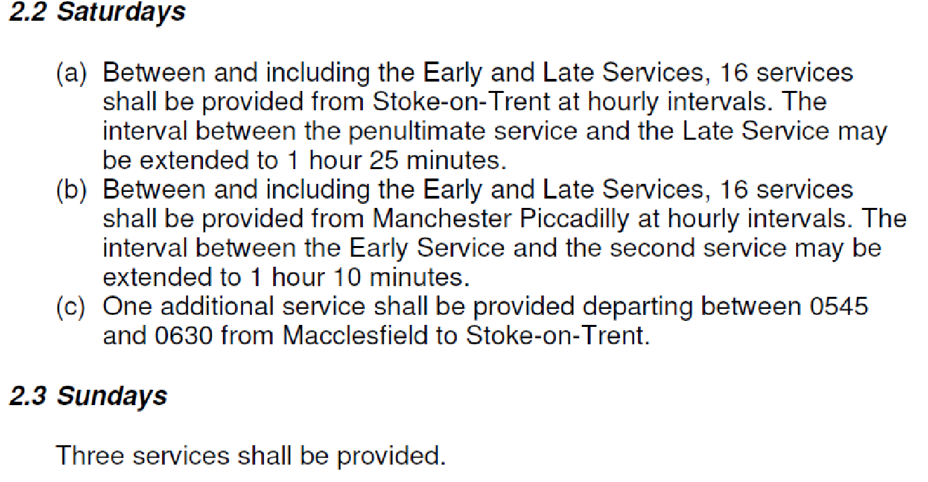

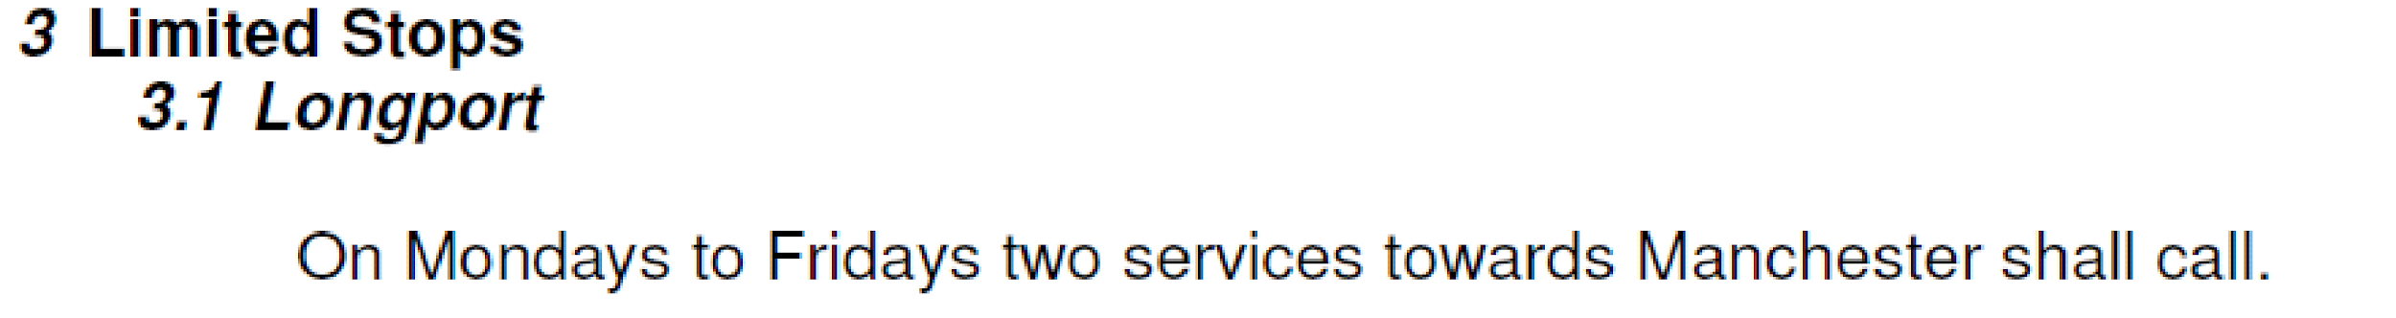
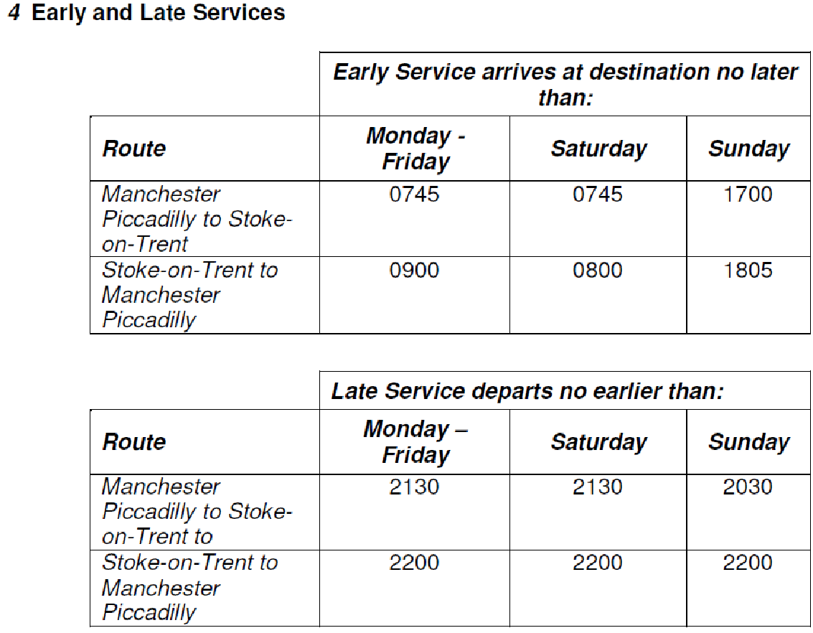

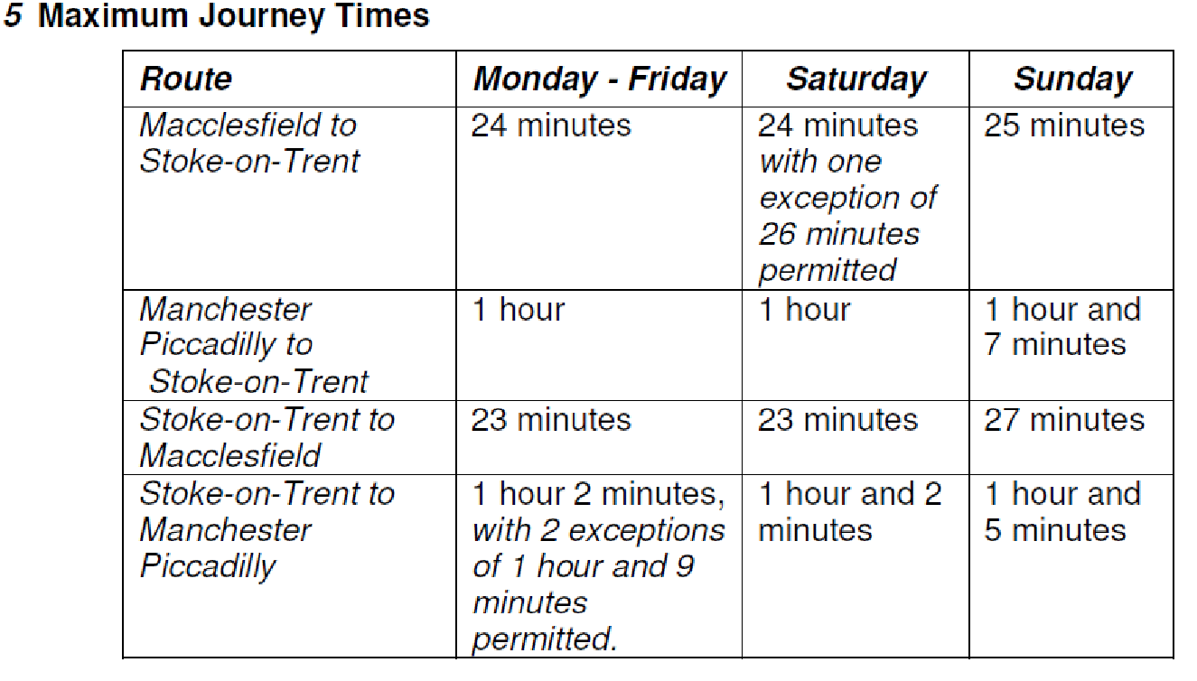

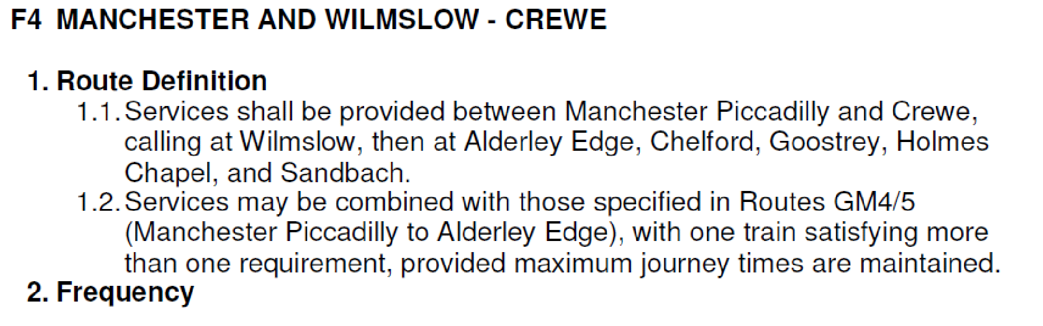

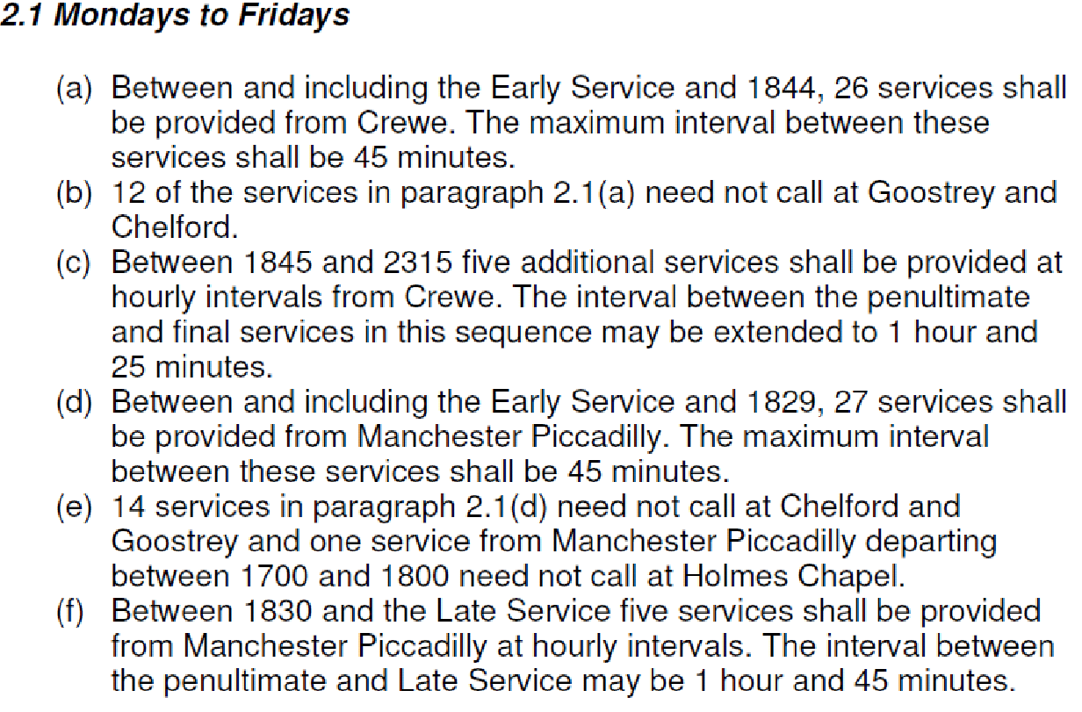
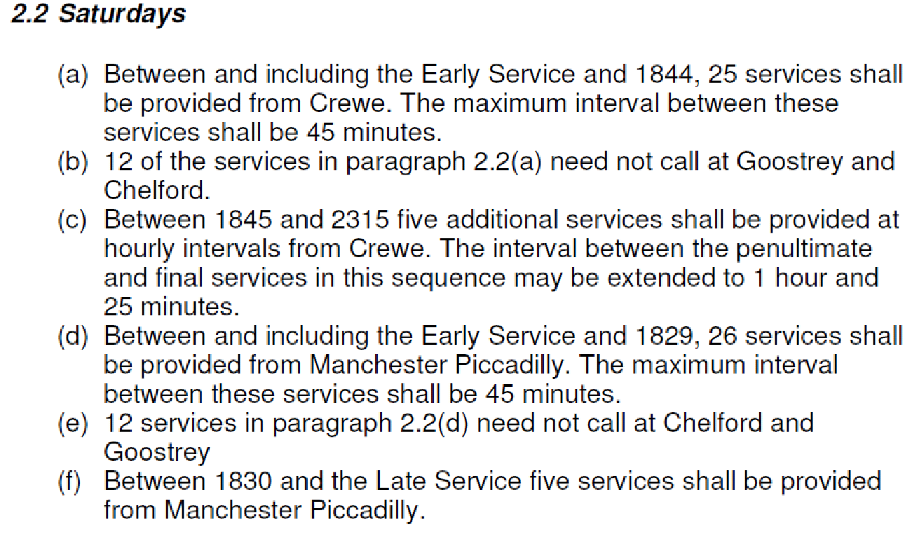

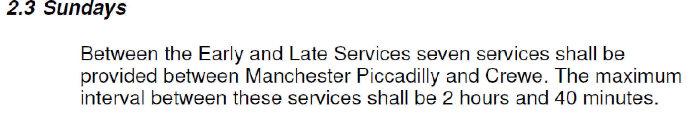

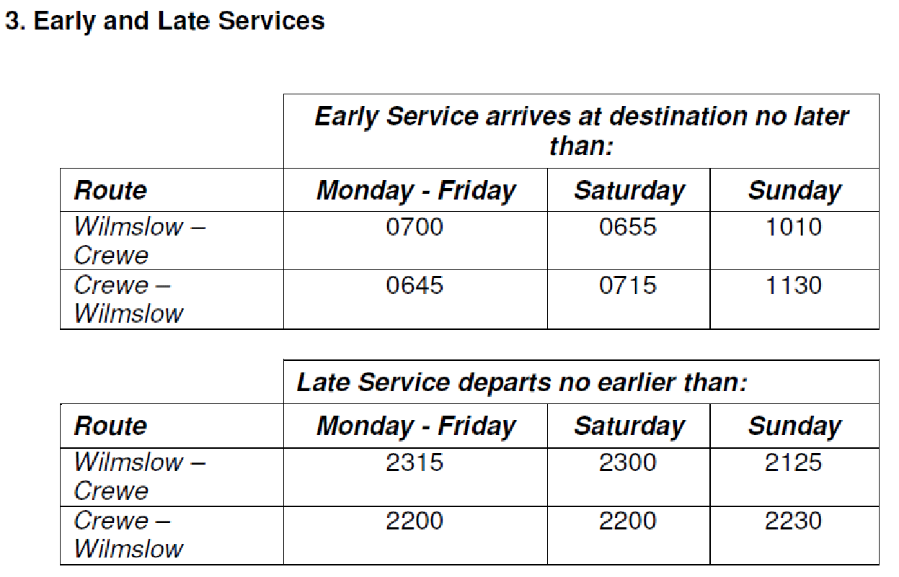

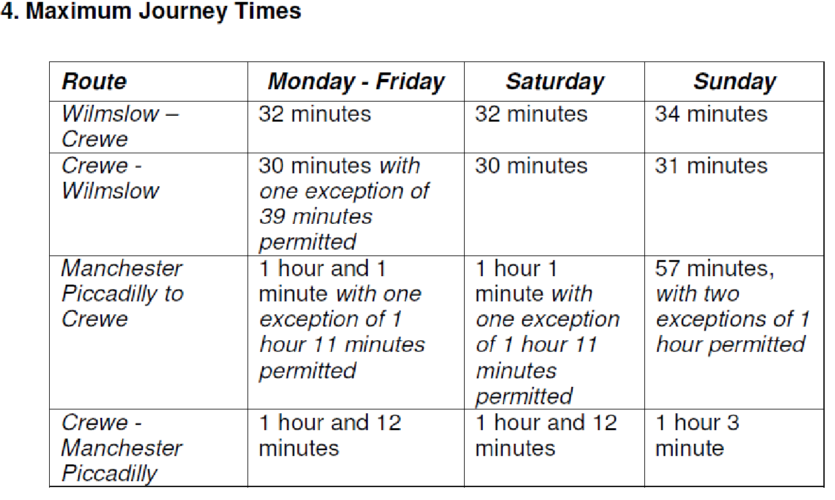

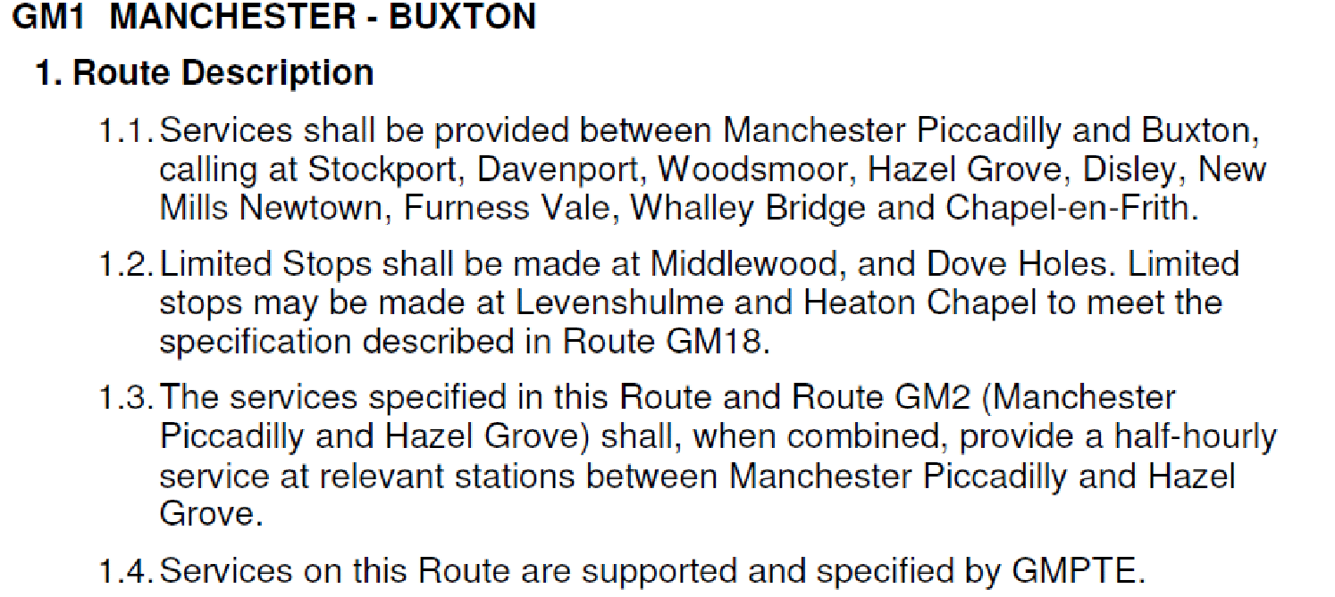

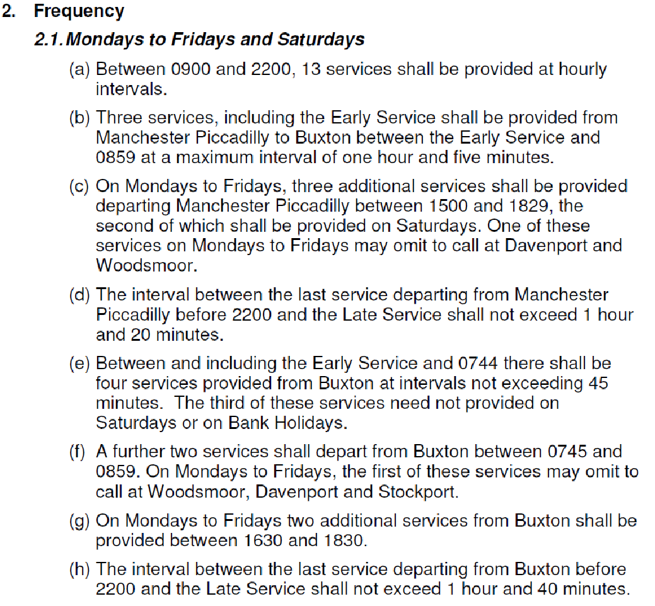

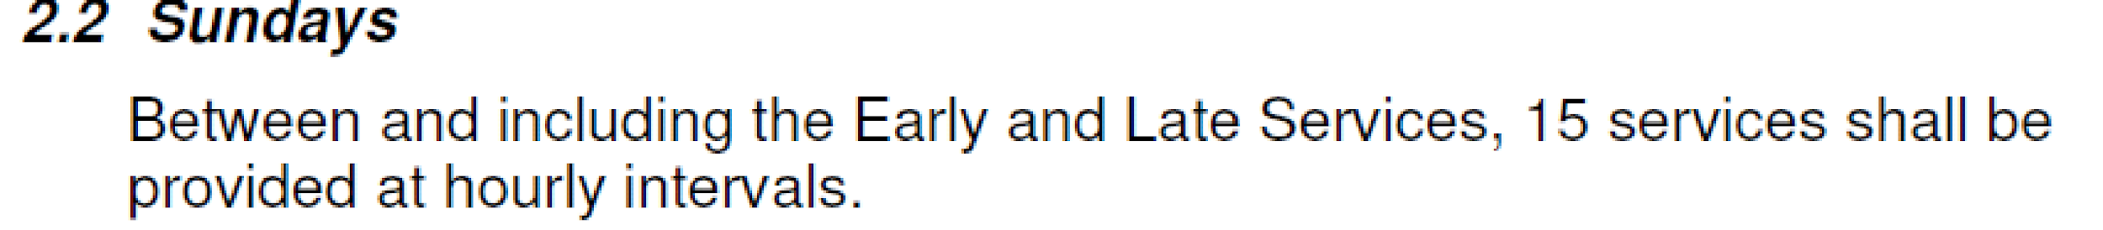

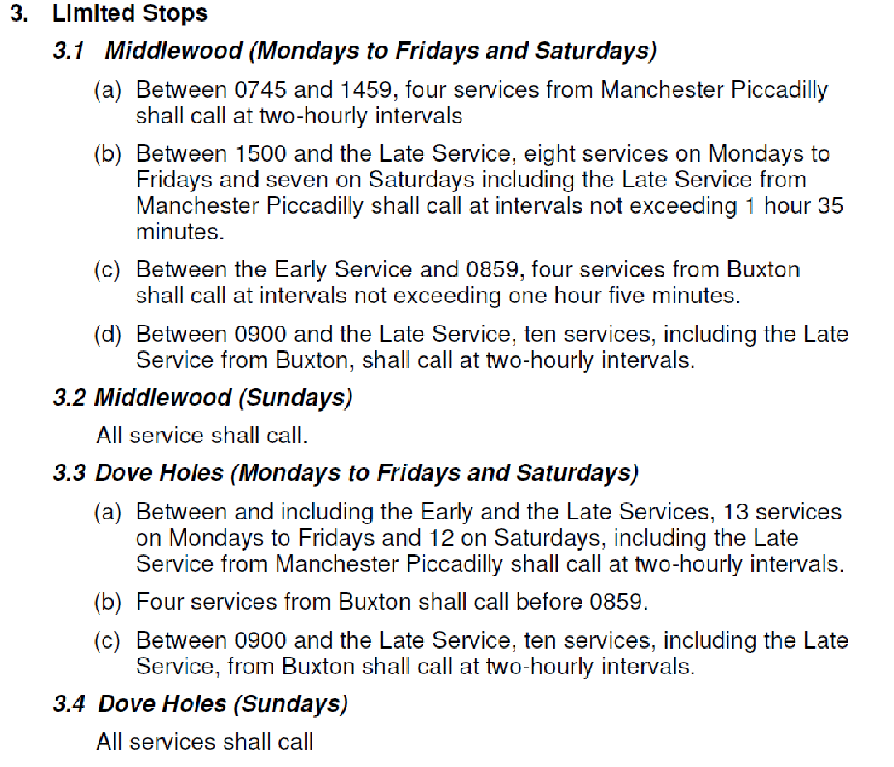

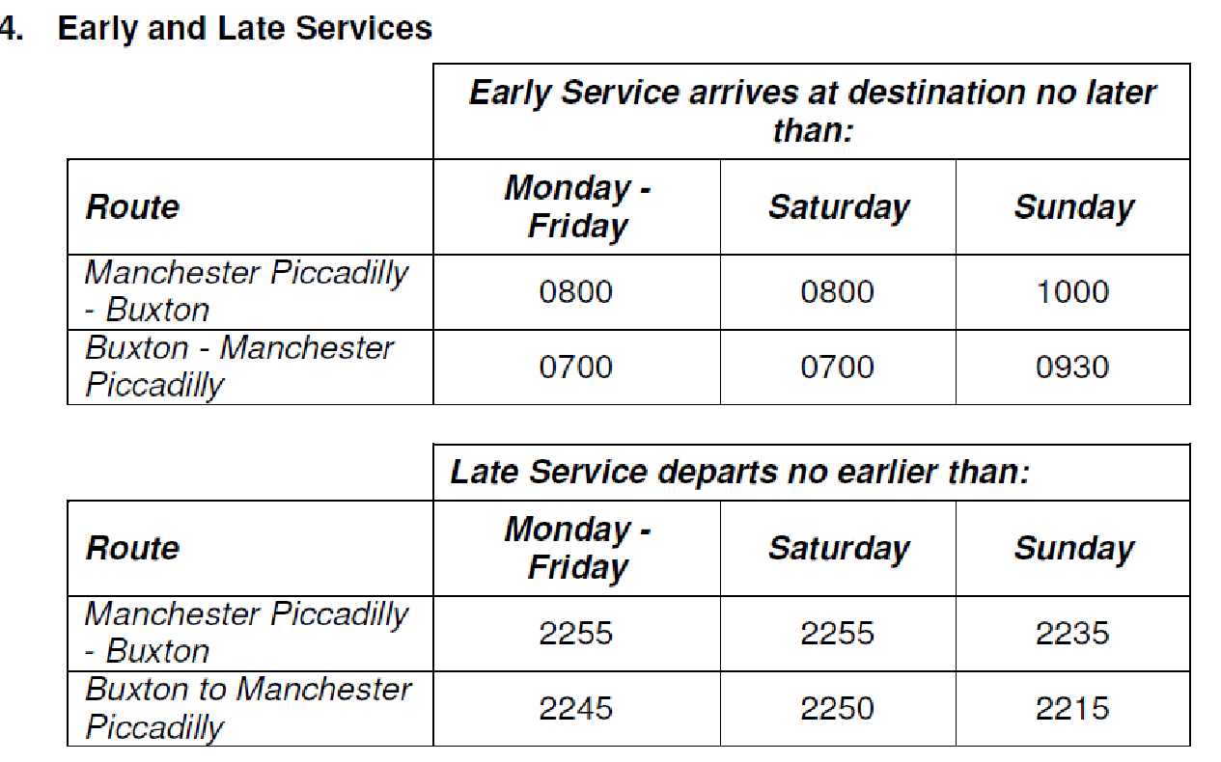

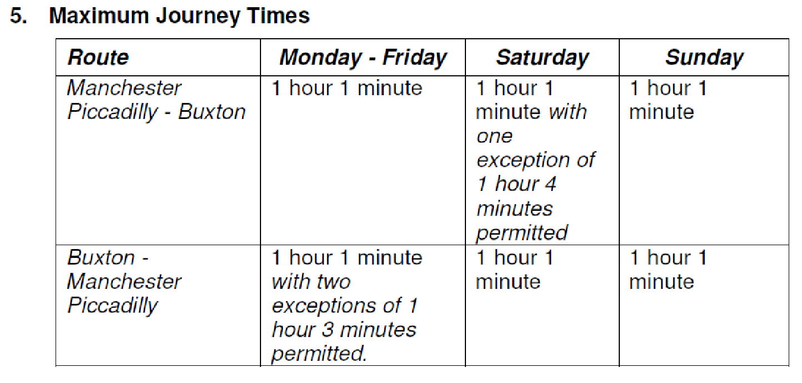

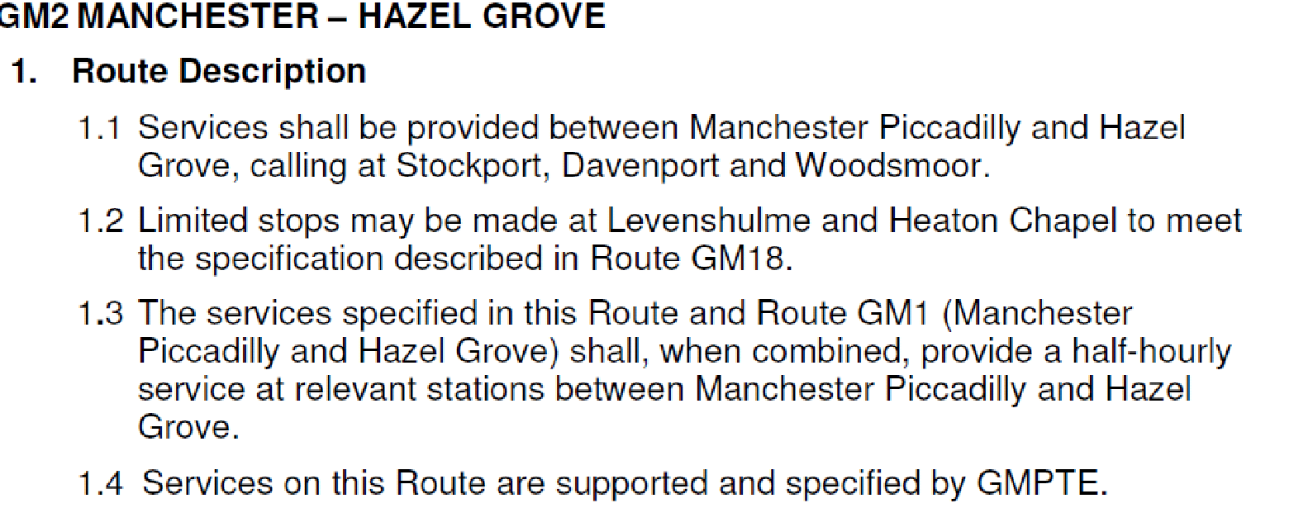
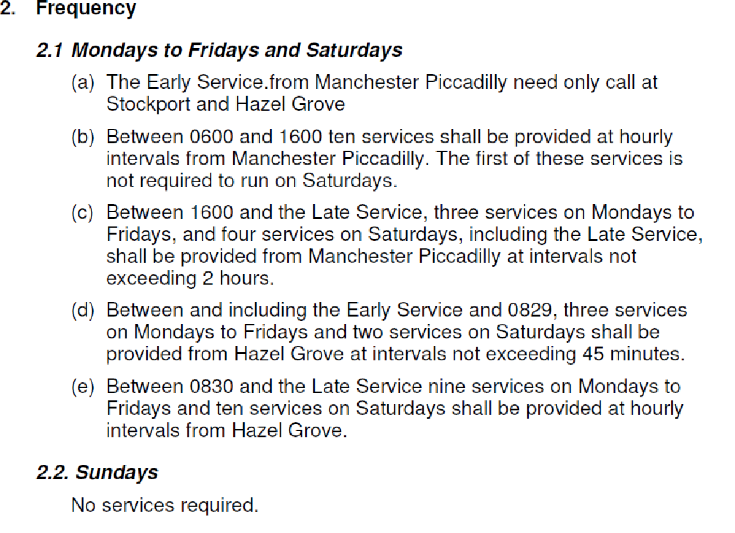

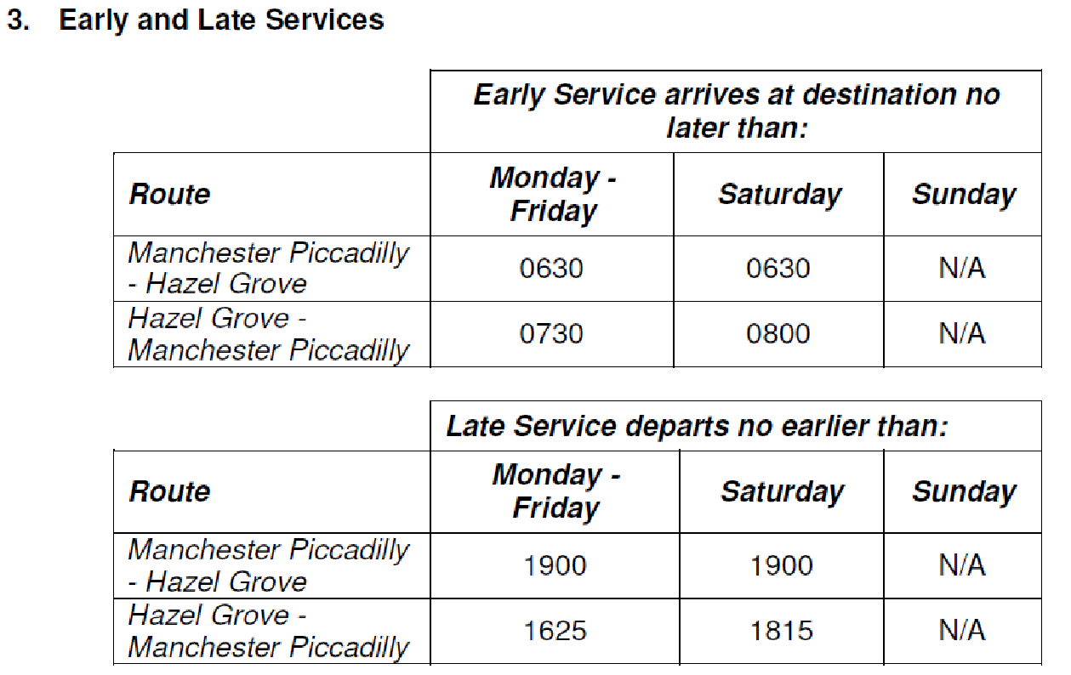

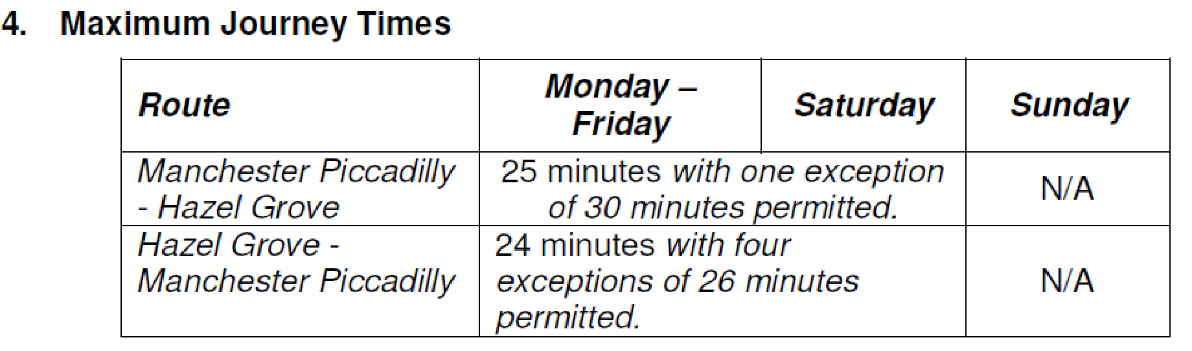

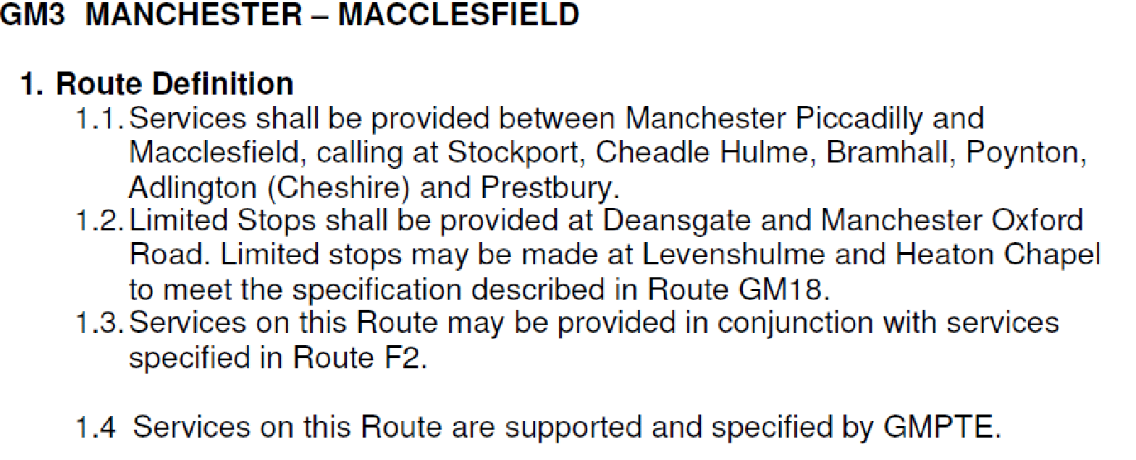
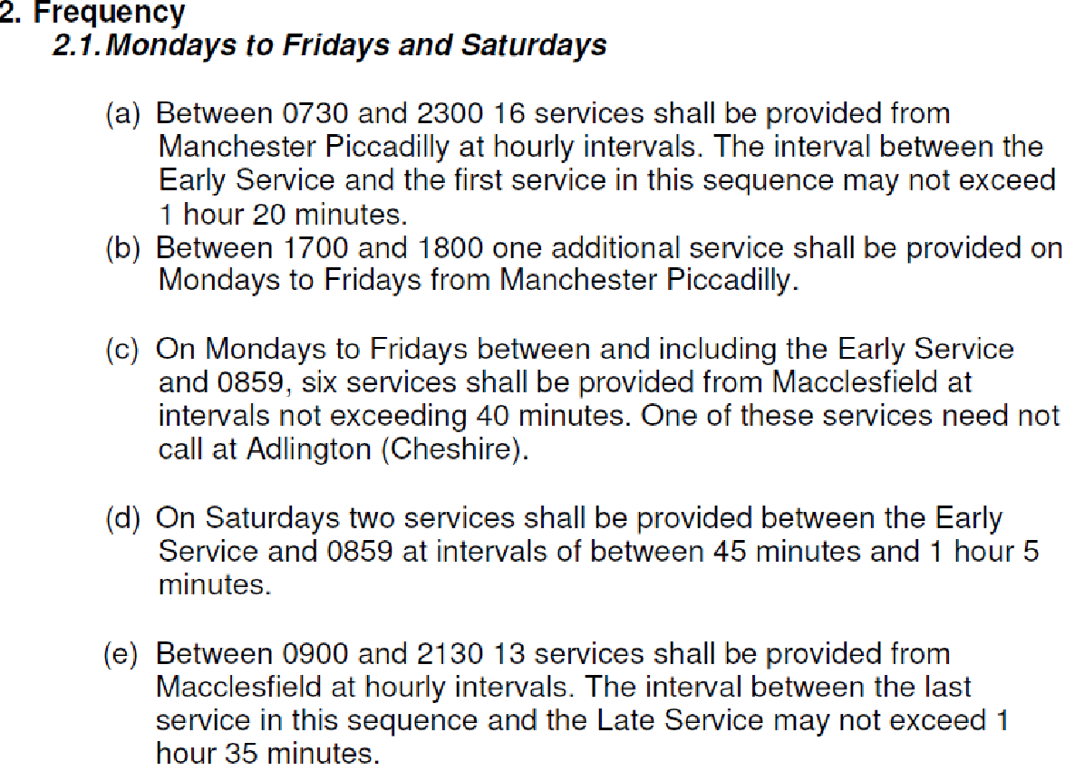

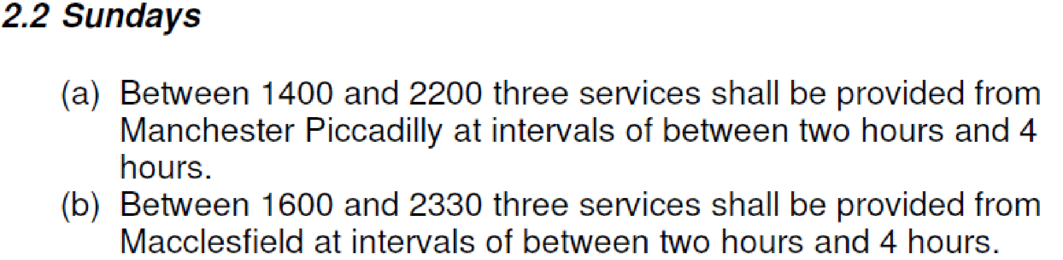

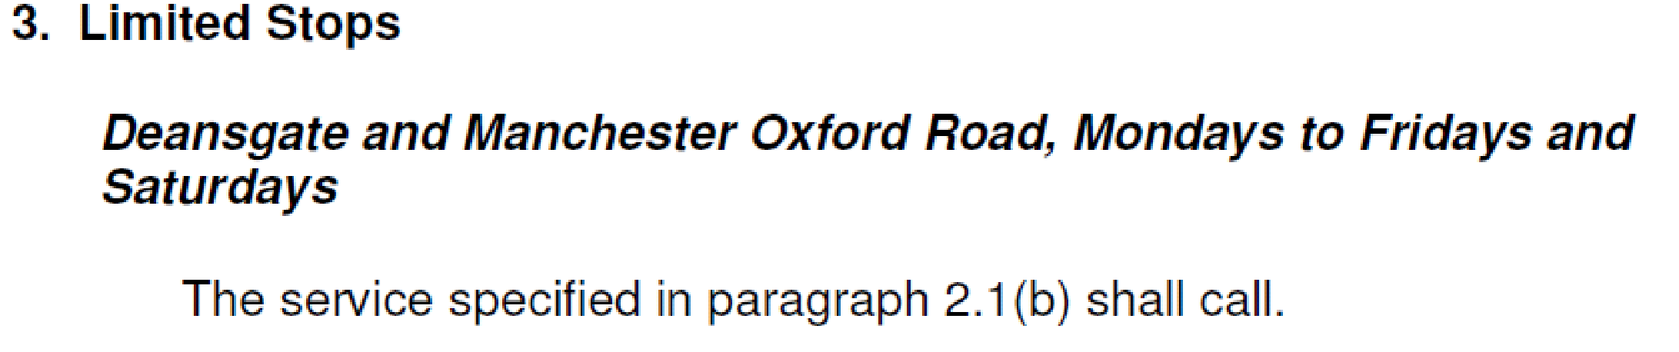

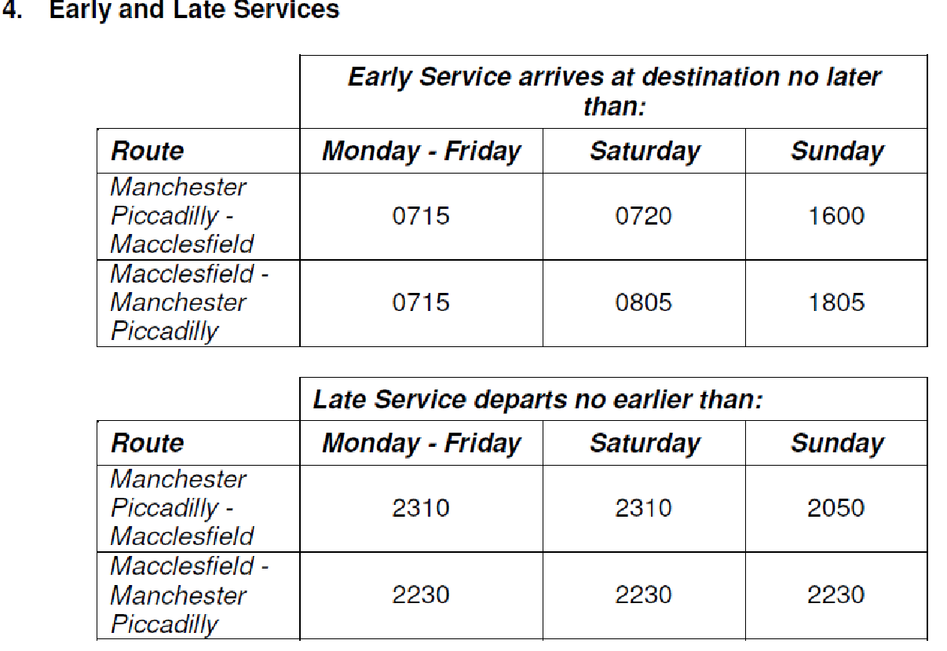
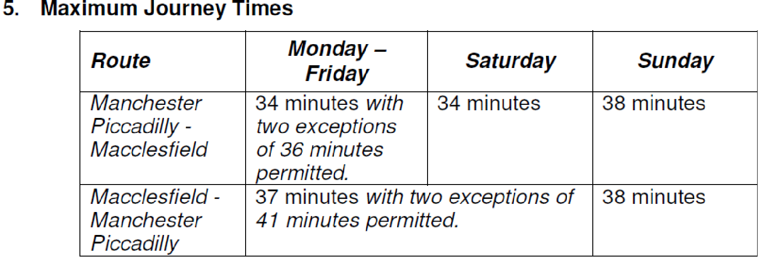

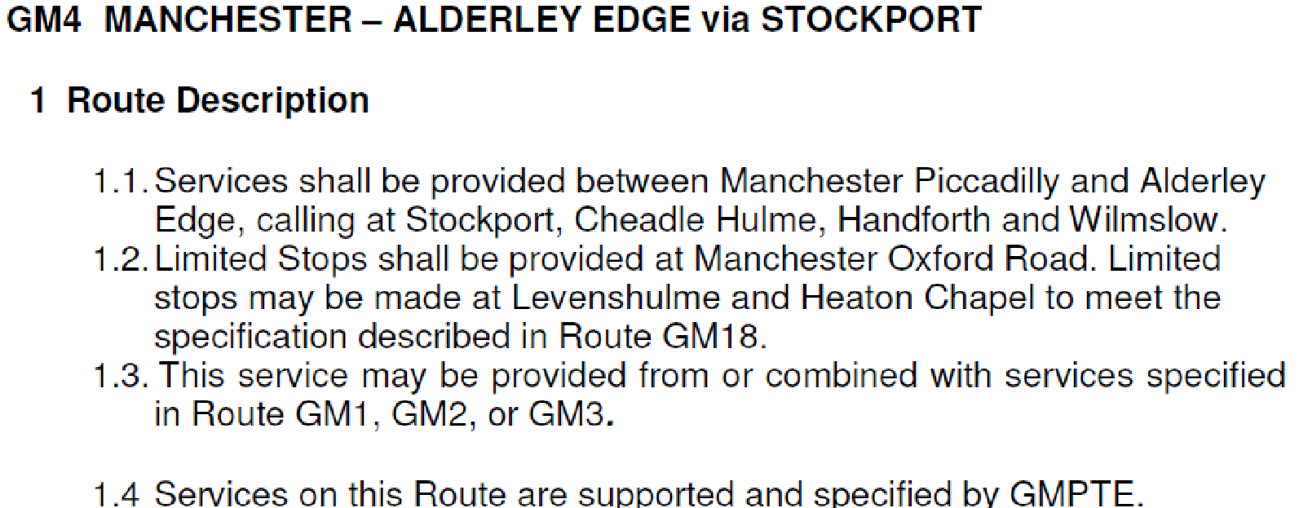

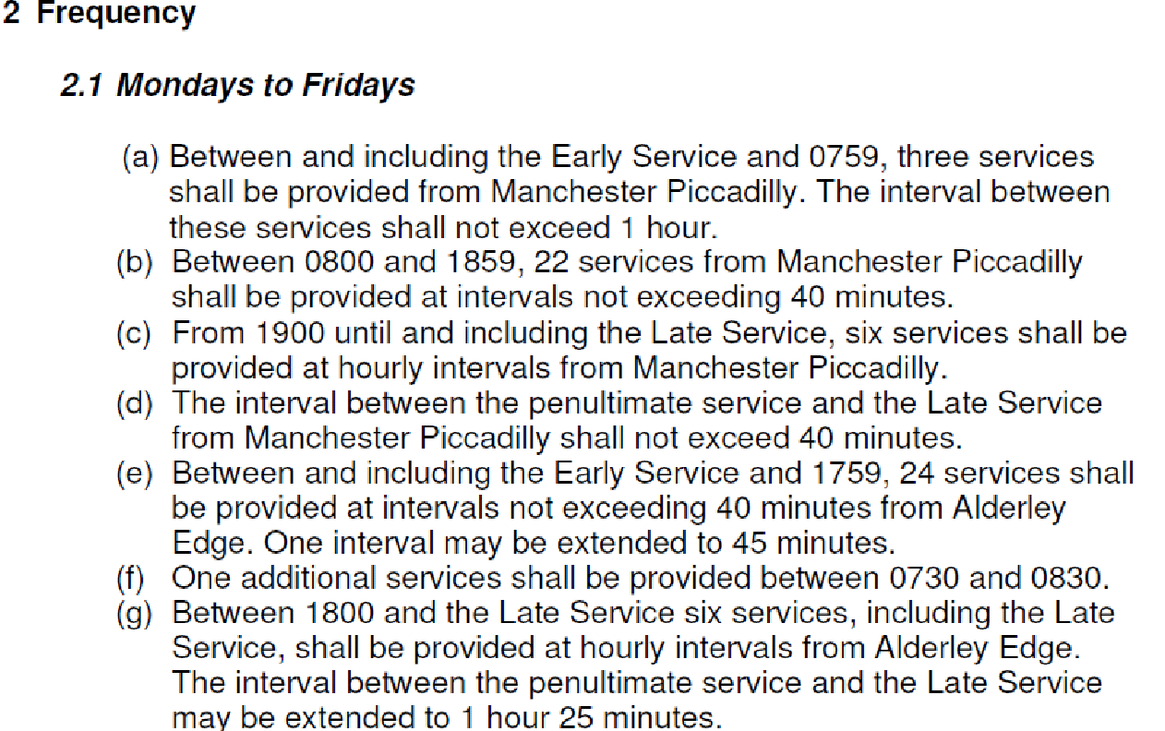

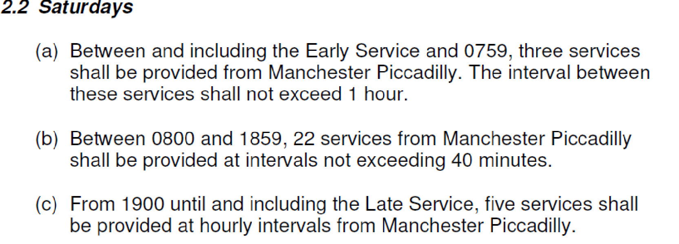

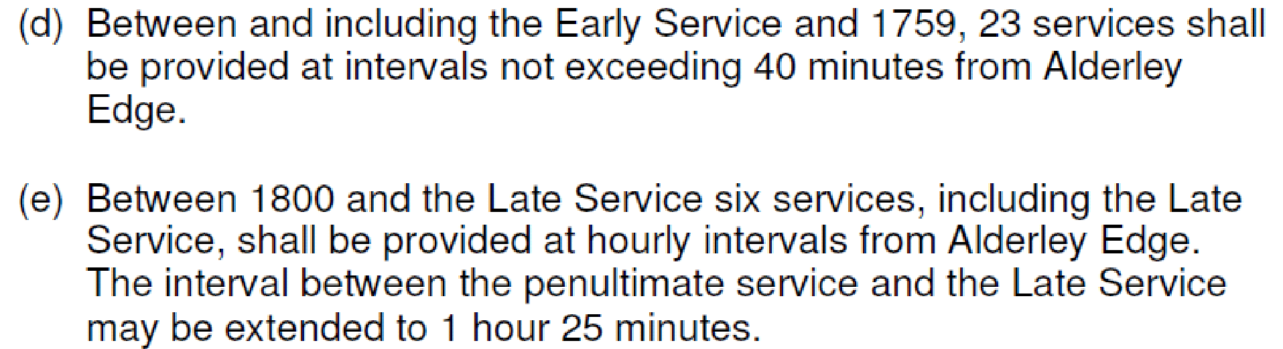

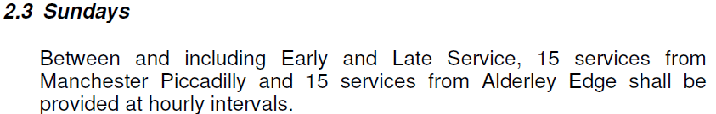

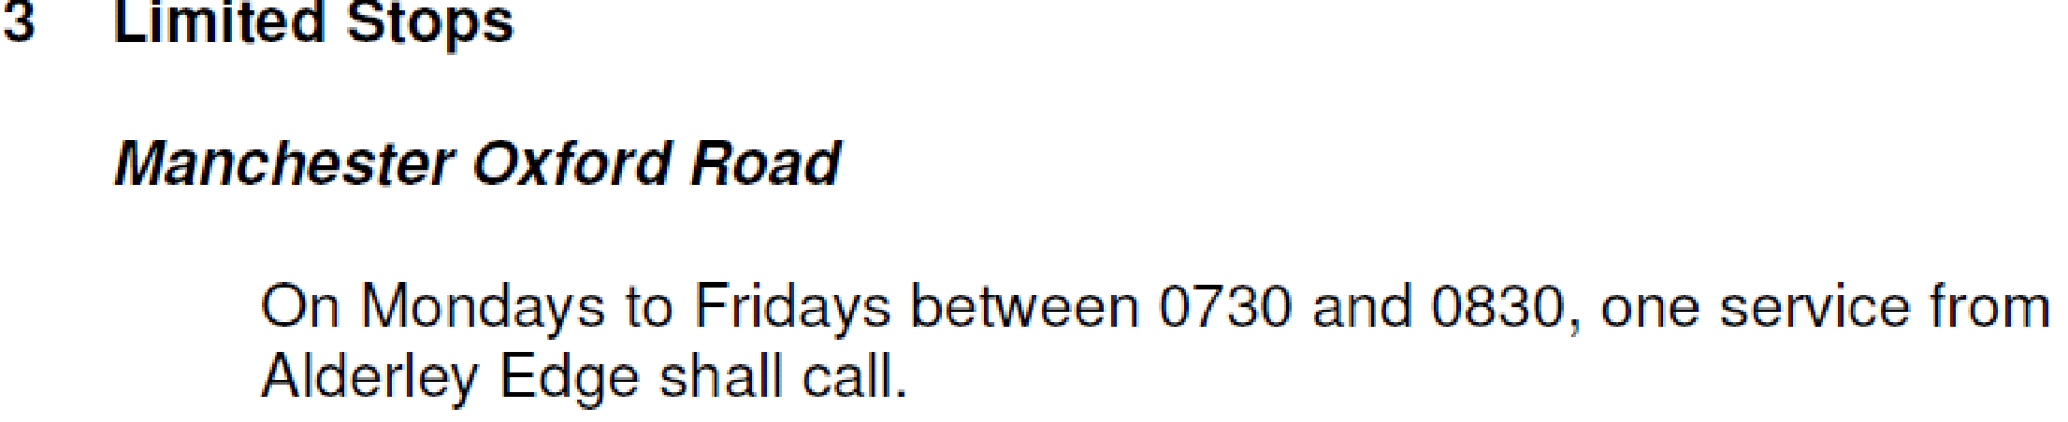
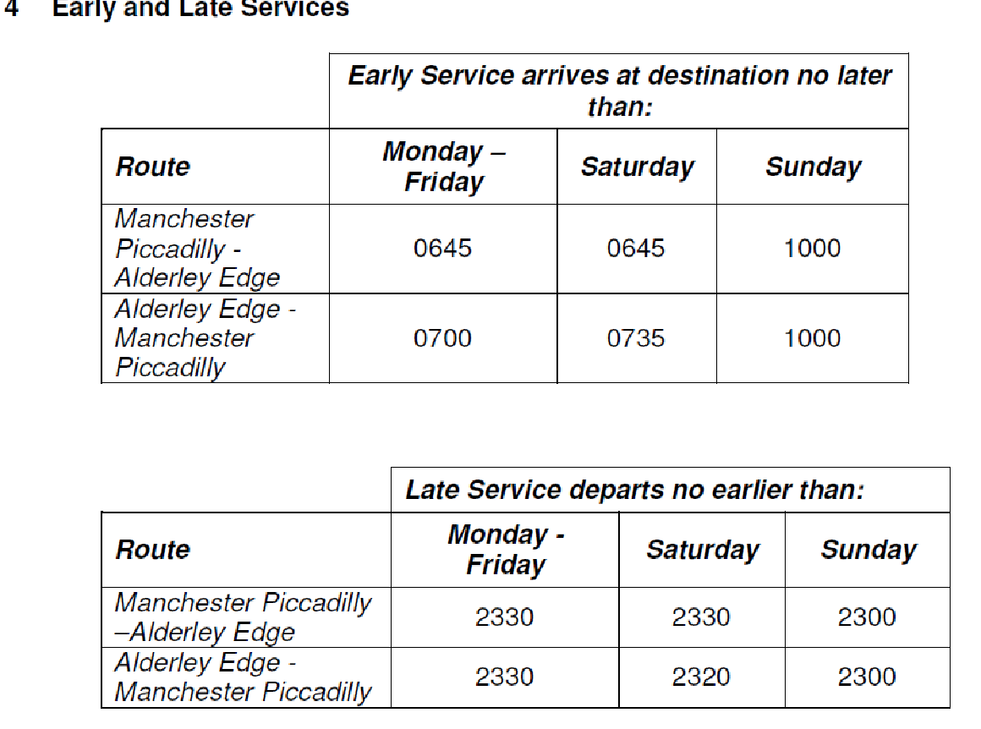
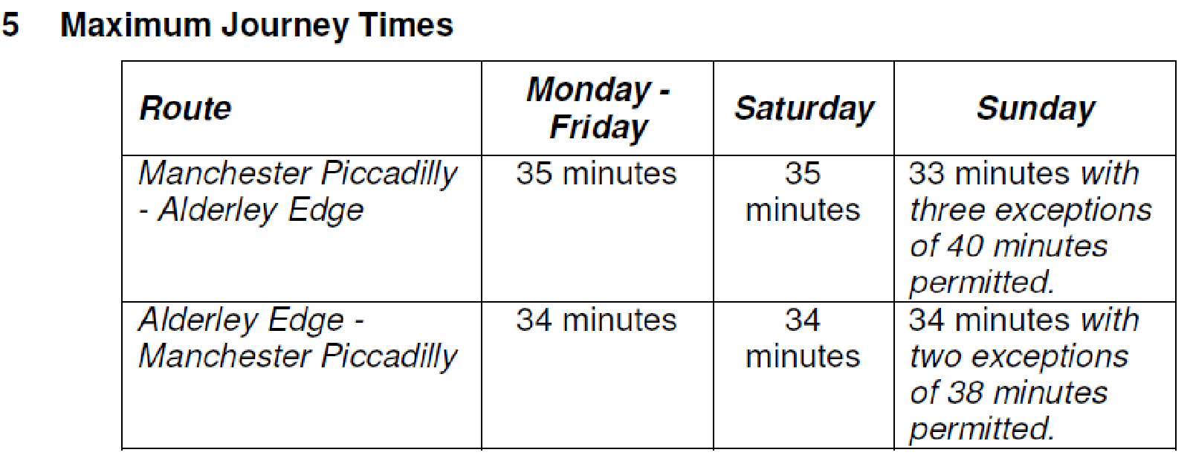

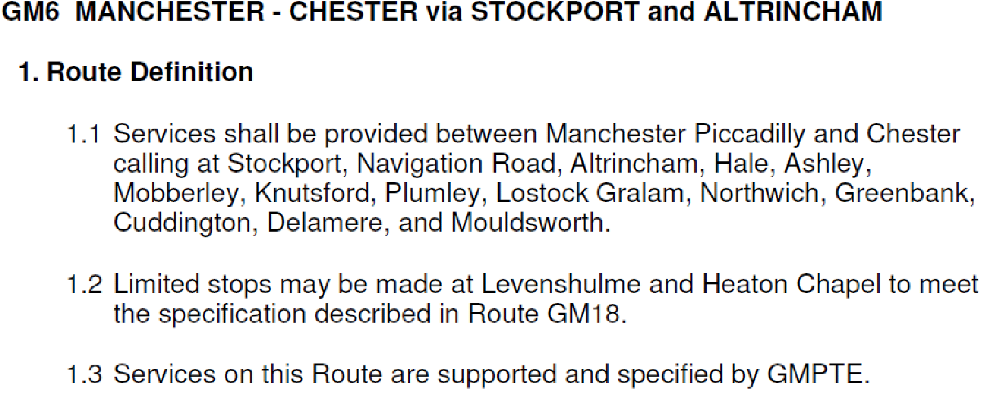
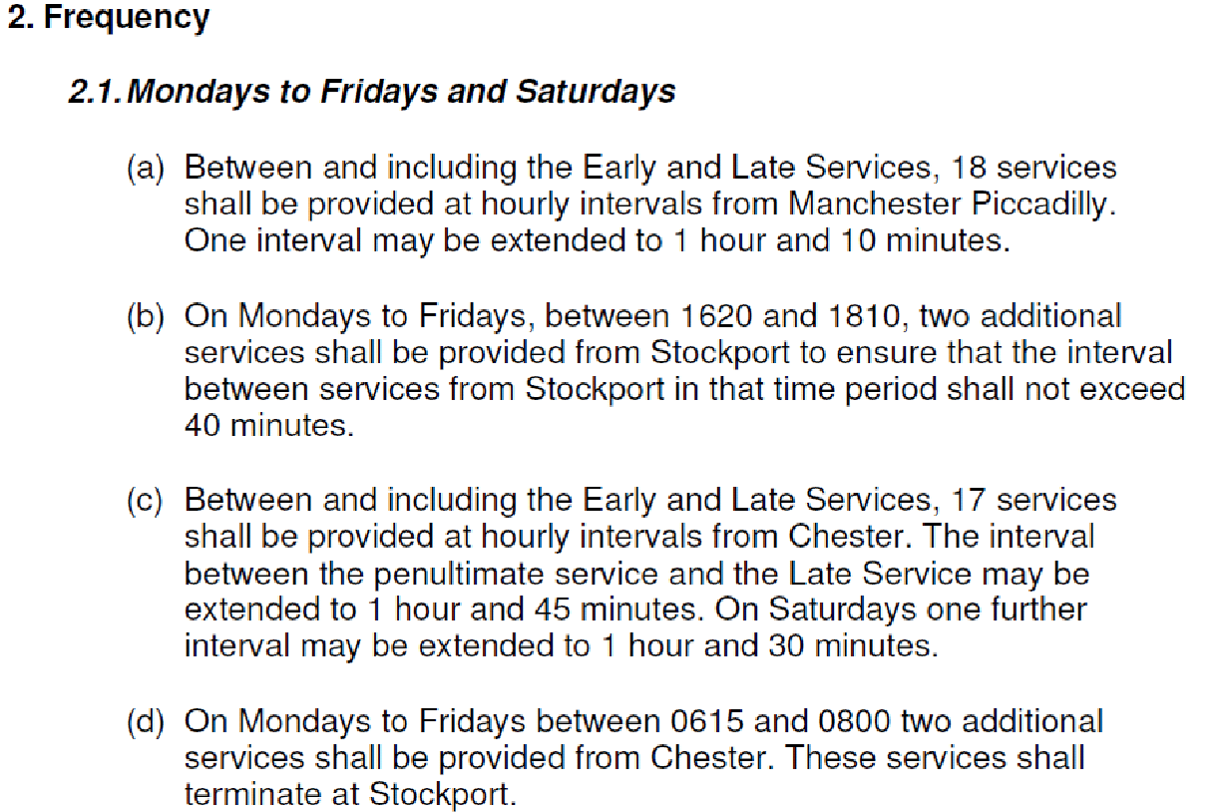

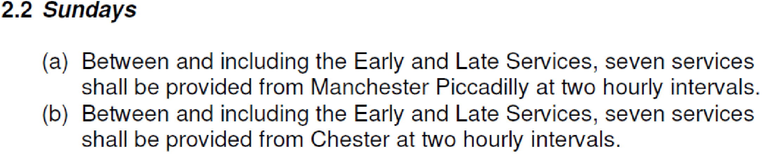

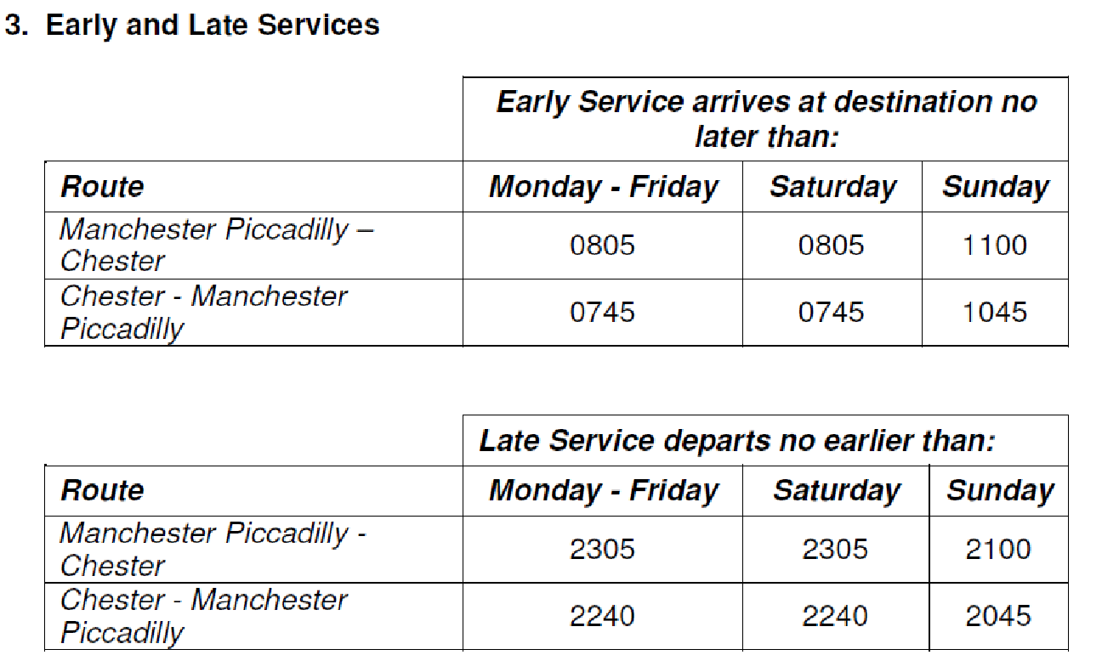

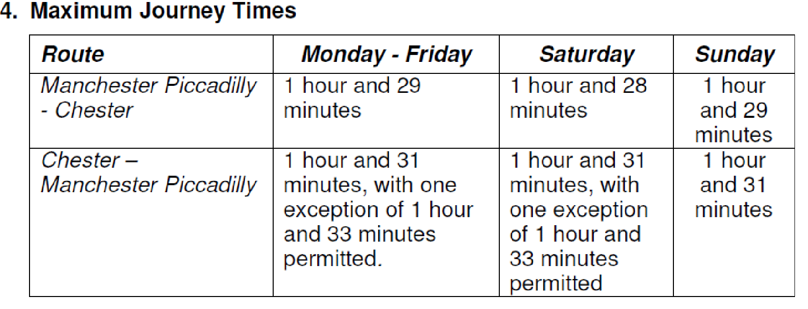

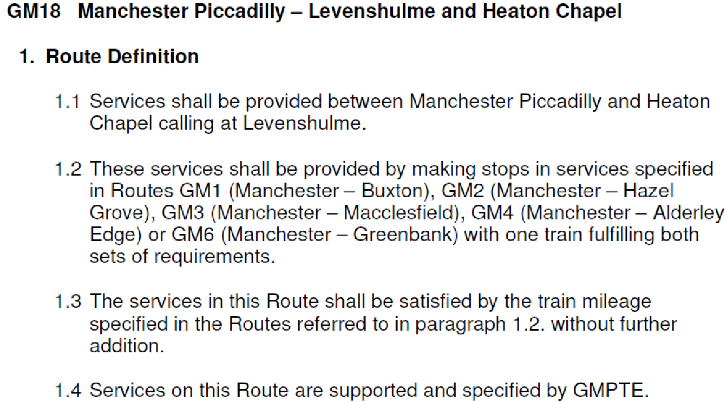
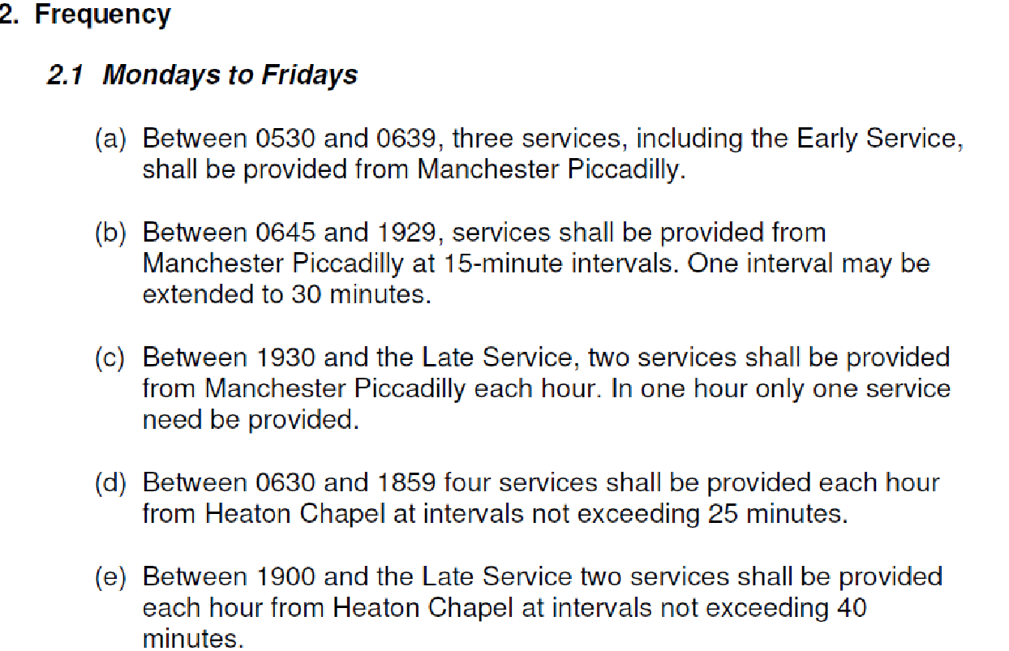

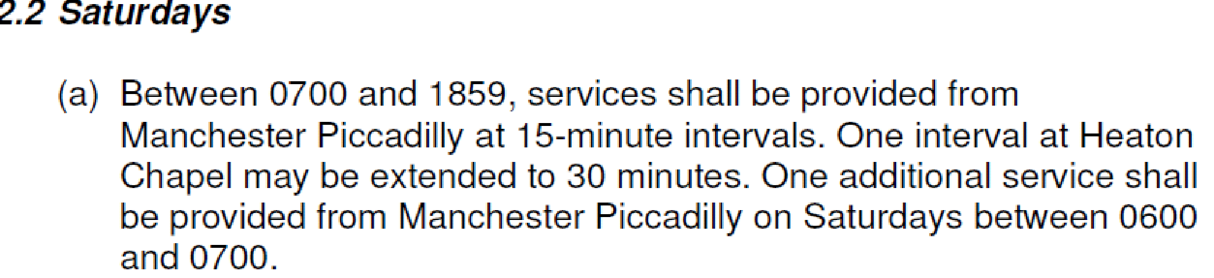

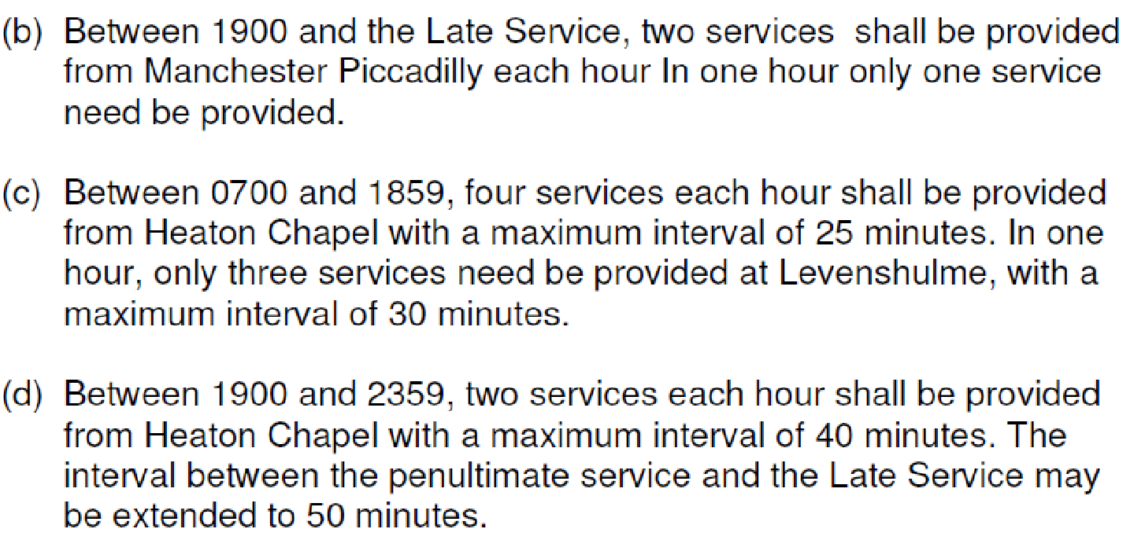

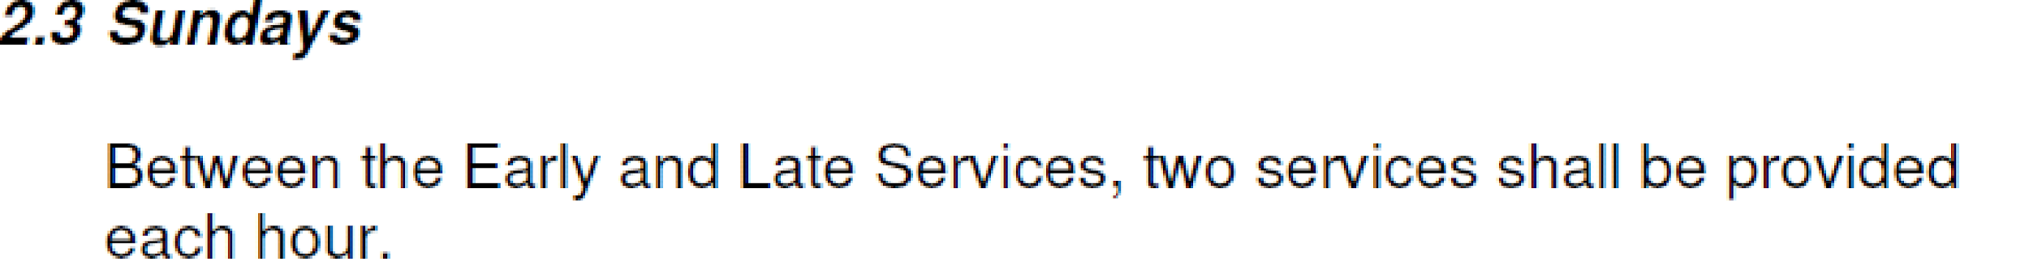

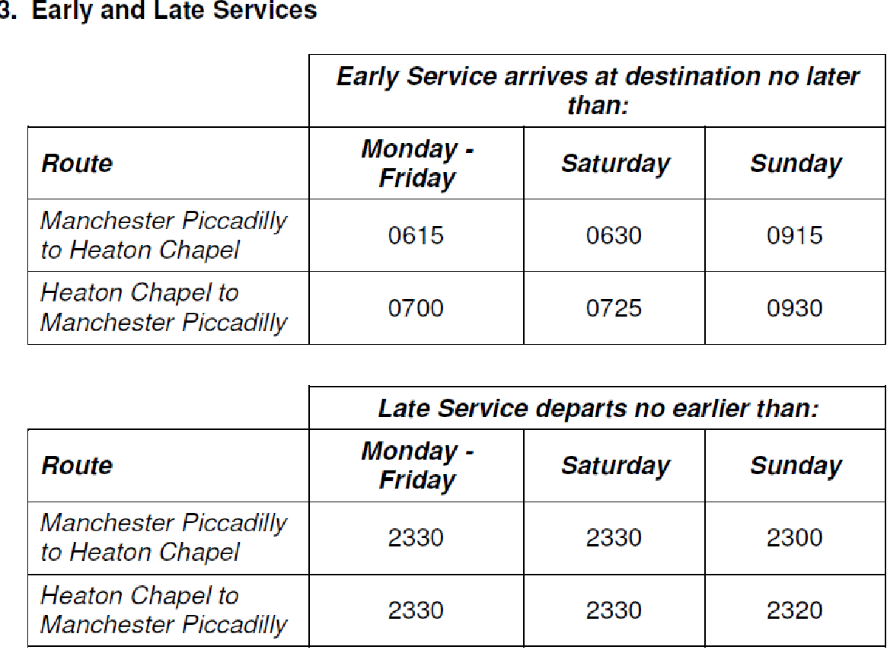

Annex C

IMPLICATIONS OF BUS REPLACEMENT SERVICES ON
BRITISH TRANSPORT POLICE – MANCHESTER

I have been asked to outline the policing considerations with regard to the proposed plans to commence the engineering block between Piccadilly and Stockport at 2100 hours on the three Saturdays in June/July 2011.

The demand profile for the policing services provided by the British Transport Police invariably peaks on Friday and Saturday evenings, and this is directly linked to weekend revellers and the excessive consumption of alcohol. A typical Saturday evening for Manchester BTP is a challenging one. The demands on the organisation coupled with a large geographical area covering four Home Office policing areas means at times Manchester resources are understandably stretched.

Anti-social behaviour and public order related offences mainly fuelled by drink are the main demands on our service and arrests arising from this behaviour mean that resources can be removed from frontline duties for a considerable time whilst processing the prisoners. The Chief Inspector’s instructions to supervisors on duty during Saturday evenings is to have a policing presence on identified late night troublesome trains to provide reassurance to staff and travelling members of public.

Past experience shows that bus replacement services do not move passengers as effectively as a train service and leads to groups of passengers congregating on the station and station approach. Previous late evening bus replacement services/operations at Piccadilly have involved BTP officers being called to numerous disputes concerning rail staff and bus drivers with problematic rowdy/drunk passengers.

Despite publishing information through various media sources about bus replacement services my experience is that either through the effects of excessive alcohol, or ignorance of the facts, the majority of passengers turning up at Piccadilly station still expect to be conveyed by train. Frustrations then arise due to the inconvenience to their journeys or a perceived/real lack of information, which places a large demand on police, who are targeted along with rail staff and bus operatives.

In relation to the specific proposals I add the following;

While the time of year, ie summer, means that police resources will not be abstracted to deal with football policing, the chance of good weather means that people are encouraged to stay out later and potentially consume more alcohol. Police resources are also more likely to be depleted by seasonal annual leave.

While the provision of information, queuing, loading and despatch in relation to the bus operation is clearly a matter for the rail and bus companies to organise ( with appropriate extra resourcing ) there will be clear expectations for a dedicated police presence to support the operation, especially in view of the expected demeanour of the majority of passengers.

With around 50 bus movements each Saturday evening between Manchester and Stockport, dedicated resources would need to be in place at Piccadilly and Stockport. These would be in addition to the normal Saturday complement of officers, some of whom will be required to be deployed elsewhere throughout the Greater Manchester area to service other policing commitments.

Having now been fully briefed of the nature and scale of the proposed operation it is evident that BTP would require dedicated resources at Piccadilly and Stockport stations and a mobile resource between the two. These would be over and above the normal complement of officers in order to deal as effectively as possible with the anticipated public order issues arising from this operation, and if this were to be the case, then additional funding would be sought.

Peter Holden
Area Commander

Annex D

Northern Rail passenger counts for Stockport / Manchester Piccadilly services – Sunday pm.

Train |  | Max Count ex Piccadilly | Max Count ex Stockport
2H92FB | 1252 Piccadilly - Buxton | 49 | 59
2K26FC | 1304 Piccadilly - Crewe | NO COUNT DATA AVAILABLE
2D44FB | 1205 Southport - Chester | 77 | 73
2H94FB | 1352 Piccadilly - Buxton | 79 | 65
2K20FD | 1404 Piccadilly - Alderley Edge | 44 | 43
2H06FB | 1301 Southport - Stockport | 8
2K10EN | 1441 Piccadilly - Stoke | NO COUNT DATA AVAILABLE
2H96FB | 1452 Piccadilly - Buxton | 118 | 102
2K24FD | 1504 Piccadilly - Crewe | 91 | 90
2D48FB | 1405 Southport - Chester | 87 | 95
 | Total | 553 | 527
Train |  | Max Count arr Stockport | Max Count arr Piccadilly
2H09FB | 1227 Buxton - Piccadilly | 40 | 64
2F81FB | 1322 Stockport - Southport |  | 37
2H29FC | 1256 Crewe - Piccadilly | 89 | 105
2H01FC | 1327 Buxton - Piccadilly | 89 | 112
2F83FB | 1307 Chester - Southport | 79 | 61
2H23FD | 1419 Alderley Edge - Piccadilly | 44 | 63
2H03FC | 1427 Buxton - Piccadilly | 103 | 116
2F85FB | 1522 Stockport - Southport |  | 43
2H27FD | 1456 Crewe - Piccadilly | 34 | 73
 | Total | 478 | 674

