SOLE SUBMISSION TO TIMETABLING PANEL
By
WEST COAST TRAINS LIMITED

TTP Reference 441 (Late Notification Decision Documentation LNW12-CE-12)

13th October 2011

1. DETAILS OF PARTIES
  - The names and addresses of the parties to the reference are as follows:-
    - West Coast Trains Ltd. (Company number 3007940) whose Registered Office is at The school house, 50 brook green, London W6 7RR (“WCTL” - "the Claimant"); and
    - WCTL contact details are Robert Hodgkinson, Commercial Operations Manager, North Wing Offices, Euston Station, London, NW1 2HS
    - Network Rail contact details are Joe Warr, Lead Access Planner LNW, Engineering Access Planning, 500 Station House, Elder Gate, Milton Keynes Central MK9 1BB

  - Third parties that may be affected by the Panel finding in any of the ways sought and determined under Section 8 are as follows:
    - Arriva Trains Wales
    - DB Schenker
    - Direct Rail Services
    - Freightliner Group
    - GBRf
    - Northern Rail

- THE PARTYS’ RIGHT TO BRING THIS REFERENCE
  - These matters are referred to the Timetabling Panel ("the TTP") for determination in accordance with Conditions D3.4.5 and D5.1.of the Network Code (as applicable to the July 2011 Re-Issue) and Section 3.5.4. of the National Rules of the Plan (the ‘ROTP’. – Annexes “K” & “L” refer.

- CONTENTS OF REFERENCE
3.1 The Party have together produced this joint reference and it includes:-
    - The subject matter of the dispute in Section 4;
    - A summary of the issues in dispute in Section 5;
    - A detailed explanation of those issues in dispute prepared by the claimant in Section 6 (with a section outlining the dispute issues in association with Decision Criteria);
    - Any further issues raised by the respondent in Section 7;
    - In Section 8, the decisions of principle sought from the Panel in respect of
      - legal entitlement and ii) remedies;
    - Appendices and other supporting material.

- SUBJECT MATTER OF DISPUTE
  - The principle issue at the centre of this West Coast Trains Ltd (WCTL) sole submission, is the affect of a late notice section 7 engineering possession item, proposed by Network Rail (London North Western – LNW) on 25th August 2011 for a weekend closure between Crewe and Warrington in February 2012; this being confirmed later, through decision documentation sent out on the 9th September 2011 – (Annexes A & B refer).
  - This possession was originally planned to take place in engineering week 9 of 2011 (Saturday 28th and Sunday 29th May) but was cancelled at short notice, due to the potential of air traffic disruption (alongside many other works, including some cancelled due to a lack of resources), resultant from an Icelandic volcanic ash cloud event. The resultant impact of re-dating this possession from a Bank Holiday to a normal weekend will ultimately see yet more detrimental affect on WCTL business & operations, specifically weekend Anglo-Scottish operations, this being out-with the lack of confidence we have, regarding the huge amount of work still outstanding north of Crewe, over the next few years, (including the potential for long blockade(s)).
  - WCTL does not consider that Network Rail, in consideration of its proposals, has taken due cognisance of industry accepted principles associated with its ‘7–Day Railway’ vision. As a consequence, WCTL will be unable to operate its Firm Contractual Rights (FCR), such rights being those principal Anglo-Scottish train services (service groups HF06 and HF08) as contained within WCTL Track Access Agreement, Schedule 5.

  - WCTL has attempted to work with Network Rail and other operators to reach an acceptable solution in re-dating this work, but to no avail. WCTL has received no viable reasoning (other than a bland ‘lack of resources’), and consequently has no confidence in, Network Rail’s requirement to undertake such works at these particular times, and whether, indeed, they do actually have sufficiently planned and/or available resources in place with which to carry out such work.
4.5 Such lack of confidence relates to the fact that it has now taken Network Rail 4 months to re-plan such work, thus importing an element of risk however small, (taking cognisance of those timescales involved) onto WCTL ability to meet its Informed Traveller timescales. In outline, WCTL considers that the onus is on Network Rail to prove both, how & why they have arrived at such a late proposal, whilst having due regard to Decision Criteria D4.6.1{a} - (Network Code D4.6 – including the newly proposed part D4.6.1 of the Decision Criteria issued in October 2010 - Annexes “D” & “P” refer).
- SUMMARY OF DISPUTE
5.1 WCTL is responsible for running a Very High Frequency timetable (VHF) along the whole of the West Coast Main Line (WCML) from London Euston to major conurbations throughout the Home Counties, West Midlands, Liverpool, Manchester & Scotland as well as serving areas in North Wales and the Lake District. The VHF timetable is the output from a culmination of 10 years of Upgrade work and £8.9bn of expenditure, and represented, at its introduction, a 35% uplift in the number of services provided. Part of this uplift in service provision, has been the introduction of hourly Anglo-Scottish services between London & the West Midlands and Preston & Carlisle, Glasgow & Edinburgh – See Map in Annex “R”.
  - As noted above, WCTL timetable obligations are enshrined both within its Passenger Service Level Commitments (Version 4 / Dec 2008) contained in WCTL Franchise Agreement with the Department for Transport (DfT); and within those Rights specified under Schedule 5 of its Track Access Contract (TAC – dated 12th Dec 2008). (Extracts of these, pertinent to those services affected, are shown for reference in Annexes “C” and “O”).
  - The fundamental basis behind the Rail Industry’s WCML upgrade was to vastly improve journey times, alongside improved access opportunities particularly for weekend travel in conjunction with its 7-Day Railway Vision (including Joint Network Availability Plans which detail jointly agreed disruption parameters – Annex “N” refers; supplemented alongside other documentation, namely Network Rail’s Network Statement 2012, 2007 Business Plan and Efficient Engineering Access ‘EEA’ – Annex ‘E’ refers to all.

5.4 However, in order to reach a position which enabled Network Rail additional qualitative access opportunity to undertake key works, Bank Holiday weekend periods were seen as the only real opportunity within which to carry out such major work. Such advantageous prospects, (already supplemented by historically acceptable standard weekend periods - i.e. during Spring & early Summer and Autumn – see Para 5.7 below for further details), which although affecting an ever increasing number of passengers (travelling during Bank Holiday periods), are nonetheless, the only viable alternative to undertaking such work that would otherwise require a number of ‘additional’ standard weekend engineering closures, like the one proposed here-in.
  - Such an approach to undertaking engineering work, has, since the upgrade was completed, allowed WCTL to grow its weekend passenger market significantly (see Para 6.11 for more details), in the full knowledge that its customer’s travel arrangements, by exception, will only be affected during Bank Holiday weekends when some train services are either diverted and/or replaced by road transport.
  - With Network Rail now re-proposing this additional possession between Weaver Jn and Warrington South, between the hours of 1330 Saturday and 1500 Sunday, on one weekend in Period C (Week 46 – 11th / 12th February 2012, resultant from the cancelling of work over the Spring Bank Holiday Weekend in week 9 – 28th / 29th May 2011), the consequential effect is that WCTL is no longer able to operate services over the route between Crewe and Preston, thus affecting Anglo-Scottish traffic flows to/from Glasgow and Edinburgh.
5.7 Therefore, the affect of this weekend work on Anglo-Scottish train services is additional to the significant number of standard weekend opportunities that are already planned for 2012 – see below for primary examples:
- Lancaster & Carnforth (2105 -1115) Periods B & C – Annex ‘F’ refers ~
necessitating the retiming of some early & late services.
- Gretna Jn to Lockerbie (1945 Sat to 1215 Sun) Period “D” in parallel with North of Preston works in the Penrith area – Annex “G” part refers
necessitating the retiming of an increased number of early & late services, with limited diversions via the S&C.
- Weaver Jn to Golborne (1335 Sat to 1500 Sun) Period “H” – Annex “H” part refers
necessitating the diversion of services via Manchester.

5.7 Cont.....
d) as well as significant work during Easter, May Day and Spring Bank Holidays, alongside other deferred works primarily those at Standish towards the end of the year. – Annex “H” part refers necessitating the diversion of services either via Manchester or S&C.
......thus amounting to already an approximate 33¹ weekends of varying Anglo-Scottish train service disruption, equating to 684 hours of disruption.
5.8 On this basis, WCTL has no other alternative but to decline such a proposal due to the amount of significant disruption already planned over the same route for the 2012 timetable year (even more relevant, now that another possession request for a three day closure during Spring Bank Holiday next year, has recently been discussed between Crewe and Warrington). Such decision complemented by other pertinent issues namely, non visibility of Network Rail’s motives for leaving the decision to take such weekend so late (i.e. its business case, as set out in its Engineering Access Statement – “Guidelines for Granting Possessions” – Annex ‘I’ refers), and the lack of clarity over resources and optimisation of other possession opportunities.
  - WCTL therefore now takes the following opportunity to provide a full synopsis regarding those issues outlined above, with a detailed explanation (and supporting evidence / annexes) in Section 6 below, in parallel with Network Rail’s counter-responses.

- EXPLANATION OF THE ISSUES IN DISPUTE WITH RESPONSE
  - WCTL fully recognises that these works need to be undertaken at some juncture and has been consistently working with Network Rail to find a suitable opportunity to accommodate the re-planning of such work – discussions took place in June & July earlier this year. WCTL considers that such work, which was originally intended to be undertaken during a Bank Holiday period, still requires a likewise opportunity and is the most optimal and sensible solution, rather than the potential for an additional <third¹> weekend, as is hereby proposed; thereby adding to those already historically planned and agreed weekend works taking place, (Para 5.7 refers).

¹ For reference, this number may increase by more than 3 occasions, as Network Rail has also proposed additional disruption in the Oxenholme North area, in weeks 41 & 42, work originally deferred from week 9 and the subject of a separate, earlier hearing, under ref TTP439) and in the Standish area as noted under 5.7d above..
  - WCTL originally asked of Network Rail (like other late notice possession requests also received) that they reconsider doing the work on one or more of the days after the Christmas shutdown, such as the 27th or 28th December 2011 or over New Year when there is not a great deal of work currently planned (see Annex ‘J’ for a map of Christmas Period WCML activity). As highlighted above, such timeframe is during a period when leisure customers tend to expect such disruption, and therefore we would anticipate them, based on previous experience, to make alternative travel arrangements, in this case either later in the week or using a combination of alternative road & rail modes.
  - WCTL, like all Train Operators (TOC’s) has been acutely aware that actually, the ideal time for network closures are over the Christmas period ( ie, 25th & 26th December) when effectively (by exception) no trains operate over the route with negligible peripheral disruption. However, we have been previously made aware that significant major work is already planned to be undertaken during these dates around the Network and on the WCML, and therefore spare resources would not be available for undertaking any further work.
6.4 Obviously taking cognisance of current informed traveller timescales in juxtaposition with the dating of this hearing, to carry out such work at Christmas (or New Year) now, would import a significant risk to the business and onto passengers. We have (and continue to do so), suggest to Network Rail that they investigate undertaking this work in future alternative 2012 Bank Holidays, such as Good Friday and/or Easter Saturday, when the route on Easter Sunday is already blocked through to Scotland, as well as possibly May Day & Spring Bank subject to other works taking place (Annex “J” also refer).
6.5 We are also conscious that to enable this work in week 46 to be undertaken, Network Rail are likely to have to cancel possession(s) elsewhere, in order to release sufficient resources necessary to undertake the work. Network Rail have not visibly expanded on where such resources will come from for this Warrington area work and which ‘other’ work might therefore be affected by the release of such resources; (although we are led to believe, both on the basis of being invited to an applicable meeting and through the possible connection associated with an e-mail {as attached in Annex “Q”}, that works in the Manchester Victoria and Pendleton areas played a part in this). This offers another example of late notifications for possessions where access appears to take precedence before resources & optimisation of work is potentially known.
6.6 Correspondingly, the business case that should underpin one or more of those reasons where late possession requests are to be considered, (inc. the setting out of those reasons for applying appropriate Decision Criteria where necessary), has never been presented to us or other TOC’s (Part 3.2.2 of the EAS - Annex “I” and 3.3.2 of the National Panning Rules – Annex “L” refer).
  - For complete clarity it is important at this juncture, to also emphasise that this Late Decision Notification was advised to WCTL on Friday 9th September (Annex ‘B’ refers), and despite just being within those timescales (T-22) applicable in which to make a revised timetable bid within Informed Traveller timescales, (we are contractually obliged to submit our timetable bid for week 46 by Friday 7th October), there are no guarantees’ particularly at this late stage, that pathways would be available over those corresponding diversionary routes (i.e. Manchester & Chorley).
6.8 Whilst we are obliged to submit bids that are revised to take account of these engineering works in accordance with this Week 46 possession proposal, (subject to any later determination from this hearing), it is perhaps useful to highlight that the affect of this proposal on our business and customers would, as a prime example relating to rolling stock constraints, mean we will have to re-diagram all applicable Anglo-Scottish services (with resultant knock-on affects to other traffic flows), in order to release diesel units for diversions via Manchester as well as starting / terminating services at Crewe / Warrington and/or Wigan. This is aside from any consequential resourcing & diagramming necessities required alongside inherent marketing / reservation system requirements that tend to be, the standard frustrating prerequisites associated with STP planning.
6.9 Furthermore, based upon their clarification outlined under reference TTP439, Network Rail do presuppose that at this time of year there is a reduction in the numbers of Passengers being carried by Operators particularly at weekends; although we can only presume in this specific case that Network Rail have made a similar assumption as part of their decision making process, principally on the basis that this could be the least disruptive period overall, to the industry.
6.10 Nevertheless, as we have highlighted previously, there is now an established recognition throughout the Industry that weekend travel opportunities are just as important as weekdays irrespective of ‘time of year’. Network Rail has been funded and is thus committed to achieving a regulated network availability output improvement, during Control Period 4 (CP4), of 37% for Passenger services, such requirement seeing them introducing a Vision where the principles of a Seven Day Railway [7DR] over a ‘Top 20’ set of routes, (which includes the whole of the WCML) has now been introduced - again Annexes ‘E’ & ‘N’ refer).
6.11 To put all this into some context WCTL has seen its rail / air market share of Anglo-Scottish flows rise between 2004 and 2010 to an average 29% on West Midland flows and 21% on London flows. In passenger load terms, the Anglo-Scottish flows have seen loadings rise by over 55%. With the WCML being Britain’s busiest railway, and with WCTL passenger numbers rising from 13.6m to 28.2m actual journeys in the last year, it is also experiencing increasing and at times unprecedented levels of overcrowding.
6.12 Whilst we are only able to provide the Chairman with detailed Anglo-Scottish passenger loadings data for February this year compared with other dates of the year, (primarily redacted for the Chairman’s use only due to confidentiality reasons associated with the ongoing franchise bid); based upon a reasonable request from the Chairman under the auspices of TTP439 for some form of comparative data for the Panel’s benefit, we will also provide information pertaining to a view of the proportionality of loadings in comparison with other times of the year.
6.13 overview of comparison to be given here – STILL AWAITING INFORMATION – TO BE PROVIDED IN THE FORM OF A LATER SUPPLEMENT
6.14 Nonetheless the principle here is that WCTL is operating a service all year round and it should not, taking into consideration its rights as well as its ongoing quest to grow Anglo-Scottish traffic along the WCML, be prevented from providing efficient services of economic value, purely on the basis of the time of year.
6.15 In view of previous approaches to written submissions in conjunction with Network Rail taking due regard of Decision Criteria, alongside the view of the Chairman in the determination of TTP376/377, in that Decision Criteria should be applied reasonably (i.e. with appropriate weight), taking cognisance of those circumstances involved (Annex “P” refers), and consequently the recent change to Part D4.6.1 – Part 8; we consider it of value to the Panel to provide clarity regarding those decisions made by Network Rail in relation to the context of their application of current Decision Criteria, alongside WCTL’s counter considerations; such views are shown below:
Decision Criterion | Evidence | Weighting | WCTL Opinion
(a) sharing the capacity, and securing the development, of the Network for the carriage of passengers and goods in the most efficient and economical manner in the interests of all users of railway services having regard, in particular, to safety, the effect on the environment of the provision of railway services and the proper maintenance, improvement and enlargement of the Network; |  |  | The most efficient and economical manner in which to undertake these original Bank Holiday possessions, now re-proposed in standard weekends, is to re-plan the work into other future Bank Holiday periods when the WCML is already blocked, rather than cause additional further disruption on top of the number of standard weekend opportunities already planned ~ Paras 6.1 to 6.14 throughout refer.
(b) seeking consistency with any current Route Utilisation Strategy which is either (i) published by the Strategic Rail Authority or the Department for Transport before 31 May 2006, or (ii) established by Network Rail in accordance with its Network Licence | No evidence |  | N/A
(c) enabling a Timetable Participant to comply with any contract to which it is party (including any contracts with their customers and, in the case of a Timetable Participant who is a franchisee or franchise operator, including the franchise agreement to which it is a party), in each case to the extent that Network Rail is aware or has been informed of such contracts |  |  | i) WCTL will be unable to comply with its Firm Rights as contained within Schedule 5 of its TAA if these proposals went ahead. Whilst our Rights permit us to operate Anglo-Scottish services throughout the week, Part 7.1 of Schedule 5 does also allow Network Rail to take possessions where necessary - (Annex ‘N’ refers). However it is Network Rails responsibility to apply Decision Criteria dutifully in conjunction with overall Industry affect; to this end we have proposed to Network Rail alternative possession dates which maxims the rights to which we are entitled, whilst balancing Network Rail’s need to undertake such renewal work. We have received no response as to why alternate proposals are not acceptable ~ Paras 4.3 & 5.2 refer.  ii) Under schedule 1.2, paragraph 9.1 (B) of WCTL current Franchise Agreement, WCTL has “.....an obligation to use all endeavours to operate railway passenger services taking reasonable measures to avoid/or reduce the impact of any disruption to its services, having regard to all the circumstances referred to in paragraph 9.2 (A).these being ‘...Variations in operating conditions (including Network Rail’s infrastructure not being available for any reason)....” WCTL considers that its alternative possession proposals, fulfil its obligations in respect to its franchise obligation ~ Paras 6.3 & 6.4 refer.  refers
(d) maintaining and improving the levels of service reliability | N/A |  | During any time when routes are closed or significantly reduced (in terms of capacity), for engineering work requirements, the probability of importing significant additional risk into the operations of train services is always liable to be higher than during periods of normal operation. Performance & Safety issues tend to increase, with overcrowding and delays, due to operating heavily reduced services over non electrified diversionary routes (via Manchester). The question remains why this work is not being carried out in Bank Holiday periods when disruptive access already stops WCTL from operating their Anglo – Scottish services ~ Paras 6.4 & 6.8 refer
(e) maintaining, renewing and carrying out other necessary work on or in relation to the Network
(f) maintaining and improving connections between railway passenger services | N/A |  | During the proposed work in week 46, WCTL will expect to operate as a result of these works, an hourly diverted service via the Manchester route. This diversion adds up to 60 minutes to the overall journey time and would significantly impact on customer connection times at key locations such as Preston and Carlisle as well as other stations further down the line. Additionally, during those hours in which there is no direct route, customers would be forced to make additional connections onto rail replacement transport ~ Para 6.8 refers
(g) avoiding material deterioration of the service patterns of operators of trains (namely the train departure and arrival frequencies, stopping patterns, intervals between departures and journey times) which those operators possess at the time of the application of these criteria |  |  | Any block of the WCML has an onerous affect on the service pattern, frequency & travel opportunities for long distance passengers. The hourly direct service that we would be obliged to operate via the Manchester route would have to utilise 5 or 10 Car Voyager diesel units rather than 9 -Car Pendolino electric units, which might cause overcrowding. Also over this weekend we would have to operate a rail replacement shuttle between Preston & Warrington. ~ Para 6.8 refers
(h) ensuring that, where the demand of passengers to travel between two points is evenly spread over a given period, the overall pattern of rail services should be similarly spread over that period
(i) ensuring that where practicable appropriate provision is made for reservation of capacity to meet the needs of Timetable Participants whose businesses require short term flexibility where there is a reasonable likelihood that this capacity will be utilised during the currency of the timetable in question |  |  | Whilst WCTL are just able to bid compliantly within due timescales, due to having to find paths over diversionary routes there is no guarantee that pathways will be available over such routes – i.e. via Chat Moss / Chorley ~ Para 6.7 refers
(j) enabling operators of trains to utilise their railway assets efficiently and avoiding having to increase the numbers of railway assets which the operators require to maintain their service patterns |  |  | Whenever the WCML is blocked there is an inherent need to terminate and start back both sides of the blockade, complemented by rail replacement shuttles. Additionally, as in this case, there is a need to resource diversions via Manchester. WCTL does not see this as a viable and efficient use of assets given that if the work was to take place during a Bank Holiday period, there would be a considerable less number of customers likely to be travelling, alongside when assets would be already reallocated. WCTL will also have to provide additional staff alongside the Rail Replacement Services, in order to maintain connections around the blockade. For the diverted services there would be the additional journey times requiring additional rolling stock and traincrew to cover the longer diagrams and additional hours worked. ~ Para 6.8 refers
(k) facilitating new commercial opportunities, including promoting competition in final markets and ensuring reasonable access to the Network by new operators of trains
(l) avoiding wherever practicable frequent timetable changes, in particular for railway passenger services |  |  | The WCML north of Weaver Jn is already disrupted in some form for approximately 24≥ weeks of the year. A further weekend of disruption in week 46 further compounds this, in a year when, due to the Olympics we already have a further three timetable date-sets. WCTL has spent a lot of time working with Network Rail in the earlier planning stages of the 2012 Engineering Access Statement (EAS), in getting the level of disruption to acceptable levels and thus negating the need for too many timetable changes. WCTL believes that the level of late notice disruptive access is increasing at concerning levels and that Network Rail do not seem to be tackling this problem. ~ Paras 6.7, 6.8 refer
(m) encouraging the efficient use of capacity by considering a Timetable Participant’s previous level of utilisation of Train Slots | N/A |  | N/A
(n) avoiding, unless absolutely necessary, changes to provisional International Paths following issue of the applicable Rules of the Plan | N/A |  | N/A
(o) taking into account the commercial interests of Network Rail and existing and potential operators of trains in a manner compatible with the foregoing

7. ANY FURTHER ISSUES RAISED
  - WCTL has no items to raise under this Section 7.

8. DECISION SOUGHT FROM THE PANEL
  - WCTL seeks the following outcome from the Panel’s Determination:
    - That the possession in Week 46 between Preston Brook (Weaver Jn) & Warrington South (PPS Ref No. 1528980) is cancelled, and consequently withdrawn from the applicable ‘Rules’.
  - .1 The remedy to this issue upon cancellation of the work in week 46, following a re-appraisal of the most suitable period within which to undertake these applicable works, in conjunction with all affected Train Operators, is that Network Rail re-propose them into an appropriate Bank Holiday period within applicable train planning timescales.
- APPENDICES AND ANNEXES
WCTL confirms that they have complied with Rule H.21 of the Access Dispute Resolution Rules, which requires that
- the relevant extracts of contractual Documents containing the provision(s) under which the referral to the Timetabling Panel arises and/or provisions associated with the substance of the dispute, namely:
Annex “A” Decision Documentation pertaining to weeks 46;
Annex “B” Proposal Documentation pertaining to week 46;
Annex “C” WCTL Contractual Firm Access Rights taken from Schedule 5 of its 2008 Track Access Agreement (Extracts);
Annex “D” Relevant paragraphs relating to Network Code D.6 [Decision Criteria];
Annex “I” Relevant extracts from Network Rail’s Engineering Access Statement,
Annex “K” Relevant paragraphs relating to Network Code D3.4.7, D3.5.2 & 5.1;
Annex “L” Extracts from applicable sections of the 2012 National Rules of the Plan (ROTP);
Annex “O” Extracts from WCTL Service Level Commitments with the DfT;

- relevant extracts of any other Documents referred to in the reference, namely:
Annex “E” Extracts from applicable sections of Network Rail’s SSSG and 7 Day Railway documentation;
Annex “F” Examples of similar Engineering work in period “B”;
Annex “G” Examples of similar Engineering work in period “D””;
Annex “H” Examples of similar Engineering work in period “H”;
Annex “J” Maps of Engineering work in Bank Holidays from December 2011 to June 2012
Annex “M” Weekend Passenger Load figures for Anglo-Scottish Traffic in February 2011, alongside comparative data un-redacted – TO BE PROVIDED IN A SUPPLEMENTAL NOTICE
Annex “N” Extracts from Network Rail & WCTL Joint Network Availability Plan;
Annex “P” Extract from the Determination of TTP376/7 – Decision criteria refers
Annex “Q” Copy of e-mail from Network Rail relating to the cancellation of a possession in the Manchester Victoria area, where resources may have been relocated for the Warrington area work.
Annex “R” Map of WCTL Services and Routes

10 SIGNATURES
The Claimant

For and on behalf of
West Coast Trains Limited (‘Virgin Trains’)

___________________________________
Signed

-----------------------------------------------------------
Robert Hodgkinson
___________________________________
Commercial Operations Manager

___________________________________

ANNEX “A”
From: Fredriksson Daniel
To: [addresses redacted]
Cc: [addresses redacted]
Sent: Fri Sep 09 16:20:12 2011
Subject: DECISION - LNW12-CE-12 - AMENDMENT TO THE LNW NORTH CPPP Week 46 - 2012
AMENDMENT TO THE LONDON NORTH WESTERN NORTH CPPP Week 46 - 2012
NW1001 ARMITAGE JN (INCL) TO PRESTON (FYLDE JN.
NW1019 ACTON GRANGE JN. TO WARRINGTON STH. JN. (HELSBY LINES)
NW3003 CHESTER EAST JN TO ACTON GRANGE JN

EAP Reference: LNW12-LC-12

Further to my email of Friday 25th August, and having given due consideration to responses received in terms of likely appeals from train operators to the decision to take access in week 46 in connection with Acton Grange. This email details Network Rail’s decision on the possession that is required between Preston Brook Tunnel and Warrington South Jn to deliver the required renewals. I can confirm that Network Rail will be making these late notice possession changes to the London North Western North 2012 EAS and subsequent CPPP.

Week 46 of the LNW North CPPP will be amended to include:

Saturday 11 to Sunday 12 February
PPS Ref: P2011/1528980
At/Between: Preston Brook Tunnel and Warrington South Jn
Lines: Down and Up (Possession)
Times: 1330 Sat – 1500 Sun
and
At/Between: Runcorn East and Walton Old Jn
Lines: Down and Up (Possession)
Times: 1330 Sat – 1500 Sun

Traffic Remarks: WCML TRAINS TO START/TERMINATE AT CREWE AND WARRINGTON BANK QUAY. DIVERT DIESEL HAULED SERVICE VIA MANCHESTER AND CHAT MOSS.

ELLESMERE PORT SERVICE TO TERMINATE RUNCORN EAST. RAIL REPLACEMENT ROAD SERVICE TO OPERATE.

CHESTER TO MANCHESTER SERVICE TO DIVERT VIA ALTRINCHAM. RAIL REPLACEMENT ROAD SERVICE TO OPERATE.

ACCESS TO ARPLEY FROM WARRINGTON BANK QUAY VIA MSC SIDING (RUN ROUND). FIDDLERS FERRY TRAFFIC TO DIVERT VIA GARSTON (RUN ROUND) AND WEAVER. ANGLO-SCOTTISH FREIGHT TO DIVERT VIA MANCHESTER OR EAST COAST MAIN LINE.

STRUCTURE FOR THE AMENDED TRAIN PLAN
Network Rail requires operators to prepare a revised bid

Northern: Bid to terminate Ellesmere Port service at Runcorn East, rail replacement road service to operate.

ATW: Bid to divert services via Altrincham, rail replacement road service to operate.

VT: Bid to start/terminate WCML services at Warrington and Crewe. Divert Voyager service via Manchester and Chat Moss.

Freight: bid to retime or divert.

I will now arrange for this amendment to be reflected in the relevant Weekly Operating Notice.

This email is in accordance with Access Condition D3.4.2 and relates to Section 3.1 of the Timetable Planning Rules being the Procedure for Altering the Engineering Access Statement or Timetable Planning other than through the Twice-Yearly Process Having Effect from a Passenger Change Date.

Kind Regards,

Daniel Fredriksson
Access Planning Specialist

ANNEX “B”

From: Fredriksson Daniel
To: [addresses redacted]
Cc: [addresses redacted]
Sent: Thu Aug 25 14:26:42 2011
Subject: REQUEST - LNW12-CE-12 - AMENDMENT TO THE LNW NORTH CPPP Week 46 - 2012
AMENDMENT TO THE LONDON NORTH WESTERN NORTH CPPP Week 46 - 2012
NW1001 ARMITAGE JN (INCL) TO PRESTON (FYLDE JN.
NW1019 ACTON GRANGE JN. TO WARRINGTON STH. JN. (HELSBY LINES)
NW3003 CHESTER EAST JN TO ACTON GRANGE JN

EAP Reference: LNW12-LC-12

Due to the strategic decision to withdraw access from the north end of the WCML on the last bank holiday (week 9, 2011) Network Rail is seeking disruptive access to re-plan the lost worksites. The decision was taken due to the potential threat of air traffic being disrupted by volcanic ash, therefore the rail industry sought to provide an alternative Anglo-Scottish travelling opportunity for passengers. The delivery team has assessed opportunities to re-plan this work. Outlined below is the proposal to recover Acton Grange S&C work.

Week 46 of the LNW North CPPP will, if agreed, be amended to include:

Saturday 11 to Sunday 12 February
PPS Ref: P2011/1528980
At/Between: Preston Brook Tunnel and Warrington South Jn
Lines: Down and Up (Possession)
Times: 1330 Sat – 1500 Sun
and
At/Between: Runcorn East and Walton Old Jn
Lines: Down and Up (Possession)
Times: 1330 Sat – 1500 Sun

Traffic Remarks: WCML TRAINS TO START/TERMINATE AT CREWE AND WARRINGTON BANK QUAY. DIVERT DIESEL HAULED SERVICE VIA MANCHESTER AND CHAT MOSS.

ELLESMERE PORT SERVICE TO TERMINATE RUNCORN EAST. RAIL REPLACEMENT ROAD SERVICE TO OPERATE
CHESTER TO MANCHESTER SERVICE TO DIVERT VIA ALTRINCHAM. RAIL REPLACEMENT ROAD SERVICE TO OPERATE
ACCESS TO ARPLEY FROM WARRINGTON BANK QUAY VIA MSC SIDING (RUN ROUND). FIDDLERS FERRY TRAFFIC TO DIVERT VIA GARSTON (RUN ROUND) AND WEAVER. ANGLO-SCOTTISH FREIGHT TO DIVERT VIA MANCHESTER OR EAST COAST MAIN LINE.

ANNEX “B” Cont....

STRUCTURE FOR THE AMENDED TRAIN PLAN
Network Rail requires operators to prepare a revised bid

Northern: Bid to terminate Ellesmere Port service at Runcorn East, rail replacement road service to operate.

ATW: Bid to divert services via Altrincham, rail replacement road service to operate.

VT: Bid to start/terminate WCML services at Warrington and Crewe. Divert Voyager service via Manchester and Chat Moss.

Freight: bid to retime or divert.

I look forward to receiving your formal response to the above proposal by close of play on Thursday 8th September.

This email is in accordance with Access Condition D3.4.2 and relates to Section 3.1 of the Timetable Planning Rules being the Procedure for Altering the Engineering Access Statement or Timetable Planning other than through the Twice-Yearly Process Having Effect from a Passenger Change Date.

Kind Regards,

Daniel Fredriksson
Access Planning Specialist

****************************************************************************************************************************************************************

The content of this email (and any attachment) is confidential. It may also be legally privileged or otherwise protected from disclosure.

This email should not be used by anyone who is not an original intended recipient, nor may it be copied or disclosed to anyone who is not an original intended recipient.

If you have received this email by mistake please notify us by emailing the sender, and then delete the email and any copies from your system.

Liability cannot be accepted for statements made which are clearly the senders own and not made on behalf of Network Rail.

Network Rail Infrastructure Limited registered in England and Wales No. 2904587, registered office Kings Place, 90 York Way London N1 9AG

****************************************************************************************************************************************************************

ANNEX “C”
Table 2.1: Passenger Train Slots
1 |  |  |  |  | 2
Service Group 6: London Euston to Preston, Lancaster and Glasgow Central
Service description |  |  |  |  | Passenger Train Slots
From | To | Via | Description | TSC | Weekday | Saturday | Sunday
London Euston | Glasgow Central | N/A | HF06.1 | 22112001 | 10^{3 7th} | 13 | 11
 |  |  | HF06.2 | 22112001 | 3¹ | N/A | N/A
 |  |  | HF06.3 | 22112001 | 1 | N/A | N/A
Glasgow Central | London Euston | N/A | HF06.4 | 22112001 | 9 | 10 | 9
 |  |  | HF06.5 | 22112001 | 2 | 4 | N/A
 |  |  | HF06.6 | 22112001 | 2 | N/A | N/A
London Euston | Lancaster | N/A | HF06.7 | 22112001 | 3 | N/A | N/A
 | Preston | N/A | HF06.8 | 22112001 | 2^{4 7th} | 2 | 2
Preston | London Euston | N/A | HF06.9 | 22112001 | 2^{5 7th} | N/A | 3
Lancaster | London Euston | N/A | HF06.10 | 22112001 | 3 | 1 | N/A
Lancaster | Crewe | N/A | HF06.11 | 22112001 | 1² | N/A | N/A
Notes to Table:

¹ Of these Services, one shall be Scheduled to terminate at Preston.

² This Service shall be Scheduled to couple at Crewe with the first Service of each Weekday originating from Holyhead in Service Group HF02.4 so as to form a through Service from each of Lancaster to London Euston and Holyhead to Euston.

³ 11 on Friday Only^{7th}

⁴ 3 on Friday Only^{7th}

⁵ 3 on Friday Only^{7th}
ANNEX “C” Cont....
Table 2.1: Passenger Train Slots
1 |  |  |  |  | 2
Service Group 8: Birmingham New Street to Preston, Glasgow Central and Edinburgh; Rugby, Crewe and Preston to Glasgow Central; and Crewe to Preston
Service description |  |  |  |  | Passenger Train Slots
From | To | Via | Description | TSC | Weekday | Saturday | Sunday
Birmingham New Street | Glasgow Central | N/A | HF08.1 | 22114001 | 7 | 6 | 6
Glasgow Central | Birmingham New Street | N/A | HF08.2 | 22114001 | 7 | 8 | 4
Birmingham New Street | Edinburgh | N/A | HF08.3 | 22114001 | 7 | 6 | 5
Edinburgh | Birmingham New Street | N/A | HF08.4 | 22114001 | 7 | 7 | 5
Crewe | Glasgow Central | N/A | HF08.5 | 22114001 | 1 | 1 | 1³
Lancaster | Birmingham New Street | N/A | HF08.6 | 22114001 | 2¹ | 2¹ | 3⁴
Glasgow Central | Crewe | N/A | HF08.8 | 22114001 | 1 | N/A | 1
Birmingham New Street | Preston | N/A | HF08.7 | 22114001 | 2 | 3² | 3
Note to Table:

¹ Of these Services, one shall be Scheduled to start from Preston.
² Of these Services, the last one shall be Scheduled to terminate at Crewe.
³ This Service shall be Scheduled to terminate at Lancaster.
⁴ Of these Services, the first two shall be Scheduled to start at Preston.

ANNEX “D”

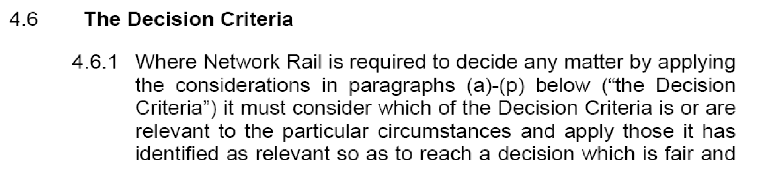
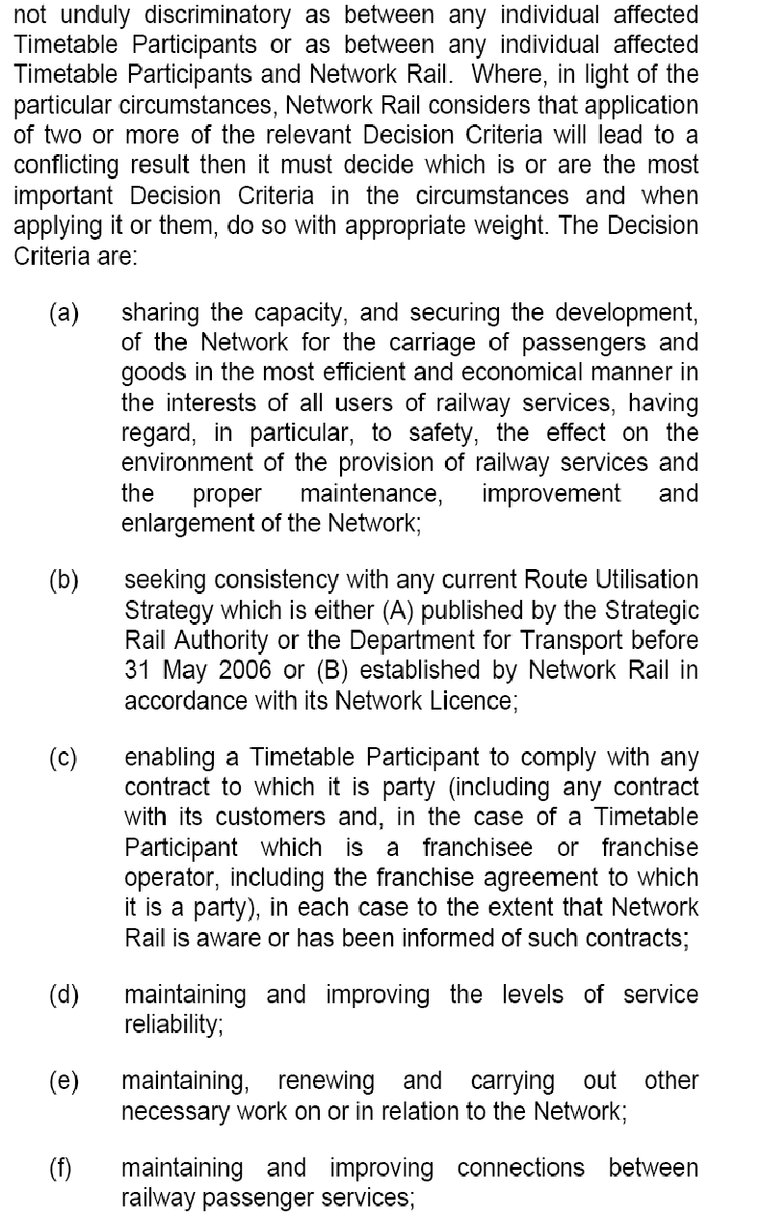
ANNEX “D”
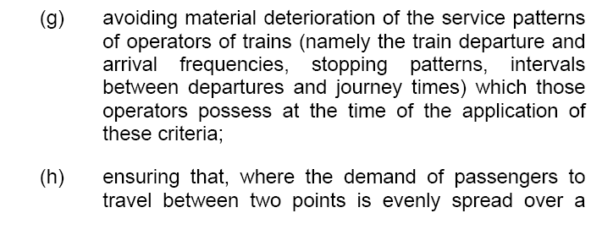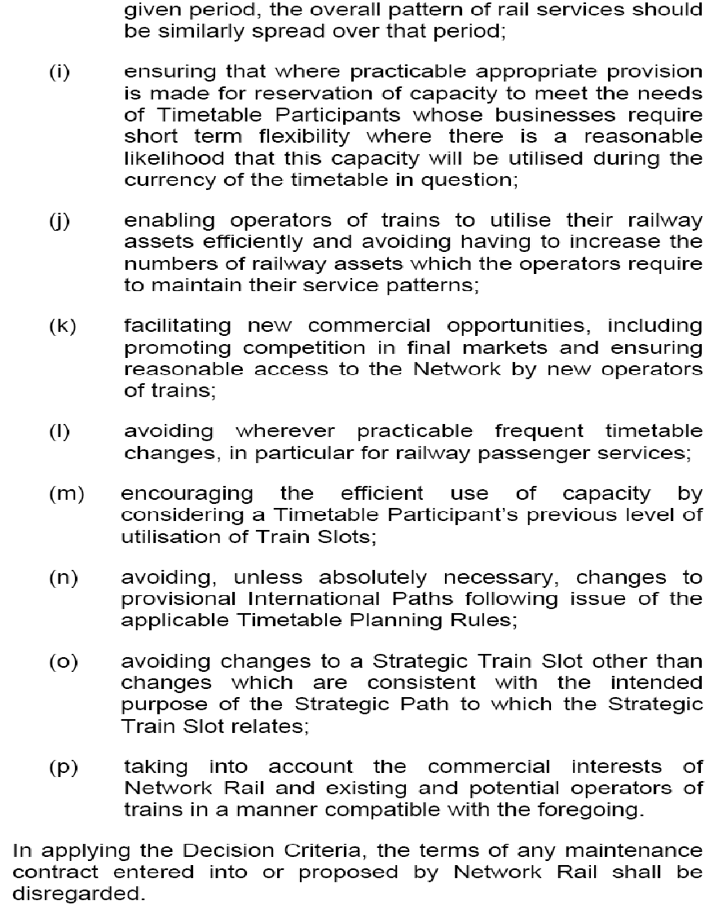

ANNEX “E”
Extract from 2012 Network Statement
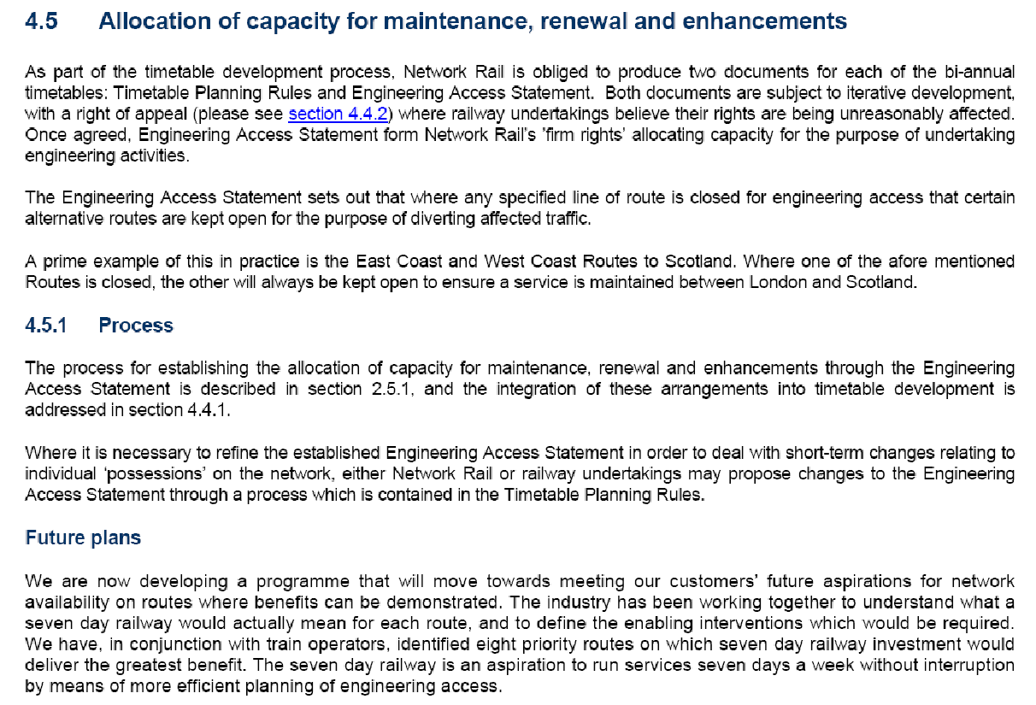

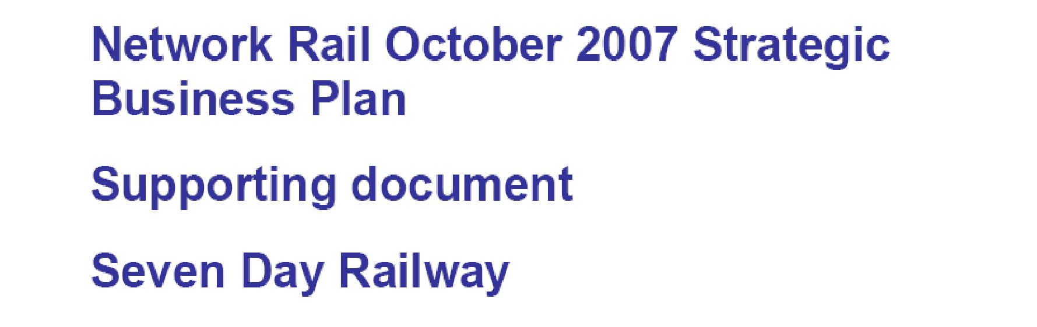
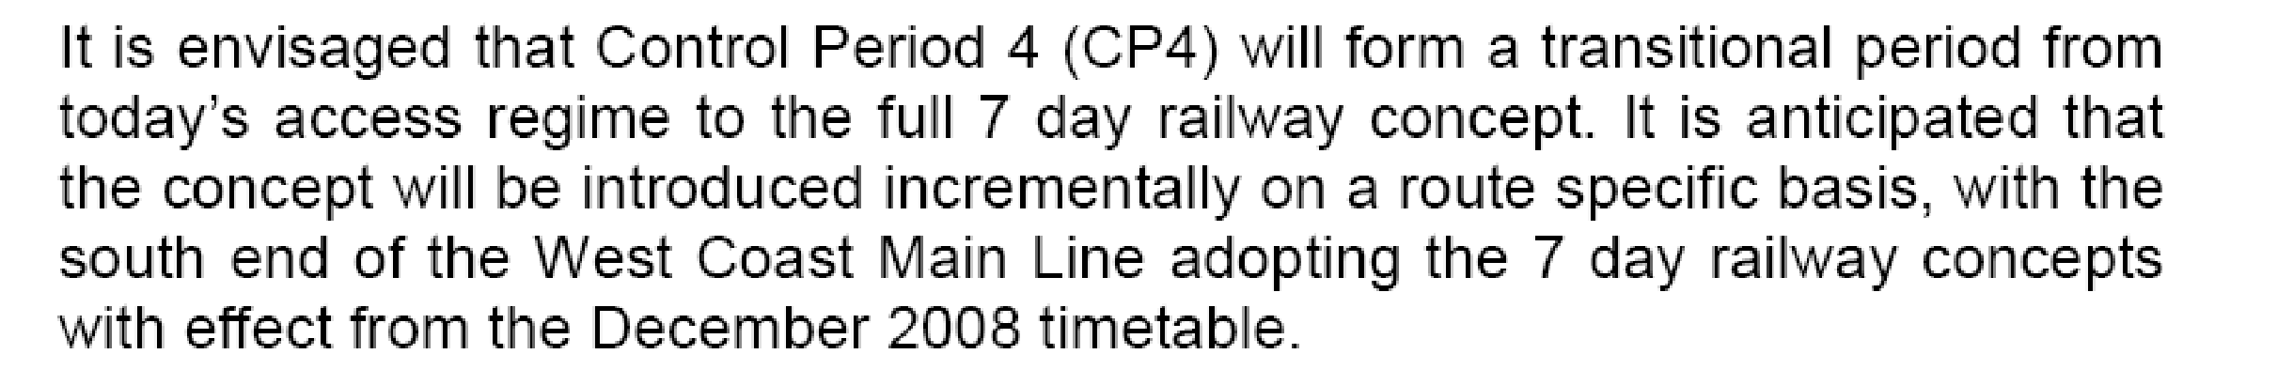

Demand
The following key conclusions have been reached from our analysis with operators of the potential demand:
• there is strong evidence of suppressed demand at weekends, especially on Sundays;

• weekend revenues affected by disrupted services (25-50% loss);

• there is additional demand late evening and on specialist flows such as airports traffic;

TOCs (and passengers) do not like bus substitution (especially at weekends), and the costs of putting on a bus replacement service are high. Bus substitution is suppressing demand as passengers are deterred from using trains on the weekend from fear of being put on a bus for part of their journey;

ANNEX “E” Cont....
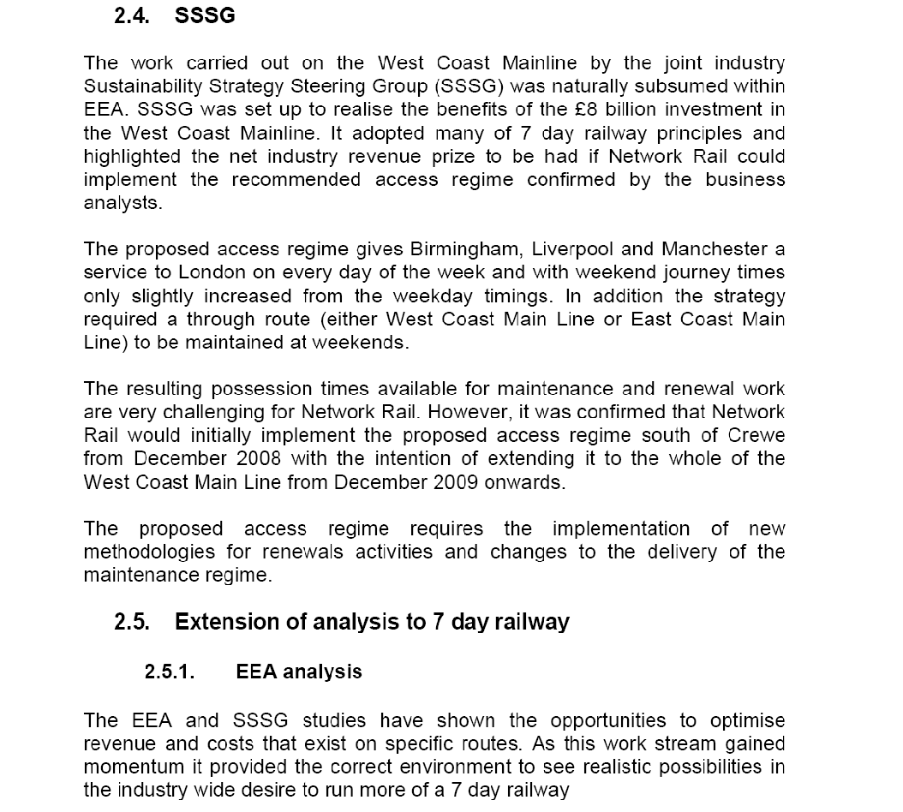
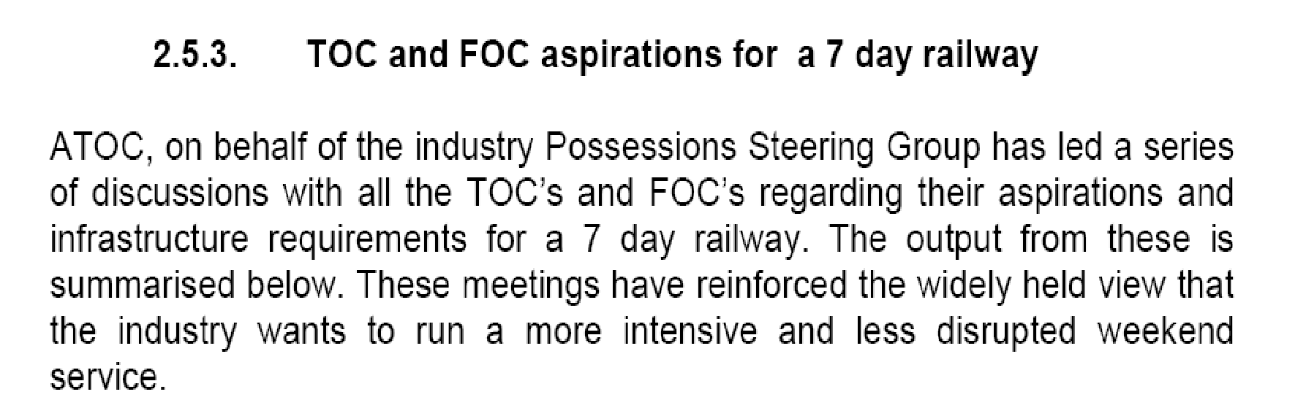

ANNEX “F”
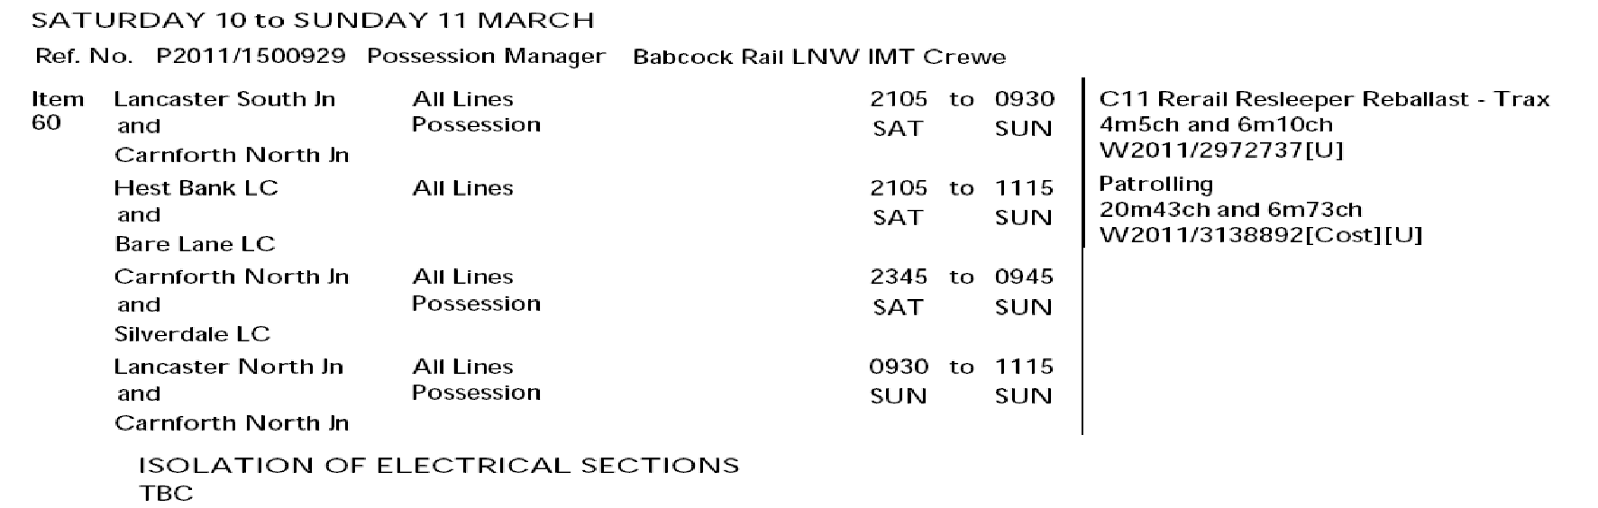
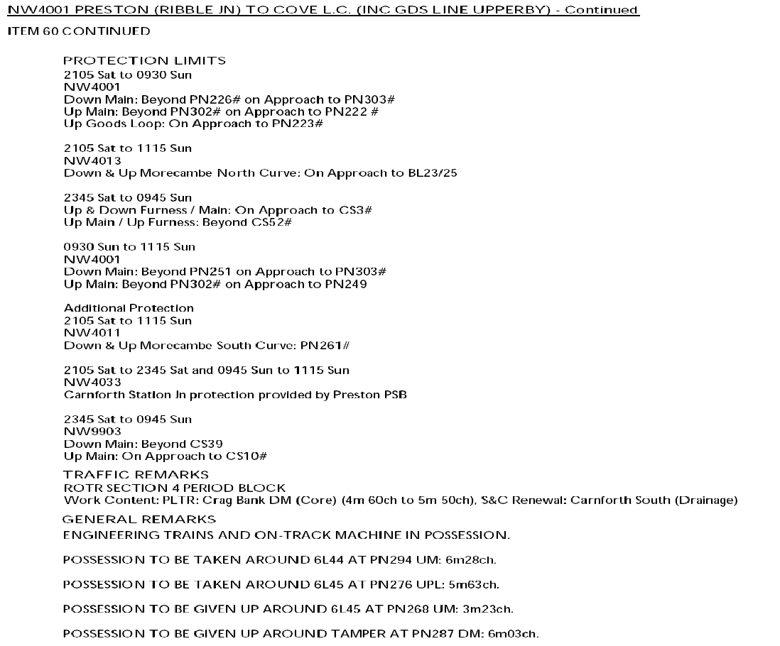
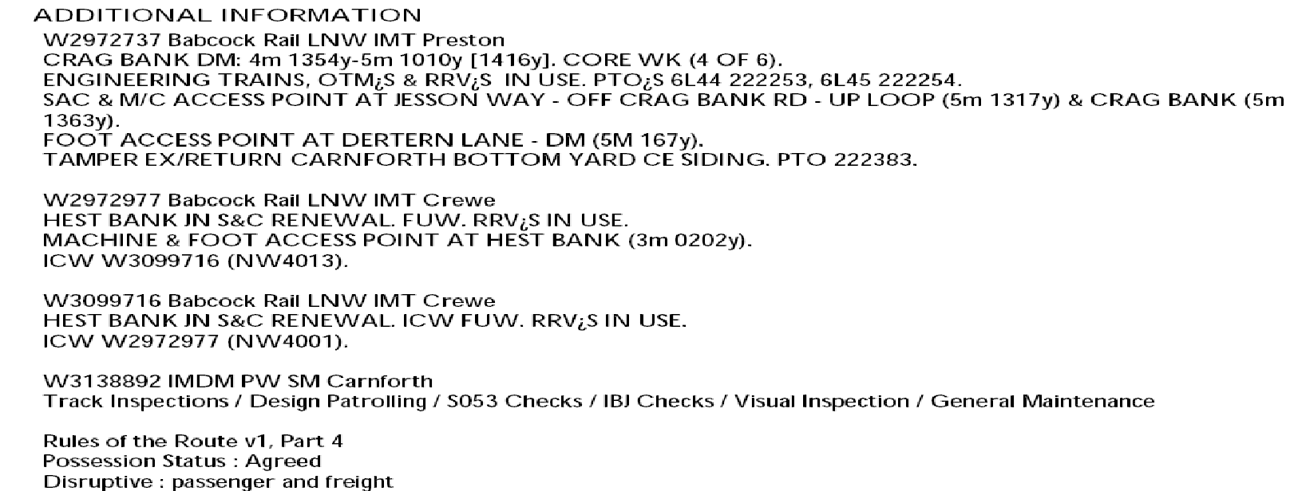

ANNEX “G”

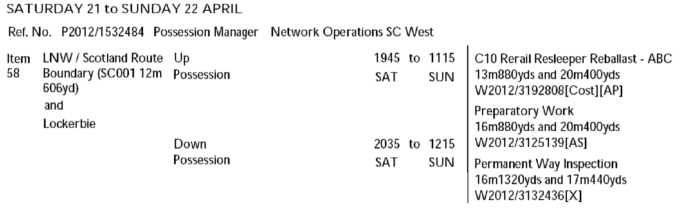
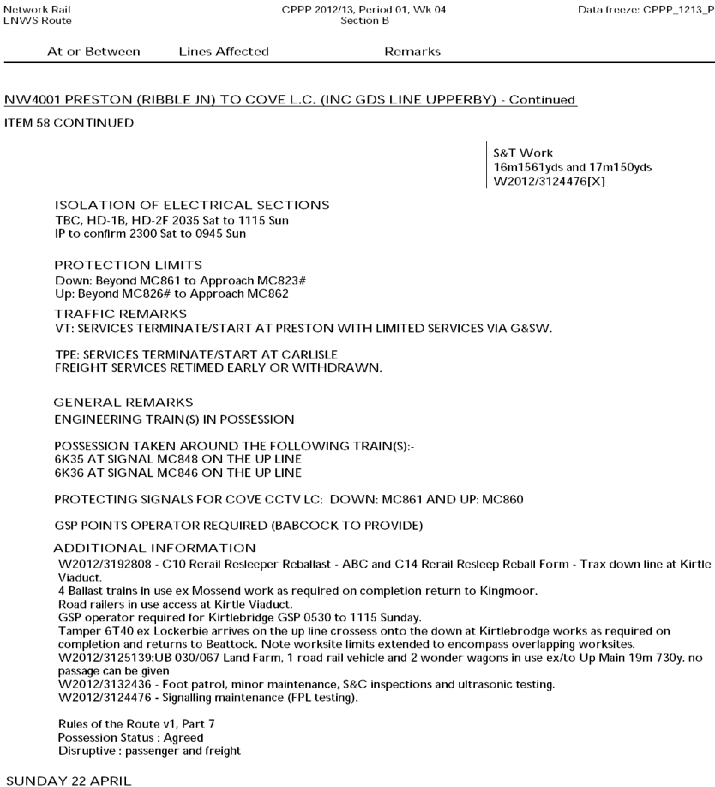
Insert details of Penrith Work in Period “G”

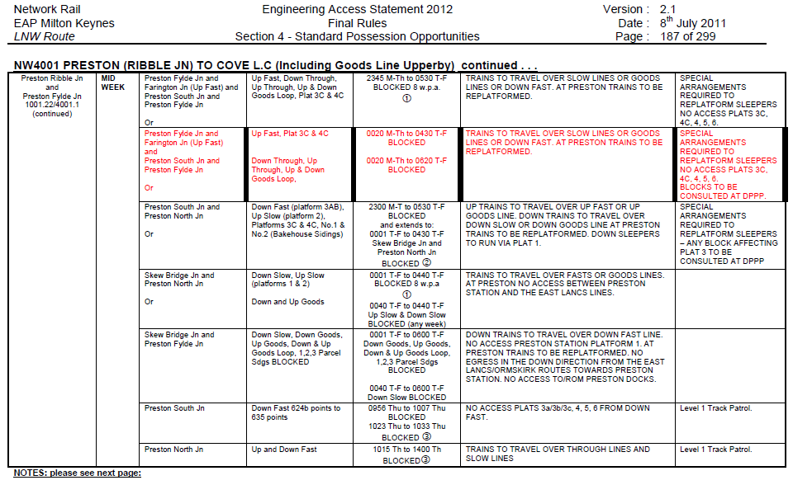
ANNEX “H”
Week 2
NW1001
New item previously planned to be done in 2 track access. New restrictions on crane and RRV operation next to open lines mean that the Up Slow has to be blocked. As WCML traffic is not running, this week is felt to be the best week to propose this access, note however the impact on Liverpool-Blackpool and Manchester-Blackpool services:

This item appears in version EAS V2.1 with incorrect times. Please disregard the times and blocking points shown in EAS V2.1. The possession will be published in the DPPP with the times and locations as shown below:

Saturday 07 April to Monday 09 April
PPS Ref: P2012/1489005
At/Between: Euxton Jn and Preston Ribble Jn
Lines: Down & Up Fast (Possession)
Times: 1000 Sat to 0900 Mon
At/Between: Euxton Jn and Farington Jn
Lines: Up Slow (Possession)
Times: 1000 Sat to 0900 Mon

Traffic Remarks: TRAINS TO START/TERMINATE AT WIGAN NW AND PRESTON. TRAINS BETWEEN EUXTON JN AND FARINGTON JN TO TRAVEL UNDER SINGLE LINE WORKING ARRANGEMENTS OVER THE DOWN SLOW– CAPACITY 2 TPH IN EACH DIRECTION.

Week 5
NW4001

Worksite to fit in times of period block to Penrith, but is outside of the limits of the period block so is included in the Section 7 possession register.

Saturday 28 April to Sunday 29 April
PPS Ref: P2012/1492460
At/Between: Penrith and Carlisle South Jn
Lines: All Lines (Possession)
Times: 2040 Sat to 1140 Sun

Traffic Remarks: SECTION 7 REGISTER ITEM WITHIN TIMES OF PERIOD BLOCK ON NW4001

Week 10
NW1001
New possession created for deferred renewal work.

Saturday 02 June to Monday 04 June
PPS Ref: P2012/1488948
At/Between: Acton Grange Jn and Winwick Jn
Lines: All Lines (Possession (T3))
Times: 0600 Sat to 0500 Mon

Traffic Remarks: WCML TRAINS TO START/TERMINATE CREWE AND WIGAN. DIVERT DIESEL SERVICE VIA MANCHESTER. RAIL REPLACEMENT ROAD SERVICE TO OPERATE.
CHESTER TO MANCHESTER SERVICE TO DIVERT VIA ALTRINCHAM AND STOCKPORT. RAIL REPLACEMENT ROAD SERVICE TO OPERATE.
LIVERPOOL TO WARRINGTON SERVICE TO START/TERMINATE AT EARLESTOWN.
FREIGHT ACCESS INTO ARPLEY AVAILABLE ON HELSBY LINES.
Disruptive Work Content: Warrington PLTR DS
ANNEX “H” Cont....

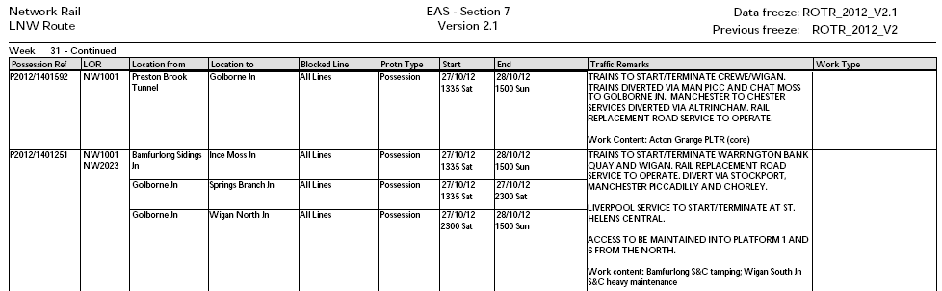

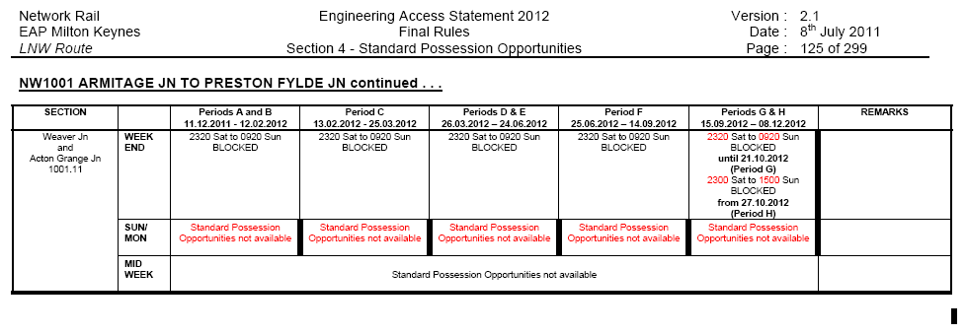

ANNEX “I”

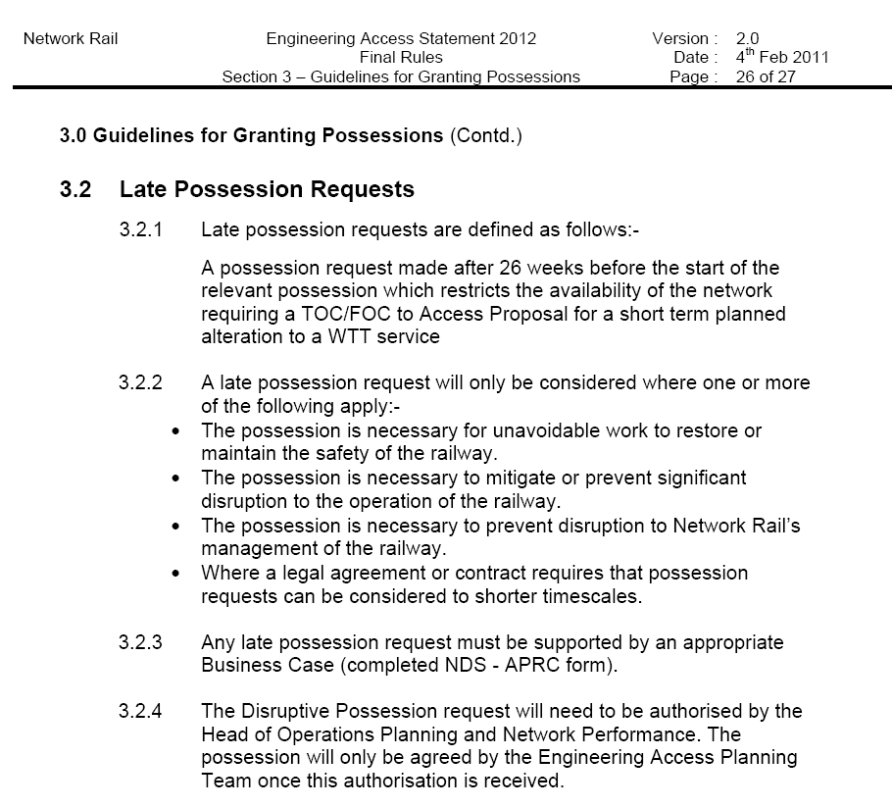
ANNEX “J”

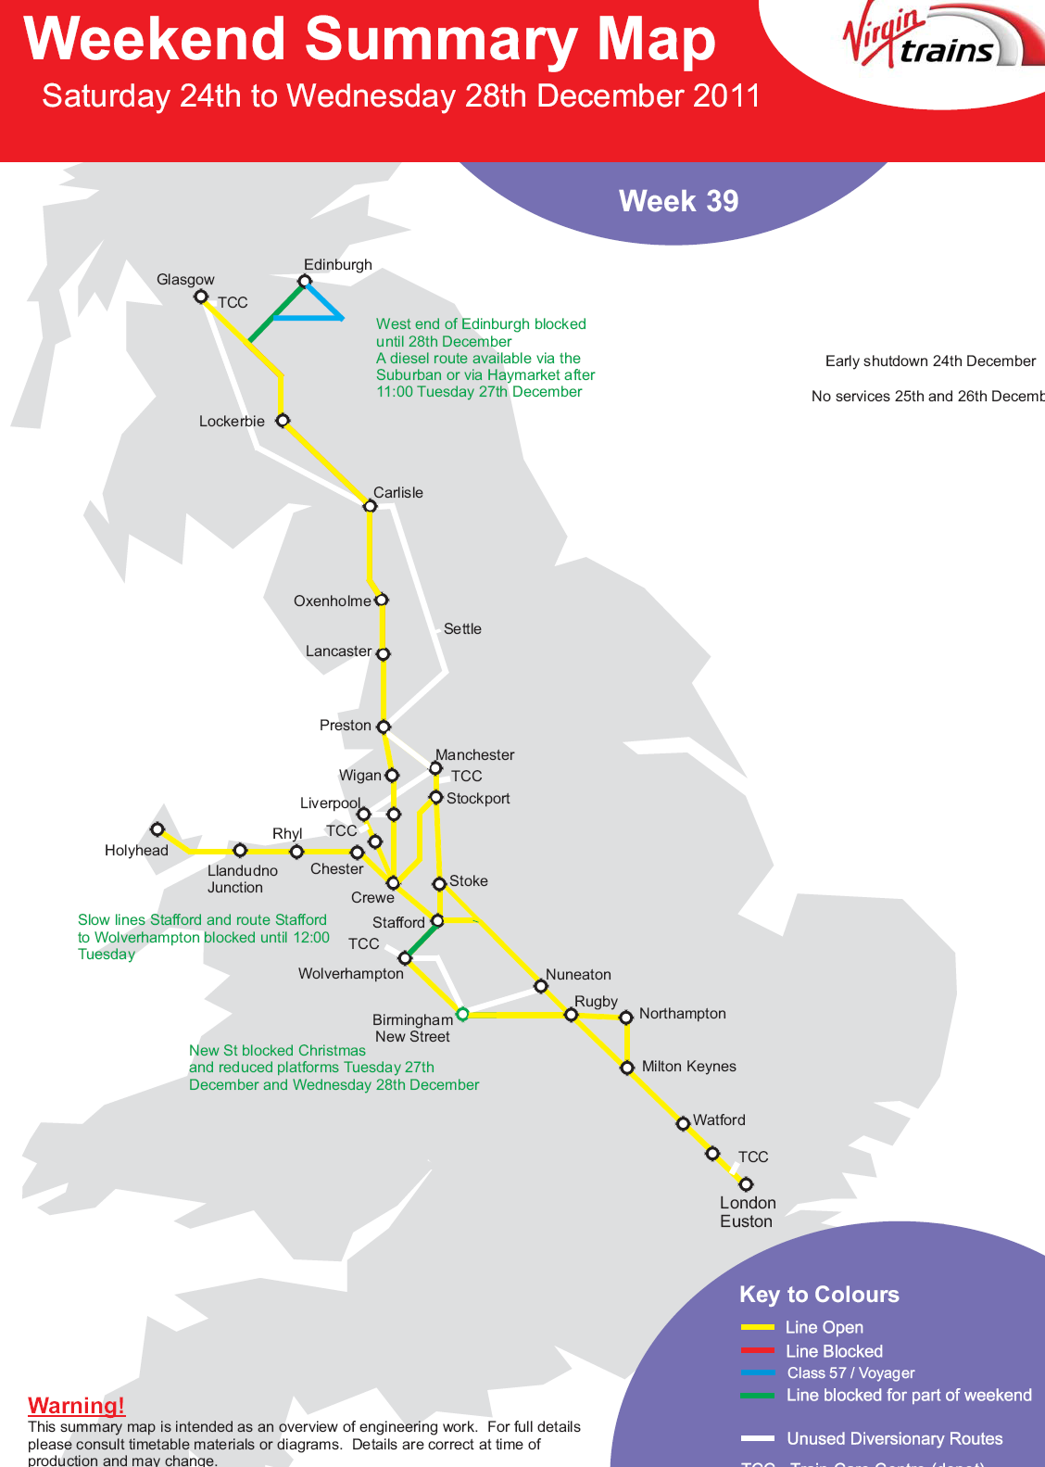
PLUS:
Recent two track Railway block agreed south of Rugby on 27/12

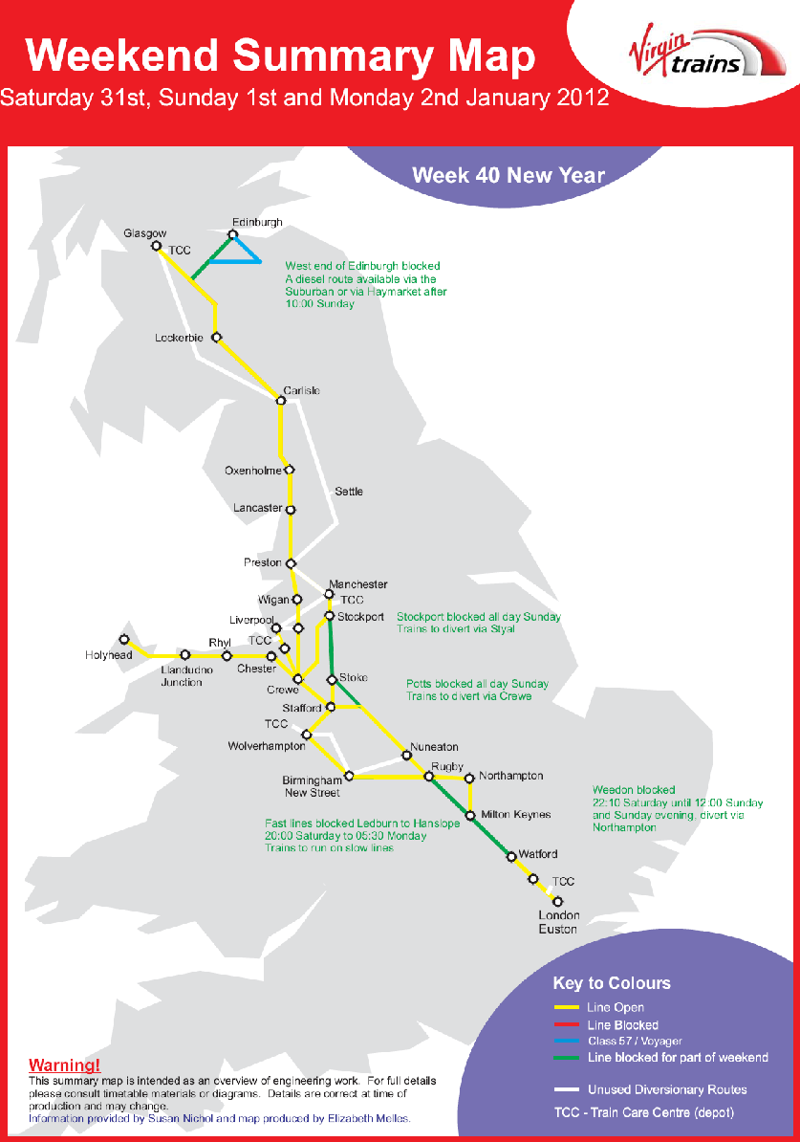

ANNEX “J” Cont....

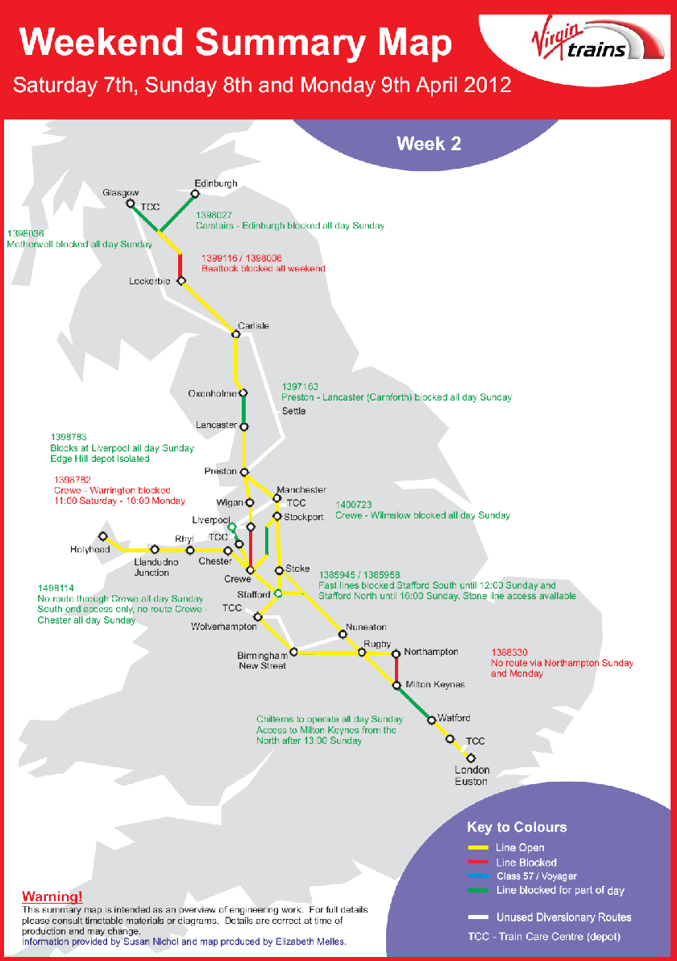
ANNEX “J” Cont....

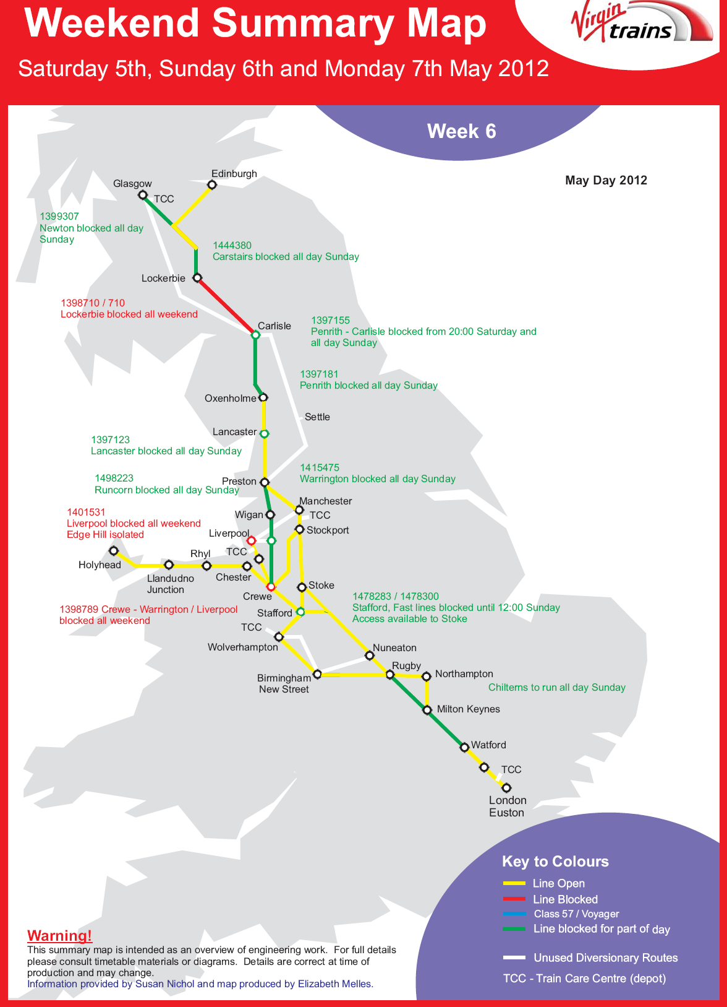
ANNEX “J” Cont....

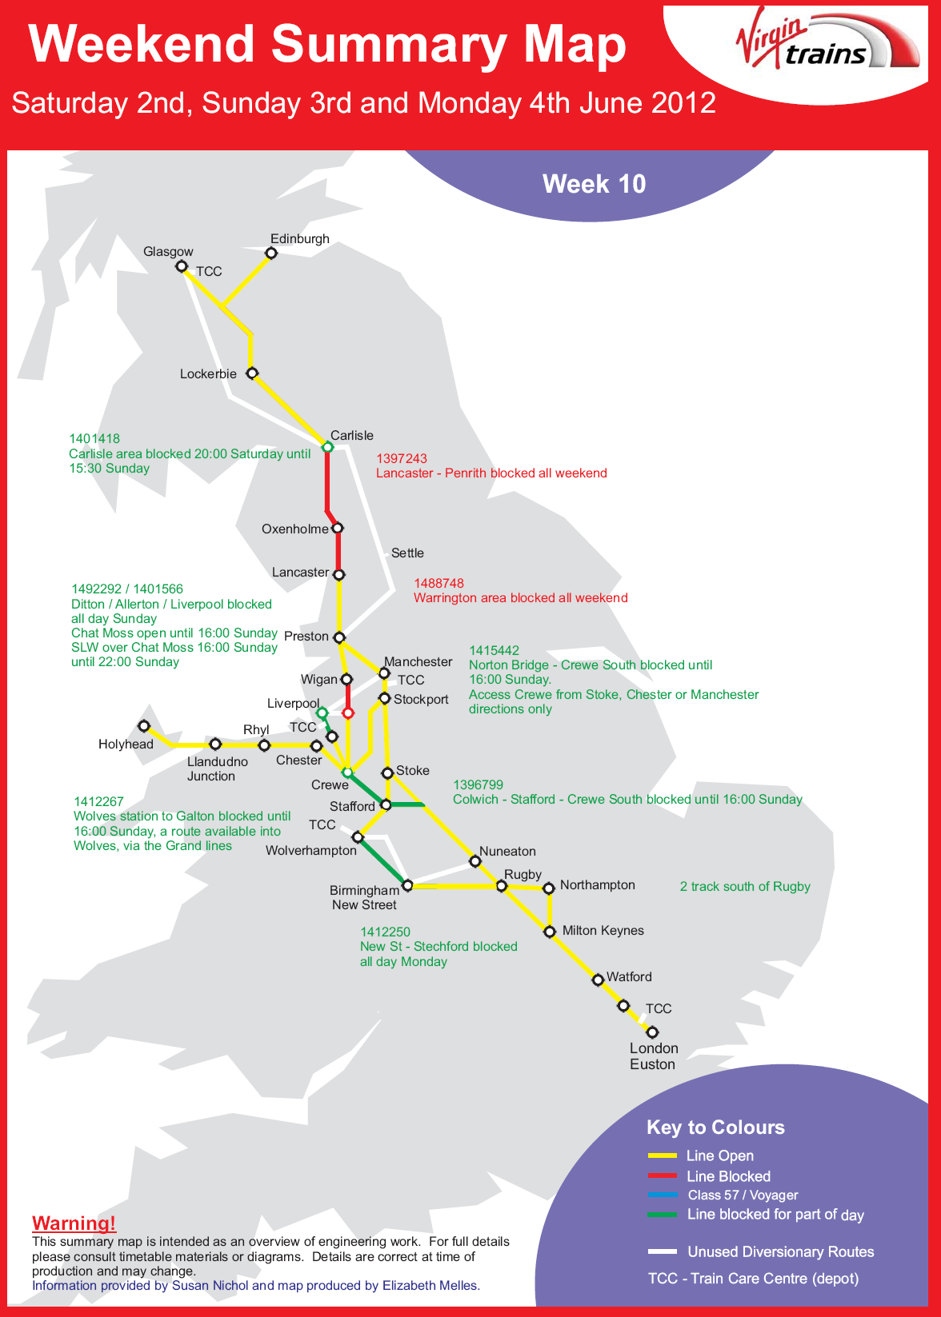
ANNEX “K”

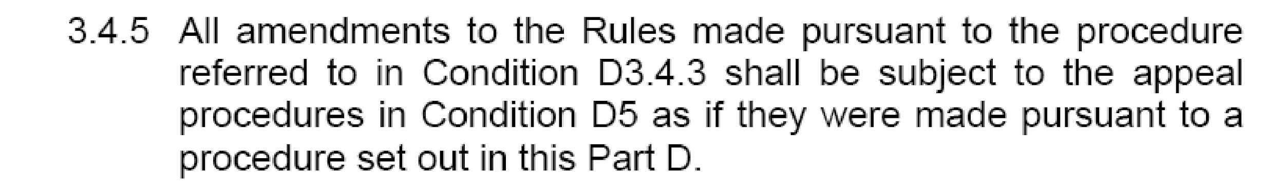

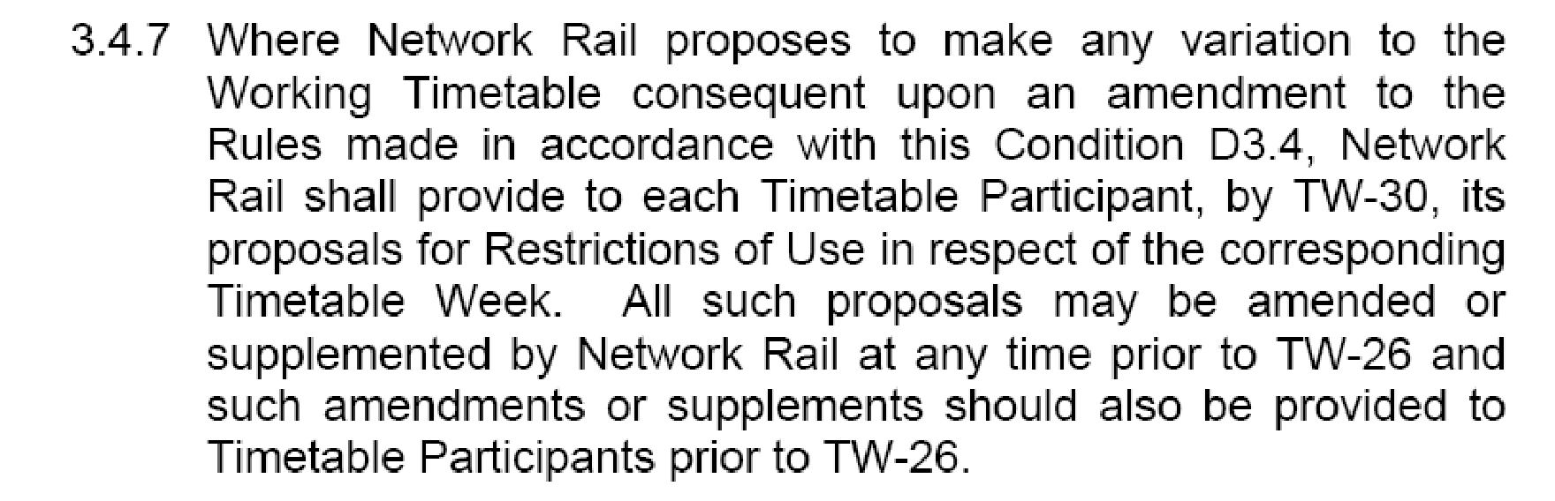

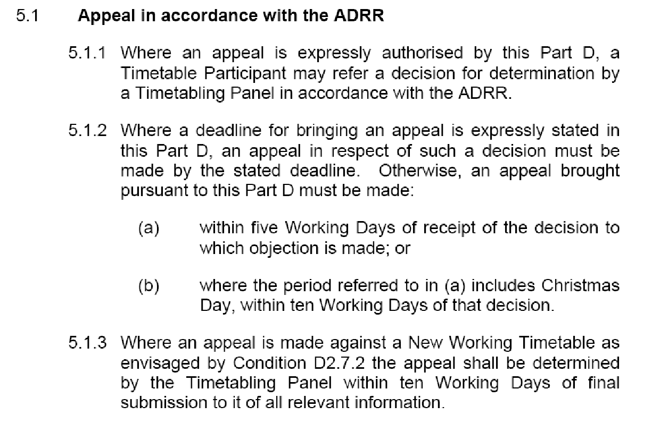

ANNEX “L”

Section 3 Procedure for Altering Rules of the Route or Rules of the Plan other than through the Twice-Yearly Process Having Effect from a Passenger Change Date

3.1. Introduction
3.1.1. This Procedure has been devised in accordance with Network Code Condition D 2.1.10 to provide a means of altering Rules of the Route and/or Rules of the Plan other than through the twice-yearly process having effect from the Passenger Change Dates. It supersedes the interim arrangements included within certain Train Operators’ Track Access Agreements and within certain Regional Rules of the Route and Rules of the Plan documents.

3.1.2. This procedure will be used by Network Rail to add, substitute or delete engineering access opportunities contained within Rules of the Route. All possessions so agreed will be regarded as being within Rules of the Route. Network Rail is committed to the achievement of the Informed Traveller deadlines resulting in details of amended train services being available 12 weeks before the date of operation, consequently, wherever possible, Network Rail will consult with Train Operators regarding possessions and other capacity restrictions which are disruptive to agreed train paths in sufficient time to allow details of those disruptive possessions to be included in a Confirmed Period Possessions Plan which will be published 26 weeks prior to the start of each 4-week period.

3.1.3. Where a need arises to amend Rules of the Route/Plan to cater for urgent safety requirements or other emergency situations, all parties concerned will co-operate in accelerating the normal timescales in this Procedure commensurate with the urgency of the circumstances.

3.2. Changes Initiated by Train Operators
3.2.1. A Train Operator may propose changes to any part of ROTR/P affecting or likely to affect that Train Operator.

3.2.2. The Train Operator shall submit a written statement of the proposed change and a concise explanation of the reasons for that change:

3.2.2.1. for ROTP, to its Network Rail lead Train Planning Manager who will acknowledge receipt and immediately copy the proposal to the Network Rail Train Planning Manager responsible for the relevant section of ROTP if not the lead TPM.

3.2.2.2. for ROTR, to the Network Access Unit Manager, who will acknowledge receipt.

3.2.3. Within 5 Working Days of receipt of the proposed change, Network Rail shall notify to all Train Operators affected details of the proposed change and Network Rail’s comments including concise reasons for the change and a statement as to whether Network Rail supports the proposal.

3.3. Changes Initiated by Network Rail
3.3.1. Network Rail may propose changes to any part of ROTR/P.

3.3.2. Network Rail shall notify to all Train Operators affected details of the proposed change including a concise explanation of its reasons. Proposed changes to ROTR arising before publication of the Draft Period Possessions Plan shall be notified by Network Rail in a single coordinated document to be issued each 4 weeks.

3.4. Response by Train Operators
3.4.1. Each Train Operator receiving notification of a proposed change in accordance with paragraphs 2.3 or 3.2 above will consider that proposal and respond to Network Rail within 10 Working Days from receipt of the notification, indicating:
3.4.1.1. its agreement to the proposed change or
3.4.1.2. details of a counter-proposal and an explanation of its reasons or
3.4.1.3. in the case of ROP items such as section running times, a request that a joint investigation is carried out.

3.4.2. Any Train Operator whose response is not received by Network Rail within 10 Working Days will be deemed to have agreed to the proposed change and will forfeit any right of Appeal.

ANNEX “L” Cont....
3.5. Decision by Network Rail
3.5.1. Network Rail shall give due consideration to responses received from Train Operators in accordance with paragraphs3.4.1 and 3.4.2 above and shall decide which changes, if any, should be made to ROR/P.

3.5.2. In reaching its decision, Network Rail shall have due regard to the Decision Criteria in Network Code Condition D6.

3.5.3. Network Rail will notify its decision to each affected Train Operator within 5 Working Days of the last date for receipt of responses under paragraph 3.4 above.

3.5.4. Any Train Operator, if it disputes Network Rail’s decision, may Appeal to a Timetabling Panel and any such Appeal will be dealt with as though it had been made in accordance with Network Code Condition D2.1.7. Any Appeal must be referred to the Access Disputes Secretary in accordance with the timescales shown in Condition D5.1.2 (i.e. within 5 Working Days of notification by Network Rail of its decision except at Christmas when the period is increased to 10 Working days.

ANNEX “M”
SATURDAY LOADINGS – Week 46 -2011

TO BE ADDED AS A SUPPLEMENTAL

ANNEX “M” Cont....
SUNDAY LOADINGS – Week 46 -2011

TO BE ADDED AS A SUPPLEMENTAL

ANNEX “N”

1. Executive Summary

1.1 Plan Overview
This Joint Network Availability Plan (JNAP) describes the plans that will enable Virgin West Coast and Network Rail to deliver their contribution to the CP4 Network Availability target of a 37% reduction in disruption to passenger services caused by engineering works.
The overall objectives of the Network Availability programme are as follows:
- With immediate effect and continuing over the Control Period Network Rail and West Coast Trains Limited / ICWC will work together to reduce the disruption to rail users by engineering work
- Network Rail will put measures in place so that, over Virgin West Coast Category A routes, unless exceptional circumstances make it impractical, passengers travelling at weekends between the originating and terminating stations or between 'primary intermediate stations' on a route:
  - will not be transferred on to buses; and
  - where trains have to be diverted, on shorter diversionary routes this will be limited as shown in Appendix 3 and follow the currently agreed Rules of the Route pattern. When longer diversions are called for then the number of occasions and the times will be limited to those shown in Appendix 3.
  - As a result, West Coast Trains Limited / ICWC will be able to run more trains compared with 2008/09
- Network Rail will deliver its regulatory target to cut disruption by at least 37% by 2013/14 across the network
- While this JNAP initially focuses on category A routes, both parties agree that improvements in availability shall be across all West Coast Trains Limited / ICWC routes
- Network Rail and West Coast Trains Limited / ICWC commit that wherever we can reasonably do so we will keep passengers on a train in preference to transferring them to a bus
In addition to the above, general objectives, the nature of West Coast Trains Limited / ICWC business and franchise specifications means it is focused on and committed to:
- Increasing the proportion of services that can be operated at weekends
- Weekend journey times to reflect those Rights permitted under Section 6.3 of WCTL TAC Schedule 5, unless circumstances make it impractical to do so
- An absolute priority to run trains rather than buses wherever possible
- Improving the management of people’s journeys through the availability of appropriate stations for ease of interchange, fewer transfers between bus and train and stabling and platforming arrangements to mitigate disruption

ANNEX “N” Cont...

This is the second Network Rail - West Coast Trains Limited / ICWC JNAP and it is anticipated that as the parties become used to working with it, they will develop and refine the content.
It is agreed that the initial focus for 2011-12 will be on those routes over which West Coast Trains Limited / ICWC operates which have been designated as ‘Category A’ routes.

Category A routes
Figure 1 below lists the Category A routes which are on the West Coast Trains Limited / ICWC’s network.
Figure 1: West Coast Trains Limited / ICWC Category A routes
Route | Primary intermediate stations on route by route Categorisation | Primary Stations served by the trains on the route
London Euston to Wolverhampton | Coventry, Birmingham New Street | MKC, Rugby, Coventry, Birmingham International, Birmingham New Street
London Euston to Manchester via Stoke-on-Trent | Stoke-on-Trent | Stoke –on- Trent, Stockport
London Euston to Manchester via Crewe |  | Crewe, Stockport
London Euston to Liverpool |  | Stafford, Runcorn
London Euston to Glasgow | Preston | Warrington BQ, Wigan, Preston, Carlisle, Motherwell
Birmingham to Glasgow | Preston | Wolverhampton, Crewe, Warrington BQ, Wigan NW, Preston, Carlisle

For the above routes, unless exceptional circumstances make it impractical, Passengers travelling at weekends between the originating and terminating stations or between ‘primary intermediate stations’ on a route:
- Will not be transferred onto buses
- Will not see an increase planned journey times by more than 25% due to diversions away from a train’s normal route
- These principles take effect from the start of the December 2011 timetable
- ANNEX “N” Cont...

2. JNAP objectives

2.1 National objectives
For Control Period 4, Network Rail have committed to achieving the regulated network availability output measured by the Possession Disruption Indices (PDI’s) for passenger (P) and freight (F) train services. The regulated outputs for network availability are a 37% improvement in PDI-P (i.e. a reduction of the index from 1.0 to 0.63) for passengers, while ensuring the level of disruption as experienced by freight customers’ remains the same at an index of 1.0. This JNAP supports and informs the national implementation plan that we produce for ORR, to report on progress towards the regulated outputs.

2.2 West Coast Trains Limited - specific objectives
From Monday to Thursday, the peak customer flows are predominantly business customers travelling to & from London. Although off-peak leisure travel is continuing to grow strongly on all routes, and this is especially marked between London & Birmingham and Scotland. On Fridays there is slightly less business travel but a marked increase in leisure traffic which escalates through the afternoon to the evening. On the two Anglo Scottish routes, additional capacity is provided on Friday afternoons to cater for the large increase in demand.
Saturdays & Sundays are also busy on all routes with strong leisure flows but again the Anglo Scottish services are by far the busiest. The peak is reached on a Sunday afternoon / evening which is second only to the equivalent period on a Friday in terms of volumes of customers being carried.
ECML vs WCML Possession Matrix
The EC v WC planning rules being used for the development of the 2013 ROTR:

Both routes will be normally open on a Saturday.

- If a through journey opportunity is maintained on both routes then disruptive engineering access can be taken on both routes simultaneously providing typical journey times for each route are not extend by greater than 25%
- It is acceptable to block on any weekend both routes for a maximum of 14-16hrs Sat/Sun (e.g. 2000 Sat to 1200 Sun) with times dependant upon location of possession and timings to avoid key services. However there is a commitment to provide capacity for one train per hour on a Sunday morning and two trains per hour Sunday afternoon, between London and Scotland.
- There must always be an opportunity for a passenger to join the train in London and depart the same train in Scotland from the same seat
- Overlaying the possession planning process there will be meetings between WCTL / EC / XC/ NR. This meeting shall discuss specific weekends highlighted by Network Rail when the combination of possessions proposed would not produce a robust train plan that provides sufficient capacity between England and Scotland. This meeting shall be held sufficient far in advance of the timetable year to allow NR time to produce alternative proposals for possessions.

ANNEX “N” Cont...

Appendix C route specific diversionary routes and bus transfer points

8.6 Euston – Lancaster / Carlisle / Glasgow Central

Route facts
Category “A” Route; RC050 – Euston, Rugby, Colwich, Stafford, Crewe, Preston, Carlisle, Glasgow Central
Normal end-to-end time: 2 hours 25 minutes Euston – Preston 2 hours 29 minutes Euston – Lancaster and 4 hours 27 minutes Euston - Glasgow
25% of end-to-end time: 36 minutes Euston – Preston 37 minutes Euston – Lancaster and 67 minutes Euston to Glasgow
Capacity required:
- 1 tph Euston to Lancaster and nearly hourly Preston to Glasgow Central with a few peak hour additional trains between Euston and Preston and Euston and Glasgow.
Primary Stations:
- Euston, Warrington Bank Quay, Wigan North Western, Preston, Lancaster, Oxenholme, Penrith and Carlisle, Motherwell

Saturday Night / Sunday Morning services subject diversion and / or bus substitution
Day | Section | Headcode | Departure Time | From | To | Remarks
SO | Preston - Carlisle | 1S95 | 18:30 | Euston | Glasgow Central | Divert via S&C
SUN | Preston - Carlisle | 1S37 | 08:45 | Euston | Glasgow Central | Divert via S&C
SUN | Preston - Carlisle | 1S37 | 08:45 | Euston | Glasgow Central | Divert via S&C
SUN | Preston - Carlisle | 1M05 | 09:37 | Glasgow Central | Euston | Start earlier form Glasgow and divert via S&C
SO | Carlisle – Glasgow | 1S90 | 17:30 | Euston | Glasgow Central | Divert via G&SW
SO | Carlisle – Glasgow | 1S95 | 18:30 | Euston | Glasgow Central | Divert via G&SW
SUN | Carlisle – Glasgow | 1M05 | 09:37 | Glasgow Central | Euston | Start earlier form Glasgow and divert via G&SW

Diversions via Manchester apply 23:00 Saturday until 1500 Sunday, for a total of 12 weeks in the timetable year.
Preston to Carlisle diversions are to apply for a total of 22 weeks in the timetable year.

ANNEX “O”
Route E: London Euston to Preston and Glasgow Central
- ROUTE DEFINITION
1.1 Services shall be provided between London Euston and Glasgow Central, calling at Warrington Bank Quay, Wigan North Western, Preston, Lancaster and Carlisle.
1.2 Secondary Stops shall also be made at, Oxenholme Lake District and Penrith as set out in Paragraphs 5.1, 5.2 and 5.3.
LIMITED STOPS
SATURDAYS
  - Watford Junction: One service to Glasgow Central and one service to Preston shall call. One service from Glasgow Central shall call.
  - Milton Keynes Central: Two services from Glasgow Central and one service from Preston shall call. One service to Glasgow shall call.
  - Rugby: One service to Glasgow Central and one service to Preston shall call.
  - Tamworth and Lichfield Trent Valley: One service from London Euston shall call.
  - Stafford: One service to Glasgow Central shall call.
  - Crewe: Three services from London Euston shall call. One service to London Euston shall call.
  - Lockerbie: Two services to London Euston shall call.
  - Motherwell: One service from London Euston and three services to London Euston shall call.
SUNDAYS
  - Watford Junction: One service from Glasgow Central and one service from Preston shall call.
  - Milton Keynes Central: Three services to London Euston and four services from London Euston shall call.
  - Rugby: Two services to London Euston and four services from London Euston shall call.
  - Tamworth and Lichfield Trent Valley: One service from London Euston shall call.
  - Crewe: Three services to London Euston and five services from London Euston shall call.
ANNEX “O” Cont....

3. SERVICE PATTERN - SATURDAYS
NORTHBOUND
3.1 Between 0700 and the Late Glasgow Service, services shall be provided from London Euston to Glasgow Central at hourly intervals, calling at the stations in Paragraph 1.1.
3.2 Between 1900 and 2000, an additional service shall be provided from London Euston to Preston, calling at the stations specified in Paragraph 1.1
SOUTHBOUND
3.3 Between and including the Early Service and the Late Service, services shall be provided from Glasgow Central to London Euston at approximately hourly intervals, calling at the stations in Paragraph 1.1.

4. SERVICE PATTERN - SUNDAYS
NORTHBOUND
  - Between and including the Early Service and the Late Glasgow Service, services shall be provided from London Euston to Glasgow Central at hourly intervals, calling at the stations in Paragraph 1.1. There may be one interval of two hours.
4.2 Between 2000 and the Late Preston service, one additional service shall be provided from London Euston to Preston, calling at the stations in Paragraph 1.1.
SOUTHBOUND
4.3 Between and including the Early Glasgow Service and the Late Service, services shall be provided from Glasgow Central to London Euston at approximately hourly intervals, calling at the stations in Paragraph 1.1. Three services may start from Preston at approximately hourly intervals between 0830 and 1130.

ANNEX “O” Cont....

5 SECONDARY STOPS AND SUBSIDIARY CALLING PATTERN
5.2 On Saturdays, Secondary Stops shall be made at the following stations:
Services departing London Euston | Oxenholme | Penrith
0600-0659 | 1 | 1
0700-0759 | 0 | 1
0800-0859 | 1 | 0
0900-0959 | 0 | 1
1000-1059 | 1 | 0
1100-1159 | 1 | 0
1200-1259 | 0 | 1
1300-1359 | 1 | 0
1400-1459 | 0 | 1
1500-1559 | 1 | 0
1600-1659 | 1 | 1
1700-1759 | 1 | 1
1800-1859 | 1 | 1

Services departing Glasgow Central to London Euston | Penrith | Oxenholme
0400-0459 | 1 | 1
0500-0559 | 0 | 1
0600-0659 | 1 | 1
0700-0759 | 0 | 1
0800-0859 | 1 | 0
0900-0959 | 0 | 1
1000-1059 | 0 | 1
1100-1159 | 1 | 0
1200-1259 | 0 | 1
1300-1359 | 0 | 1
1400-1459 | 0 | 1
1500-1559 | 1 | 0
1600-1659 | 0 | 1
1700-1759 | 1 | 1
ANNEX “O” Cont....

5.3 On Sundays, Secondary Stops shall be made at the following stations:
Services departing London Euston | Oxenholme | Penrith
0800-0859 | 1 | 1
0900-0959 | 1 | 1
1000-1059 | 1 | 1
1100-1159 | 0 | 0
1200-1259 | 0 | 1
1300-1359 | 1 | 0
1400-1459 | 0 | 1
1500-1559 | 1 | 0
1600-1659 | 1 | 1
1700-1759 | 1 | 1
1800-1859 | 1 | 1
1900-1959 | 1 | 1

Services departing Glasgow Central to London Euston | Penrith | Oxenholme
0900-0959 | 1 | 1
1000-1059 | 1 | 1
1100-1159 | 0 | 1
1200-1259 | 0 | 1
1300-1359 | 0 | 1
1400-1459 | 0 | 1
1500-1559 | 1 | 0
1600-1659 | 1 | 1
1700-1759 | 1 | 1

ANNEX “O” Cont....

6. EARLY AND LATE SERVICES
 | Early Service arrives at destination no later than:
Route | Monday - Friday | Saturday | Sunday
London Euston –  Preston | 0830 | 0915 | 1220
Preston - London Euston | 0815 | 0845 | 1215
London Euston –  Glasgow Central | 1045 | 1145 | 1445
Glasgow Central –  London Euston | 0915 | 0930 | 1430

 | Late Service departs no earlier than:
Route | Monday - Friday | Saturday | Sunday
London Euston –  Preston | 2030 | 2000 | 2030
Preston - London Euston | 2030 | 2000 | 1945
London Euston –  Glasgow Central | 1915 | 1800 | 1845
Glasgow Central –  London Euston | 1815 | 1730 | 1730

7. MAXIMUM JOURNEY TIMES
Route | Monday - Friday | Saturday | Sunday
London Euston –  Preston | 2 hours 11 minutes with 2 intermediate stops, with one exception of 2 hours 12 minutes | 2 hours 11 minutes with 2 intermediate stops | 2 hours 16 minutes with 2 intermediate stops, with one exception of 2 hours 20 minutes
Preston - London Euston | 2 hours 15 minutes with 2 intermediate stops | 2 hours 15 minutes with 2 intermediate stops, with one exception of 2 hours 23 minutes | 2 hours 18 minutes with 2 intermediate stops, with one exception of 2 hours 23 minutes
London Euston –  Glasgow Central | 4 hours 31 minutes, with 6 intermediate stops, with one exception of 4 hours 34 minutes | 4 hours 31 minutes, with 6 intermediate stops | 4 hours 38 minutes, with 6 intermediate stops, with one exception of 4 hours 40 minutes
Glasgow Central –  London Euston | 4 hours 35 minutes, with 6 intermediate stops | 4 hours 35 minutes, with 6 intermediate stops, with one exception of 4 hours 46 minutes | 4 hours 38 minutes, with 6 intermediate stops

ANNEX “O” Cont....
Route F: Birmingham New Street to Preston and Glasgow Central or Edinburgh

1. ROUTE DEFINITION
1.1 Services shall be provided between Birmingham New Street and Glasgow Central or Edinburgh, calling at Wolverhampton, Crewe, Warrington Bank Quay, Wigan North Western, Preston, Lancaster, Carlisle, then Glasgow Central or Haymarket and Edinburgh.
LIMITED STOPS
SATURDAY
1.5 Stafford: Two services to Birmingham New Street shall call. One service departing from Birmingham New Street shall call.
1.6 Lockerbie: One service arriving at Glasgow Central between 0900 and 1000 shall call.
1.7 Motherwell: The Early Service departing Glasgow Central shall call.
SUNDAY
1.8 Stafford: One service to Birmingham New Street shall call. Three services departing from Birmingham New Street shall call.
1.9 Lockerbie: One service to Glasgow Central and one service from Glasgow Central shall call.
  - Motherwell: The Late Service to Glasgow Central shall call.

3. SERVICE PATTERN - SATURDAYS
NORTHBOUND
3.1 Between the Early and Late Services an hourly service shall be provided to Carlisle, proceeding alternately to Edinburgh and Glasgow Central, calling at the stations specified in Paragraph 1.1.
3.2 Between the Late Service and 2000, two services shall be provided from Birmingham New Street to Preston, calling at the stations specified in Paragraph 1.1.
3.3 Before 0610, an additional service shall be provided from Crewe to Glasgow Central, calling at the stations specified in Paragraph 1.1.
SOUTHBOUND
3.4 Between the Early and Late Services an approximate hourly service (measured at Carlisle) shall be provided, originating alternately from Edinburgh and Glasgow Central, calling at the stations specified in Paragraph 1.1.

ANNEX “O” Cont....

3.5 Between 0600 and the Early Service, two additional services shall provided from Preston to Birmingham New Street, one of which may originate at Lancaster.
3.6 Between 1830 and 1900, one additional service shall be provided from Glasgow Central to Birmingham New Street, calling at the stations specified in Paragraph 1.1.

4. SERVICE PATTERN - SUNDAYS
NORTHBOUND
  - Between 0830 and 0900, one additional service shall be provided from Birmingham New Street to Preston, calling at the stations specified in Paragraph 1.1.
  - Between the Early and Late Services an hourly service shall be provided to Carlisle, proceeding alternately to Edinburgh and Glasgow Central, calling at the stations specified in Paragraph 1.1.
  - Between the Late Service and 2130, one service shall be provided from Birmingham New Street and Preston, calling at the stations specified in Paragraph 1.1 and additionally at Stafford, and one service shall be provided from Birmingham New Street to Crewe, calling at Wolverhampton and Stafford.
SOUTHBOUND
  - Between 1000 and 1230, three additional services shall be provided from Preston to Birmingham New Street, calling at the stations specified in Paragraph 1.1. One of these services may originate from Lancaster.
  - Between the Early and Late Services, one service in each hour (measured at Carlisle) shall be provided, originating alternately from Edinburgh and Glasgow Central, calling at the stations specified in Paragraph 1.1. Two of these services need not call at Lancaster.
  - Between the Late Service and 2030 an additional service shall be provided from Glasgow Central to Preston.
ANNEX “O” Cont....

5. SECONDARY STOPS
5.2 On Saturdays, Secondary Stops shall be made at the following stations:

Services departing Birmingham New Street | Oxenholme | Penrith
0600-0659 | 1 | 0
0700-0759 | 0 | 1
0800-0859 | 1 | 0
0900-0959 | 0 | 1
1000-1059 | 1 | 0
1100-1159 | 1 | 0
1200-1259 | 0 | 1
1300-1359 | 1 | 0
1400-1459 | 0 | 1
1500-1559 | 1 | 0
1600-1659 | 1 | 1
1700-1759 | 1 | 0
Services departing Crewe
0555-0610 | 1 | 1

Services departing Glasgow Central or Edinburgh (interval measured at Carlisle) | Penrith | Oxenholme
0700-0759 | 1 | 1
0800-0859 | 1 | 0
0900-0959 | 0 | 0
1000-1059 | 0 | 1
1100-1159 | 1 | 0
1200-1259 | 0 | 1
1300-1359 | 0 | 0
1400-1459 | 1 | 0
1500-1559 | 0 | 1
1600-1659 | 1 | 0
1700-1759 | 0 | 1
1800-1859 | 0 | 1
1900-1959 | 2 | 2
2000-2059 | 1 | 1

ANNEX “O” Cont....

5.3 On Sundays, Secondary Stops shall be made at the following stations:
Services departing Birmingham New Street | Oxenholme | Penrith
0900-0959 | 1 | 0
1000-1059 | 1 | 0
1100-1159 | 1 | 0
1200-1259 | 0 | 1
1300-1359 | 1 | 0
1400-1459 | 0 | 1
1500-1559 | 1 | 0
1600-1659 | 1 | 1
1700-1759 | 1 | 0
1800-1859 | 0 | 1
1900-1959 | 1 | 0

Services departing Glasgow Central or Edinburgh (interval measured at Carlisle) | Penrith | Oxenholme
1200-1259 | 0 | 1
1300-1359 | 0 | 0
1400-1459 | 1 | 0
1500-1559 | 0 | 1
1600-1659 | 1 | 0
1700-1759 | 0 | 1
1800-1859 | 0 | 1
1900-1959 | 0 | 1
2000-2059 | 1 | 0

ANNEX “O” Cont....
6. EARLY AND LATE SERVICES

 | Early Service arrives at destination no later than:
Route | Monday - Friday | Saturday | Sunday
Birmingham New Street –  Glasgow | 1130 | 1130 | 1400
Glasgow Central –  Birmingham New Street | 1000 | 1000 | 1600
Birmingham New Street –  Edinburgh | 1030 | 1030 | 1430
Edinburgh –  Birmingham New Street | 1100 | 1100 | 1500

 | Late Service departs no earlier than:
Route | Monday - Friday | Saturday | Sunday
Birmingham New Street –  Glasgow | 1900 | 1700 | 1900
Glasgow Central –  Birmingham New Street | 1730 | 1730 | 1730
Birmingham New Street –  Edinburgh | 1800 | 1800 | 1800
Edinburgh –  Birmingham New Street | 1830 | 1830 | 1830

ANNEX “P”

8.5 The next general issue is central to this dispute, namely NR's method of applying and weighting the DC.

8.5.1 Various provisions of Network Code Part D require Network Rail to have 'due regard' to the DC. This language by itself is not of much assistance in determining how the DC are to be evaluated and applied in any particular instance, since 'due' is a relative term that only has any meaning in relation to a suitable given benchmark. Up till now neither the Network Code nor precedent TTP determinations on the point have offered such a benchmark.

8.5.2 On this point I was assisted by Virgin's submission, as noted in paragraph 4.4.7.3 above, which referred me to the new Decision Criteria section of the Network Code effective from 1 October 2010, contained in new Condition D4.6. This reflects a welcome change of language in the whole of the new Part D, whereby NR is now required simply to 'apply' the DC in appropriate circumstances, rather than have 'due regard' to them. In evaluating the former version of the DC for the purposes of this Determination, I propose to interpret 'have due regard' accordingly.

8.5.3 Many of the Decision Criteria, in both the old and new versions, are in direct conflict with each other, in that they cannot all be satisfied at the same time. Some Criteria however conflict not so much with each other but internally, that is, in the application of the same Criterion to different parties and in differing circumstances. Any system adopted to rationalise their application must at least accommodate both these distinct kinds of conflict.

8.5.4 For the first time the new Condition D4.6 goes some way towards recognising and accommodating the fact that there are two different ways of applying the DC. First, NR"must consider which of the Decision Criteria are relevant to the particular circumstances and apply those it has identified as relevant so as to reach a decision which is fair and not unduly discriminatory as between any individual affected Timetable Participants or as between any individual affected Timetable Participant and Network Rail." Secondly, "Where, in light of the particular circumstances, Network Rail considers that application of two or more of the relevant Decision Criteria will lead to a conflicting result then it must decide which is or are the most important Decision Criteria in the circumstances and when applying it or them, do so with appropriate weight”.

8.5.5 At least two weighting systems are therefore possible: weighting the relevance and degree of satisfaction of each individual Criterion in a scale relative to the others, in its application to all potentially affected parties in the particular set of facts under consideration; or weighting the extent to which the application of each relevant Criterion favours the position taken by one dispute party or another. Network Rail's DC grids included in the two joint submissions mostly adopt the latter system, but not completely and not entirely consistently. I note that TTP350, a very recent TTP determination and one of only two so far under the new ADRR regime, also appears to adopt the latter weighting system.

8.5.6 Here, as in TTP350, although NR has retrospectively constructed DC grids showing its weighting of a number of different Criteria which, not surprisingly, apparently work out as favouring NR, in reality the focus is on one Criterion, (a) "sharing the capacity, and securing the development of, the Network for the carriage of passengers and goods in the most efficient and economical manner in the interests of all users of railway services…" The exercise thus becomes entirely one of assessing and balancing the practical merits of the parties' various competing interests in relation to the application of the single relevant Criterion, rather than comparing the merits of competing Criteria. I do not think it necessary, therefore, to undertake a detailed analysis or commentary on the components of the DC grids produced by NR in the joint submissions.

ANNEX “P” Cont....

8.5.7 In trying to achieve that balance of competing interests, in the absence of any other contractually explicit yardstick for determining what lies at the heart of DC D6(a) – "sharing the capacity….of the Network… in the most efficient and economical manner in the interests of all users of railway services…" – I concluded, with the concurrence of the Panel, that the most sensible metric was that of benefit to the ultimate consumer, the passenger or freight customer, in the sense of looking for the solution that demonstrably provides the greatest good for the greatest number. Hence our requests to the parties for more concrete and complete information as to likely numbers of passengers on the potentially affected services.

8.6 The final general issue is as to the timing of NR's applying and weighting the DC. The question here is what is the effect of (if such be proved to be the case) of Network Rail not having actively applied or evaluated them at the time of making its original decisions, but instead using them retrospectively to justify the position it has taken on issues of conflict. This issue also is touched on in the determination in TTP350.

8.6.1 As previously noted, during the Hearing the Panel and I questioned all the parties as to the extent of NR's apparent consideration or explicit mentioning of the DC actually at the time of discussions and correspondence concerning the successive stages of the 2011 RotR process. At the end we included a request for copies of correspondence which might assist in this area. All the parties produced something along these lines.

8.6.2 At the Hearing I observed that when dealing with the conflicting interests of different operators, NR perhaps needed to be more communicative, because, for example, when the issues surrounding Decision Criterion (a) in reference TTP377 were examined rigorously, the volume of passengers and distances being travelled clearly became matters of relevance warranting quantification. NR had heard the Panel asking the operators for more information but, for the future, this was an area where NR should be seeking facts and figures to inform its decision making. NR asked what would then happen if one operator provided visible hard data but experience informed NR that the circumstances should be weighed more favourably for another operator which did not provide relevant data. I advised that it would be satisfactory for NR to make a decision if it set out the thought process which included its knowledge of the aspect about which it did not have facts provided by an operator. However, NR’s overriding approach to transparency clearly needed to be kept proportionate and it was unlikely to be necessary for data gathering to be done for every possession.

8.6.3 As regards actual application of the DC in this case, my reading of the oral exchanges and the correspondence subsequently produced is that it all does reasonably demonstrate Network Rail as having given consideration to the relevant factors for the DC, at least Criterion (a), at the appropriate times, in substance if not in form. Clearly, however, it would have been more helpful if Network Rail's 'workings' could have been clearly explained at each stage by reference to specific contractual Criteria.

ANNEX “Q”

-----Original Message-----
From: Chris Hassall
Sent: 20 September 2011 17:29
To: Nichol, Susan
Subject: FW: DECISION - LNW12-CE-16 AMENDMENT TO LONDON NORTH WESTERN NORTH CONFIRMED PERIOD POSSESSION PLAN - Week 46 2012

Think this was one connected to that Acton Grange one isnt it?

________________________________
From: McBride Helen
Sent: Tue 20/09/2011 16:56
To: [addresses redacted]
Cc: Bamford Amy; Dawson Helen; Fitton Gary; Mohmed Suhail; Sinacola Nick; NAU LNW; Operational Planning Production - LNW; Freight - MK; DB Schenker - Leeds
Subject: DECISION - LNW12-CE-16 AMENDMENT TO LONDON NORTH WESTERN NORTH CONFIRMED PERIOD POSSESSION PLAN - Week 46 2012

AMENDMENT TO LONDON NORTH WESTERN NORTH CONFIRMED PERIOD POSSESSION PLAN - Week 46 2012

NW6005 MANCHESTER VICTORIA EAST JN TO WINDSOR BRIDGE STH JN
EAP Reference: LNW12-CE-16

Dear All

Due to the scope of work being reduced by Network Rail, the following item published in the LNWN CPPP Week 46 is no longer required.

We apologise for any inconvenience caused.

Item 147 in the LNWN Week 46 CPPP - WILL BE AMENDED TO READ

CANCELLED Saturday 11 to Monday 13 February

PPS Ref: P2011/1299767
At/Between: Miles Platting Jn and Deal Street Jn
Lines: Down Rochdale Fast/Up Salford fast (Possession)
Times: 1730 Sat to 0500 Mon

and

At/Between: Miles Platting Jn and Deal Street Jn
Lines: Down Rochdale Fast/Platform 6 (Possession)
Times: 1730 Sat to 0500 Mon

Traffic Remarks:

POSSESSION TO BE TAKEN AFTER THE DEPARTURE OF 2J60. ACCESS TO BE MAINTAINED TO PLATFORMS 1-5. TRAINS TO BE REPLATFORMED

ANNEX “Q” Cont....

I will now arrange for this possession to be reflected in the relevant Weekly Operating Notice.

This email is in accordance with Access Condition D2.1.10 and relates to Section 3.1 of National Rules of the Plan being the Procedure for Altering Timetable Planning Rules or Engineering Access Statement other than through the Twice-Yearly Process Having Effect from a Passenger Change.

Kind Regards,

Helen McBride

Engineering Access Planner
Network Rail - Milton Keynes

****************************************************************************************************************************************************************

The content of this email (and any attachment) is confidential. It may also be legally privileged or otherwise protected from disclosure.
This email should not be used by anyone who is not an original intended recipient, nor may it be copied or disclosed to anyone who is not an original intended recipient.
If you have received this email by mistake please notify us by emailing the sender, and then delete the email and any copies from your system.
Liability cannot be accepted for statements made which are clearly the senders own and not made on behalf of Network Rail.
Network Rail Infrastructure Limited registered in England and Wales No. 2904587, registered office Kings Place, 90 York Way London N1 9AG
****************************************************************************************************************************************************************
ANNEX “R”

