Network Rail Defendant’s Response to West Coast Trains Limited Sole Submission to a Timetable Panel
Dispute Reference: TTP441

- DETAILS OF PARTIES
  - The names and addresses of the parties to the reference are as follows:-
    - West Coast Trains Ltd. (Company number 3007940) whose Registered Office is at The School House, 50 Brook Green, London W6 7RR (“WCTL” - "the Claimant");
WCTL contact details are Robert Hodgkinson, Commercial operations Manager, email: [redacted]; and
(b) Network Rail Infrastructure Limited whose Registered Office is at Kings Place, 90 York Way, London N1 9AG ("Network Rail”") ("the Respondent").
Network Rail’s contact details are Matt Allen, Engineering Access Manager, [redacted].

  - Third parties that may be affected by the Panel finding in any of the ways sought and determined under Section 8 are as follows:
    - DB Schenker
    - Freightliner Group
    - GBRf
    - Arriva Trains Wales
    - Direct Rail Services
    - First Scotrail
    - Northern Rail

- THE DEFENDANT’S RIGHT TO CONTEST THIS REFERENCE
2.1 This matter is referred to a Timetabling Panel] ("the Panel") for determination in accordance with Condition D3.5 and D5 of the Network Code.
2.2 The contractual provisions which entitle Network Rail to facilitate the Restrictions of Use in week 46 between Preston Brook Tunnel and Warrington South Jn are detailed in Network Code Part D, clause 3.5 and Section 3 of the National Timetable Planning Rules ‘Procedure for Altering the Engineering Access Statement or Timetable Planning Rules other than through the Twice-Yearly Process’.
2.3 Network Code Part D clause D3.5.3 allows for any Timetable Participant that is dissatisfied with Network Rail’s decision to appeal in accordance with D5. Network Rail accepts that West Coast Trains Ltd is entitled to raise this dispute.

- CONTENTS OF REFERENCE
3.1 This Response to the Claimant’s Sole References includes:-
    - The subject matter of the dispute in Section 4;
    - A summary of the issues in dispute in Section 5;
    - A detailed explanation of those issues in dispute prepared by the claimant in Section 6
    - In Section 7, the decision sought from the Panel
    - Appendices and other supporting material.

- SUBJECT MATTER OF DISPUTE
4.1 The matter in dispute is Network Rail’s decision to plan a further 25.5hr possession in week 46 between Preston Brook Tunnel and Warrington South Jn to deliver outstanding signalling interlocking renewals in the Acton Grange area.
Saturday 11 to Sunday 12 February
PPS Ref: P2011/1528980
At/Between: Preston Brook Tunnel and Warrington South Jn
Lines: Down and Up (Possession)
Times: 1330 Sat – 1500 Sun
and
At/Between: Runcorn East and Walton Old Jn
Lines: Down and Up (Possession)
Times: 1330 Sat – 1500 Sun

Traffic Remarks: WCML TRAINS TO START/TERMINATE AT CREWE AND WARRINGTON BANK QUAY. DIVERT DIESEL HAULED SERVICE VIA MANCHESTER AND CHAT MOSS. ELLESMERE PORT SERVICE TO TERMINATE RUNCORN EAST. RAIL REPLACEMENT ROAD SERVICE TO OPERATE. CHESTER TO MANCHESTER SERVICE TO DIVERT VIA ALTRINCHAM. RAIL REPLACEMENT ROAD SERVICE TO OPERATE. ACCESS TO ARPLEY FROM WARRINGTON BANK QUAY VIA MSC SIDING (RUN ROUND). FIDDLERS FERRY TRAFFIC TO DIVERT VIA GARSTON (RUN ROUND) AND WEAVER. ANGLO-SCOTTISH FREIGHT TO DIVERT VIA MANCHESTER OR EAST COAST MAIN LINE.

4.2 Network Rail understands that West Coast Trains Ltd are concerned about the detrimental affect that this decision to include this additional disruptive engineering access into the 2012 timetable year will have on their business and operations.

- SUMMARY OF DISPUTE
5.1 The signalling works now included in the plan for week 46 of 2012 complete the work to remove the 3 emergency ground frames at Acton Grange Jn. This infrastructure was deemed surplus to operational requirements and a performance risk due to failure and the Network Change process had been carried out to seek industry agreement for its removal. This work was originally planned to be completed in week 9 (Sat/Sun 28/29 May 2011), the May Spring Bank Holiday weekend. The original week 9 possession (along with other disruptive access on the WCML) was cancelled with only 2 days’ notice. This was to allow the UK rail industry to react to the potential volcanic ash cloud which was forecast to threaten UK air space during the Bank Holiday weekend. The decision to cancel these works was not taken lightly, the mobilisations of manpower and specialist plant had already started and considerable abortive costs were associated with stepping down the works at such short notice.
5.2 Previous volcanic ash cloud restrictions impacting the UK air space had seen air passengers switch to rail, in particular for Anglo-Scottish journeys, as well as aircraft diverted to alternative airports in the UK and passengers using rail as an additional leg in the return journey home. Deferring the decision to cancel the work even closer to the start of the access would have risked the industry’s ability to upload and advertise revised timetables to passengers, although in the event the ash cloud blew away.
5.3 The disruptive engineering plan confirmed in the 2012 timetable year is less disruptive than the footprint we forecast after the completion of the WCRM project in December 2008. Network Rail is predicting successful delivery of both the PDI-P and PDI-F for CP4 (the emerging Severn Day Railway Plans), but continues to monitor access plans against our regulated target of improving the availability of the network for passenger trains by 37% (extract from Network Availability Implementation Plan - March 2011 Update is provided in annex ‘A’).
5.4 The permanent way works in connection with the removal of the ground frames at Acton Grange were completed in week 50 (Sunday 13th March 2011), and the 25.5hrs of signalling alterations and commissioning were planned for week 9. The signal interlocking in the Acton Grange area is currently a temporary arrangement (the works to be delivered being the renewal of wiring in the signal box/location cabinets as opposed to the visible changing of signal positions or enhancement to signalling operations). Following the recovery of the ground frames engineers had a 6 month period within which to replace the temporary signalling interlocking arrangements with a permanent solution. After the cancellation of the week 9 works a Signalling Temporary Non-compliance against the signal engineering standards was agreed, authoring the an extension of the temporary signal interlocking wiring arrangement to a maximum of 12 months.
5.5 A brief overview of the Acton Grange works:
- The work content is location cabinet rewiring, removal of redundant interlocking components, changes to the signaller’s control panel in Warrington Power Signalbox.
- These works need to be completed in a single stage prior to week 50 (Sunday 11th March 2012).
- Leaving the signalling system in a ‘temporary’ state adds additional requirements to the maintenance regime due to the residual risks inherent in leaving redundant interlocking components out of use
- It is not feasible under the current TNC to carry out the works at a later date.
- Project Costs - £43k
5.6 The inclusion of this possession in the plan does not require West Coast Trains Ltd to completely stop operating a through WCML Anglo Scottish train service. A diversionary route to Euxton Jn via Stockport or Styal, Manchester Piccadilly, Bolton and Chorley is available for the diversion of diesel hauled service, extending journeys times by up to 60 minutes (depending on the traction arrangements).

- EXPLANATION FROM THE DEFENDANT’S PERSPECTIVE OF EACH ISSUE IN DISPUTE
6.1 The Ground Frames at Acton Grange were recovered physically during week 47, 48 and 50 in the programme year 2010/11. However, the associated signalling interlocking recoveries were not expedited due to time constraints. Network Rail Signalling Standards require that full interlocking recoveries are undertaken within a six month timeframe on the grounds of system safety. The ‘Project’ currently have a Temporary Non Compliance (TNC) agreed to extend this by six months. The signalling engineer has indicated that he will not agree to further extension of the TNC, as it has already been extended once. When the TNC expires, the signalling engineer will be forced to sign the signalling in the area concerned out of use until work can be undertaken to re-establish the integrity of the interlocking in the area. In this situation the functionality of Acton Grange Jn will be lost and the only possibility of running trains across the junction would be to secure the points in the ‘normal’ position and implement a temporary method of working. This will have a significant detrimental affect on the train services, both of West Coast Trains Ltd and of other train operators.
6.2 Issues where the Defendant Accepts the Claimant’s Case
6.2.1 Network Rail is agreeable to the general principle of only planning disruption greater than 16hrs between Preston Brook Tunnel on Bank Holiday weekends, but this can only be done when reasonable to do so. Factors for consideration:
- Other bank holiday works at critical locations on the network
- Availability of critical engineering resource
- Availability of diversionary routes and co-ordination with EC v WC plans
6.3 Issues where the Defendant qualifies or refutes the Claimant’s Case
6.3.1 Network Rail does not agree with West Coast Trains Ltd (WCTL sole submission paragraphs 6.1, 6.2 & 6.3) that the dating of this work should be constrained to a Bank Holiday weekend only: with the exception of Christmas, there are no Bank Holidays between now and the expiry of the authority to operate under the Signalling Temporary Non-Compliance in the Acton Grange area. We are unable to provide a signalling testing resource at Christmas due to critical work at other locations on the network. Christmas sees the heaviest demand on signalling testing resources as the Christmas shutdown is an opportunity to carry out works which would be too disruptive to be carried out at other times of the year; accordingly signalling resources are at a premium. Network Rail has to balance its usage of this critical resource nationally and it is inevitable that works such as Crossrail and Reading remodelling will take priority. Even during the New Year period, despite WCTL’s suggestions that we propose access at New Year, suitable resources are unavailable. Further, whilst accepting as a general principle that it should seek to avoid ‘all lines’ access greater than 16 hours duration between Weaver Jn and Euxton Jn, Network Rail does not believe that it has any obligation under 7 day railway principles, the Network Code, Efficient Engineering Access (EEA) or its Track Access Agreement with West Coast Trains Ltd to completely avoid such access outside a Bank Holiday.
6.3.2 Network Rail does not accept WCTL’s contention (WCTL sole submission, para. 6.4) that the Acton Grange work would be more suitably carried out in the Easter, May or Spring Bank Holidays in 2012. Quite apart from the fact that the Signalling Temporary Non-Compliance will expire in week 50, moving Acton Grange to any of the above Bank Holidays will require the cancellation of other work to release resources to deliver the Acton Grange work (the very issue which WCTL highlights in WCTL sole submission para. 6.5.). The background to the current situation on the WCML north of Lichfield is that much of the existing infrastructure was not renewed by the West Coast Route Modernisation project apart from works to deliver the track geometry required to support 125 mph running with tilt. We therefore have a significant renewals workbank to replace infrastructure which dates from the early 1970s or earlier; we are currently engaging in dialogue with WCTL and other customers as to how we might successfully deliver this work volume over CP4 and CP5, but in the meantime every item of work lost from the workbank due to the requirement to carry out work in Bank Holidays with the limited resources available adds to the lengthening renewals backlog and makes our future delivery plans harder to achieve, whilst putting the performance of the current infrastructure at risk. We believe the current access regime on the WCML is very favourable to WCTL and the needs of its business, especially when compared with the access regime on the parallel ECML route, which has historically had a higher renewals investment profile.
6.3.3 In response to WCTL’s sole submission, paragraph 6.5, Network Rail wishes to clarify that the work at Pendleton in week 46 was cancelled to enable a suitable diversionary train plan to be constructed for the Acton Grange works. This enables us to state with some confidence that we will be able to offer an hourly path in each direction via either the Chat Moss route or via Chorley for diverted WCTL services (see WCTL sole submission, para. 6.7). Historically WCTL have chosen to alternate between Birmingham-Scotland (and vice-versa) services and Euston-Glasgow (and vice-versa) services over successive hours.
6.3.4 Network Rail notes WCTL’s comments regarding the impact on WCTL’s business outlined in the WCTL sole submission, para. 6.8, but we would contend that these issues are more manageable when dealt with at Informed Traveller timescales. WCTL accepts (WCTL sole submission para. 6.7) that the decision on the week 46 access was issued in time for WCTL to submit revised bids at normal timescales (commence work at T-22 for T-18 bid). If the Panel rules in favour of WCTL, Network Rail will then be faced with managing the consequences of the expiry of the Signalling Temporary Non-Compliance in week 50 on a short-term basis. This will lead to a drastic reduction in the availability of the infrastructure as outlined in para. 6.1 above and will probably result in Network Rail arranging for the works to be carried on an emergency basis to ensure that the route is again available for normal operations. We do not believe that such an approach is in the best interests of Network Rail’s customers but we cannot accept the continued operation of the interlocking at Acton Grange in a temporary state.
6.3.5 At various points in its sole submission (e.g. paras. 6.9, 6.10, 6.11, 6.14) WCTL objects to Network Rail’s planning assumption that February is a better time of year than others to carry out extended weekend disruption. WCTL advises on the extent to which weekend travel has grown throughout the year. Network Rail accepts that passenger demand has grown significantly and in fact we are delighted to see increased business for WCTL, from which Network Rail and the whole railway industry benefits. However, as the custodian of the national railway infrastructure, Network Rail is required to temper the requirement to run trains with the need to maintain and renew the network to ensure its continued safety and reliability, as well as to implement enhancements designed to offer greater capacity in an expanding industry. In order to deliver the Acton Grange work, WCTL gave us the options of a) Christmas, b) New Year, c) another Bank Holiday later in the year. Once we had exhausted all these options, WCTL did not work with us to find further alternatives and Network Rail was forced to find a compromise position, which we believed was less damaging to WCTL’s business, but of course could not substantiate as WCTL were not willing to engage in effective dialogue on the matter. From the Network Rail perspective, WCTL focuses its efforts on maximising revenue growth on the route (WCTL sole submission para. 6.14), while at the same time it does not engage in constructive dialogue with Network Rail to ensure that revenue growth is achieved and infrastructure reliability is maintained and improved at the same time. In its sole submission paragraph 6.1, WCTL recognises the need for the work to be delivered ‘at some time’ yet it will not take part in a dialogue which may lead to WCTL having to compromise on its position of only carrying out disruptive work at Christmas or in Bank Holidays. It is Network Rail’s view that a partnership-based approach to disruptive access planning would lead to a more balanced decision-making process which would ultimately benefit WCTL’s business. The current approach leads to inefficiency due to its excessive focus on Bank Holidays and means that WCTL is unable to effectively develop the Bank Holiday market. It is also leading to a backlog of renewals which will further intensify the pressure on future planning years. If we could develop a culture which enabled us to share our key business constraints more openly at an earlier stage in the dialogue on disruptive access, Network Rail believes that we would solve many of the issues currently heard at the ADC without needing to refer them to the ADC. Network Rail would be interested to hear the views of the panel on this.

6.4 Issues not addressed by the Claimant that the Defendant considers should be taken into account as material to the determination
  - None
6.4 Why the arguments raised in 6.1 to 6,3 taken together favour the position of the Defendant
Network Rail has based its application of the Decision Criteria around:
6.4.1 The fact that the Signalling Temporary Non-Compliance to allow the Acton Grange interlocking to be operated in a temporary condition expires in week 50 and will not be extended. We have applied Decision Criteria a) and e) to support this.
6.4.2 Its view that it is not in the best interests of the rail industry as a whole to cancel major works at Christmas 2011 to allow the Acton Grange work to take place then.
6.4.2 It is Network Rail’s view that without a realistic Operator counter-proposal the decision to plan for week 46 and the Saturday lunchtime to Sunday lunchtime timing of this Restriction of Use are the best allocation of network capacity, (decision criterion a)) between timetable access and engineering access. The timing of the access reflects the need to have the railway open on Sunday afternoon and evening. The dating of the works is at a time when Network Rail perceives there to be a dip in passenger demand, although this cannot be substantiated due to WCTL’s unwillingness to share this information with Network Rail in detail and its contention that all weekends (except Bank Holidays) are equal (WCTL sole submission para. 6.10).
6.4.3 That there has been no breach of any Operator’s contractual rights, (decision criterion c)).
6.4.4 That the temporary interlocking arrangement at Acton Grange must be removed as soon as possible (decision criterion e)
It is Network Rail’s view that the decision taken to include at TW-22 this additional Restriction of Use into the plan for week 46 is also supported by the revised Decision Criteria sponsored by ORR which is currently subject to Industry consultation.

- DECISION SOUGHT FROM THE PANEL
  - Network Rail seeks the following outcomes from the Panel’s Determination:
    - That Network Rail has correctly applied the Decision Criteria in regard to the decisions taken to include the week 46 Preston Brook Tunnel and Warrington South Jn Restriction of Use in the respective timetable week.
    - There are no other remedies or issues to be determined.

- APPENDICES AND ANNEXES
Network Rail confirms that it has complied with Rule H21 of the Access Dispute Resolution Rules, which requires that
- the relevant extracts of contractual Documents containing the provision(s) under which the referral to the Timetabling Panel arises and/or provisions associated provision(s) associated with the substance of the dispute; and
- [the relevant extracts of] any other Documents referred to in the reference”. [Rule H21(b) (I)]
Annex “A” Annex ‘A’ Extract from Network Availability Implementation Plan - March 2011 Update
Annex “B” Annex ‘B’ Formal Consultation e-mails
Annex “C” Annex ‘C’ Operator responses to formal consultation
Annex “D” Annex ‘D’ Network Rail response to ATW query
Annex “E” Annex ‘E’ New version of Network Code, Part ‘D’

- SIGNATURES
The Defendant
For and on behalf of
Network Rail Infrastructure Limited ___________________________________
Signed

-----------------------------------------------------------
Print Name
Matt Allen
___________________________________
Position
Engineering Access Manager, Network Rail
___________________________________

Annex ‘A’ Extract from Network Availability Implementation Plan - March 2011 Update

2.2.1 Measuring the outputs
Over the last two years, Network Rail has delivered network availability improvements through collaborative planning and delivery processes, the introduction of new technologies and new ways of working. This has enabled us to reduce our disruptive access footprint while delivering engineering work. This means we are now delivering much more of our maintenance, renewals and enhancements in ways that are less disruptive to passenger and freight services.
The improvement in network availability reflects both a reduction in the amount of disruptive access and the effects of re-profiling renewals and enhancement activity to the later years of CP4. By taking fewer disruptive possessions than the previous year, we have improved network availability for our customers. This is reflected in the positive PDI results reported in figures 2 and 3. The result shows that Network Rail outperformed the target in 2009/10 and 2010/11.
The PDI improvement is the result of a reduction in the total number of possessions taken and a steady decline in the number of longer possession durations as demonstrated in figure 4. Note that this graph focuses on possession durations that most disrupt the travelling public (in this case we have used durations of 13 hours or more).
The PDI improvements are also linked to a number of other factors that include:
- The effect of the robust challenge of work deliverers’ access plans by our engineering planning processes. Longer possessions and all line block are no longer the norm as the process ensures that Route Categorisation principles are applied and work deliverers consider ALO or SLW where appropriate

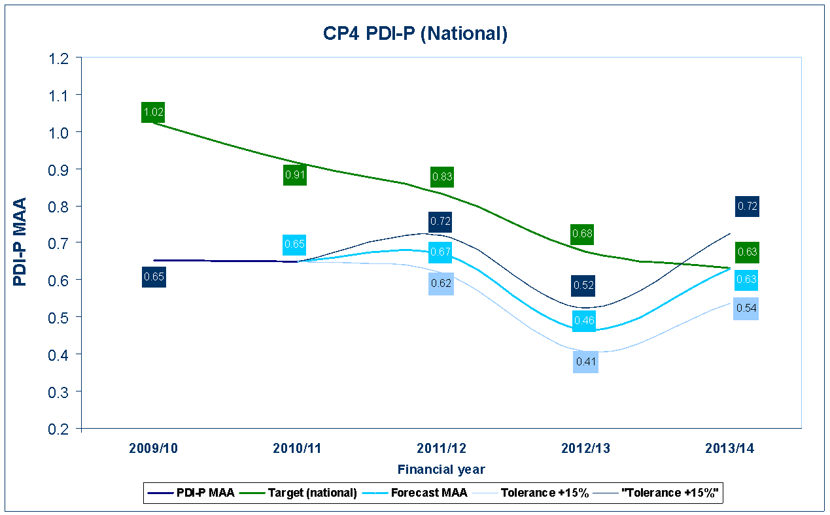
Figure 2 Possession Disruption Index - Passenger
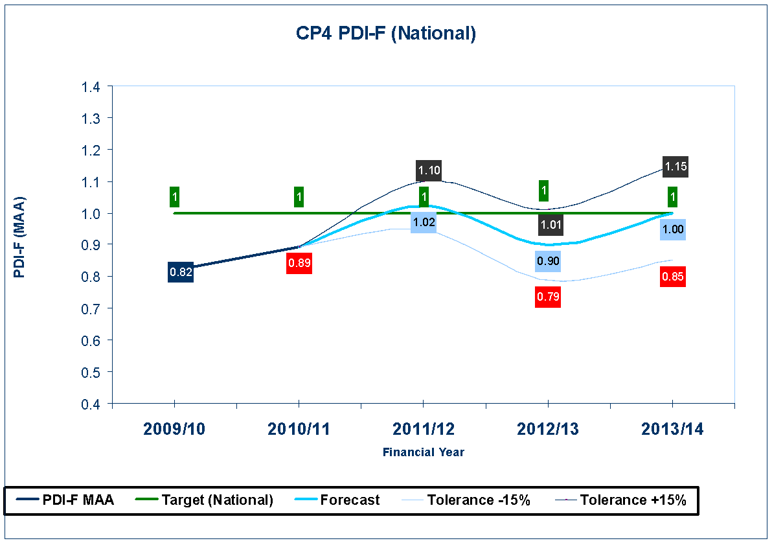
Figure 3 Possession Disruption Index – Freight

- The track glide path of reducing possession lengths has enabled the delivery of over 50% of track renewals in shorter possession durations compared with a figure of less than 25% in 2007/08.
- The successful implementation of maintenance initiatives such as rail head repair and lightweight stressing are helping to significantly reduce maintenance disruptive access requirements
- The packaging and programming of work such as Filton Bank, Bristol into efficient packages to minimise overall cost of delivering work, whilst minimising the overall disruption to our customers.
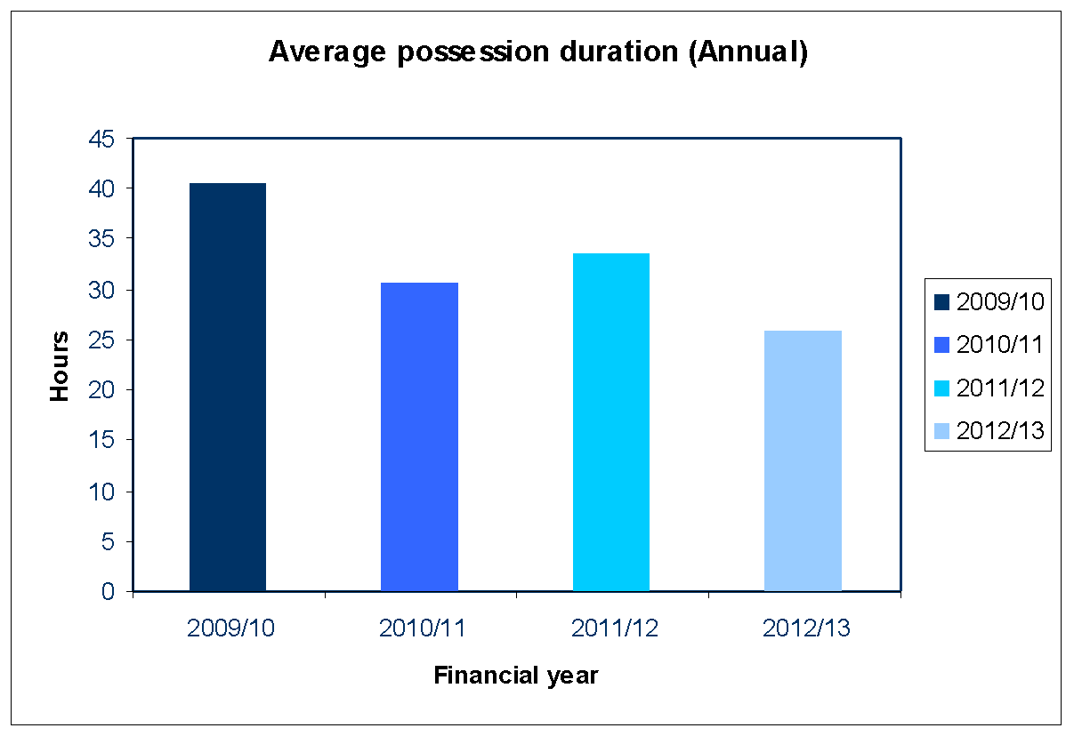
Figure 4 Average possession duration in hours (based on possessions of duration greater than 13 hours)
In addition, the re-profiling of renewals and enhancement works has to some extent contributed to the lower level of possessions being taken in the first 2 years of the control period. As a result of this re-profiling of works, it is likely that there will upward pressure on the PDIs towards the end of CP4. While we still expect to meet our regulated outputs for both PDI-P and PDI-F, we are continuing to analyse the impact on the PDIs of re-profiling to better understand this upward pressure. We have included in Figures 2 and 3 the impact of potential variations of 15% in the forecast PDIs to illustrate potential future uncertainties arising from the work profile revisions and to reflect uncertainty in possession plan information for the final two years of the control period which is less granular than 2011/12.
We will continue to monitor the PDI outputs regularly through our ongoing processes to reduce our possession footprint. We will continue to vigorously challenge disruptive possessions requests especially for 2013/14 to improve the PDI forecast of 2013/14.
Annex ‘B’ – Formal Consultation Emails

Subject: REQUEST - LNW12-CE-12 - AMENDMENT TO THE LNW NORTH CPPP Week 46 - 2012

AMENDMENT TO THE LONDON NORTH WESTERN NORTH CPPP Week 46 - 2012
NW1001 ARMITAGE JN (INCL) TO PRESTON (FYLDE JN.
NW1019 ACTON GRANGE JN. TO WARRINGTON STH. JN. (HELSBY LINES)
NW3003 CHESTER EAST JN TO ACTON GRANGE JN

EAP Reference: LNW12-LC-12

Due to the strategic decision to withdraw access from the north end of the WCML on the last bank holiday (week 9, 2011) Network Rail is seeking disruptive access to re-plan the lost worksites. The decision was taken due to the potential threat of air traffic being disrupted by volcanic ash, therefore the rail industry sought to provide an alternative Anglo-Scottish travelling opportunity for passengers. The delivery team has assessed opportunities to re-plan this work. Outlined below is the proposal to recover Acton Grange S&C work.

Week 46 of the LNW North CPPP will, if agreed, be amended to include:

Saturday 11 to Sunday 12 February
PPS Ref: P2011/1528980
At/Between: Preston Brook Tunnel and Warrington South Jn
Lines: Down and Up (Possession)
Times: 1330 Sat – 1500 Sun
and
At/Between: Runcorn East and Walton Old Jn
Lines: Down and Up (Possession)
Times: 1330 Sat – 1500 Sun

Traffic Remarks: WCML TRAINS TO START/TERMINATE AT CREWE AND WARRINGTON BANK QUAY. DIVERT DIESEL HAULED SERVICE VIA MANCHESTER AND CHAT MOSS.

ELLESMERE PORT SERVICE TO TERMINATE RUNCORN EAST. RAIL REPLACEMENT ROAD SERVICE TO OPERATE

CHESTER TO MANCHESTER SERVICE TO DIVERT VIA ALTRINCHAM. RAIL REPLACEMENT ROAD SERVICE TO OPERATE

ACCESS TO ARPLEY FROM WARRINGTON BANK QUAY VIA MSC SIDING (RUN ROUND). FIDDLERS FERRY TRAFFIC TO DIVERT VIA GARSTON (RUN ROUND) AND WEAVER. ANGLO-SCOTTISH FREIGHT TO DIVERT VIA MANCHESTER OR EAST COAST MAIN LINE.

STRUCTURE FOR THE AMENDED TRAIN PLAN
Network Rail requires operators to prepare a revised bid

Northern: Bid to terminate Ellesmere Port service at Runcorn East, rail replacement road service to operate.

ATW: Bid to divert services via Altrincham, rail replacement road service to operate.

VT: Bid to start/terminate WCML services at Warrington and Crewe. Divert Voyager service via Manchester and Chat Moss.

Freight: bid to retime or divert.

I look forward to receiving your formal response to the above proposal by close of play on Thursday 8th September.

This email is in accordance with Access Condition D3.4.2 and relates to Section 3.1 of the Timetable Planning Rules being the Procedure for Altering the Engineering Access Statement or Timetable Planning other than through the Twice-Yearly Process Having Effect from a Passenger Change Date.

Kind Regards,

Daniel Fredriksson
Access Planning Specialist

Subject: DECISION - LNW12-CE-12 - AMENDMENT TO THE LNW NORTH CPPP Week 46 – 2012

AMENDMENT TO THE LONDON NORTH WESTERN NORTH CPPP Week 46 - 2012
NW1001 ARMITAGE JN (INCL) TO PRESTON (FYLDE JN.
NW1019 ACTON GRANGE JN. TO WARRINGTON STH. JN. (HELSBY LINES)
NW3003 CHESTER EAST JN TO ACTON GRANGE JN

EAP Reference: LNW12-LC-12

Further to my email of Friday 25th August, and having given due consideration to responses received in terms of likely appeals from train operators to the decision to take access in week 46 in connection with Acton Grange. This email details Network Rail’s decision on the possession that is required between Preston Brook Tunnel and Warrington South Jn to deliver the required renewals. I can confirm that Network Rail will be making these late notice possession changes to the London North Western North 2012 EAS and subsequent CPPP.

Week 46 of the LNW North CPPP will be amended to include:

Saturday 11 to Sunday 12 February
PPS Ref: P2011/1528980
At/Between: Preston Brook Tunnel and Warrington South Jn
Lines: Down and Up (Possession)
Times: 1330 Sat – 1500 Sun
and
At/Between: Runcorn East and Walton Old Jn
Lines: Down and Up (Possession)
Times: 1330 Sat – 1500 Sun

Traffic Remarks: WCML TRAINS TO START/TERMINATE AT CREWE AND WARRINGTON BANK QUAY. DIVERT DIESEL HAULED SERVICE VIA MANCHESTER AND CHAT MOSS.

ELLESMERE PORT SERVICE TO TERMINATE RUNCORN EAST. RAIL REPLACEMENT ROAD SERVICE TO OPERATE.

CHESTER TO MANCHESTER SERVICE TO DIVERT VIA ALTRINCHAM. RAIL REPLACEMENT ROAD SERVICE TO OPERATE.

ACCESS TO ARPLEY FROM WARRINGTON BANK QUAY VIA MSC SIDING (RUN ROUND). FIDDLERS FERRY TRAFFIC TO DIVERT VIA GARSTON (RUN ROUND) AND WEAVER. ANGLO-SCOTTISH FREIGHT TO DIVERT VIA MANCHESTER OR EAST COAST MAIN LINE.

STRUCTURE FOR THE AMENDED TRAIN PLAN
Network Rail requires operators to prepare a revised bid

Northern: Bid to terminate Ellesmere Port service at Runcorn East, rail replacement road service to operate.

ATW: Bid to divert services via Altrincham, rail replacement road service to operate.

VT: Bid to start/terminate WCML services at Warrington and Crewe. Divert Voyager service via Manchester and Chat Moss.

Freight: bid to retime or divert.

I will now arrange for this amendment to be reflected in the relevant Weekly Operating Notice.

This email is in accordance with Access Condition D3.4.2 and relates to Section 3.1 of the Timetable Planning Rules being the Procedure for Altering the Engineering Access Statement or Timetable Planning other than through the Twice-Yearly Process Having Effect from a Passenger Change Date.

Kind Regards,

Daniel Fredriksson
Access Planning Specialist

Annex ‘C’ – Other Operator Responses
Virgin Trains
From: EXTL: Dunster Jonathan
Sent: 25 August 2011 14:37
To: [addresses redacted]
Cc: [addresses redacted]
Subject: Re: REQUEST - LNW12-CE-12 - AMENDMENT TO THE LNW NORTH CPPP Week 46 - 2012
Daniel
The proposal is unacceptable to Virgin Trains.
Kind regards
Jonathan Dunster
Head of Operations and Planning
Virgin Trains
DB Schenker
From: Wileman, Tim
Sent: 31 August 2011 14:11
To: Fredriksson Daniel
Cc: Wileman, Tim; Lewis, Richard
Subject: RE: REQUEST - LNW12-CE-12 - AMENDMENT TO THE LNW NORTH CPPP Week 46 - 2012

Daniel,

I confirm that DB Schenker agrees to this additional possession.

Regards,

Tim

Tim Wileman
Engineering Planning
DB Schenker

DRS
From: David McConnochie
Sent: 25 August 2011 14:48
To: Fredriksson Daniel
Subject: RE: REQUEST - LNW12-CE-12 - AMENDMENT TO THE LNW NORTH CPPP Week 46 - 2012
Dan,

As long as there is a W9 route (and path!!) available for 4M44 and 4M16 on the Saturday via the Chat Moss, Man Picc and Wilmslow then this is OK by DRS.

Regards,

David.

FLHH
From: EXTL: Hassall Chris
Sent: 25 August 2011 15:06
To: [addresses redacted]
Cc: [addresses redacted]
Subject: RE: REQUEST - LNW12-CE-12 - AMENDMENT TO THE LNW NORTH CPPP Week 46 - 2012
Daniel,

Noting the declined from Virgin Trains, we are less affected this time as you have more routes available at Warrington, so can accept as shown with the following trains affected.

We would lose the NDS service 6K65 ( please advise them will you) and the 4F03/4K04 empties would have to go back to Garston via Latchford RR.

6M11 appears able to run as booked as the limits are warrington Sth Jn and the 4F06 empties would thence run to Garston again via Latchford.

Regards
[Chris Hassall]

From: Fredriksson Daniel
To: [addresses redacted]
Cc: [addresses redacted]
Sent: Thu Aug 25 14:26:42 2011
Subject: REQUEST - LNW12-CE-12 - AMENDMENT TO THE LNW NORTH CPPP Week 46 - 2012

AMENDMENT TO THE LONDON NORTH WESTERN NORTH CPPP Week 46 - 2012
NW1001 ARMITAGE JN (INCL) TO PRESTON (FYLDE JN.
NW1019 ACTON GRANGE JN. TO WARRINGTON STH. JN. (HELSBY LINES)
NW3003 CHESTER EAST JN TO ACTON GRANGE JN

EAP Reference: LNW12-LC-12

Due to the strategic decision to withdraw access from the north end of the WCML on the last bank holiday (week 9, 2011) Network Rail is seeking disruptive access to re-plan the lost worksites. The decision was taken due to the potential threat of air traffic being disrupted by volcanic ash, therefore the rail industry sought to provide an alternative Anglo-Scottish travelling opportunity for passengers. The delivery team has assessed opportunities to re-plan this work. Outlined below is the proposal to recover Acton Grange S&C work.

Week 46 of the LNW North CPPP will, if agreed, be amended to include:

Saturday 11 to Sunday 12 February
PPS Ref: P2011/1528980
At/Between: Preston Brook Tunnel and Warrington South Jn
Lines: Down and Up (Possession)
Times: 1330 Sat – 1500 Sun
and
At/Between: Runcorn East and Walton Old Jn
Lines: Down and Up (Possession)
Times: 1330 Sat – 1500 Sun

Traffic Remarks: WCML TRAINS TO START/TERMINATE AT CREWE AND WARRINGTON BANK QUAY. DIVERT DIESEL HAULED SERVICE VIA MANCHESTER AND CHAT MOSS.
ELLESMERE PORT SERVICE TO TERMINATE RUNCORN EAST. RAIL REPLACEMENT ROAD SERVICE TO OPERATE
CHESTER TO MANCHESTER SERVICE TO DIVERT VIA ALTRINCHAM. RAIL REPLACEMENT ROAD SERVICE TO OPERATE
ACCESS TO ARPLEY FROM WARRINGTON BANK QUAY VIA MSC SIDING (RUN ROUND). FIDDLERS FERRY TRAFFIC TO DIVERT VIA GARSTON (RUN ROUND) AND WEAVER. ANGLO-SCOTTISH FREIGHT TO DIVERT VIA MANCHESTER OR EAST COAST MAIN LINE.

STRUCTURE FOR THE AMENDED TRAIN PLAN
Network Rail requires operators to prepare a revised bid
Northern: Bid to terminate Ellesmere Port service at Runcorn East, rail replacement road service to operate.
ATW: Bid to divert services via Altrincham, rail replacement road service to operate.
VT: Bid to start/terminate WCML services at Warrington and Crewe. Divert Voyager service via Manchester and Chat Moss.
Freight: bid to retime or divert.

I look forward to receiving your formal response to the above proposal by close of play on Thursday 8th September.

This email is in accordance with Access Condition D3.4.2 and relates to Section 3.1 of the Timetable Planning Rules being the Procedure for Altering the Engineering Access Statement or Timetable Planning other than through the Twice-Yearly Process Having Effect from a Passenger Change Date.

Kind Regards,

Daniel Fredriksson
Access Planning Specialist

Annex ‘D’ – Network Rail Response to ATW
Reply sent to Chris Dellard following clarification of the deferred work mentioned in a previous decision for EAS v2.1

Chris,

The renewal work in week 10 is required in order to carry out deferred track renewals work which had previously been dated across weeks 10 to 12 in 2011 planning year. This work was withdrawn as part of the changes that saw Winwick Jn S&C work introduced into the plan for week 9.

The Route Asset Management team agreed to defer this work at Warrington North in 2011 on the proviso that it would not be put back beyond a year. The resource allocation meant that this was best placed in week 10 of the 2012 planning year.

The access required for Acton Grange in week 46 requires wheels free access as it is for Signalling commissioning, therefore is not compatible with the possession in week 10. It is this signalling work that was cancelled at very late notice in week 9, 2011 due to the potential disruption to travellers between London and Scotland due to the volcanic ash clouds affecting air travel in the days leading up to the weekend in week 9.

The signalling commissioning work at Acton Grange is currently subject to a Temporary Non-Compliance notice; therefore we have revisited the plan for these weeks to see what could be done to accommodate this work in line with available resources. The TNC is in place because the ground frames and associated cross-overs were recovered in access in 2011 as planned. The remaining panel and interlocking work was due to be completed in week 9. As a consequence, the signallers’ panel does not currently represent actual infrastructure.

We appreciate that this does introduce significant additional pressures on your resources, but we have endeavoured to provide your team with sufficient time to plan this within industry deadlines and maintain Informed Traveller publication at T-12.

Regards,

Dan

From: EXTL: Dellard Chris
Sent: 25 August 2011 15:40
To: [addresses redacted]
Cc: Warr Joe; Allen Matthew; Evans Gary; Fitton Gary; Storrie David; NAU LNW; 'VT: Susan Nichol'; 'Thorpe, Steve'; Sebastian Barrow; Sarah Bolton; EXTL: Bolton Dean; Jonathan Goode; Nigel Williams; LNWNorthPlanning; Mohmed Suhail; Bulman Julie; Johnson Nathan; Bamford Amy; Dawson Helen; Freight - MK; DB Schenker - Leeds
Subject: RE: REQUEST - LNW12-CE-12 - AMENDMENT TO THE LNW NORTH CPPP Week 46 - 2012

Daniel,

Last month NR published a new 2-day possession for Week 10 which was for 'deferred renewal work' (I have pasted it below). Perhaps I misunderstood but I took that to be a replacement for the 2-day possession cancelled with barely any notice earlier this year due to the phantom ash cloud. Could you please explain what work is planned for both Week 10 and now Week 46 and how that relates to the work abandoned earlier this year.

Regards,

Chris

Week 10
NW1001
New possession created for deferred renewal work.

Saturday 02 June to Monday 04 June
PPS Ref: P2012/1488948
At/Between: Acton Grange Jn and Winwick Jn
Lines: All Lines (Possession (T3))
Times: 0600 Sat to 0500 Mon

Traffic Remarks: WCML TRAINS TO START/TERMINATE CREWE AND WIGAN. DIVERT DIESEL SERVICE VIA MANCHESTER. RAIL REPLACEMENT ROAD SERVICE TO OPERATE.
CHESTER TO MANCHESTER SERVICE TO DIVERT VIA ALTRINCHAM AND STOCKPORT. RAIL REPLACEMENT ROAD SERVICE TO OPERATE.
LIVERPOOL TO WARRINGTON SERVICE TO START/TERMINATE AT EARLESTOWN.
FREIGHT ACCESS INTO ARPLEY AVAILABLE ON HELSBY LINES.
Disruptive Work Content: Warrington PLTR DS

Annex ‘E’ – 24th August Proposed Changes to the Part D of the Network Code - Annex B extract from PfC60

4.6 The Decision Criteria

4.6.1 Where Network Rail is required to decide any matter in this Part D its objective shall be to share capacity on the Network for the safe carriage of passengers and goods in the most efficient and economical manner in the overall interest of current and prospective: users, providers and funders, of railway services (“the Objective”).

4.6.2 In achieving the Objective, Network Rail shall apply any or all of the considerations in paragraphs (a)-(j) below (“the Considerations”) in accordance with Condition D4.6.3 below:

(a) maintaining, developing and improving the capability of the Network;

(b) that the spread of services reflects demand;

(c) maintaining and improving train service performance;

(d) that journey times are as short as reasonably possible;

(e) maintaining and improving an integrated system of transport for passengers and goods;

(f) the commercial interests of Network Rail (apart from the terms of any maintenance contract entered into or proposed by Network Rail), any Timetable Participant and funder, of which Network Rail is aware;

(g) seeking consistency with any relevant Route Utilisation Strategy;

(h) that, as far as possible, International Paths included in the New Working Timetable at D-48 are not subsequently changed;

(i) mitigating Environmental Damage; and

(j) avoiding changes, as far as possible, to a Strategic Train Slot other than changes which are consistent with the intended purpose of the Strategic Path to which the Strategic Train Slot relates.

4.6.3 When applying the Considerations, Network Rail must consider which of them is or are relevant to the particular circumstances and apply those it has identified as relevant so as to reach a decision which is fair and is not unduly discriminatory as between any individual affected Timetable Participants or as between any individual affected Timetable Participants and Network Rail. Where, in light of the particular circumstances, Network Rail considers that application of two or more of the relevant Considerations will lead to a conflicting result then it must decide which of them is or are the most important in the circumstances and when applying it or them, do so with appropriate weight.

4.6.4 The Objective and the Considerations together form the Decision Criteria.

Consequential Amendment

Insert as a Definition in Part D:

“Environmental Damage shall have the meaning shown in Part E of this code.”

