West Coast Trains Ltd Sole submission to
‘The Timetabling Panel’
Dispute Reference TTP439
22nd September 2011

THE TEMPLATE
- DETAILS OF PARTIES
  - The names and addresses of the parties to the reference are as follows:-
    - West Coast Trains Ltd. (Company number 3007940) whose Registered Office is at The School House, 50 Brook Green, London W6 7RR (“WCTL” - "the Claimant"); and
    - WCTL contact details are Robert Hodgkinson, Commercial operations Manager, North Wing Offices, Euston Station, London, NW1 2HS
    - Correspondence address for Network Rail - Joe Warr, Lead Access Planner, Engineering Access Planning, 4th Floor, 500 Station House, Elder Gate, Milton Keynes. MK9 1BB Email [redacted]
  - Third parties that may be affected by the Panel finding in any of the ways sought and determined under Section 8 are as follows:
    - DB Schenker
    - First Keolis (TransPennine Express)
    - Freightliner Group
    - GBRf
    - Northern Rail
    - Direct Rail Services

- THE CLAIMANT’S’ RIGHT TO BRING THIS REFERENCE
  - These matters are referred to the Timetabling Panel ("the TTP") for determination in accordance with Conditions D3.4.5 and D5.1.of the Network Code (as applicable to the July 2011 Re-Issue) and Section 3.5.4. of the National Rules of the Plan (the ‘ROTP’. – Annexes “K” & “L” refer.

- CONTENTS OF REFERENCE
This Sole Reference includes:-
    - The subject matter of the dispute in Section 4;
    - A summary of the issues in dispute in Section 5;
    - A detailed explanation of those issues in dispute prepared by the claimant in Section 6 (with a section outlining the dispute issues in association with Decision Criteria);
    - Any further issues raised by the respondent in Section 7;
    - In Section 8, the decisions of principle sought from the Panel in respect of
      - legal entitlement and
      - remedies;
    - Appendices and other supporting material.

- SUBJECT MATTER OF DISPUTE
  - The principle issue at the heart of this West Coast Trains Ltd (WCTL) submission, is the affect of two late notice section 7 engineering possession items, proposed by Network Rail (London North Western – LNW) on 12th August 2011 for two weekends in January 2012; these being confirmed later, through decision documentation sent out on the 1st September 2011 – (Annexes A & B refer).
  - These possessions were originally planned to take place in engineering week 9 of 2011 (Saturday 28th and Sunday 29th May) but were cancelled at short notice due to the potential of air traffic disruption, resultant from an Icelandic volcanic ash cloud event. The resultant impact of re-dating these possessions from a Bank Holiday to a normal weekend will ultimately see a detrimental affect on WCTL business & operations, specifically weekend Anglo-Scottish operations.
  - WCTL does not consider that Network Rail, in consideration of its proposals, has taken due cognisance of industry accepted principles associated with its ‘7–Day Railway’ vision. As a consequence, WCTL will be unable to operate its Firm Contractual Rights (FCR), such rights being those principal Anglo-Scottish train services (service groups HF06 and HF08) as contained within WCTL Track Access Agreement, Schedule 5, dated 12th December 2008 – (Annex ‘C’ refers) and Franchise Agreement (Annex “O” refers).
  - WCTL has attempted to work with Network Rail and other operators to reach an acceptable solution to the re-dating of this work, but to no avail. We have since been advised of additional related disruption which has recently been proposed, which is subject to a separate dispute hearing (ADRC ref TTP441). WCTL has received no viable reasoning, and consequently has no confidence in, Network Rail’s requirement to undertake such works at these particular times, and whether, indeed, they have sufficiently planned and/or available resources in place with which to carry out such work.
4.5 Such lack of confidence relates to the fact that it has now taken Network Rail almost 4 months to re-plan such work, thus now placing a significant risk on WCTL meeting its Informed Traveller timescales in terms of being able to deliver robust timetable information to its customers. In outline, WCTL considers that the onus is now on Network Rail to prove both how & why they have arrived at such proposals, when having due regard to Decision Criteria D4.6.1{a} - (Network Code D4.6 – including the newly proposed part D4.6.1 of the Decision Criteria issued in October 2010 - Annexes “D” & “P” refer).
- SUMMARY OF DISPUTE
5.1 The fundamental basis behind the Rail Industry’s £9bn WCML upgrade was to vastly improve journey times, alongside improved access opportunities particularly for weekend travel in conjunction with its 7-Day Railway Vision, (see extracts from Network Rail’s Network Statement 2012, 2007 Business Plan and efficient engineering Access ‘EEA’ – Annex ‘E’ refers to all). However, to reach such a position, it has transpired over the last few years, that a compromise has had to be reached with Network Rail, which would allow them additional qualitative access opportunities to undertake major work, but only during Bank Holiday weekend periods (alongside historically acceptable standard weekend periods - i.e. during Spring & early Summer and Autumn – see Para 5.4 below for further details). Whilst this affects an ever increasing number of passengers travelling during Bank Holiday periods, they are nonetheless, the only viable alternative to undertake such work that would otherwise require a number of additional standard weekend engineering closures.
  - With Network Rail taking the approach to undertake most major work during Bank Holidays, coupled with other historically planned work primarily factored around 7-Day Railway and Effective Engineering access (EEA) principles (Annex “E” part refers), has allowed WCTL to grow its weekend passenger market significantly, in the full knowledge that its customer’s travel arrangements, by exception, will for the most part, only be affected during Bank Holiday weekends when some train services are either diverted and/or replaced by road transport.
  - With Network Rail now re-proposing additional possessions between Oxenholme and Penrith, between the hours of 1320 Saturday and 1455 Sunday, over two consecutive weekends in Period B (weeks 41 & 42¹ – 7th / 8th January & 14th /15th January 2012, resultant from the cancelling of work over the Spring Bank Holiday weekend in week 9 – 28th / 29th May 2011), the consequential effect is that WCTL is no longer able to operate services between Preston and Glasgow on these two Saturday (pm). as well as Sunday (am).
5.4 Therefore, aside from the obvious impact and risk with Informed Traveller timescales, (which is explained in more detail in sections 6.8 & 6.9), the affect of these works on Anglo-Scottish train services is additional to those significant number of standard weekend opportunities that are already planned for 2012 – see below for primary examples:
- Lancaster & Carnforth (2105 -1115) Periods B & C – Annex ‘F’ refers ~
necessitating the retiming of some early & late services.
- Gretna Jn to Lockerbie (1945 Sat to 1215 Sun) Period “D” – Annex “G” refers
necessitating the retiming of an increased number of early & late services, with limited diversions via the S&C.
- Weaver Jn to Golborne (1335 Sat to 1500 Sun) Period “H” – Annex “H” part refers
necessitating the diversion of services via Manchester.
- as well as significant work during Easter, May Day and Spring Bank Holidays. – Annex “H” part refers
necessitating the diversion of services either via Manchester and / or S&C.
......thus amounting to already an approximate 24 weekends of varying Anglo-Scottish train service disruption.
¹ For reference, Network Rail has also proposed additional disruption in the Warrington area in week 46 which is deferred from week 9 (to be heard at a separate hearing ref TTP441).
5.5 On this basis, WCTL has no other alternative but to decline such proposals due to the amount of significant disruption already planned over the same route for the 2012 timetable year, coupled with those issues already highlighted, namely the risk to informed traveller timescales, non visibility of Network Rail’s motives for leaving the decision to take such weekends so late (i.e. its business case, as set out in its Engineering Access Statement – “Guidelines for Granting Possessions” – Annex ‘I’ refers), and the lack of clarity over resources and optimisation of other possession opportunities.

- EXPLANATION OF EACH ISSUE IN DISPUTE AND THE CLAIMANT’S ARGUMENTS TO SUPPORT ITS CASE
  - WCTL fully recognises that these works need to be undertaken at some juncture and has been consistently working with Network Rail to find a suitable opportunity to accommodate the re-planning of such work – discussions took place in June & July earlier this year. WCTL considers that such work, which was originally intended to be undertaken during a Bank Holiday period, still requires a likewise opportunity and is the most optimal and sensible solution, where only one complete weekend of disruption would be involved; rather than the potential for additional weekends, as is hereby proposed.
  - Taking cognisance of Para 6.1, WCTL, like all Train Operators (TOC’s) has been acutely aware that actually the ideal time for network closures are over the Christmas period ( ie, 25th & 26th December) when effectively (by exception) no trains operate over the route with peripheral disruption being negligible. However, we have been previously made aware that significant major work is already planned to be undertaken during these dates around the Network and on the WCML, (see Annex ‘J’ for a map of Christmas WCML activity), and therefore spare resources would not available for undertaking any further work.
  - WCTL therefore requested of Network Rail, that they reconsider doing the work on one or more of the days after the Christmas shutdown, such as the 27th or 28th December 2011 when there is not a great deal of work currently planned. As highlighted above, such timeframe is during a period when leisure customers tend to expect such disruption, and therefore we would anticipate them, based on previous experience, to make alternative travel arrangements, in this case either later in the week or using a combination of alternative road & rail modes.

6.4 We have also alternatively suggested to Network Rail that they investigate either undertaking this work on 1st January 2012 or later on during the Christmas week (29th & 30th December), again at a time when leisure customers would expect some element of disruption. Furthermore, WCTL has in addition, for example, suggested future 2012 Bank Holidays, such as Easter Saturday, when the route on Easter Sunday is already blocked through to Scotland, as well as possibly May Day & Spring Bank subject to other works taking place.
6.5 We are also conscious that to enable this work in weeks 41 & 42 to be undertaken, Network Rail will have to cancel possession(s) elsewhere, in order to release sufficient resources necessary to undertake the work; (this was verbally discussed at a meeting chaired by Network Rail with TOC’s on 14th September 2011, but unfortunately no minutes have ever been released pertaining to such discussions – out-with the e-mail supplied by Network Rail in Annex “R” refers.
6.6 Network Rail have not expanded on where such resources will come from and which ‘other’ work will be affected by the release of such resources; accordingly WCTL is concerned that the work between Oxenholme and Penrith is being planned by Network Rail without them knowing the full extent of what resources are actually available, and is thus another example of late notifications² for possessions where access appears to take precedence before resources and optimisation of work is potentially known. Furthermore, the business case that should underpin one or more of those reasons where late possession requests are to be considered, (including the setting out of those reasons for applying appropriate Decision Criteria where necessary), has never been presented to us or other TOC’s (see Part 3.2.2 pertaining to Annex ‘I’).
  - It is also crucial to highlight the fact that despite the Late Decision Notification being advised to WCTL late on Thursday 1st September (Annex ‘B’ refers), we had already been contractually obliged to submit our timetable bid for week 41 by Friday 2nd September, with Week 42 following by Friday 9th September. As a result of such late notification, WCTL was in no position at that time, to submit revised bids (i.e. those containing revised train services pertaining to these late engineering works) within the contractual timeframe.

² For reference Network Rail has already submitted nationally approx 1350 late notice possession requests since December 2010, (expected to rise to 1750 by December 2011) which would see a rise of over 40% from 991 since the 2008-09 timetable year – see our request for further Remedy; under Section 8.2.2 below.

  - We are naturally concerned that as a result of this late notification, we will not be able to meet Informed Traveller (T-12) timescales for those services in weeks 41 & 42, as both of these weeks now require a timetable re-write; this issue being aside from our lack of confidence in whether Network Rail actually has the timetabling resources within the Informed Traveller timetable team to actually re-plan this work, (and, dependant upon the determination of this hearing, possibly re-plan back the work applicable to an open railway)?
6.9 In order to highlight the affect on our business and customers by taking such late notice possessions, we would, as a prime example of rolling stock constraints, have to re-diagram all applicable Anglo-Scottish services (with resultant knock-on affects to other traffic flows), in order to release diesel units for limited diversions via the S&C as well as starting / terminating services at Oxenholme & Preston in the south and Penrith / Carlisle in the North. This is aside from consequential resourcing & diagramming issues of traincrew & catering staff alongside marketing /reservation system issues that go hand in hand with late notice amendments to train-plan(s).
6.10 WCTL therefore considers that Network Rail, in this particular circumstance of late notification proposals outside the ‘twice yearly rules process’, is in breach of clauses 3.4.7 and 3.4.10 of the Network Code (Annex ‘K’ refers) in association with ‘The Planning Rules’ part 3.1.2 (Annex ‘L’ refers), which state in combination that “....wherever possible, Network Rail will consult with TOC’s in sufficient time so as to allow such possessions to be proposed within the Confirmed Period Possession Plan (CPPP) process, thereby enabling TOC’s to submit revised Access Proposals no later than TW-18, so as to achieve {i.e. without deviation) Network Rail’s commitment to allow revised train services to be available to customers by T-12”..... Taking either possession proposal, both were submitted at T-18/T-19, which despite any best intentions, is outside due process and thus unachievable in terms of meeting informed traveller timescales.
6.11 Furthermore, it also appears (Annex “R” refers) that Network Rail have based part of their decision making process for these proposals, on the assumption that January represents that period when TOC’s carry their lowest number of passengers, and is therefore the least disruptive in overall terms to the industry.
6.12 Once again, just to re-iterate, there is now an established recognition throughout the Industry that weekend travel opportunities are just as important as weekdays irrespective of ‘time of year’. Network Rail has been funded and is thus committed to achieving a regulated network availability output improvement, during Control Period 4 (CP4), of 37% for Passenger services, such requirement seeing them introducing a “Network Availability Implementation and Delivery Plan (NAIP)”, where the principles of a Seven Day Railway [7DR] over a ‘Top 20’ set of routes, (which includes the whole of the WCML) has now been introduced.
6.13 To put all this into some context WCTL has seen its rail / air market share of Anglo-Scottish flows rise between 2004 and 2010 to an average 29% on West Midland flows and 21% on London flows. In passenger load terms, the Anglo-Scottish flows have seen loadings rise by over 55%. With the WCML being Britain’s busiest railway, and with WCTL passenger numbers rising from 13.6m to 28.2m actual journeys in the last year, it is also experiencing increasing and at times unprecedented levels of overcrowding.
6.14 Whilst we are content to provide Anglo-Scottish passenger load figures for January last year as a means of comparison, (Annex ‘M’ refers - to be redacted for the Chairman’s use only, due to confidentiality reasons associated with the ongoing franchise bid), the principle here is that WCTL is operating a service all year round and it should not, taking into consideration its rights as well as its ongoing quest to grow Anglo-Scottish traffic along the WCML, be prevented from providing efficient services of economic value, purely on the basis of the time of year.
[It is worth noting at this juncture, that although the ECML is not blocked on these weekends the service pattern changes recently introduced, provide no direct London-Glasgow service (except first & last services). The net result of this being, that there would be no ‘direct’ Anglo-Scottish route available to passengers other than a few token services].
6.15 In view of previous approaches to written submissions in conjunction with Network Rail taking due regard of Decision Criteria, alongside the view of the Chairman in the determination of TTP376/377, in that Decision Criteria should be applied reasonably (i.e. with appropriate weight), taking cognisance of the circumstances involved (Annex “P” refers), and consequently the recent change to Part D4.6.1 – Part 8; we consider it of value to the Panel in highlighting WCTL considerations in relation to the context within which Network Rail have perhaps applied relevant current Decision Criteria to such late notification proposals; we indicate such views below:
PRIMARY CRITERIA
    - a) Sharing the capacity and securing the development, of the network for the carriage of passengers in the most efficient and economical manner in the interests of all users of the railway D4.6.1 & D4.6.1a. –
The most efficient and economical manner in which to undertake these original Bank Holiday possessions, now re-proposed in standard weekends, is to re-plan the work into other Bank Holiday periods when the WCML is already blocked, rather than cause additional further disruption on top of the number of standard weekend opportunities already planned ~ Paras 6.1 to 6.14 throughout refer.
PERTINENT SUPPLEMENTARY CRITERIA
    - c) enabling a Timetable Participant to comply with any contract to which it is party D4.6.1c
- WCTL will be unable to comply with its Firm Rights as contained within Schedule 5 of its TAA if these proposals went ahead. Whilst our Rights permit us to operate Anglo-Scottish services throughout the week, Part 7.1 of Schedule 5 does also allow Network Rail to take possessions where necessary - (Annex ‘N’ refers). However it is Network Rails responsibility to apply Decision Criteria dutifully in conjunction with overall Industry affect; to this end we have proposed to Network Rail alternative possession dates which maxims the rights to which we are entitled, whilst balancing Network Rail’s need to undertake such renewal work. We have received no response as to why alternate proposals are not acceptable ~ Paras 4.3 & 6.6 refer.
ii) Under schedule 1.2, paragraph 9.1 (B) of WCTL current Franchise Agreement, WCTL has “.....an obligation to use all endeavours to operate railway passenger services taking reasonable measures to avoid/or reduce the impact of any disruption to its services, having regard to all the circumstances referred to in paragraph 9.2 (A).these being ‘...Variations in operating conditions (including Network Rail’s infrastructure not being available for any reason)....” WCTL considers that its alternative possession proposals, fulfil its obligations in respect to its franchise obligation ~ Paras 6.3 & 6.4 refer.
iii) WCTL is obliged to comply with both its TAA (Clause 5 and Schedule 5) and Franchise agreement, in terms of bidding compliantly in conjunction with those defined requirements as set out in Network Code Part “D” & The Planning Rules, particularly in relation to meeting its obligations relative to Informed Traveller timescale requirements. WCTL does not see how, in view of the proposals provided for here-in, how we can comply with such obligations ~ Para 6.10 refers
    - d) To maintain and improve the levels of service reliability D4.6.1d.
During any time when routes are closed or significantly reduced (in terms of capacity), for engineering work requirements, the probability of importing significant additional risk into the operations of train services is always liable to be higher than during periods of normal operation. Performance & Safety issues tend to increase, with overcrowding and delays, due to operating heavily reduced services over non electrified diversionary routes (S&C). The question remains why this work is not being carried out in Bank Holiday periods when disruptive access already stops WCTL from operating their Anglo – Scottish services ~ Para 6.9 refers
    - f) To maintain and improve connections between railway passenger services D4.6.1f.
During the proposed works in weeks 41 & 42, WCTL will operate a limited service over the S&C diversionary route. This diversion adds approximately 90 minutes to the overall journey time and would significantly impact on customer connection times at key locations such as Preston and Carlisle as well as other stations further down the line. Additionally, during hours in which there was no direct route, customers would be forced to make additional connections onto rail replacement transport. Furthermore as a result of changes to the ECML timetable (with the exception of a token service) there would be no direct alternative direct service from London on the ECML during the proposed possession weekends on the WCML ~ Paras 6.9 & 6.14 refer
    - g) To avoid a material deterioration of its service patterns and frequencies D4.6.1g.
Any block of the WCML has an onerous affect on the service pattern, frequency & travel opportunities for long distance passengers. The limited direct service that we would be obliged to operate over the S&C diversionary route would have to utilise 5 or 10 Car Voyager diesel units rather than 9 / 11-Car Pendolino electric units, which might cause overcrowding. Also over these two weekends we would have to operate a rail replacement shuttle between Oxenholme & Penrith. ~ Para 6.9 refers
    - i) Ensuring that where practicable, appropriate provision is made for reservation of capacity to meet the needs of the timetable participant D4.6.1i.
WCTL were not able to bid compliantly for this possession due to the late notification. Any later submission of our re-bid, might prevent us from securing the necessary capacity over the S&C, and the reservation suitable train paths to and from Oxenholme and Penrith, as we would tend to be, under these circumstances ‘last onto the graph’ ~ Paras 6.8 & 6.10 refer

6.16.7 j) Enabling operators of trains to utilise their assets efficiently and avoid having to increase such assets D4.6.1j
Whenever the WCML is blocked there is an inherent need to terminate and start back both sides of the blockade, complemented by rail replacement shuttles. Additionally, there is the need to resource diversions over the S&C . WCTL does not see this as a viable and efficient use of assets given that if the work was to take place during a Bank Holiday period, when a considerable less number of customers are likely to be travelling, alongside when assets would be already reallocated,. WCTL will also have to provide additional staff alongside the Rail Replacement Services, in order to maintain connections around the blockade. For the diverted services there would be the additional journey times requiring additional rolling stock and traincrew to cover the longer diagrams and additional hours worked. ~ Paras 6.9 & 6.14 refer
6.16.8 j) Avoiding wherever practicable frequent timetable change in part for railway participant
The WCML north of Weaver Jn is already disrupted in some form for approximately 24 weeks of the year. A further two weekends of disruption in weeks 41 & 42 further compounds this, in a year when, due to the Olympics we already have a further three timetable date-sets. WCTL has spent a lot of time working with Network Rail in the earlier planning stages of the 2012 Engineering Access Statement (EAS), in getting the level of disruption to acceptable levels and thus negating the need for too many timetable changes. WCTL believes that the level of late notice disruptive access is increasing at concerning levels and that Network Rail do not seem to be tackling this problem. ~ Paras 6.6, 6.8 & 6.10 refer.

7. ANY FURTHER ISSUES RAISED
  - WCTL has no items to raise under this Section 7.

8. DECISION SOUGHT FROM THE PANEL
  - WCTL seeks the following outcome from the Panel’s Determination:
    - That the possessions in Weeks 41 & 42 between Oxenholme & Penrith (PPS Ref Nos. 1528978 & 1528979) are cancelled, and consequently withdrawn from the applicable ‘Rules’.
  - .1 The remedy to this issue upon cancellation of the works in weeks 41 & 42, following a re-appraisal of the most suitable period within which to undertake these applicable works, in conjunction with affected Train Operators, is that Network Rail re-propose them into an appropriate Bank Holiday period within applicable planning timescales.
8.2.2 A further supplementary remedy, to the overall subject matter here in dispute and relevant to the apparent lack of control within Network Rail of the Late Notification process, is the requirement to bring some discipline to the sheer volume of late submissions, a process so provided for in the EAS – (See Para 6.9 footnote ² for details).

- APPENDICES AND ANNEXES
WCTL confirms that they have complied with Rule H.21 of the Access Dispute Resolution Rules, which requires that
- the relevant extracts of contractual Documents containing the provision(s) under which the referral to the Timetabling Panel arises and/or provisions associated with the substance of the dispute, namely:
Annex “A” Proposal Documentation pertaining to weeks 41 and 42;
Annex “B” Decision Documentation pertaining to weeks 41 and 42;
Annex “C” WCTL Contractual Firm Access Rights taken from Schedule 5 of its 2008 Track Access Agreement (Extracts);
Annex “D” Relevant paragraphs relating to Network Code D.6 [Decision Criteria];
Annex “K” Relevant paragraphs relating to Network Code D3.4.7 , D3.5.2 & 5.1;
Annex “L” Extracts from applicable sections of the 2012 National Rules of the Plan (ROTP);
Annex “N” Part 7.1 of Schedule 5 of WCTL 2008 Track Access Agreement.
Annex “O” Extracts from WCTL Service Level Commitments with the DfT;

- relevant extracts of any other Documents referred to in the reference, namely:
Annex “E” Extracts from applicable sections of Network Rail’s SSSG and 7 Day Railway documentation;
Annex “F” Examples of similar Engineering work in period “B”;
Annex “G” Examples of similar Engineering work in period “D””;
Annex “H” Examples of similar Engineering work in period “H”;
Annex “I” Relevant extracts from Network Rail’s Engineering Access Statement,
Annex “J” Map of Engineering works over the Christmas 2011 period;
Annex “M” Weekend Passenger Load figures for Anglo-Scottish Traffic in January 2011
Annex “P” Extract from the Determination of TTP376/7 – Decision criteria refers
Annex “Q” Copy of e-mail from Network Rail relating to why they are proposing the Late Notification proposals
Annex “R” Map of WCTL Services and Routes
10 SIGNATURES
The Claimant

For and on behalf of
West Coast Trains Limited (‘Virgin Trains’)
___________________________________
Signed

-----------------------------------------------------------
Robert Hodgkinson
___________________________________
Commercial Operations Manager

___________________________________

ANNEX “A”
From: Fredriksson Daniel
Sent: 12 August 2011 18:42
To: [operators’ addresses redacted] Cc: Warr Joe; Allen Matthew; Evans Gary; Fitton Gary; Storrie David; NAU LNW; Nichol, Susan; Thorpe, Steve
Subject: REQUEST - LNW12-LC-02 - AMENDMENT TO THE LONDON NORTH WESTERN NORTH CPPP WEEK 41 AND 42 2012

AMENDMENT TO THE LONDON NORTH WESTERN NORTH CPPP
NW4001 PRESTON (RIBBLE JN) TO COVE L.C. (INC GDS LINE UPPERBY)
EAP Reference: LNW12-LC-02
Due to the strategic decision to withdraw access from the north end of the WCML on the last bank holiday (week 9, 2011) Network Rail is seeking disruptive access to re-plan the lost worksites. The decision was taken due to the potential threat of air traffic being disrupted by volcanic ash, therefore the rail industry sought to provide an alternative Anglo-Scottish travelling opportunity for passengers. The delivery team has assessed opportunities to re-plan this work. Outlined below is the proposal to recover S&C renewals at Shap.

Week 41 of the LNW North CPPP will, if agreed, be amended to include:
Saturday 7th January to Sunday 8th January
PPS Ref: P2012/TBA
At/Between: Oxenholme and Penrith
Lines: All lines
Times: 1305 Sat to 1455 Sun
Traffic Remarks: TRAINS TO START / TERMINATE AT OXENHOLME AND PENRITH. RAIL REPLACEMENT ROAD SERVICE TO OPERATE. FREIGHT TO BE DIVERTED VIA ECML OR SETTLE AND CARLISLE LINE.
NOTE: Special Operating Instructions to be written to allow Up Trains to start from Platform 2 at Oxenholme.

Week 42 of the LNW North CPPP will, if agreed, be amended to include:
Saturday 14th January to Sunday 15th January
PPS Ref: P2012/TBA
At/Between: Oxenholme and Penrith
Lines: All lines
Times: 1305 Sat to 1455 Sun
Traffic Remarks: TRAINS TO START / TERMINATE AT OXENHOLME AND PENRITH. RAIL REPLACEMENT ROAD SERVICE TO OPERATE. FREIGHT TO BE DIVERTED VIA ECML OR SETTLE AND CARLISLE LINE.

NOTE: Special Operating Instructions to be written to allow Up Trains to start from Platform 2 at Oxenholme.

I look forward to receiving your formal response to the above proposal by Friday 26th August.
This email is in accordance with Access Condition D3.4.2 and relates to Section 3.1 of the Timetable Planning Rules being the Procedure for Altering the Engineering Access Statement or Timetable Planning other than through the Twice-Yearly Process Having Effect from a Passenger Change Date.

Kind Regards,
Daniel Fredriksson
Access Planning Specialist

ANNEX “B”
From: Fredriksson Daniel
Sent: 01 September 2011 16:45
To: [operators’ addresses redacted]
Cc: Warr Joe; Allen Matthew; Evans Gary; Fitton Gary; Storrie David; NAU LNW; Thorpe, Steve; Preston Chris (AOPC Lancs & Cumbria); Bamford Amy; Bulman Julie; Johnson Nathan; Dawson Helen; Freight - MK; DB Schenker - Leeds
Subject: DECISION - LNW12-LC-02 - AMENDMENT TO THE LONDON NORTH WESTERN NORTH CPPP WEEK 41 AND 42 2012

AMENDMENT TO THE LONDON NORTH WESTERN NORTH CPPP
NW4001 PRESTON (RIBBLE JN) TO COVE L.C. (INC GDS LINE UPPERBY)
EAP Reference: LNW12-LC-02
Further to my email of Friday 12th August, and having given due consideration to responses received in terms of likely appeals from train operators to the decision to take access in weeks 41 and 42 in connection with Shap S&C renewals. This email details Network Rail’s decision on the possessions that are required between Oxenholme and Penrith to deliver the required renewals. I can confirm that Network Rail will be making these late notice possession changes to the London North Western North 2012 EAS and subsequent CPPP.

Week 41 Saturday 7th January to Sunday 8th January
PPS Ref: P2012/1528978
At/Between: Oxenholme and Penrith
Lines: All lines
Times: 1320 Sat to 1455 Sun
Traffic Remarks: TRAINS TO START / TERMINATE AT OXENHOLME AND PENRITH. RAIL REPLACEMENT ROAD SERVICE TO OPERATE. FREIGHT TO BE DIVERTED VIA ECML OR SETTLE AND CARLISLE LINE.

NOTE: Special Operating Instructions to be written to allow Up Trains to start from Platform 2 at Oxenholme.

Week 42 Saturday 14th January to Sunday 15th January
PPS Ref: P2012/1528979
At/Between: Oxenholme and Penrith
Lines: All lines
Times: 1320 Sat to 1455 Sun
Traffic Remarks: TRAINS TO START / TERMINATE AT OXENHOLME AND PENRITH. RAIL REPLACEMENT ROAD SERVICE TO OPERATE. FREIGHT TO BE DIVERTED VIA ECML OR SETTLE AND CARLISLE LINE.
NOTE: Special Operating Instructions to be written to allow Up Trains to start from Platform 2 at Oxenholme.

I will now arrange for this to be reflected in the relevant Weekly Operating Notice.

This email is in accordance with Access Condition D3.4.2 and relates to Section 3.1 of the Timetable Planning Rules being the Procedure for Altering the Engineering Access Statement or Timetable Planning other than through the Twice-Yearly Process Having Effect from a Passenger Change Date.

Kind Regards,
Daniel Fredriksson
Access Planning Specialist

ANNEX “C”
Table 2.1: Passenger Train Slots
1 |  |  |  |  | 2
Service Group 6: London Euston to Preston, Lancaster and Glasgow Central
Service description |  |  |  |  | Passenger Train Slots
From | To | Via | Description | TSC | Weekday | Saturday | Sunday
London Euston | Glasgow Central | N/A | HF06.1 | 22112001 | 10^{3 7th} | 13 | 11
 |  |  | HF06.2 | 22112001 | 3¹ | N/A | N/A
 |  |  | HF06.3 | 22112001 | 1 | N/A | N/A
Glasgow Central | London Euston | N/A | HF06.4 | 22112001 | 9 | 10 | 9
 |  |  | HF06.5 | 22112001 | 2 | 4 | N/A
 |  |  | HF06.6 | 22112001 | 2 | N/A | N/A
London Euston | Lancaster | N/A | HF06.7 | 22112001 | 3 | N/A | N/A
 | Preston | N/A | HF06.8 | 22112001 | 2^{4 7th} | 2 | 2
Preston | London Euston | N/A | HF06.9 | 22112001 | 2^{5 7th} | N/A | 3
Lancaster | London Euston | N/A | HF06.10 | 22112001 | 3 | 1 | N/A
Lancaster | Crewe | N/A | HF06.11 | 22112001 | 1² | N/A | N/A
Notes to Table:

¹ Of these Services, one shall be Scheduled to terminate at Preston.

² This Service shall be Scheduled to couple at Crewe with the first Service of each Weekday originating from Holyhead in Service Group HF02.4 so as to form a through Service from each of Lancaster to London Euston and Holyhead to Euston.

³ 11 on Friday Only^{7th}

⁴ 3 on Friday Only^{7th}

⁵ 3 on Friday Only^{7th}
ANNEX “C” Cont....
Table 2.1: Passenger Train Slots
1 |  |  |  |  | 2
Service Group 8: Birmingham New Street to Preston, Glasgow Central and Edinburgh; Rugby, Crewe and Preston to Glasgow Central; and Crewe to Preston
Service description |  |  |  |  | Passenger Train Slots
From | To | Via | Description | TSC | Weekday | Saturday | Sunday
Birmingham New Street | Glasgow Central | N/A | HF08.1 | 22114001 | 7 | 6 | 6
Glasgow Central | Birmingham New Street | N/A | HF08.2 | 22114001 | 7 | 8 | 4
Birmingham New Street | Edinburgh | N/A | HF08.3 | 22114001 | 7 | 6 | 5
Edinburgh | Birmingham New Street | N/A | HF08.4 | 22114001 | 7 | 7 | 5
Crewe | Glasgow Central | N/A | HF08.5 | 22114001 | 1 | 1 | 1³
Lancaster | Birmingham New Street | N/A | HF08.6 | 22114001 | 2¹ | 2¹ | 3⁴
Glasgow Central | Crewe | N/A | HF08.8 | 22114001 | 1 | N/A | 1
Birmingham New Street | Preston | N/A | HF08.7 | 22114001 | 2 | 3² | 3
Note to Table:

¹ Of these Services, one shall be Scheduled to start from Preston.
² Of these Services, the last one shall be Scheduled to terminate at Crewe.
³ This Service shall be Scheduled to terminate at Lancaster.
⁴ Of these Services, the first two shall be Scheduled to start at Preston.

ANNEX “D”

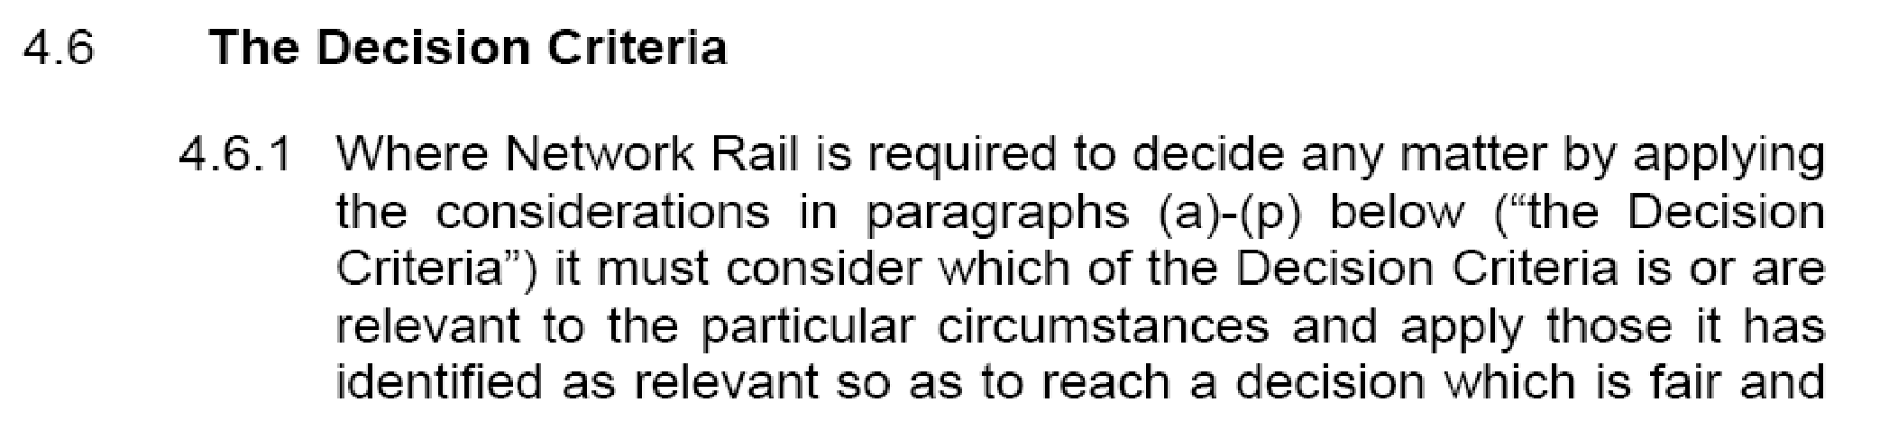
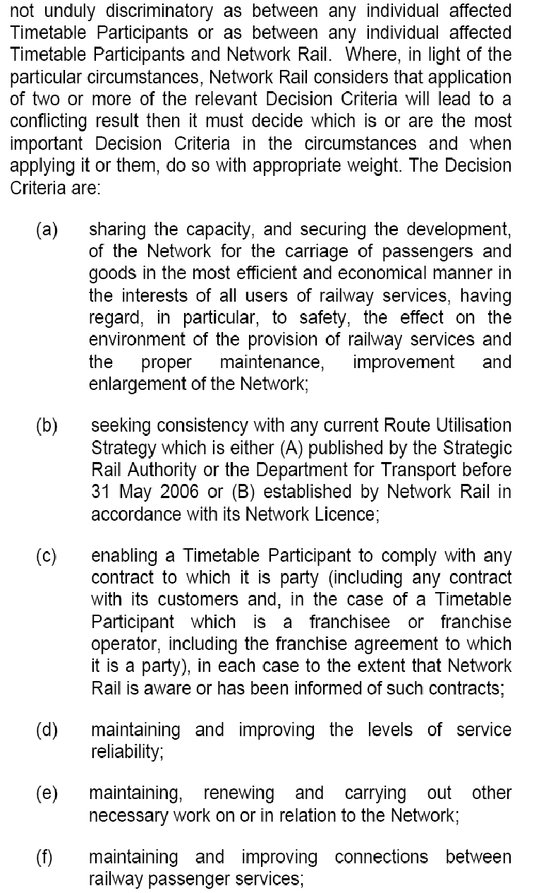
ANNEX “D”
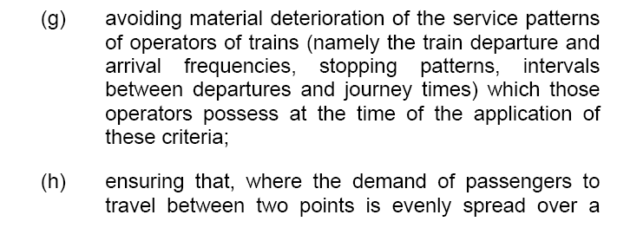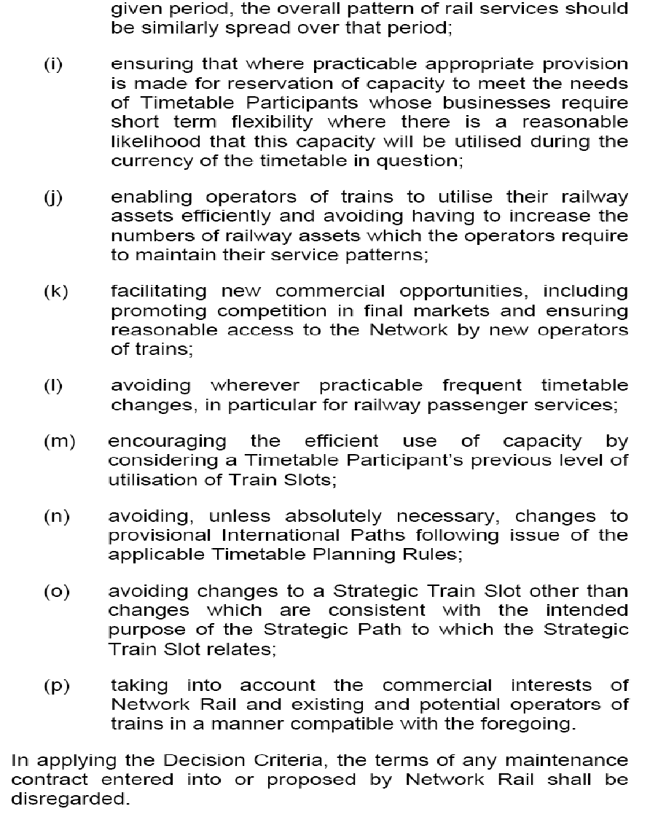

ANNEX “E”
Extract from 2012 Network Statement
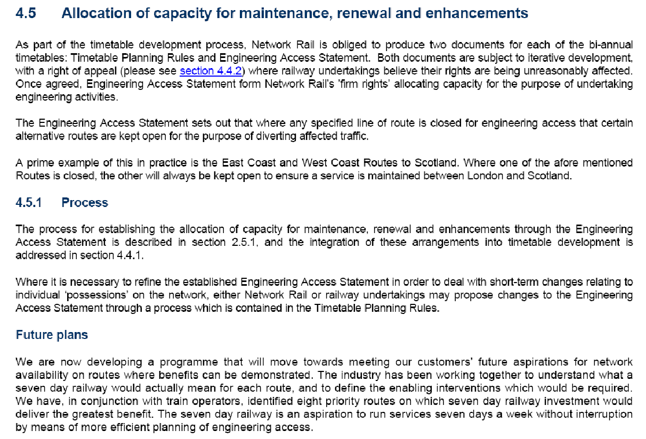

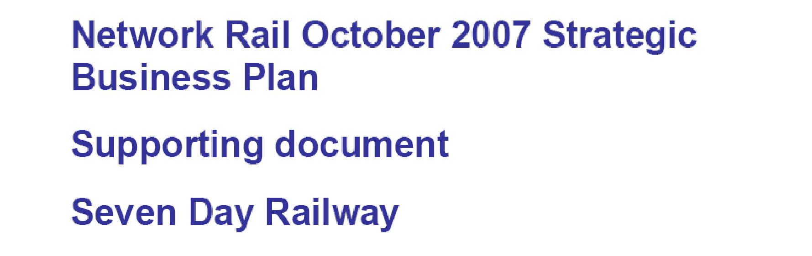
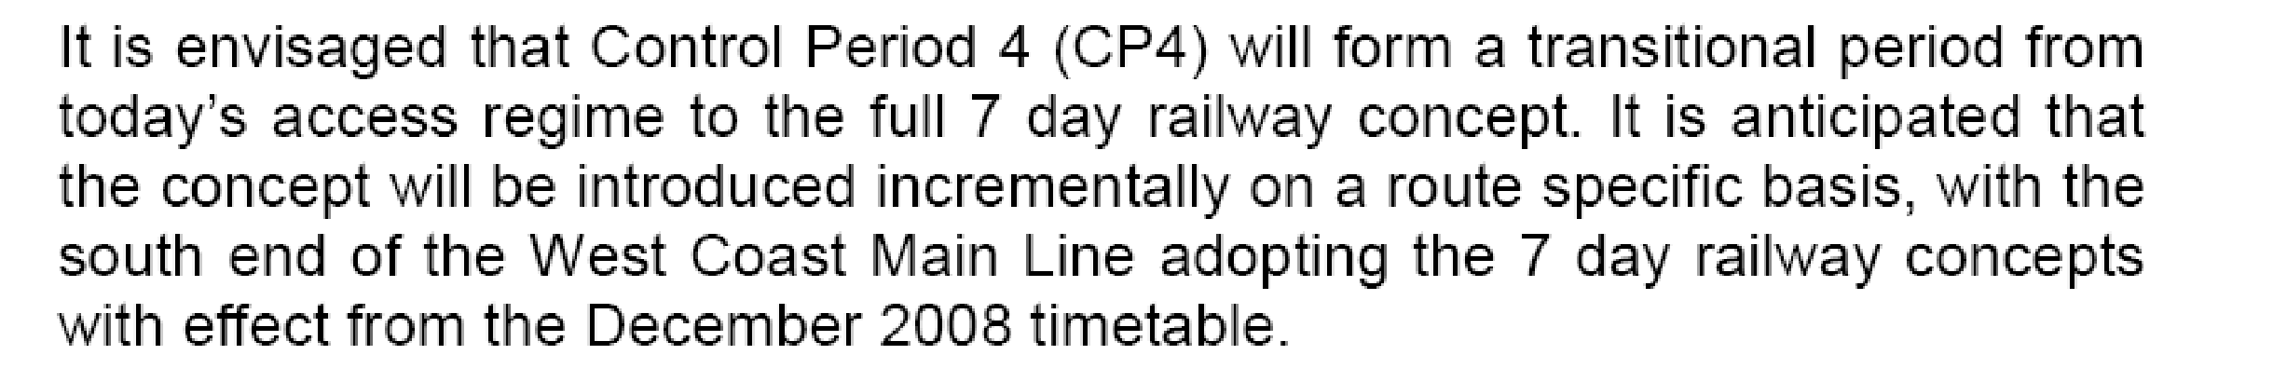

Demand
The following key conclusions have been reached from our analysis with operators of the potential demand:
• there is strong evidence of suppressed demand at weekends, especially on Sundays;

• weekend revenues affected by disrupted services (25-50% loss);

• there is additional demand late evening and on specialist flows such as airports traffic;

TOCs (and passengers) do not like bus substitution (especially at weekends), and the costs of putting on a bus replacement service are high. Bus substitution is suppressing demand as passengers are deterred from using trains on the weekend from fear of being put on a bus for part of their journey;

ANNEX “E” Cont....
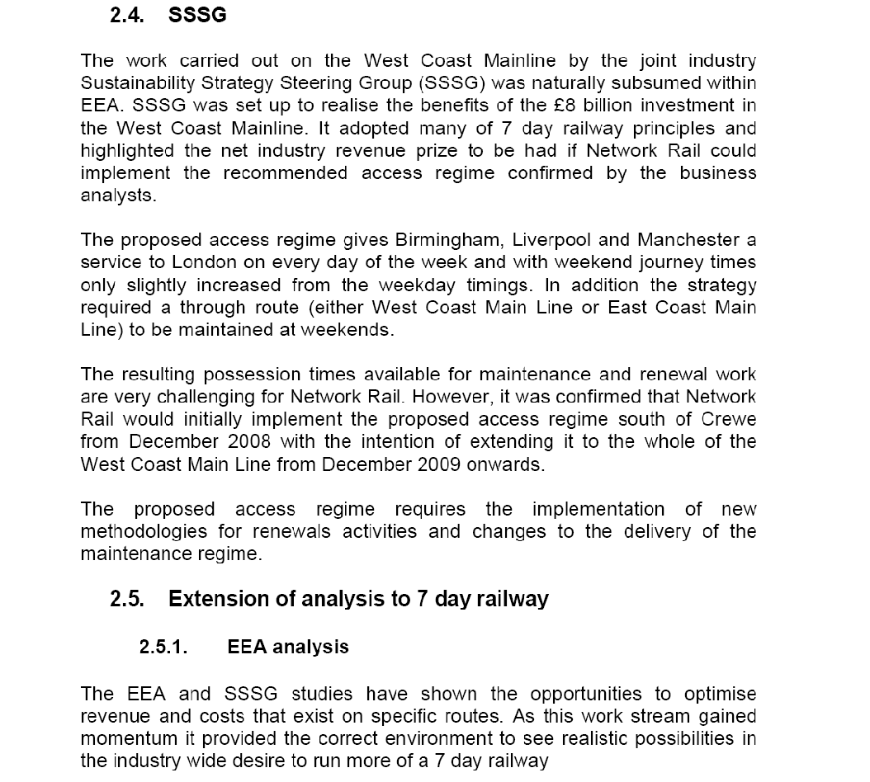
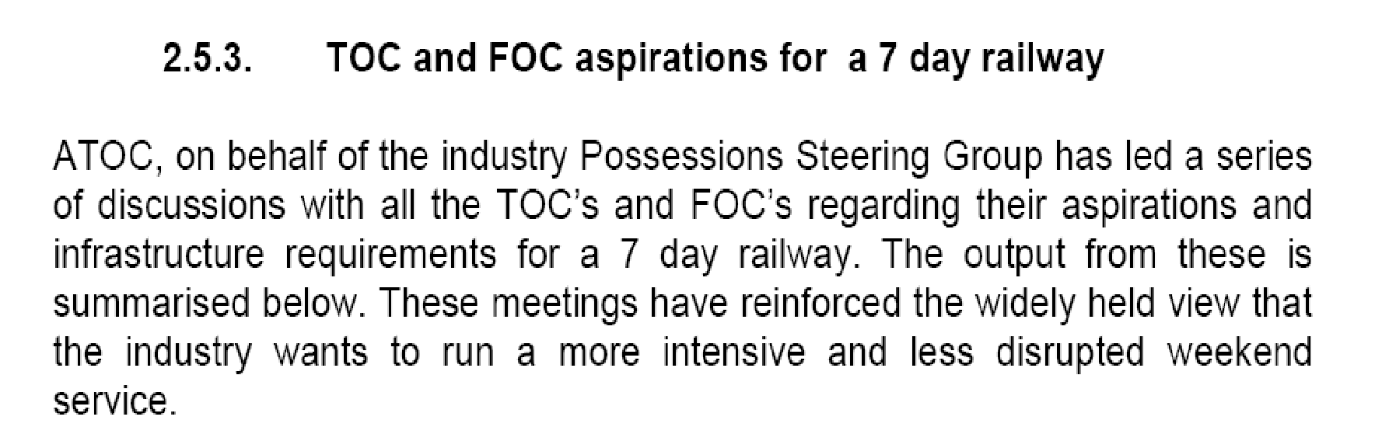

ANNEX “F”
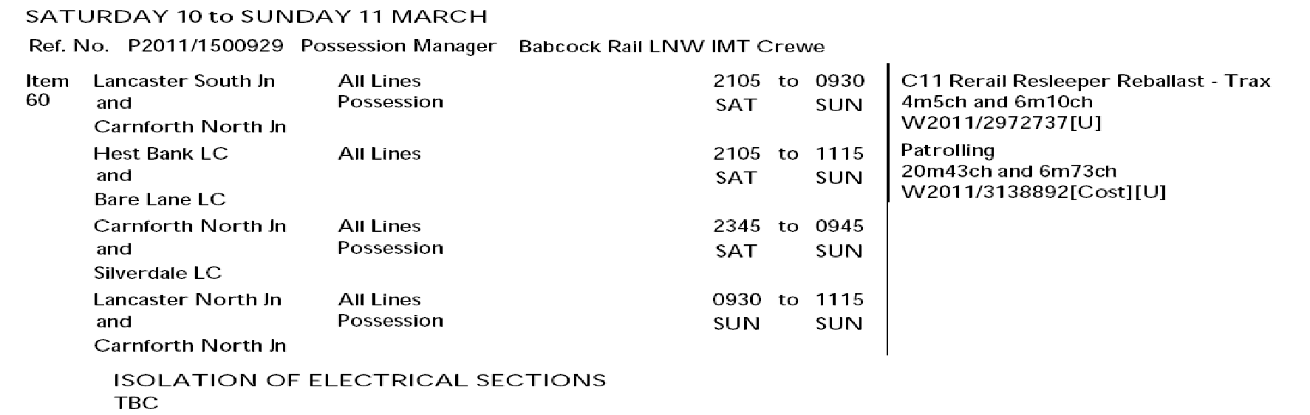
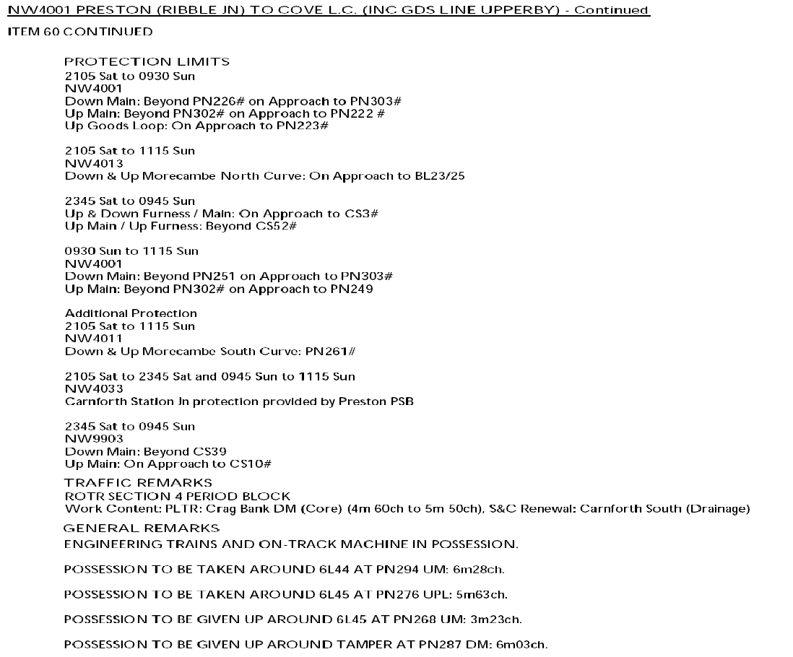
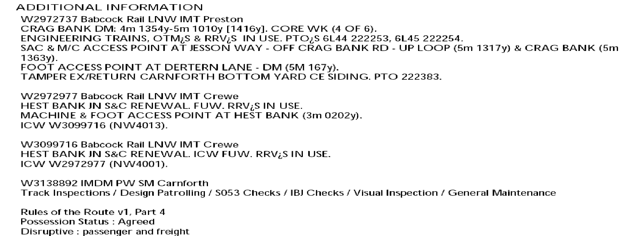

ANNEX “G”

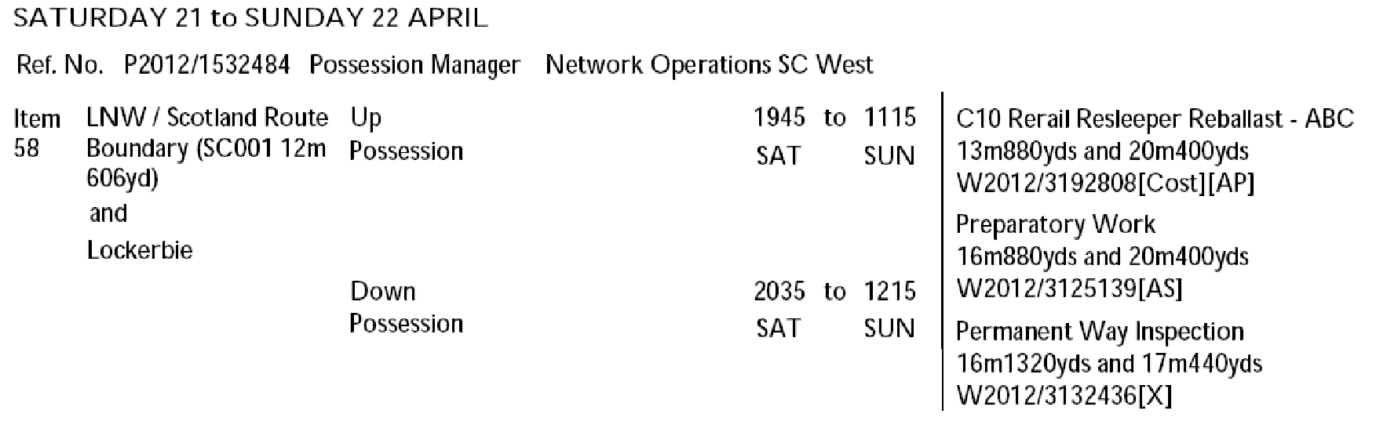
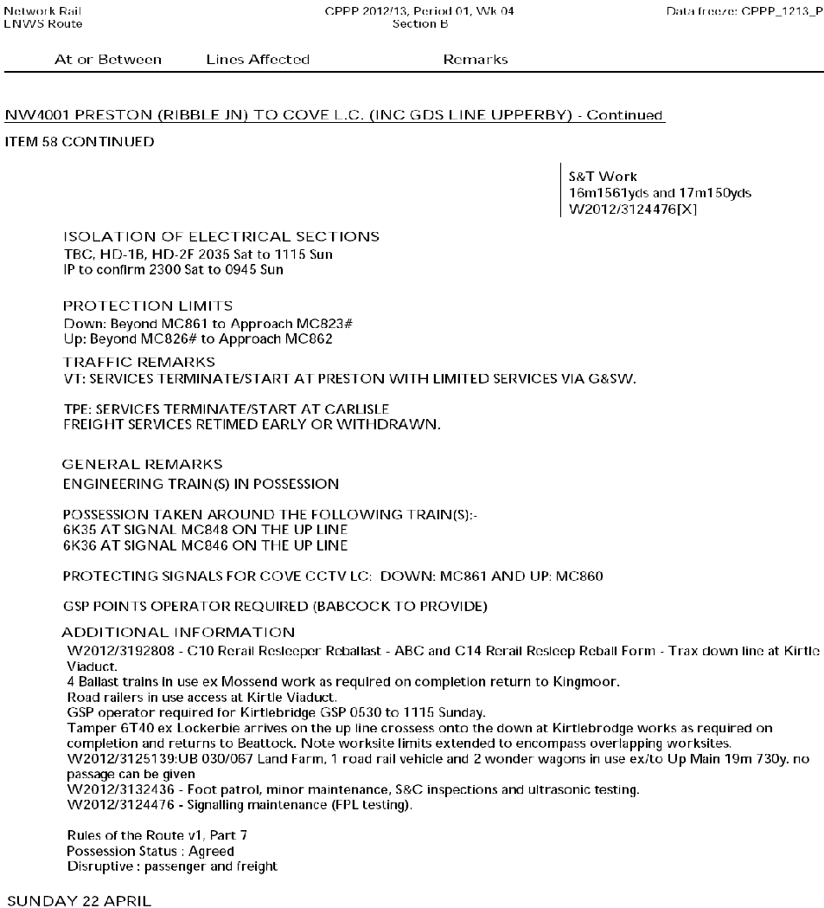

ANNEX “H”
Week 2
NW1001
New item previously planned to be done in 2 track access. New restrictions on crane and RRV operation next to open lines mean that the Up Slow has to be blocked. As WCML traffic is not running, this week is felt to be the best week to propose this access, note however the impact on Liverpool-Blackpool and Manchester-Blackpool services:

This item appears in version EAS V2.1 with incorrect times. Please disregard the times and blocking points shown in EAS V2.1. The possession will be published in the DPPP with the times and locations as shown below:

Saturday 07 April to Monday 09 April
PPS Ref: P2012/1489005
At/Between: Euxton Jn and Preston Ribble Jn
Lines: Down & Up Fast (Possession)
Times: 1000 Sat to 0900 Mon
At/Between: Euxton Jn and Farington Jn
Lines: Up Slow (Possession)
Times: 1000 Sat to 0900 Mon

Traffic Remarks: TRAINS TO START/TERMINATE AT WIGAN NW AND PRESTON. TRAINS BETWEEN EUXTON JN AND FARINGTON JN TO TRAVEL UNDER SINGLE LINE WORKING ARRANGEMENTS OVER THE DOWN SLOW– CAPACITY 2 TPH IN EACH DIRECTION.

Week 5
NW4001

Worksite to fit in times of period block to Penrith, but is outside of the limits of the period block so is included in the Section 7 possession register.

Saturday 28 April to Sunday 29 April
PPS Ref: P2012/1492460
At/Between: Penrith and Carlisle South Jn
Lines: All Lines (Possession)
Times: 2040 Sat to 1140 Sun

Traffic Remarks: SECTION 7 REGISTER ITEM WITHIN TIMES OF PERIOD BLOCK ON NW4001

Week 10
NW1001
New possession created for deferred renewal work.

Saturday 02 June to Monday 04 June
PPS Ref: P2012/1488948
At/Between: Acton Grange Jn and Winwick Jn
Lines: All Lines (Possession (T3))
Times: 0600 Sat to 0500 Mon

Traffic Remarks: WCML TRAINS TO START/TERMINATE CREWE AND WIGAN. DIVERT DIESEL SERVICE VIA MANCHESTER. RAIL REPLACEMENT ROAD SERVICE TO OPERATE.
CHESTER TO MANCHESTER SERVICE TO DIVERT VIA ALTRINCHAM AND STOCKPORT. RAIL REPLACEMENT ROAD SERVICE TO OPERATE.
LIVERPOOL TO WARRINGTON SERVICE TO START/TERMINATE AT EARLESTOWN.
FREIGHT ACCESS INTO ARPLEY AVAILABLE ON HELSBY LINES.
Disruptive Work Content: Warrington PLTR DS
ANNEX “H” Cont....

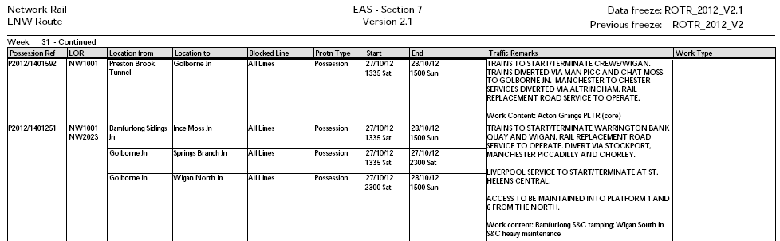

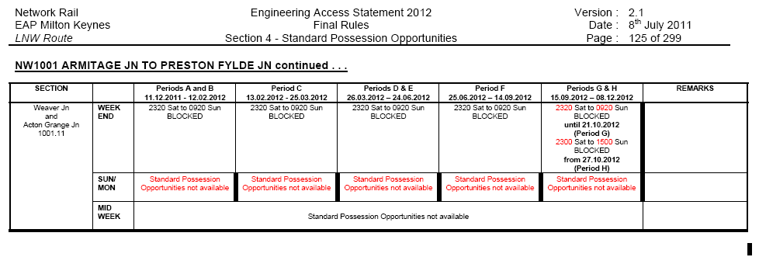

ANNEX “I”

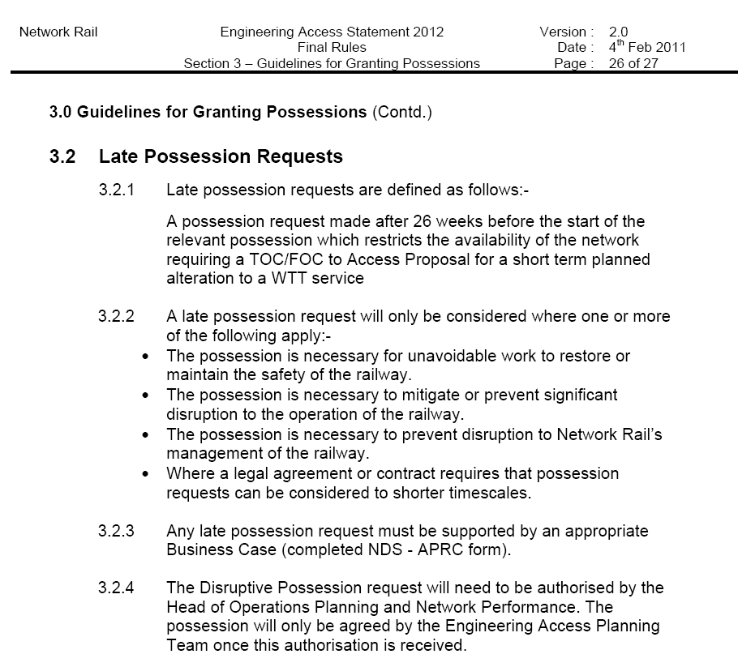
ANNEX “J”

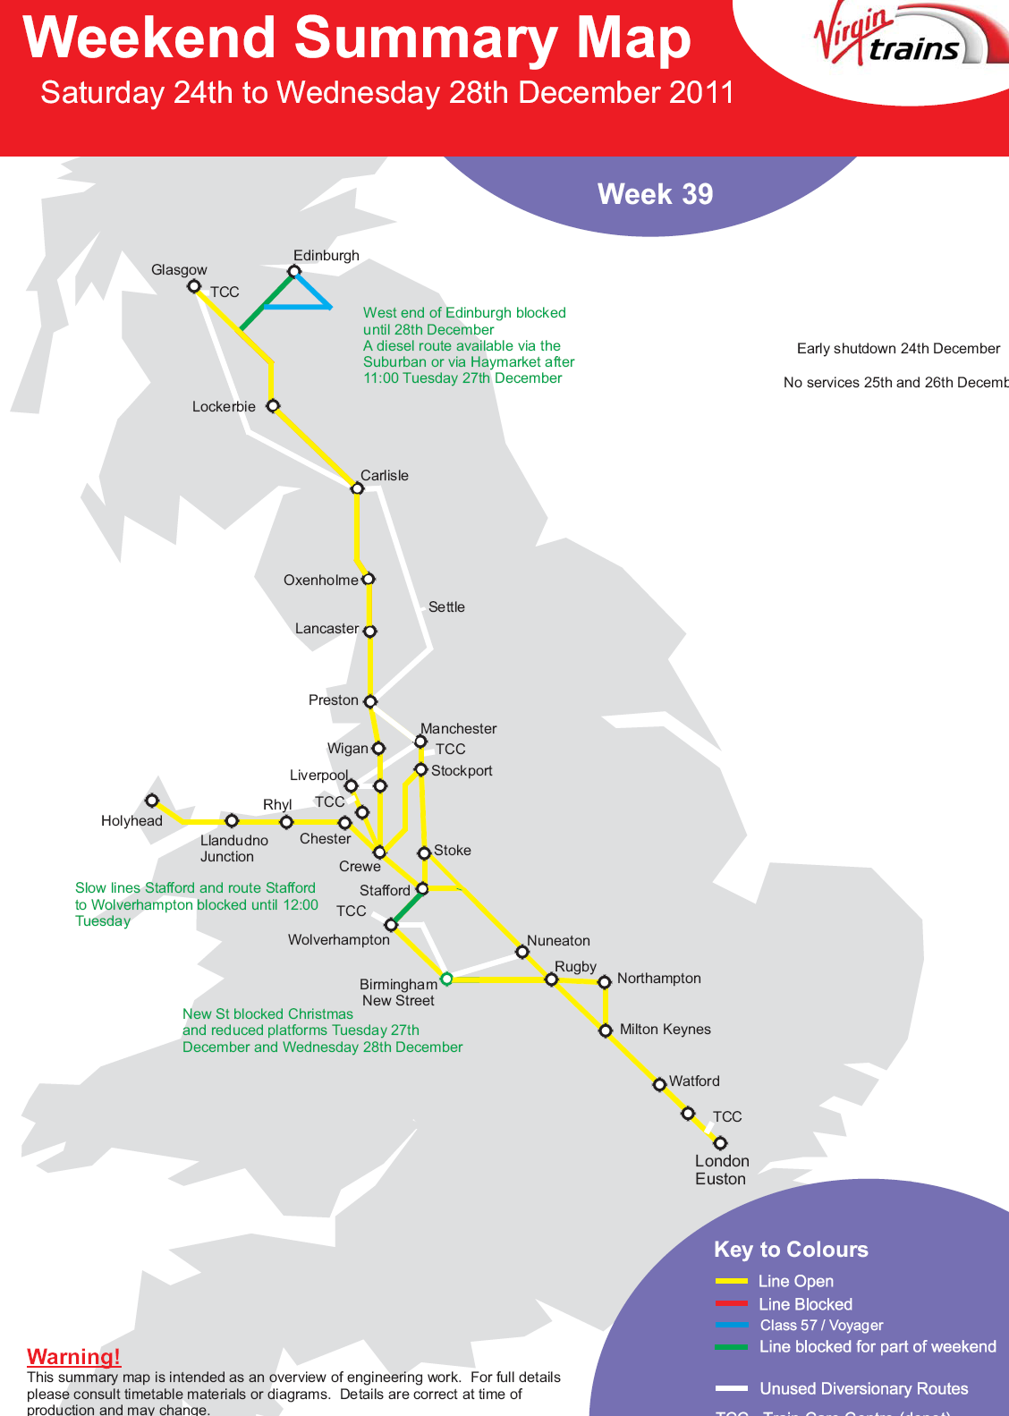
PLUS:
Recent two track Railway block agreed south of Rugby on 27/12

ANNEX “K”

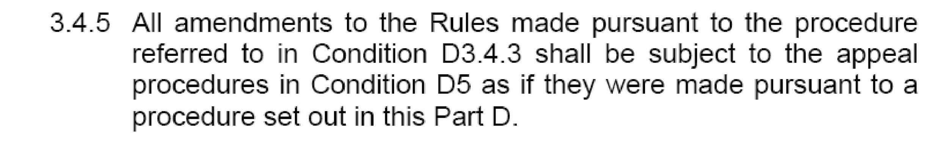

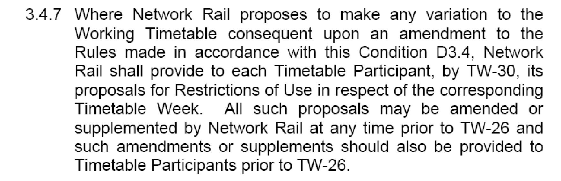

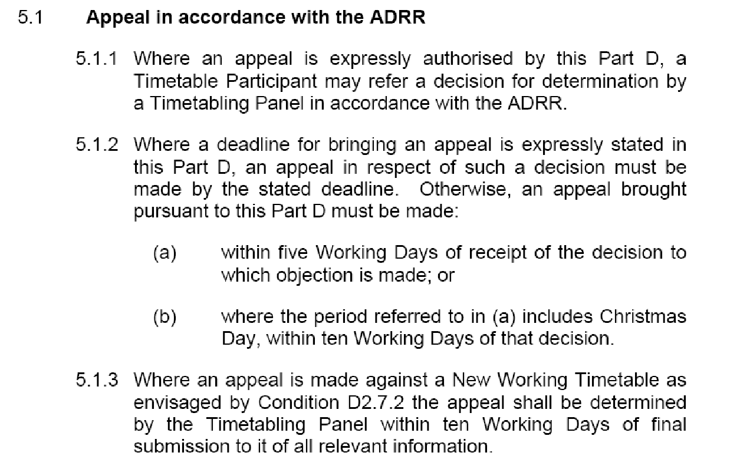

ANNEX “L”

Section 3 Procedure for Altering Rules of the Route or Rules of the Plan other than through the Twice-Yearly Process Having Effect from a Passenger Change Date

3.1. Introduction
3.1.1. This Procedure has been devised in accordance with Network Code Condition D 2.1.10 to provide a means of altering Rules of the Route and/or Rules of the Plan other than through the twice-yearly process having effect from the Passenger Change Dates. It supersedes the interim arrangements included within certain Train Operators’ Track Access Agreements and within certain Regional Rules of the Route and Rules of the Plan documents.

3.1.2. This procedure will be used by Network Rail to add, substitute or delete engineering access opportunities contained within Rules of the Route. All possessions so agreed will be regarded as being within Rules of the Route. Network Rail is committed to the achievement of the Informed Traveller deadlines resulting in details of amended train services being available 12 weeks before the date of operation, consequently, wherever possible, Network Rail will consult with Train Operators regarding possessions and other capacity restrictions which are disruptive to agreed train paths in sufficient time to allow details of those disruptive possessions to be included in a Confirmed Period Possessions Plan which will be published 26 weeks prior to the start of each 4-week period.

3.1.3. Where a need arises to amend Rules of the Route/Plan to cater for urgent safety requirements or other emergency situations, all parties concerned will co-operate in accelerating the normal timescales in this Procedure commensurate with the urgency of the circumstances.

3.2. Changes Initiated by Train Operators
3.2.1. A Train Operator may propose changes to any part of ROTR/P affecting or likely to affect that Train Operator.

3.2.2. The Train Operator shall submit a written statement of the proposed change and a concise explanation of the reasons for that change:

3.2.2.1. for ROTP, to its Network Rail lead Train Planning Manager who will acknowledge receipt and immediately copy the proposal to the Network Rail Train Planning Manager responsible for the relevant section of ROTP if not the lead TPM.

3.2.2.2. for ROTR, to the Network Access Unit Manager, who will acknowledge receipt.

3.2.3. Within 5 Working Days of receipt of the proposed change, Network Rail shall notify to all Train Operators affected details of the proposed change and Network Rail’s comments including concise reasons for the change and a statement as to whether Network Rail supports the proposal.

3.3. Changes Initiated by Network Rail
3.3.1. Network Rail may propose changes to any part of ROTR/P.

3.3.2. Network Rail shall notify to all Train Operators affected details of the proposed change including a concise explanation of its reasons. Proposed changes to ROTR arising before publication of the Draft Period Possessions Plan shall be notified by Network Rail in a single coordinated document to be issued each 4 weeks.

3.4. Response by Train Operators
3.4.1. Each Train Operator receiving notification of a proposed change in accordance with paragraphs 2.3 or 3.2 above will consider that proposal and respond to Network Rail within 10 Working Days from receipt of the notification, indicating:
3.4.1.1. its agreement to the proposed change or
3.4.1.2. details of a counter-proposal and an explanation of its reasons or
3.4.1.3. in the case of ROP items such as section running times, a request that a joint investigation is carried out.

3.4.2. Any Train Operator whose response is not received by Network Rail within 10 Working Days will be deemed to have agreed to the proposed change and will forfeit any right of Appeal.

ANNEX “L” Cont....
3.5. Decision by Network Rail
3.5.1. Network Rail shall give due consideration to responses received from Train Operators in accordance with paragraphs3.4.1 and 3.4.2 above and shall decide which changes, if any, should be made to ROR/P.

3.5.2. In reaching its decision, Network Rail shall have due regard to the Decision Criteria in Network Code Condition D6.

3.5.3. Network Rail will notify its decision to each affected Train Operator within 5 Working Days of the last date for receipt of responses under paragraph 3.4 above.

3.5.4. Any Train Operator, if it disputes Network Rail’s decision, may Appeal to a Timetabling Panel and any such Appeal will be dealt with as though it had been made in accordance with Network Code Condition D2.1.7. Any Appeal must be referred to the Access Disputes Secretary in accordance with the timescales shown in Condition D5.1.2 (i.e. within 5 Working Days of notification by Network Rail of its decision except at Christmas when the period is increased to 10 Working days.

ANNEX “M”
SATURDAY LOADINGS – Week 41 -2011
REDACTED

ANNEX “M” Cont....
SUNDAY LOADINGS – Week 40 -2011
REDACTED
ANNEX “M” Cont....

SUNDAY LOADINGS – Week 41 -2011
REDACTED
ANNEX “N”

7 Provisions applicable to Journey Time protection
Restriction on changes to Engineering Access Statement and Timetable Planning Rules
7.1 In relation to the Applicable Engineering Access Statement and the Applicable Timetable Planning Rules:
(a) Network Rail shall not propose or agree to any amendments to the Applicable Engineering Access Statement or the Applicable Timetable Planning Rules which would prevent it from Scheduling a Journey Time in the Weekday, Saturday and Sunday Working Timetables:
(i) which is equal to or less than the Fastest Key Journey Time specified for at least one Passenger Train Slot for each of the Key Journeys specified in Table 6.2 in respect of each Weekday; and
(ii) which is equal to or less than the relevant Maximum Key Journey Time specified for every Passenger Train Slot consistent with each Key Journey of the type specified in Table 6.3;
(b) paragraph 7.1(a) shall not apply in relation to any such amendment which is proposed by the Train Operator or effected pursuant to the order of an appeal body under Part D of the Network Code or any other competent tribunal; and
(c) Network Rail shall not be in breach of paragraph 7.1(a) to the extent that the failure to Schedule any Journey Time in accordance with paragraph 7.1(a)(i) or (ii) is the result of any Network Rail Restriction of Use, Competent Authority Restriction of Use or Operator Restriction of Use (as these terms are defined in or for the purposes of Part 3 of Schedule 4).
ANNEX “O”

Route E: London Euston to Preston and Glasgow Central
- ROUTE DEFINITION

1.1 Services shall be provided between London Euston and Glasgow Central, calling at Warrington Bank Quay, Wigan North Western, Preston, Lancaster and Carlisle.

1.2 Secondary Stops shall also be made at, Oxenholme Lake District and Penrith as set out in Paragraphs 5.1, 5.2 and 5.3.
LIMITED STOPS
SATURDAYS
  - Watford Junction: One service to Glasgow Central and one service to Preston shall call. One service from Glasgow Central shall call.
  - Milton Keynes Central: Two services from Glasgow Central and one service from Preston shall call. One service to Glasgow shall call.
  - Rugby: One service to Glasgow Central and one service to Preston shall call.
  - Tamworth and Lichfield Trent Valley: One service from London Euston shall call.
  - Stafford: One service to Glasgow Central shall call.
  - Crewe: Three services from London Euston shall call. One service to London Euston shall call.
  - Lockerbie: Two services to London Euston shall call.
  - Motherwell: One service from London Euston and three services to London Euston shall call.
SUNDAYS
  - Watford Junction: One service from Glasgow Central and one service from Preston shall call.
  - Milton Keynes Central: Three services to London Euston and four services from London Euston shall call.
  - Rugby: Two services to London Euston and four services from London Euston shall call.
  - Tamworth and Lichfield Trent Valley: One service from London Euston shall call.
  - Crewe: Three services to London Euston and five services from London Euston shall call.
ANNEX “O” Cont....

3. SERVICE PATTERN - SATURDAYS
NORTHBOUND
3.1 Between 0700 and the Late Glasgow Service, services shall be provided from London Euston to Glasgow Central at hourly intervals, calling at the stations in Paragraph 1.1.
3.2 Between 1900 and 2000, an additional service shall be provided from London Euston to Preston, calling at the stations specified in Paragraph 1.1
SOUTHBOUND
3.3 Between and including the Early Service and the Late Service, services shall be provided from Glasgow Central to London Euston at approximately hourly intervals, calling at the stations in Paragraph 1.1.

4. SERVICE PATTERN - SUNDAYS
NORTHBOUND
  - Between and including the Early Service and the Late Glasgow Service, services shall be provided from London Euston to Glasgow Central at hourly intervals, calling at the stations in Paragraph 1.1. There may be one interval of two hours.
4.2 Between 2000 and the Late Preston service, one additional service shall be provided from London Euston to Preston, calling at the stations in Paragraph 1.1.
SOUTHBOUND
4.3 Between and including the Early Glasgow Service and the Late Service, services shall be provided from Glasgow Central to London Euston at approximately hourly intervals, calling at the stations in Paragraph 1.1. Three services may start from Preston at approximately hourly intervals between 0830 and 1130.

ANNEX “O” Cont....

5 SECONDARY STOPS AND SUBSIDIARY CALLING PATTERN
5.2 On Saturdays, Secondary Stops shall be made at the following stations:
Services departing London Euston | Oxenholme | Penrith
0600-0659 | 1 | 1
0700-0759 | 0 | 1
0800-0859 | 1 | 0
0900-0959 | 0 | 1
1000-1059 | 1 | 0
1100-1159 | 1 | 0
1200-1259 | 0 | 1
1300-1359 | 1 | 0
1400-1459 | 0 | 1
1500-1559 | 1 | 0
1600-1659 | 1 | 1
1700-1759 | 1 | 1
1800-1859 | 1 | 1

Services departing Glasgow Central to London Euston | Penrith | Oxenholme
0400-0459 | 1 | 1
0500-0559 | 0 | 1
0600-0659 | 1 | 1
0700-0759 | 0 | 1
0800-0859 | 1 | 0
0900-0959 | 0 | 1
1000-1059 | 0 | 1
1100-1159 | 1 | 0
1200-1259 | 0 | 1
1300-1359 | 0 | 1
1400-1459 | 0 | 1
1500-1559 | 1 | 0
1600-1659 | 0 | 1
1700-1759 | 1 | 1
ANNEX “O” Cont....

5.3 On Sundays, Secondary Stops shall be made at the following stations:
Services departing London Euston | Oxenholme | Penrith
0800-0859 | 1 | 1
0900-0959 | 1 | 1
1000-1059 | 1 | 1
1100-1159 | 0 | 0
1200-1259 | 0 | 1
1300-1359 | 1 | 0
1400-1459 | 0 | 1
1500-1559 | 1 | 0
1600-1659 | 1 | 1
1700-1759 | 1 | 1
1800-1859 | 1 | 1
1900-1959 | 1 | 1

Services departing Glasgow Central to London Euston | Penrith | Oxenholme
0900-0959 | 1 | 1
1000-1059 | 1 | 1
1100-1159 | 0 | 1
1200-1259 | 0 | 1
1300-1359 | 0 | 1
1400-1459 | 0 | 1
1500-1559 | 1 | 0
1600-1659 | 1 | 1
1700-1759 | 1 | 1

ANNEX “O” Cont....

6. EARLY AND LATE SERVICES
 | Early Service arrives at destination no later than:
Route | Monday - Friday | Saturday | Sunday
London Euston –  Preston | 0830 | 0915 | 1220
Preston - London Euston | 0815 | 0845 | 1215
London Euston –  Glasgow Central | 1045 | 1145 | 1445
Glasgow Central –  London Euston | 0915 | 0930 | 1430

 | Late Service departs no earlier than:
Route | Monday - Friday | Saturday | Sunday
London Euston –  Preston | 2030 | 2000 | 2030
Preston - London Euston | 2030 | 2000 | 1945
London Euston –  Glasgow Central | 1915 | 1800 | 1845
Glasgow Central –  London Euston | 1815 | 1730 | 1730

7. MAXIMUM JOURNEY TIMES
Route | Monday - Friday | Saturday | Sunday
London Euston –  Preston | 2 hours 11 minutes with 2 intermediate stops, with one exception of 2 hours 12 minutes | 2 hours 11 minutes with 2 intermediate stops | 2 hours 16 minutes with 2 intermediate stops, with one exception of 2 hours 20 minutes
Preston - London Euston | 2 hours 15 minutes with 2 intermediate stops | 2 hours 15 minutes with 2 intermediate stops, with one exception of 2 hours 23 minutes | 2 hours 18 minutes with 2 intermediate stops, with one exception of 2 hours 23 minutes
London Euston –  Glasgow Central | 4 hours 31 minutes, with 6 intermediate stops, with one exception of 4 hours 34 minutes | 4 hours 31 minutes, with 6 intermediate stops | 4 hours 38 minutes, with 6 intermediate stops, with one exception of 4 hours 40 minutes
Glasgow Central –  London Euston | 4 hours 35 minutes, with 6 intermediate stops | 4 hours 35 minutes, with 6 intermediate stops, with one exception of 4 hours 46 minutes | 4 hours 38 minutes, with 6 intermediate stops

ANNEX “O” Cont....

Route F: Birmingham New Street to Preston and Glasgow Central or Edinburgh

1. ROUTE DEFINITION

1.1 Services shall be provided between Birmingham New Street and Glasgow Central or Edinburgh, calling at Wolverhampton, Crewe, Warrington Bank Quay, Wigan North Western, Preston, Lancaster, Carlisle, then Glasgow Central or Haymarket and Edinburgh.

LIMITED STOPS

SATURDAY
1.5 Stafford: Two services to Birmingham New Street shall call. One service departing from Birmingham New Street shall call.
1.6 Lockerbie: One service arriving at Glasgow Central between 0900 and 1000 shall call.
1.7 Motherwell: The Early Service departing Glasgow Central shall call.

SUNDAY
1.8 Stafford: One service to Birmingham New Street shall call. Three services departing from Birmingham New Street shall call.
1.9 Lockerbie: One service to Glasgow Central and one service from Glasgow Central shall call.
  - Motherwell: The Late Service to Glasgow Central shall call.

3. SERVICE PATTERN - SATURDAYS
NORTHBOUND
3.1 Between the Early and Late Services an hourly service shall be provided to Carlisle, proceeding alternately to Edinburgh and Glasgow Central, calling at the stations specified in Paragraph 1.1.
3.2 Between the Late Service and 2000, two services shall be provided from Birmingham New Street to Preston, calling at the stations specified in Paragraph 1.1.
3.3 Before 0610, an additional service shall be provided from Crewe to Glasgow Central, calling at the stations specified in Paragraph 1.1.
SOUTHBOUND
3.4 Between the Early and Late Services an approximate hourly service (measured at Carlisle) shall be provided, originating alternately from Edinburgh and Glasgow Central, calling at the stations specified in Paragraph 1.1.

ANNEX “O” Cont....

3.5 Between 0600 and the Early Service, two additional services shall provided from Preston to Birmingham New Street, one of which may originate at Lancaster.
3.6 Between 1830 and 1900, one additional service shall be provided from Glasgow Central to Birmingham New Street, calling at the stations specified in Paragraph 1.1.

4. SERVICE PATTERN - SUNDAYS
NORTHBOUND
  - Between 0830 and 0900, one additional service shall be provided from Birmingham New Street to Preston, calling at the stations specified in Paragraph 1.1.
  - Between the Early and Late Services an hourly service shall be provided to Carlisle, proceeding alternately to Edinburgh and Glasgow Central, calling at the stations specified in Paragraph 1.1.
  - Between the Late Service and 2130, one service shall be provided from Birmingham New Street and Preston, calling at the stations specified in Paragraph 1.1 and additionally at Stafford, and one service shall be provided from Birmingham New Street to Crewe, calling at Wolverhampton and Stafford.
SOUTHBOUND
  - Between 1000 and 1230, three additional services shall be provided from Preston to Birmingham New Street, calling at the stations specified in Paragraph 1.1. One of these services may originate from Lancaster.
  - Between the Early and Late Services, one service in each hour (measured at Carlisle) shall be provided, originating alternately from Edinburgh and Glasgow Central, calling at the stations specified in Paragraph 1.1. Two of these services need not call at Lancaster.
  - Between the Late Service and 2030 an additional service shall be provided from Glasgow Central to Preston.
ANNEX “O” Cont....

5. SECONDARY STOPS
5.2 On Saturdays, Secondary Stops shall be made at the following stations:

Services departing Birmingham New Street | Oxenholme | Penrith
0600-0659 | 1 | 0
0700-0759 | 0 | 1
0800-0859 | 1 | 0
0900-0959 | 0 | 1
1000-1059 | 1 | 0
1100-1159 | 1 | 0
1200-1259 | 0 | 1
1300-1359 | 1 | 0
1400-1459 | 0 | 1
1500-1559 | 1 | 0
1600-1659 | 1 | 1
1700-1759 | 1 | 0
Services departing Crewe
0555-0610 | 1 | 1

Services departing Glasgow Central or Edinburgh (interval measured at Carlisle) | Penrith | Oxenholme
0700-0759 | 1 | 1
0800-0859 | 1 | 0
0900-0959 | 0 | 0
1000-1059 | 0 | 1
1100-1159 | 1 | 0
1200-1259 | 0 | 1
1300-1359 | 0 | 0
1400-1459 | 1 | 0
1500-1559 | 0 | 1
1600-1659 | 1 | 0
1700-1759 | 0 | 1
1800-1859 | 0 | 1
1900-1959 | 2 | 2
2000-2059 | 1 | 1

ANNEX “O” Cont....

5.3 On Sundays, Secondary Stops shall be made at the following stations:
Services departing Birmingham New Street | Oxenholme | Penrith
0900-0959 | 1 | 0
1000-1059 | 1 | 0
1100-1159 | 1 | 0
1200-1259 | 0 | 1
1300-1359 | 1 | 0
1400-1459 | 0 | 1
1500-1559 | 1 | 0
1600-1659 | 1 | 1
1700-1759 | 1 | 0
1800-1859 | 0 | 1
1900-1959 | 1 | 0

Services departing Glasgow Central or Edinburgh (interval measured at Carlisle) | Penrith | Oxenholme
1200-1259 | 0 | 1
1300-1359 | 0 | 0
1400-1459 | 1 | 0
1500-1559 | 0 | 1
1600-1659 | 1 | 0
1700-1759 | 0 | 1
1800-1859 | 0 | 1
1900-1959 | 0 | 1
2000-2059 | 1 | 0

ANNEX “O” Cont....
6. EARLY AND LATE SERVICES

 | Early Service arrives at destination no later than:
Route | Monday - Friday | Saturday | Sunday
Birmingham New Street –  Glasgow | 1130 | 1130 | 1400
Glasgow Central –  Birmingham New Street | 1000 | 1000 | 1600
Birmingham New Street –  Edinburgh | 1030 | 1030 | 1430
Edinburgh –  Birmingham New Street | 1100 | 1100 | 1500

 | Late Service departs no earlier than:
Route | Monday - Friday | Saturday | Sunday
Birmingham New Street –  Glasgow | 1900 | 1700 | 1900
Glasgow Central –  Birmingham New Street | 1730 | 1730 | 1730
Birmingham New Street –  Edinburgh | 1800 | 1800 | 1800
Edinburgh –  Birmingham New Street | 1830 | 1830 | 1830

ANNEX “P”

8.5 The next general issue is central to this dispute, namely NR's method of applying and weighting the DC.

8.5.1 Various provisions of Network Code Part D require Network Rail to have 'due regard' to the DC. This language by itself is not of much assistance in determining how the DC are to be evaluated and applied in any particular instance, since 'due' is a relative term that only has any meaning in relation to a suitable given benchmark. Up till now neither the Network Code nor precedent TTP determinations on the point have offered such a benchmark.

8.5.2 On this point I was assisted by Virgin's submission, as noted in paragraph 4.4.7.3 above, which referred me to the new Decision Criteria section of the Network Code effective from 1 October 2010, contained in new Condition D4.6. This reflects a welcome change of language in the whole of the new Part D, whereby NR is now required simply to 'apply' the DC in appropriate circumstances, rather than have 'due regard' to them. In evaluating the former version of the DC for the purposes of this Determination, I propose to interpret 'have due regard' accordingly.

8.5.3 Many of the Decision Criteria, in both the old and new versions, are in direct conflict with each other, in that they cannot all be satisfied at the same time. Some Criteria however conflict not so much with each other but internally, that is, in the application of the same Criterion to different parties and in differing circumstances. Any system adopted to rationalise their application must at least accommodate both these distinct kinds of conflict.

8.5.4 For the first time the new Condition D4.6 goes some way towards recognising and accommodating the fact that there are two different ways of applying the DC. First, NR"must consider which of the Decision Criteria are relevant to the particular circumstances and apply those it has identified as relevant so as to reach a decision which is fair and not unduly discriminatory as between any individual affected Timetable Participants or as between any individual affected Timetable Participant and Network Rail." Secondly, "Where, in light of the particular circumstances, Network Rail considers that application of two or more of the relevant Decision Criteria will lead to a conflicting result then it must decide which is or are the most important Decision Criteria in the circumstances and when applying it or them, do so with appropriate weight”.

8.5.5 At least two weighting systems are therefore possible: weighting the relevance and degree of satisfaction of each individual Criterion in a scale relative to the others, in its application to all potentially affected parties in the particular set of facts under consideration; or weighting the extent to which the application of each relevant Criterion favours the position taken by one dispute party or another. Network Rail's DC grids included in the two joint submissions mostly adopt the latter system, but not completely and not entirely consistently. I note that TTP350, a very recent TTP determination and one of only two so far under the new ADRR regime, also appears to adopt the latter weighting system.

8.5.6 Here, as in TTP350, although NR has retrospectively constructed DC grids showing its weighting of a number of different Criteria which, not surprisingly, apparently work out as favouring NR, in reality the focus is on one Criterion, (a) "sharing the capacity, and securing the development of, the Network for the carriage of passengers and goods in the most efficient and economical manner in the interests of all users of railway services…" The exercise thus becomes entirely one of assessing and balancing the practical merits of the parties' various competing interests in relation to the application of the single relevant Criterion, rather than comparing the merits of competing Criteria. I do not think it necessary, therefore, to undertake a detailed analysis or commentary on the components of the DC grids produced by NR in the joint submissions.

ANNEX “P” Cont....

8.5.7 In trying to achieve that balance of competing interests, in the absence of any other contractually explicit yardstick for determining what lies at the heart of DC D6(a) – "sharing the capacity….of the Network… in the most efficient and economical manner in the interests of all users of railway services…" – I concluded, with the concurrence of the Panel, that the most sensible metric was that of benefit to the ultimate consumer, the passenger or freight customer, in the sense of looking for the solution that demonstrably provides the greatest good for the greatest number. Hence our requests to the parties for more concrete and complete information as to likely numbers of passengers on the potentially affected services.

8.6 The final general issue is as to the timing of NR's applying and weighting the DC. The question here is what is the effect of (if such be proved to be the case) of Network Rail not having actively applied or evaluated them at the time of making its original decisions, but instead using them retrospectively to justify the position it has taken on issues of conflict. This issue also is touched on in the determination in TTP350.

8.6.1 As previously noted, during the Hearing the Panel and I questioned all the parties as to the extent of NR's apparent consideration or explicit mentioning of the DC actually at the time of discussions and correspondence concerning the successive stages of the 2011 RotR process. At the end we included a request for copies of correspondence which might assist in this area. All the parties produced something along these lines.

8.6.2 At the Hearing I observed that when dealing with the conflicting interests of different operators, NR perhaps needed to be more communicative, because, for example, when the issues surrounding Decision Criterion (a) in reference TTP377 were examined rigorously, the volume of passengers and distances being travelled clearly became matters of relevance warranting quantification. NR had heard the Panel asking the operators for more information but, for the future, this was an area where NR should be seeking facts and figures to inform its decision making. NR asked what would then happen if one operator provided visible hard data but experience informed NR that the circumstances should be weighed more favourably for another operator which did not provide relevant data. I advised that it would be satisfactory for NR to make a decision if it set out the thought process which included its knowledge of the aspect about which it did not have facts provided by an operator. However, NR’s overriding approach to transparency clearly needed to be kept proportionate and it was unlikely to be necessary for data gathering to be done for every possession.

8.6.3 As regards actual application of the DC in this case, my reading of the oral exchanges and the correspondence subsequently produced is that it all does reasonably demonstrate Network Rail as having given consideration to the relevant factors for the DC, at least Criterion (a), at the appropriate times, in substance if not in form. Clearly, however, it would have been more helpful if Network Rail's 'workings' could have been clearly explained at each stage by reference to specific contractual Criteria.

ANNEX “Q”

From: Dunster, Jonathan
Sent: 01 September 2011 15:24
To: 'Daniel.Fredriksson; Nichol, Susan
Cc: [addresses redacted]; Bearpark, Phil; nash, jason; Hodgkinson, Rob; NetworkRail: Ian Leigh
Subject: Re: REQUEST - LNW12-LC-02 - AMENDMENT TO THE LONDON NORTH WESTERN NORTH CPPP WEEK 41 AND 42 2012

Daniel
For the avoidance of doubt then, once issued, we will be referring these items to ADC as any further increase in the number of disruptive possessions north of Crewe next year are completely unacceptable to us considering the amount of possessions already planned and agreed affecting this route.
Following sustained and substantial growth over the past three years, there are now no times of year on this route where customer volumes can be described as low enough to justify this level of disruption. You seem to have overlooked (once again) the fact that Glasgow - London is one of the top ten passenger flows in the UK.
Regards
Gus
Jonathan Dunster
Head of Operations and Planning
Virgin Trains

From: Fredriksson Daniel
To: Dunster, Jonathan; Nichol, Susan
Cc: Allen Matthew ; Warr Joe
Sent: Thu Sep 01 15:05:45 2011
Subject: RE: REQUEST - LNW12-LC-02 - AMENDMENT TO THE LONDON NORTH WESTERN NORTH CPPP WEEK 41 AND 42 2012
Susan/Gus,

Thank you for your responses to Network Rail’s proposals for late disruptive possessions to deliver Shap S&C renewals in 2012. I thank you for your counter proposals to deliver this work in alternative access. Network Rail has considered your proposal; however, the required resources cannot be secured to deliver the required work in your suggested possession times.

It is essential that we deliver these works in order to maintain current performance levels. There are no alternative methods for delivering these works in reduced times. We believe that this access in January represents the times of lowest passenger numbers and the least overall disruption to the industry. Therefore I will be issuing a decision shortly confirming Network Rail’s decision on the access.

Regards,
Dan
ANNEX “R”

