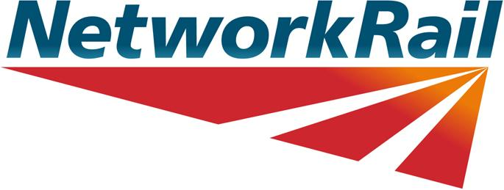

Clive Fletcher-Wood
Hearing Chair TTP434
Access Disputes Committee
Floor 8,
1 Eversholt Street
London
NW1 2DN
Friday 24th February 2012

Joe Warr
Lead Access Planner
500 Station House, Elder Gate
Milton Keynes
MK9 1BB

Dear Clive

Directions relating to Timetabling Panel hearing of dispute TTP434

Further to your letter of the 20th February, please find attached correspondence from impacted train operators in connection with the suggestion that the week 14 Stockport works should be re-dated to week 22.

The verbal and written information we have received back from other impacted operators is either supportive of, or neutral on, our decision to avoid planning this work in the August Bank Holiday weekend. As you can see passenger figures for TPE are broadly the same, although they state that August Bank Holiday is their busiest weekend. Northern advise that passenger demand increases on routes in the Stockport area during the August Bank Holiday weekend – largely as a result of the demand for suburban rail journeys within the Greater Manchester area due to events being planned in the City centre. CrossCountry have previously stated to us that they would prefer to see medium-level disruption such as Stockport S&C tamps in a normal weekend to reduce the overall disruption in Bank Holiday weekends.

In a similar vein to representations made to us by WCTL (but arguing the opposite case), the evidence from other operators is largely limited to generic support of week 14 and an objection to a proposal for week 22. For example Northern Rail seeks to protect local rail journey opportunities but has not quantified this with numerical data. Our experience is that special events in major cities do indeed guide the planning of engineering operations – for example in the North West we aim to avoid disrupting the Liverpool area due to the Matthew Street festival and in London we do all we can to support the transport requirements of the Notting Hill Carnival. The nature of events confirmed by Northern Rail as planned in Manchester on the August Bank Holiday weekend suggests that there will be a higher than normal demand for suburban passenger travel in the Greater Manchester area.

When Stockport is impacted by an all lines blocked possession suburban passenger travel is restricted to rail replacement road services, however as outlined in our sole submission, the majority of inter-city travellers can still be provided with a train service. It is still our view that we have correctly applied the decision criteria based upon the information received.

If you require further information or if I can help further, please feel free to give me a call.

Yours sincerely,
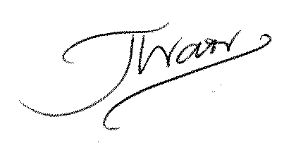

Joe Warr
Lead Access Planner LNW, Network Rail.

Attached Appendices:
Appendix ‘A’ – Northern Rail email 23rd February 2012
Appendix ‘B’ – First TPE email 24th February 2012

Appendix ‘A’ – Northern Rail email 23rd February 2012

From: Joanna Williams
Sent: 23 February 2012 17:45
To: Warr Joe; Allen Matthew
Cc: Peter Warhurst; Helen Cavanagh
Subject: Hearing of Timetabling Dispute TTP434

Good afternoon Joe & Matt,

Some wording as requested regarding the possible moving of this possession to the August Bank Holiday Weekend:

From our perspective the preference would be for this possession to take place as it was originally proposed by Network Rail. Over the August Bank Holiday weekend we have a number of special events taking place and primarily we see increased patronage for the Mathew Street Festival in Liverpool and the Gay Pride Festival in Manchester.

The routes we see increased passenger numbers travelling on for the Gay Pride Festival are the Manchester – Chester route, Manchester – Buxton route and the Wilmslow – Manchester route.

We experienced increased passenger loadings and revenue over this particular weekend and if the Saturday night were to become required for the possession access there would also be concerns about disorder issues due to the requirement of operating rail replacement buses.

Please let me know if you require any further information.

Many thanks

Jo

Joanna Williams
Head of Service Planning
Northern Rail Limited

Winner - Train Operator of the Year, Rail Business Awards 2010

Appendix ‘B’ – First TPE email 24th February 2012

From: Martin.Boekweit[address redacted]
Sent: 24 February 2012 11:03
To: David.Langton; Warr Joe
Subject: Hearing of Timetabling Dispute TTP434 - TPE Data

Hello,
I have been asked by David Langton to provide some loadings data for journeys in and out of Stockport for the affected dates. Looking at ticket sales data for last year, there is very little difference between the Sunday of Week 14 and Week 22, with week 14 showing just over 400 passengers travelling to/from Stockport and Week 22 showing just under 400, a difference of around 4%.
Therefore, based on these figures TPE would not be strongly against either of these dates, although the August Bank Holiday does tend to be our busiest weekend of the year.
Regards
Martin
-------------------------------------------
Martin Boekweit
Passenger Business Analyst
First TransPennine Express
Bridgewater House
60 Whitworth Street
Manchester, M1 6LT

