Individual submission to Timetable Panel
Dispute Reference TTP324 –

May 2010 Subsidiary Timetable Offer vs.
Schedule 5 Non Compliances in Virgin West Coast Trains Track Access Agreement
1 DETAILS OF PARTIES
1.1 The names and addresses of the parties to which this reference is made are as follows:-
(a) {Virgin} West Coast Trains Ltd. whose Registered Office is at ‘The School House’, 50 Brook Green, London W6 7RR ("WCTL") ("the Claimant");

(b) Correspondence Address: Virgin Trains Commercial Department, Room 15, North Wing Offices, Euston Station, London NW1 2HS.

For Reference Purposes Only
(c ) NR Infrastructure Ltd, whose registered office is at Kings Place, 90 York Way, London, N1 9AG (“The Respondent”)

NR correspondence Address: Ian Leigh, Acting CRE (Virgin Trains), Mailbox, Birmingham, B1 1TE Fax: 0113 341 2341 Mob: [redacted] Email:[redacted]

2 THE PARTIES’ RIGHT TO BRING THIS REFERENCE
2.1 This matter is referred to the Timetabling Panel ("the Panel") for determination in accordance with Conditions D.3.2.8 and D.5.1 of the Network Code.

3 CONTENTS OF REFERENCE
3.1 The Parties have been advised that in view of the reduced timescales involved, and the precise issue being submitted for determination, an individual Reference should be submitted by each Party, with Virgin Trains’ (“The Claimant”) concluding their reference prior to Network Rail (“The Respondent”) in order to give Network Rail the opportunity required to put their case forward, and as such includes:-

(a) The subject matter(s) of the dispute in Section 4;
(b) A detailed summary of those issues in dispute in Section 5;
(c) A listing of those items in dispute prepared by the ‘Claimant’ in Section 6,
(d) Section 7 has not been Used;
(e) The decisions of principle sought from the Panel in respect of legal entitlement and remedies in Section 8;
(f) Annexes and other supporting material.

4 SUBJECT MATTER OF DISPUTE
4.1 The key issue at the centre of this Virgin West Coast Trains Ltd. [WCTL] dispute, is that Network Rail is in breach of its Schedule 5 obligations under the West Coast Track Access Contract (TAC), the direct affect of this breach being on the operation of WCTLs’ business and services as a consequence of those non-compliant services offered by Network Rail as part of its timetable Offer for the Subsidiary Timetable for May 2010.

4.2 WCTL does not consider that Network Rail has met its contractual obligations with regards to its duties to adhere to offering timetable paths that comply with WCTL’s Firm Access Rights as expressed within Schedule 5 of its TAC, dated 10 December 2008, being those same Firm Access Rights that Network Rail has already agreed can be otherwise delivered.

4.3 Prior to submitting the TAC to the ORR for approval under the Section 18 process, Network Rail, with Industry Parties’ involvement, undertook an extensive and detailed industry consultation and timetable validation exercise to demonstrate to the ORR and the rest of the industry that the rights sought by WCTL could be delivered. Indeed, the Industry-wide West Coast Project Board and West Coast Timetable Development Groups met regularly to discuss such issues and were well versed in the conflicts and issues that arose at that time. Hence the nature and the quality of the access rights sought were well publicised and understood. Indeed, in undertaking extensive validation against ALL other Operators Access Rights (both TOC’s and FOC’s), Network Rail was obliged to demonstrate to ORR that any conflict in access rights with other parties had been resolved and that Supplemental Agreements were jointly submitted to ORR for approval, with DfT’s consent where applicable.

4.4 The Parts / Conditions of the Network Code that this dispute relates to, are those aspects associated with the Subsidiary Timetable Offer (2010) as contained under Parts D3.2.7 / D3.2.8 and D.5.1 and sections 1.9 of the National Rules of the Plan 2010 (nROTP), particularly Paragraph 1.9.6 which states: “......Network Rail will continue to resolve conflicts within the timetable by agreement where possible and by use of Part D priority levels (Network Code Part D3.2.3(a) applies) and by application of Decision Criteria. Network Rail has the right to determine the details of any train slot within the limits prescribed by the Track Access Agreement and Network Rail will exercise this right where necessary to resolve such conflicts .....”.

4.5 Copies of the relevant extract(s) from the above Network Code and nROTP referred to above, are attached as Annex “A”; this includes an extract from Network Code D3.2.3 which helps highlight the Priority of Rights in accordance with developing the timetable.
4.6 Annexes “A” to “E” are attached below for reference purposes, and are accordingly referenced throughout sections 5 - 6, indexed accordingly under section 10.

5 SUMMARY OF DISPUTE (BACKGROUND)
5.1 Whilst not forming part of this dispute it is worth noting that the number of incidents and nature of Network Rail’s failure to deliver WCTL’s access rights dates back to the development of the December 2009 timetable. At that time, WCTL entered into good faith discussions with Network Rail to resolve the non-compliances, rather than going to dispute. It became apparent that Network Rail would not be able to deliver WCTL access rights, however Network Rail did offer assurances that the problems would be rectified for the May 2010 timetable (see Annexes “C & D” for details).

5.2 Network Rail clearly confirms that such non compliances existed and whilst not rectifiable in time for the December 2009 Timetable Change Date due to the short timescales involved, nonetheless deemed they would be achievable for resolution by the May 2010 timetable Change Date. However this has not been the case, hence we have lodged this formal dispute. It is also worth noting that although WCTL did not take Network Rail to dispute for non-delivery of its obligations with regards to the December 2009 timetable, such action can not be construed as us waiving our rights, as the No-Waiver provisions of Clause 18.1 of our TAC apply.

5.3 WCTL’s Journey Time Protection rights within its Schedule 5 are, in all instances, either Fastest Key Journey Times (FKJT) or Maximum Key Journey Times (MKJT). There are no Maximum Journey Time rights. This is important as Network Rail cannot amend the contractual journey times as part of the Rules of the Route/Rules of the Plan process. Non-compliance with these rights is only permitted where such non-compliance is as a result of a restriction of use to WCTL’s services. See section 6 for further details of how we have considered this point.

5.4 WCTL submitted a fully compliant Timetable Bid (i.e. compliant with all contractual Schedule 5 Journey Times specific to each sub service group description - see Para 6.3 for an example) by the Capacity Request Deadline (17/04/09), and we received an Offer back from Network Rail during July (10/07/09). On detailed analysis, it was at this stage that we first became aware that a number of the services offered were non-compliant with our access rights in terms of overall Journey Time specification. As stated above, these non-compliances relate to services which are classified as either Fastest Key Journey Times or Maximum Key Journey Times.

5.5 The importance of this quality of access right has been reinforced by the ORR in their recent determination (dated 01/02/10) in conjunction with First Scotrail’s dispute with Network Rail (ref. 367549.05) over the application of Journey Times. The ORR states that “.....MKJT’s are similar to MJT’s in that they provide journey time caps for all services on a specified route with the same calling pattern. However, as these are “key” journey times, Network Rail is not permitted to propose or agree to any changes to the ROTR/ROTP that would prevent it from scheduling a service within the maximum journey time cap.......we expect there to be a reasonable degree of headroom included within the cap to ensure that there is not an undue constraint on Network Rail’s flexibility to timetable the network on behalf of all users....” Network Rail made representations to the ORR that the FKJTs and MKJTs as set out in the WCTL TAC, did not put an undue constraint on Network Rail’s flexibility

5.6 All those services listed in Section 6 as being non compliant relate to services where the WCML route is open and not the subject of engineering works. We do not therefore recognise for reasons that currently remain unknown, why Network Rail are not able to meet their contractual obligations in meeting our Journey Times.

5.7 When it became apparent that non-compliances existed, WCTL wrote to Network Rail in November 2009 demonstrating that they were ‘In Breach’ of our contract and that remedy should be sought as quickly as possible. In the e-mail (dated 01/10/09) as contained in Annex “C”, Network Rail clearly confirm that such non compliances did exist and whilst not rectifiable in time for the December 2009 Timetable Change Date due to the short timescales involved, would nonetheless be achievable for resolution by the May 2010 timetable Change Date. WCTL in ‘Good Faith’ therefore held Network Rail to their word that such commitments would be duly undertaken and ultimately achievable by such date, and as a consequence waived our obligation to enter into dispute as allowed for under Clause 18.1 of our TAC.

5.8 As can be seen, and hence the reasoning behind such dispute reference, Network Rail has subsequently failed to deliver on those commitments given in their previous correspondence, and as a result, 105 non-compliances remain undelivered¹.

¹ Those non compliances highlighted in Section 6.1, represent a final list established by WCTL on 13/03/10. This list thus updates the version supplied to the ADRC Secretary on 02/02/10.
6 EXPLANATION OF EACH ISSUE IN DISPUTE
6.1 The following list(s) highlight those non-compliances referred to in Section 5 above. In compiling the list, we have excluded all those WCTL services that did not comply with our access rights as a consequence of ‘Restrictions of Use’; as this is permitted and compensated for under Schedule 4:
WEEKDAY SERVICES (SX) | Schedule 5 | May 2010 Offer
1F22 17:07 London Euston to Liverpool Lime Street | 132 | 134
1F23 17:33 London Euston to Liverpool Lime Street | 137 | 139
1F24 18:07 London Euston to Liverpool Lime Street | 132 | 134
1F25 18:33 London Euston to Liverpool Lime Street | 139 | 140
1F28 21:07 London Euston to Liverpool Lime Street | 140 | 144
1P09 21:10 London Euston to Preston | 150 | 151
1S36 06:17 Birmingham New Street to Edinburgh | 242 | 243
1S39 07:19 Birmingham New Street to Glasgow Central | 236 | 237
1P99 21:20 Birmingham New Street to Preston | 95 | 102
1A74 20:48 Liverpool Lime Street to London Euston | 179 | 187
1M61 17:40 Glasgow Central to Birmingham NS | 248 | 250
1M87 20:10 Glasgow Central to Crewe | 195 | 197
1R07 05:30 Preston to London Euston | 145 | 147
1R09 06:27 Wolverhampton to London Euston | 84 Bham | 86
1R15 06:35 Manchester Piccadilly to London Euston | 130 | 131
1R20 04:28 Glasgow Central to London Euston | 276 | 277

SATURDAY SERVICES (SO) (*See Para 6.2 for more details) | Schedule 5 |  | May 2010 Offer
1G42* 19:43 London Euston to Wolverhampton |  | 85 Bham | 88
1G44* 20:24 London Euston to Wolverhampton |  | 123 | 132
1G44* 20:24 London Euston to Wolverhampton |  | 96 Bham | 101
1H74 19:40 London Euston to Manchester Piccadilly |  | 128 | 133
1H76 21:00 London Euston to Manchester Piccadilly |  | 149 | 155
1F30 16:33 London Euston to Liverpool Lime Street |  | 136 | 140
1F25 18:33 London Euston to Liverpool Lime Street |  | 136 | 137
1F27 20:12 London Euston to Liverpool Lime Street |  | 151 | 159
1P07 20:30 London Euston to Preston |  | 169 | 172
1S44 08:20 Birmingham New Street to Edinburgh |  | 241 | 242
1S51 10:20 Birmingham New Street to Edinburgh |  | 241 | 242
1S80 16:20 Birmingham New Street to Edinburgh |  | 241 | 244
1A65 18:35 Manchester Piccadilly to London Euston |  | 139 | 143
1A67 18:55 Manchester Piccadilly to London Euston |  | 127 | 143
1A68 19:35 Manchester Piccadilly to London Euston |  | 142 | 143
1A66 18:48 Liverpool Lime Street to London Euston |  | 141 | 147
1A69 19:48 Liverpool Lime Street to London Euston |  | 141 | 146
1M18 17:40 Glasgow Central to London Euston |  | 296 | 300
1M18 17:40 Glasgow Central to London Euston |  | 154 Preston | 156
1M19 18:40 Glasgow Central to Birmingham New Street |  | 240 | 246
1M62 18:52 Edinburgh to Birmingham New Street |  | 245 | 246
6.1 Continued......
SUNDAY SERVICES (SUN) | Schedule 5 |  | May 2010 Offer
1A05 08:38 Liverpool Lime Street to London Euston |  | 163 |  | 178
1A09 09:38 Liverpool Lime Street to London Euston |  | 163 |  | 176
1A30 12:48 Liverpool Lime Street to London Euston |  | 133 |  | 134
1A79 18:55 Manchester Piccadilly to London Euston |  | 134 |  | 136
1A82 19:36 Manchester Piccadilly to London Euston |  | 139 |  | 145
1A84 19:48 Liverpool Lime Street to London Euston |  | 153 |  | 158
1A87 20:48 Liverpool Lime Street to London Euston |  | 179 |  | 187
1A88 20:55 Manchester Piccadilly to London Euston |  | 172 |  | 175
1B01 08:05 Wolverhampton to London Euston |  | 132 |  | 141
1B01 08:05 Wolverhampton to London Euston |  | 107 Bham |  | 116
1B04 09:05 Wolverhampton to London Euston |  | 132 |  | 145
1B04 09:05 Wolverhampton to London Euston |  | 107 |  | 120
1B08 10:05 Wolverhampton to London Euston |  | 132 |  | 140
1B08 10:05 Wolverhampton to London Euston |  | 107 Bham |  | 115
1B81 19:45 Wolverhampton to London Euston |  | 113 |  | 127
1B81 19:45 Wolverhampton to London Euston |  | 86 Bham |  | 102
1B83 20:30 Birmingham New Street to London Euston |  | 107 |  | 112
1B86 21:07 Wolverhampton to London Euston |  | 132 |  | 139
1B86 21:07 Wolverhampton to London Euston |  | 107 Bham |  | 116
1B89 22:05 Wolverhampton to London Euston |  | 132 |  | 148
1B89 22:05 Wolverhampton to London Euston |  | 107 Bham |  | 123
1B90 22:37 Wolverhampton to London Euston |  | 122 Bham |  | 124
1M07 10:32 Glasgow Central to London Euston |  | 278 |  | 280
1M12 11:32 Glasgow Central to London Euston |  | 278 |  | 279
1M17 16:38 Glasgow Central to London Euston |  | 278 |  | 280
1M18 17:36 Glasgow Central to London Euston |  | 309 |  | 314
1M55 11:52 Glasgow Central to Birmingham New Street |  | 232 |  | 238
1M57 13:55 Glasgow Central to London Euston |  | 232 |  | 235
1M59 15:54 Glasgow Central to Birmingham New Street |  | 232 |  | 236
1M92 20:05 Glasgow Central to Crewe |  | 193 |  | 195
1C53 10:21 Crewe to Lancaster |  | 59 |  | 61
1D91 17:05 London Euston to Holyhead |  | 227 |  | 231
1F10 08:15 London Euston to Liverpool Lime Street |  | 164 |  | 171
1F11 09:15 London Euston to Liverpool Lime Street |  | 164 |  | 172
1F12 10:15 London Euston to Liverpool Lime Street |  | 164 |  | 173
1F14 12:02 London Euston to Liverpool Lime Street |  | 138 |  | 139
1F17 15:02 London Euston to Liverpool Lime Street |  | 134 |  | 138
1F18 16:02 London Euston to Liverpool Lime Street |  | 134 |  | 135
1F20 18:02 London Euston to Liverpool Lime Street |  | 134 |  | 135
1F22 20:02 London Euston to Liverpool Lime Street |  | 138 |  | 139
1F24 21:21 London Euston to Liverpool Lime Street |  | 169 |  | 185
1G02 08:50 London Euston to Wolverhampton |  | 130 |  | 141
1G02 08:50 London Euston to Wolverhampton |  | 105 Bham |  | 117
1G04 09:50 London Euston to Wolverhampton |  | 130 |  | 141
1G04 09:50 London Euston to Wolverhampton |  | 105 Bham |  | 117
6.1 Continued......  SUNDAY SERVICES (SUN) | Schedule 5 |  | May 2010 Offer
1G06 10:50 London Euston to Wolverhampton |  | 130 |  | 141
1G06 10:50 London Euston to Wolverhampton |  | 105 Bham |  | 117
1G46 17:58 London Euston to Wolverhampton |  | 113 |  | 118
1G52 18:58 London Euston to Wolverhampton |  | 112 |  | 120
1G62 20:38 London Euston to Wolverhampton |  | 113 |  | 118
1G62 20:38 London Euston to Wolverhampton |  | 87 Bham |  | 91
1G66 21:55 London Euston to Wolverhampton |  | 130 |  | 150
1G66 21:55 London Euston to Wolverhampton |  | 105 Bham |  | 129
1G68 22:25 London Euston to Wolverhampton |  | 105 Bham |  | 118
1G70 23:25 London Euston to Wolverhampton |  | 105 Bham |  | 117
1H35 21:24 London Euston to Manchester Piccadilly |  | 157 |  | 166
1H75 20:35 London Euston to Manchester Piccadilly |  | 139 |  | 142
1H77 21:50 London Euston to Manchester Piccadilly |  | 167 |  | 180
1S37 08:45 London Euston to Glasgow Central |  | 308 |  | 314
1S37 08:45 London Euston to Glasgow Central |  | 138 Preston |  | 173
1S40 09:45 London Euston to Glasgow Central |  | 308 |  | 317
1S40 09:45 London Euston to Glasgow Central |  | 138 Preston |  | 174
1S45 10:45 London Euston to Glasgow Central |  | 308 |  | 316
1S45 10:45 London Euston to Glasgow Central |  | 138 Preston |  | 175
1S69 13:25 London Euston to Glasgow Central |  | 276 |  | 277
1S78 15:25 London Euston to Glasgow Central |  | 276 |  | 277
1S80 16:20 Birmingham New Street to Edinburgh |  | 241 |  | 244

6.2 The above services and journey times (minutes) give a clear indication of those differences between Schedule 5 and the May 2010 Timetable Offer. As can be identified the differences range from between 1 min and 37 mins. To demonstrate the degree of disparity further in terms of contractual non compliance, we have taken three aforementioned highlighted services (* yellow) and attached their individual contractual (Schedule 5) entitlements (see para 6.3 below), thus providing in greater detail other elements associated with such non-compliancy.
6.3 The first of the three London Euston to Wolverhampton ‘SO’ services’ (1G42 1943 departure), represents a good example of where sufficient flex has been built into the overall Journey Time to compensate for 2-Line (instead of 4-Line) working south of Rugby. The Journey Time of 85 minutes provides an additional 3 minutes engineering allowance over and above the normal 82 minutes Journey Time of an SX service. The latter 2 services include an additional allowance of 14 minutes within the overall Journey Time Cap but again, the services remain non-compliant even with the inclusion of the extra time.
6.3 Continued......
Table 6.3: Maximum Key Journey Times
1 |  |  |  |  | 2 | 3 | 4
Service Group 1: London Euston to Birmingham New Street and Wolverhampton
Service description |  |  |  |  | Saturday
From | To | Via | Description | TSC | Calling Pattern | Specified Equipment | Maximum Key Journey Time (minutes)
London Euston | Birmingham New Street | N/A | HF01.1 | 22100001 | Rugby, Coventry and Birmingham International | Class 390 (9 Car) (T) | 84
 |  |  | HF01.2 | 22100001 | Milton Keynes Central, Coventry and Birmingham International | Class 390 (9 Car) (T) | 84
Birmingham New Street | London Euston | N/A | HF01.3 | 22100001 | Birmingham International, Coventry and Rugby | Class 390 (9 Car) (T) | 10 Services at 84  2 Services at 86
 |  |  | HF01.4 | 22100001 | Birmingham International, Coventry and Milton Keynes Central | Class 390 (9 Car) (T) | 84
London Euston | Wolverhampton¹ | N/A | HF01.7 | 22100001 | Watford Junction Coventry, Birmingham International, Birmingham New Street and Sandwell & Dudley | Class 390 (9 Car) (T) | 14 Services at 110, provided that the part of the Service between London Euston and Birmingham New Street shall not exceed 83  1 Service at 123, provided that the part of the Service between London Euston and Birmingham New Street shall not exceed 96
6.3 Continued......

1 |  |  |  |  | 2 | 3 | 4
Service Group 1: London Euston to Birmingham New Street and Wolverhampton
Service description |  |  |  |  | Saturday
From | To | Via | Description | TSC | Calling Pattern | Specified Equipment | Maximum Key Journey Time (minutes)
London Euston | Wolverhampton¹ | N/A | HF01.7 | 22100001 | Rugby, Coventry, Birmingham International, Birmingham New Street and Sandwell & Dudley | Class 390 (9 Car) (T) | 123, provided that the part of the Service between London Euston and Birmingham New Street shall not exceed 83
 |  |  | HF01.8 | 22100001 | Milton Keynes Central, Coventry, Birmingham International and Birmingham New Street | Class 390 (9 Car) (T) | 116, provided that the part of the Service between London Euston and Birmingham New Street shall not exceed 85
 |  |  | HF01.9 | 22100001 | Watford Junction, Milton Keynes Central, Rugby, Coventry, Birmingham International, Birmingham New Street and Sandwell & Dudley | Class 390 (9 Car) (T) | 126, provided that the part of the Service between London Euston and Birmingham New Street shall not exceed 103
Wolverhampton² | London Euston | N/A | HF01.10 | 22100001 | Sandwell & Dudley, Birmingham New Street, Birmingham International, Coventry and Watford Junction | Class 390 (9 Car) (T) | 12 Services at 110, provided that the part of the Service between Birmingham New Street and London Euston shall not exceed 83
 |  |  | HF01.10 | 22100001 | Sandwell & Dudley, Birmingham New Street, Birmingham International, Coventry, Milton Keynes Central | Class 390 (9 Car) (T) | 111, provided that the part of the Service between Birmingham New Street and London Euston shall not exceed 83

7. OTHER SPECIFIC ISSUE(S) HIGHLIGHTED BY WCTL
None

8 DECISION SOUGHT FROM THE PANEL
8.1 The Panel is asked to determine that:
(a) Network Rail, in relation to those Firm Access Rights listed as non-compliant, is reasoned to be in Breach of WCTL Schedule 5 Track Access Agreement;

(b) Network Rail be directed to resolve ALL those non compliant services listed, bringing them back to within their contractual Maximum or Fastest ‘Key’ Journey Time(s).

8.2 List any specific remedies.
a) None
.
8.3 The Panel is asked to decide the following other issue –.
None

9 SIGNATURES

For and on behalf of West Coast Trains Ltd.

Signed

Print name: Robert Hodgkinson

Position:

Date:

10. ANNEXES

Annex “A” : Extracts from the Network Code (D3.2.3, D3.2.7 & 3.2.8);
Annex “B” : Extract from the WCTL TAC (Schedule 5, Clause 7.1);
Annex “C” : E-Mail of Assurance from Network Rail dated 01/10/09;
Annex “D” : Minutes of Network Rail Timetable Meeting on 09/11/09 offering further assurances that resolution would be achieved by May 2010;
Annex “E” : Map of Virgin Trains Network
ANNEX “A”
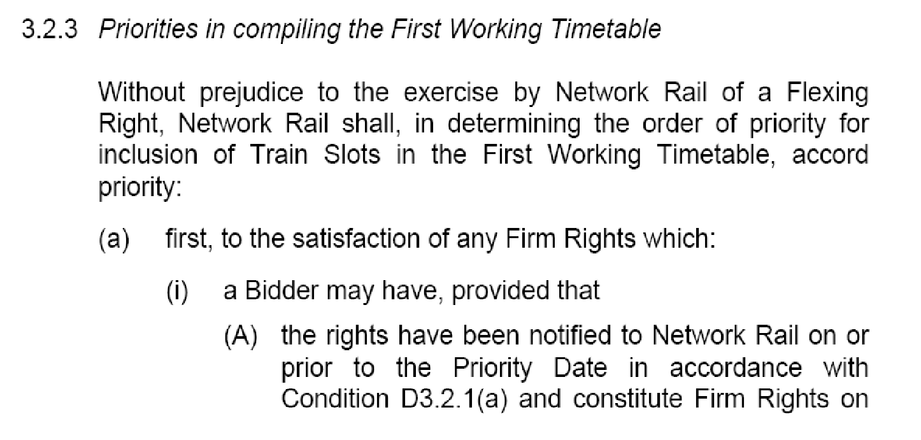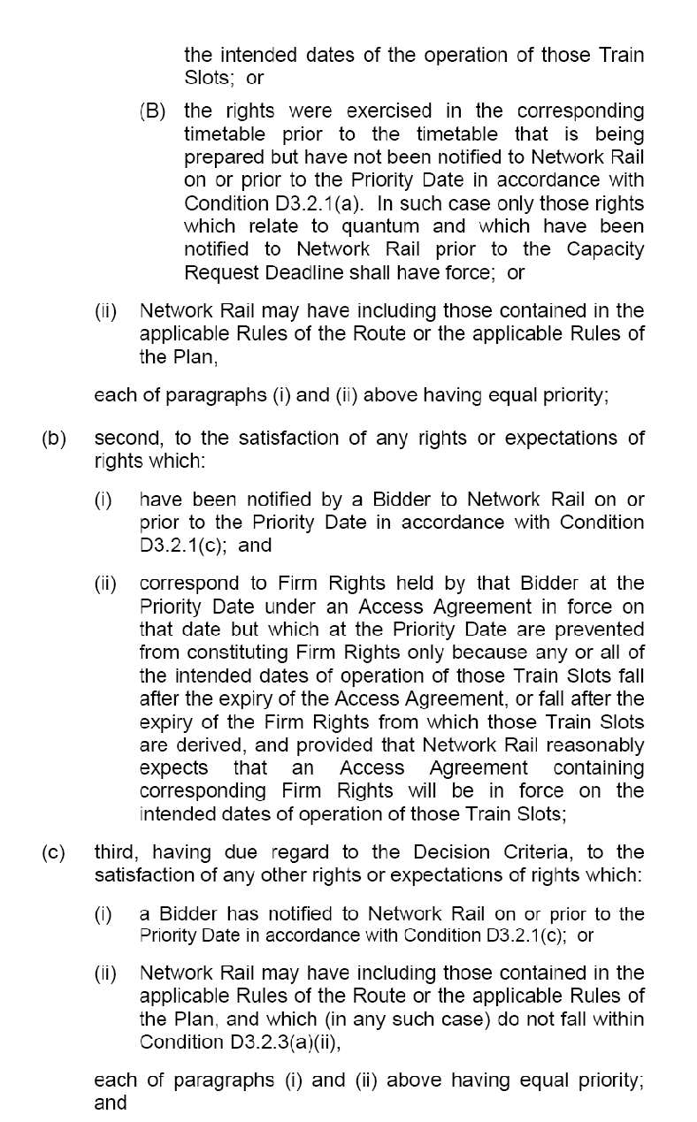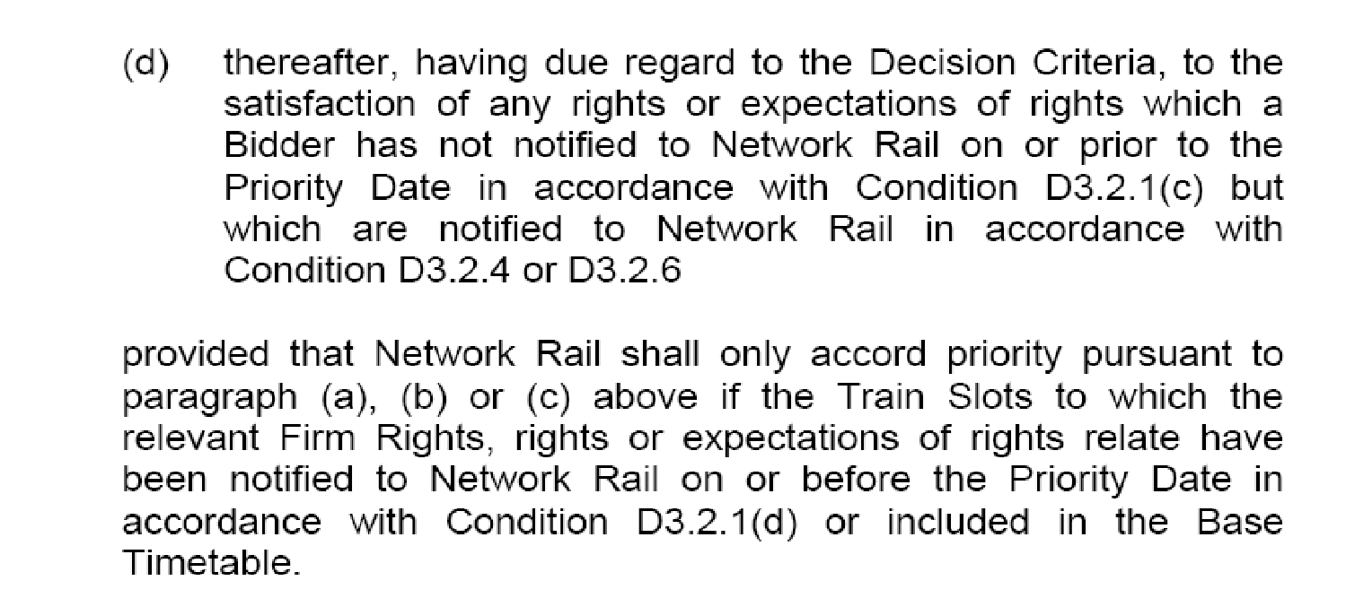
ANNEX “A”
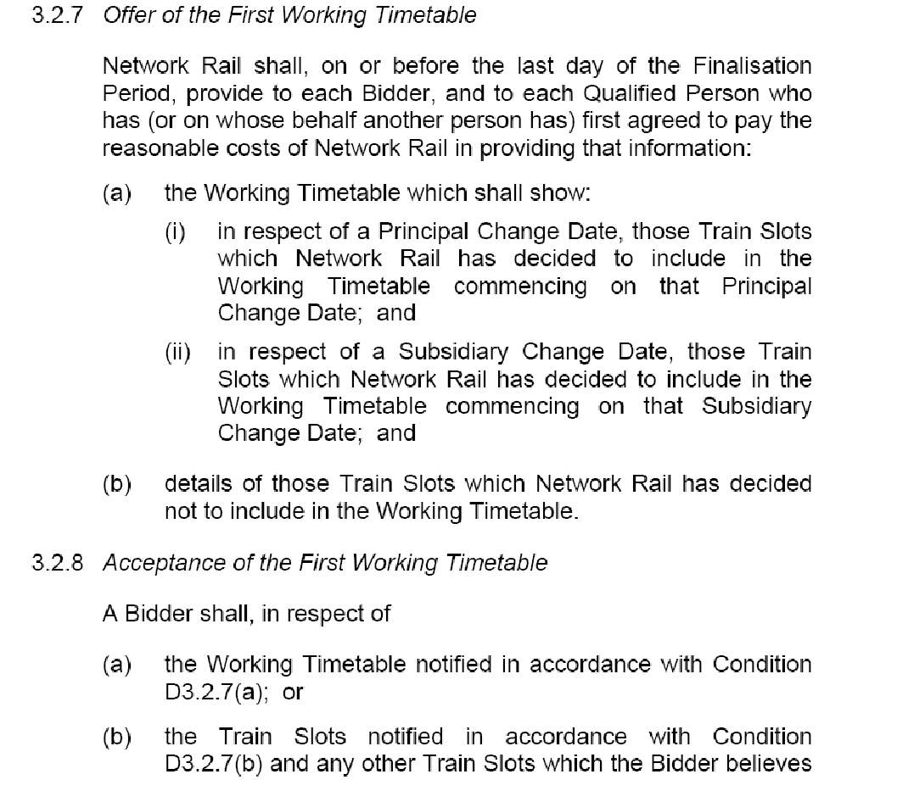
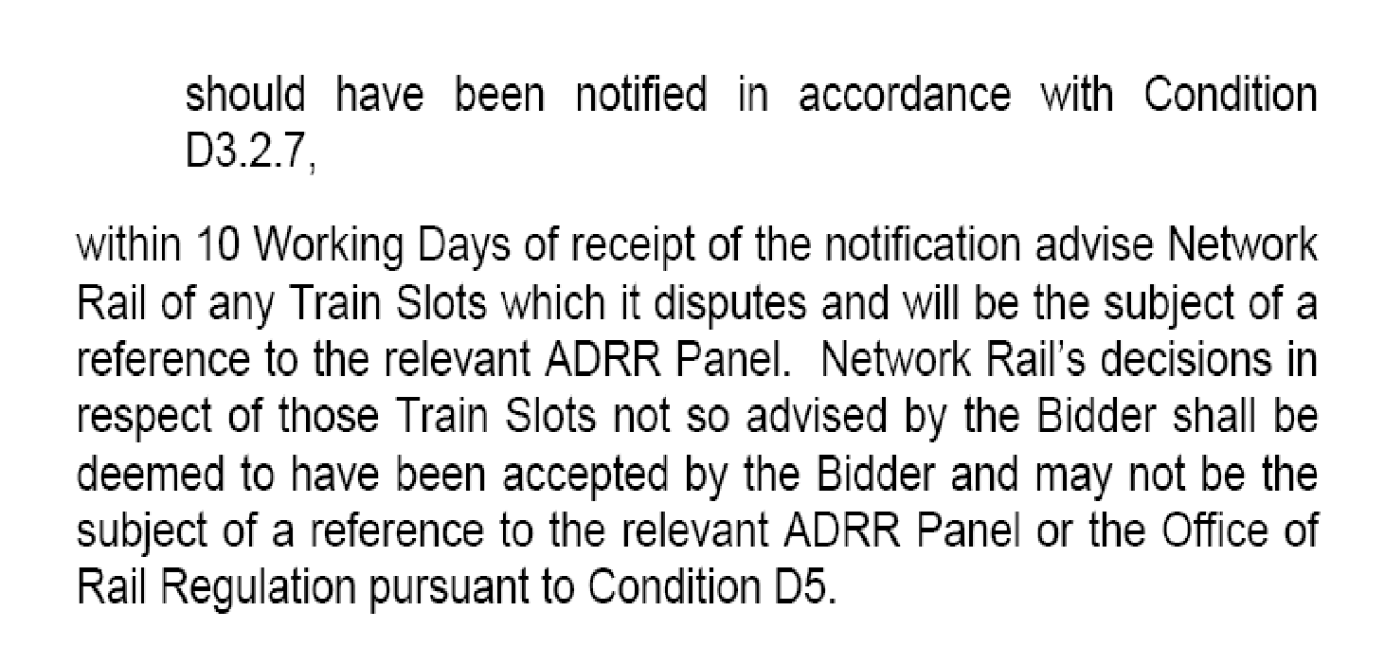
ANNEX “B”
7 Provisions applicable to Journey Time protection
Restriction on changes to Rules of the Route and Rules of the Plan
7.1 In relation to the Applicable Rules of the Route and the Applicable Rules of the Plan:
(a) Network Rail shall not propose or agree to any amendments to the Applicable Rules of the Route or the Applicable Rules of the Plan which would prevent it from Scheduling a Journey Time in the Weekday, Saturday and Sunday Working Timetables:
(i) which is equal to or less than the Fastest Key Journey Time specified for at least one Passenger Train Slot for each of the Key Journeys specified in Table 6.2 in respect of each Weekday; and
(ii) which is equal to or less than the relevant Maximum Key Journey Time specified for every Passenger Train Slot consistent with each Key Journey of the type specified in Table 6.3;
(b) paragraph 7.1(a) shall not apply in relation to any such amendment which is proposed by the Train Operator or effected pursuant to the order of an appeal body under Part D of the Network Code or any other competent tribunal; and
(c) Network Rail shall not be in breach of paragraph 7.1(a) to the extent that the failure to Schedule any Journey Time in accordance with paragraph 7.1(a)(i) or (ii) is the result of any Network Rail Restriction of Use, Competent Authority Restriction of Use or Operator Restriction of Use (as these terms are defined in or for the purposes of Part 3 of Schedule 4).

ANNEX “C”
From: Robinson Paul (CRE Virgin Trains)
Sent: 01 October 2009 18:18
To: Dunster, Jonathan
Subject: Fw: VT Schedule 5

GUS,
Sent in good faith as promised.
Just arrived in Banbury.......
Robbo
----- Original Message -----
From: Robinson Paul (CRE Virgin Trains)
To: Henry Neil
Cc: Jackson David A (TPM Birmingham); Leigh Ian
Sent: Thu Oct 01 18:14:19 2009
Subject: VT Schedule 5
Neil,
We have a potential commercial issue (David is briefed & aware) with VT whereby we have a material number of non compliances at individual train level with Schedule 5 in the TAA for the offered December 09 TT. Considerable progress has been made by the Ops Planning team to resolve but variances still exist. We have the detail - nothing for you to consider directly. Some further tweaking where it doesn't impact on other Operators is ongoing & may reduce the impact further but we are effectively at the end of the process in respect of December '09. The VT Contract specialists are weighing up the options & I will handle things whichever way they begin to emerge.
The primary reason for my note is to advise you that, in order to remove any risk to NR, there is an absolute imperative to fully eliminate these journey time variances in time for the offer which covers the subsidiary change date in May 2010. David is on the case & will work closely with Ian in my team who is a specialist on contractual matters.
For the avoidance of doubt, Sched 5 in the West Coast Trains Ltd TAA is based wholly on the TT developed in the main by Simon Pilkington in the run up to the implementation of the Dec 08 TT.
This is primarily a brief for you with no specific action needed beyond a leadership one should we have difficulty resolving this at a working level.
Happy to chat through if anything is unclear on first reading. I've a meeting at Charles Schwab in MK tomorrow & would love a guided tour of your new place if you're around?
Robbo

The content of this email (and any attachment) is confidential. It may also be legally privileged or otherwise protected from disclosure.

This email should not be used by anyone who is not an original intended recipient, nor may it be copied or disclosed to anyone who is not an original intended recipient.

If you have received this email by mistake please notify us by emailing the sender, and then delete the email and any copies from your system.

Liability cannot be accepted for statements made which are clearly the senders own and not made on behalf of Network Rail.

Network Rail Infrastructure Limited registered in England and Wales No. 2904587, registered office Kings Place, 90 York Way London N1 9AG
ANNEX “D”

Ops Planning
8th Floor West, The Axis
10 Holliday Street
Birmingham B1 1TE
Tel: +44 (0) | 121 654 2128
Fax:+44 (0) | 121 654 2761

Subject | Virgin Trains – Customer Focus Meeting (Detail) | Attendees | Ken Farms  Jonathan Dunster  Alex Grimes  Ian Swain  Paul Thompson  Joe Warr  Ian Leigh  Andrew Ward
Meeting Date | Monday 9th November 2009 @ 10:30 | Apologies | Brian Tait
Venue | Leeds TPC – City Exchange, Red Rose Room | Copy to | David Jackson  June Alebon

Agenda Item | Who | When
Welcome & meeting remit  The meeting was introduced and chaired by Jonathan Dunster. The remit will follow the agenda below, which is based on a standard template. The meeting looks at the detail in terms of the planning process, and will be held every 4 weeks alternately in Leeds and Birmingham. A separate meeting is held periodically between VT & NR (TPM & CRE) to discuss strategic items.  Actions/Items from these notes will be moved to the customer action tracker. | All
December 09 Timetable (including)  G&SW route south-bound route learning paths  This item has now been completed and trains offered to Virgin.  Journey times/Schedule 5 compliance  This has progressed further on, NR have resolved some of the trains on the original list. The item has now been agreed for completion (NR to deliver full sch5 compliance) through the May 2010 timetable validation process. We continue to look at Dec/09 in an attempt to resolve the outstanding issues.  Ian Leigh to discuss possible amendments to Schedule 5 (1707 / 1733 / 1807 Euston – Liverpool SX) with VT (GD & Richard Miller) ASAP.  [FO] 10:xx Preston – Euston additional train  VT are now bidding for an amended path between Preston and Euston, following concluding talks with LM and other parties.  1F01 Postal service and 1P05 Rugby stop LTP  VT require this train to stop at Rugby. There is an issue WTT currently that we are unable to call the train as 1F01 (postal) is pathed and conflicts. We are able to offer STP as the postal train is not yet live. Virgin has also planned changes to the peak ticket restrictions and this will become the one of the first trains to depart north outside the peak restrictions. JN is waiting information from Doug Thompson / Ian Kapur. JN would also like to confirm the rights for this train with Gordon Cox. We also need to confirm if 1F01 (the down postal) will also run as the path is ‘on’ the graph.  Post meeting note: 1F01 is an irregular runner through the year, probably averaging once per month only. However, it is heavily utilised every day (SX) through the seasonal Christmas timetable, November into December each year. The Operator is likely to accept it to be retimed, as long as the terminal times are not much different to now.  Spot Bid for 5R20  Chris Walpole will be submitting a spot bid for this train between Polmadie and Glasgow (diesel hauled). There is a ROTR issue that allows relaxation of the block for 5R20, but Virgin would like the engine to run back (if the rules can be amended). If we are unable to do this then the locomotive would need to be left on the blocks at Glasgow  Catering Specification Amendments  There will be some catering amendments for the SX timetable, and Virgin will be putting this direct into the Network Rail Dec/09 Database (in Birmingham TPC). There was a concern that by applying these it may cause problems with the live STP data. JN confirmed that the issue which affected the STP overlays last year had been resolved.  We should also check with the SIM team how we include this in the eNRT? How can we handle catering changes en-route mid-point? (CER)  Christmas/Boxing Day  We should check that all trains for Christmas Day and Boxing day have been removed from TSDB. This should be a consistent check and should be included in SIM team work-stream. Check these through TSDB. Check for duplicates etc.  Class 57 haulage  This has been reduced to a minimum in WTT passenger traffic. There are a number of planned ECS services etc hauled by these locomotives to ensure that traincrew traction knowledge is maintained. Work is on-going on how Pendolinos are assisted, including the use of Cl221 units. Pendolino to Pendolino assistance & Super Voyager to Pendolino assistance will be rescue method of choice for failed trains from Dec 09.  May 2010 Timetable (including)  Journey times/Schedule 5 compliance  We need to ensure that Schedule 5 journey times are applied consistently in this timetable. Ian Leigh is looking again at Schedule 5 of the contract. IL to confirm what services we need to look further at, and we will not progress any changes to May/10 until this is received. IL also to convene a meeting to discuss with VT (see Dec 09 action above).  ITPS Delivery/Progress against CRD  An update was given on delivery of May/10 from ITPS. Virgin asked that in the event of any difficulties we prioritise the SX offer but to keep them informed regarding progress with validation & to advise them immediately if a delayed or partial offer was going to be made (offer due 18/12/09)  Period D changes  Changes on the North Wales Coast services (11e55 Holyhead – Euston SO Periods D1/D2) have been submitted via a spot bid. We need to be careful to include the ‘dummy schedules’ that allow you to display customer service data on each unit. We also need to be aware that TSDB shutdown is in the not too far distant future, and we should start to understand the implications of this and the effect to dummy schedules. This service will attach a portion & Chester, going forward in the standard path at 1335 to Euston. | Jason Nash  Ken Farms  Ian Leigh  Alex Grimes  Jason Nash  Alex Grimes  Jason Nash  Jason Nash  Jonathan Dunster

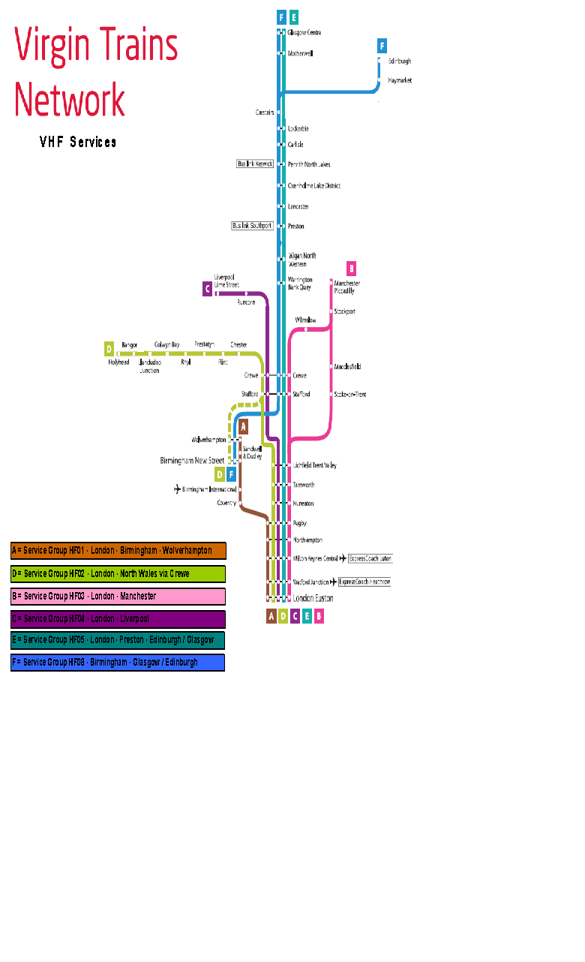
ANNEX “E”

