Joint submission to Access Disputes Panel or Timetabling Panel
Dispute Reference TTP271
Scotland Territory 2010 Rules of the Route
1 DETAILS OF PARTIES
1.1 The names and addresses of the parties to the Joint reference are as follows:-
(a) {Virgin} West Coast Trains Ltd. whose Registered Office is at ‘The School House’, 50 Brook Green, London W6 7RR ("WCTL") ("the Claimant");
(b) Correspondence Address: Virgin Trains Commercial Department, Room 15, North Wing Offices, Euston Station, London NW1 2HS.
(c ) NR Infrastructure Ltd, whose registered office is at Kings Place, 90 York Way, London, N1 9AG (“The Respondent”))
NR correspondence Address:
Pauline McFarlane, Senior Network Access Planner, Network Rail, Network Access Unit,
City Exchange, 11 Albion Street, Glasgow.
Fax: 0113 341 2341 Mob: [redacted]
Email: [redacted]

2 THE PARTIES’ RIGHT TO BRING THIS REFERENCE
2.1 These matters are referred to the Timetabling Panel ("the Panel") for determination in accordance with condition D1.3.9 of the 2010 National Rules of the Plan and Conditions D.2.1.7 and D.5.1 of the Network Code.
3 CONTENTS OF REFERENCE
3.1 The Parties have been advised that in spite of reduced timescales, a Joint Reference should still be undertaken and as such includes:-
(a) The subject matter(s) of the dispute in Section 4;
(b) A summary of those issues in dispute in Section 5;
(c) A detailed explanation of those issues in dispute prepared by the ‘Claimant’ in Section 6, with relevant counter response(s) prepared by the ‘Defendant’;
(d) Section 7 outlines the relationship and impact of the above possession proposals on the preparation of the ‘Principal’ First Working Timetable for 2010;
(e) The decisions of principle sought from the Panel in respect of legal entitlement and remedies in Section 8; and
(f) Appendices and other supporting material.
4 SUBJECT MATTER OF DISPUTE
4.1 The primary issue at the heart of this West Coast Trains Ltd. [WCTL] dispute is the affect of three, (previously four), Scottish Territory Rules of the Route [ROTR] Section 7 possession items, proposed by Network Rail under the 2010 ROTR possession plan process. (It must be highlighted that such possessions were subsequently re-proposed on the 7th April 2009 and then confirmed as required on the 20th April 2009 – see Annex “A” for all details). The resultant impact of these re-proposed possessions will ultimately see a detrimental affect on WCTL weekend Anglo-Scottish Operations through the applicable Period “C” next year.
4.2 WCTL does not consider that Network Rail, in consideration of its proposals (and indeed WCTL original response to ROTR v.1 (see Annex “B”), has applied certain crucial elements of Decision Criteria reasonably (see Annex “C”); in line with upholding its duty to implement those principles expected to be introduced during this current new Control period (CP4), under its “7-Day Railway” Vision. The fact that these three blocks (combined alongside other acceptable but bespoke 27-hour possessions), can dictate an eight week long, period timetable plan, and thus disrupt through Anglo-Scottish travel from London, the Midlands and North-West is unacceptable. WCTL will be unable to operate its applicable Firm Contractual Rights [FCR]; these Rights being those principal Anglo-Scottish services (Service Groups HF.06 & HF.08) as contained within WCTL Track Access Agreement, Schedule 5, dated 12th December 2008 – See Annex “D”.
4.2 Furthermore, in association with both Scottish and analogous LNW proposals, Network Rail’s alternative diversionary route proposal (via the Glasgow & South Western [G&SW] route) does not provide for an adequate electrified high-speed alternative.
4.3 The Parts / Conditions that this dispute relate to or are associated with, is the reasonable application of specific elements of the Network Code, namely the reasonable application of Decision Criteria [D.6] in conjunction with parts D2.1.6; D2.1.7 and D.5.1 and sections 1.3.9 of the National Rules of the Plan 2010 (nROTP), especially when considered against the overall affect to the business, operations and delivery of WCTL train services.
4.4 Copies of the relevant extract(s) from the above Network Code and nROTP referred to above, are attached as Annex “E”.
4.5 Annexes “A” to “K” are attached below for reference purposes, and are accordingly referenced throughout sections 5 - 7 below, indexed accordingly under section 10.

5 SUMMARY OF DISPUTE (BACKGROUND)
5.1 Network Rail Scotland is (re-)proposing (amongst other Section 4 period possession changes) three
possessions (again detailed in Annex “A”) over two weekends (Weeks 6 & 7) in Period C, 2010. Two
possessions are proposed in consecutive weeks, between Lanark and Law Jn between the hours of
0010 Sun and 0430 Mon; thus shutting the route between Carstairs and Glasgow all day on the two
Sundays. Additional to this, in Week 6, the route between Lockerbie and Carstairs is also blocked all
day on Sunday, thus also blocking the WCML route to Edinburgh.

5.2 The primary reason behind WCTL rejection of these all day Sunday possession proposals, is the fact
that we have just introduced our VHF timetable which offers both Families’ and Weekend travellers the
opportunity to travel on Anglo-Scottish services by train, such that “out & back” journeys (Sat morning
“out”, Sunday “afternoon / evening back”) can be undertaken over weekend periods. Indeed one of the
main premises behind Network Rail’s £8bn WCML Upgrade was to vastly improve rail travel including
weekends, again in line with NR’s CP4 Delivery Plan which includes NR’s 7-Day Railway Vision.

5.3 As described in detail in section 6 below, WCTL is not against Network Rail taking such possessions
(in this case 27 hour renewal works), in accordance with those principles set out in their own Renewal
& Maintenance WCML Sustainability Strategy (forming an integral element of their 7-Day Railway
Vision, see extracts under Annex “F”); it is the citing of such 27 hour possessions round the clock-face
which is WCTL principal objection.

5.4 Network Rail has used Decision Criteria to measure the perceived affects on all ‘likely to be
affected’ Train Operator’s (TOC’s), both in terms of their business and train service operation(s).
Such decision regarding where to place (in terms of clock-face), the required 27 hour possessions
being the primary focus of Network Rail’s decision making process.

5.5 Network Rail, in consideration of the effects to Scotrail’s local Lanark to Motherwell service, has
concluded, based on one Saturdays’ passenger numbers (supplied by Scotrail – see Annex “G”),
that local Strathclyde Saturday afternoon & evening services take precedent over Anglo-Scottish
Inter-City services. As we detail below, the dis-benefits of making such decisions regarding
Anglo-Scottish weekend travel opportunities is enormous, especially when considered against the
cost and precedent that such actions, if upheld, would mean for the Rail Industry in the future.

5.6 With an expected overall average increase in WCTL business and leisure growth for 2010, estimated
to be currently 8.8%, any degradation in WCTL service levels especially at weekends (taking
cognisance of the historical WCML weekend disruption endured over the last decade) would be
hugely detrimental to us and the Industry. We would also wish to draw to your attention our existing
Franchise Agreement with the Department for Transport (DfT), which obligates us to maintain and
grow Anglo-Scottish Markets as a viable alternative to other competing modes of travel, such as Road
and Air. This being as a direct consequence of the huge investment placed on rebuilding the WCML
during the last decade. As mentioned in previous correspondence, the recent change to VHF,
requires us until the end of our current Franchise (2012), to reasonably argue any significant
increase in timetable disruption, that occurs due to, as here-in, badly planned engineering works.

5.7 Such comments above relate ultimately to our certitude that there has been an unreasonable application of Decision Criteria by Network Rail, when considering WCTL inability to:
` i) Share capacity and secure the development of the Network for the carriage of
passengers in the most efficient and economical manner in the interests of all users of
railway services. D.6(a);
ii) To comply (as the Bidder) with any contract to which it is party D.6(c);
iii) Maintain and improve its levels of Performance & Service Provision D.6(d)
iv) Maintain Connections between its & other Operator’s services D.6(f);
v) Avoid a material deterioration of its service patterns & frequencies D.6(g);
vi) Utilise its assets efficiently, without the need to increase such assets D.6(j)
vii) Facilitate new Commercial opportunity through reasonable access to the Network D6(k)
viii) Avoid wherever practicable frequent timetable changes D.6(l) – See Section 7

6 EXPLANATION OF EACH ISSUE IN DISPUTE
“Whilst being conscious that no individual Decision Criteria has precedence over any others, and that all issues outlined below will be integral to one another, WCTL nonetheless attempts to provide evidence that Network Rail, in assessing those various Options available to them, as well as taking cognisant of the effect on other TOC’s, have taken no reasonable regard to the overall impact to WCTL business and operations, and as such reflects, in WCTL view, an unacceptable regard to those various elements of Decision Criteria. Obviously this is contested below by Network Rail as part of this Joint response”.
6.1. Decision Criteria D.6(a) – “Sharing capacity % securing the development of the Network for the carriage of passengers in the most efficient & economical manner in the interests of all users of railway services.....”
6.1.1 Both “...the sharing of capacity and securing the development of the Network for the carriage of passengers in the most efficient and economical manner in the interests of all users of railway services”….is not compelling in this instance, due to the need to significantly reduce our timetable plan (approx 40 full or part cancellations on the first Sunday, 20 on the next) as a result of the proposed engineering works. How can this be defined as ….”efficient and economical”…. when the eventual output not only considerably disrupts WCTL business market (not only to those that travel on the day or over the weekend, but also the long term affect on market growth), but would also have a significant overcrowding affect on those few remaining token WCTL diverted services over the GS&W. As such, there is the potential for an increase in weekend long distance travel using alternative transport modes i.e. Road & Air which brings with it, both geo-economic and environmental problems.

6.2. Decision Criteria D.6(c) – “Enabling a Bidder to comply with any contract to which it is party....”
6.2.1 The result of the proposed Engineering works all day on two consecutive Sundays, means WCTL will be unable to operate any of its services to/from Glasgow (and Edinburgh in the first week only). As such, WCTL will not be able to “....comply with any contract to which it is party.....” – This being its Track Access Agreement dated to start 14th December 2008 AND its contract with the Department for Transport (DfT) as contained within WCTL Franchise Agreement dated 12th December 2006.
Track Access Agreement
WCTL has Firm Contractual Rights (FCR’s) which entitle it to operate Anglo-Scottish services between both London & Birmingham and Scotland; such FCR’s as contained in Schedule 5, Parts 2.1 & 4.1 (primarily). Whilst these FCR’s mean that we have the ability and right to operate Anglo-Scottish services, we do nonetheless understand that these are subject to the applicable Rule of the Route (ROTR).
However it is Network Rail’s responsibility to apply Decision Criteria dutifully in conjunction with overall Industry affect. We have proposed to Network Rail alternative possession times over each weekend, which maximises the Rights to which we are entitled, whilst balancing Network Rail’s need to undertake Renewal works alongside the acknowledged need to offer the weekend traveller some form of ability to travel both ‘out & back’ using Anglo-Scottish train services. By Network Rail proposing the current all day Sunday possessions it is not applying this specific criteria reasonably taking cognisance of such aforementioned reasons, including our FCR’s.
Franchise Agreement
Under Schedule 1.2, Paragraph 9.1(b) see Annex “H” of our current Franchise Contract, WCTL has “....an obligation to use all endeavours to operate railway passenger services taking reasonable measures to avoid/or reduce the impact of any disruption to its services, having regard to all the circumstances referred to in Paragraph 9.2(a)....these being “.....variations in operating conditions (including Network Rail’s infrastructure not being available for any reason).....”. WCTL considers that its alternative possession proposals, fulfils its obligations in respect to its above Franchise obligatio

6.3. Decision Criteria D.6(d) – “Maintain and improve its levels of Performance & Service Provision”
6.3.1 During periods when routes are closed or significantly reduced (in terms of capacity) for engineering work requirements, the probability of importing significant additional risk into the operations of train services is always liable to be higher than during periods of normal operation. There is the risk to maintaining service reliability if engineering works either over-run, require short notice isolations, require diversions of services over other capacity restricted routes (eg. Glasgow & South Western in this case), importing delay through safety issues as a result of overcrowding (services thinned out), and the potential for diagramming and/or resource issues (as a consequence of the magnitude of engineering impact) which could all lead to delays or cancellations in train services on the day.
6.3.2 Specifically, it is in WCTL opinion that if these disputed possessions remain in their all day Sunday timeslots, then this is not sustaining service reliability; particularly when reliability is a measure of consistency. WCTL does not understand why, with the long term timetable planning process split up into 5-6 weekend periods over the year, (thus adding some form of consistency to weekend timetable construction and therefore the ability to introduce clarity and stability for the weekend travelling public), Network Rail then systematically overwrites such obvious benefit with adhoc possessions that disjointedly misalign with other Scottish or LNW possession proposals.

6.3.3 Our concerns are reinforced in terms of the Week 6 Lockerbie to Carstairs all day 27 hour Sunday possession, when they have already proposed an acceptable period possession incorporating the route (Cove – Carstairs 21.20 Sat to 1430 Sun) as well as the additionally overlaid (acceptable) Week 1 adhoc possession from 1130 Sat to 1430 Sun. Why has Network Rail not sensibly assessed moving this week 6 possession either to the ‘more or less’ acceptable times of the week 1 possession, but better still encapsulated such works into the period “C” Cove to Carstairs possessions? After all, even if you take both weeks 1 & 6 (excluding the week 5 proposals as this is a Bank Holiday weekend) we are only talking about an extra 20 hours work over 8 weeks. There is also the obvious question as to why this work could not be accommodated during the Week 5 Mayday bank Holiday period, when it is accepted that major disruption does and will take place.
6.4. Decision Criteria D.6(f) – “Maintain Connections between its & other Operator’s services”
6.4.1 In the event that those proposals for weeks 6 & 7 were agreed, the impact on maintaining and improving connections particularly during the busy Sunday ‘pm’ period would be put under serious strain. Although there is no obligation on WCTL to maintain and/or provide connecting services either into or out of its own or other Train Operators services, it is widely expected throughout the Industry that connections are generally maintained where reasonable to do so. Therefore any delay or cancellation of services which ‘connect’ into other services during this Sunday ‘pm’ period, (particularly last trains) as a result of engineering works is unacceptable, particularly in key locations such as Glasgow for Ayrshire, Stirlingshire, West & North Highlands.
6.4.2 At weekends, where nationally service levels are reduced, this tends to lead to the number of connections being generally less, the risk of missed connections is obviously greater. On Sunday evenings where larger numbers of passengers tend to travel, there is likely to be a greater impact on passenger journeys than on Saturday evenings where passenger numbers are generally lower – Although we are generalising here, Inter-City connections where passengers have travelled greater distances tend to be more important than integral localised journey connections where invariably local bus services are available later; hence another reason to sensibly consider the revised times proposed in our response, as outlined in Annex “I”.
6.5. Decision Criteria D.6(g) – “Avoid a material deterioration of its service patterns & frequencies”
6.5.1 The impact of these ‘all day’ Sunday possession proposals on WCTL services, both in terms of service pattern and frequency, will be materially greater all day Sundays than on Saturday afternoon and Sunday mornings. In this case there are two scenarios, one which captures the affects of reducing all day Sunday services; the other associated with the actual affect of the engineering works itself.
6.5.2 Any blockage of the WCML has an onerous affect on the service pattern, frequency and travel opportunities of our long distance passengers. On Anglo-Scottish routes where we have increased the service frequency by 59% on Saturdays and 36% on Sundays, (giving an average weekend increase of 47%), with improved journey times of up to 100 mins on Saturdays and 50 mins on Sundays, (all of which are now possible through the introduction of our VHF timetable), we have already seen Anglo-Scottish revenue increase by 14%, with conservative average estimates for 2010 increasing this further by 8%. In terms of passenger numbers this is an increase from approx 8800 journeys pre VHF per weekend, rising to 10250 journeys by mid 2010.
6.5.3 Certainly Network Rail makes reference to passenger count figures from Scotrail indicating the risk to XXXX local Saturday journeys. In Annex “J” we counter this number with our own detailed passenger counts for Sunday Anglo-Scottish Journeys (which thereby counter argues the affect to WCTL of blocking such routes on a Sunday). Our figures are taken from the only {to date} clear VHF weekend timetable which is dated 21st December 2008. It may be questioned that these figures are to some extent skewed by the Christmas holiday ‘get away’, but by 2010 these would be offset by the % rise highlighted in 6.5.2 above. Therefore we refute Network Rail’s argument about the volume of Scotrail affected passengers being one of the underpinning elements of their case, when it quite clearly shows we have XXXXXXXXXXXXXXXXXX passengers travelling on a Sunday. Indeed
6.5.4 The difference between blocking the Glasgow route all day Sunday against Sat ‘am’ to Sunday ‘pm’ is £400k in terms of lost revenue on the day and approximately £360k in long term Business Recovery loss. Setting aside the obvious detrimental passenger perception that if ‘through’ Return journeys cannot be undertaken on the Sunday, then there is no point in travelling out on the Saturday, alongside standard disruption afforded to normal Sunday peak travel, then we believe it is reasonable to find this unacceptable. Similarly, these same conceptual issues apply to those travelling to/from Edinburgh on the first weekend.
6.5.5 WCTL is obviously aware that it has an alternative diversionary route via the GS&W for Glasgow bound traffic. However we should point out that not only is the extended Journey Time approximately 70 mins, the route is diesel only, meaning for London services, it necessitates hauling our Class 390’s by Locomotive. This increases journey times further, as well as instilling a slight element of performance risk, not just into our services, but to those other users of the route, chiefly Scotrail and Freight. Furthermore, as capacity is already constrained over this route, there is no guarantee that all 20+ services could and would be timetabled. Indeed Network Rail have not as yet deliberated with us on pathway availability over this diversionary route, even though the First working Timetable is still being developed.
6.5.6 The issue of Edinburgh (in week 6) with no diversionary route whatsoever (except the unrealistic route via GS&W, Rutherglen & Shotts) raises the Network Rail ‘cause célèbre’ issue regarding the fact that on this and the next weekend, the East Coast Mainline {ECML) remains open throughout. This purportedly adds weight to Network Rail’s reasons for applying for all day Sunday blockades, as passengers have an alternative through Anglo-Scottish route from London to both Glasgow & Edinburgh via the ECML using NXEC and Scotrail services. We would countenance this view if it was purely just the London passenger market that was affected; not everyone lives in London or the South East.
6.5.7 WCTL provides (alongside other TOC’s) for those passenger flows from the South West, Welsh, West Midlands and North West markets to/from Scotland. Cumulatively these areas in terms of populous, equal that of London and the South-East, so we would refute any notion that just because the ECML is open then the WCML ‘could be’ closed (v.v), when considering just London based flows. Indeed on the weekend before Christmas (used for the Sunday passenger count data) 58% of WCTL revenue was generated by West Midlands and North West flows.
6.5.8 Whilst we acknowledge historically Network Rail’s requirement to keep either the WCML or ECML open at any one time for through Anglo-Scottish traffic, this view has been subject to controversy over the last few years, resulting in occasions when both are blocked. In reality if these two all day Sunday possessions remain, thus blocking any electrified route for NXEC and WCTL in terms of getting to Glasgow, then this argument is subject to scrutiny. Although the problem is not directly solved, by moving the possession re-proposals to our proposed Sat ‘am’ to Sun ‘pm’ times, this would then reduce the potential for overcrowding on the Glasgow route on the busier Sunday afternoons and evenings as well as reducing any long term rail market business recovery issues that continue to affect the Industry as a result of weekend closures

6.6. Decision Criteria D.6(j) - Utilise its assets efficiently, without the need to increase such assets
6.6.1 WCTL considers that these three possession proposals as they stand in weeks 6 & 7 combined with the overall disruptive affect to the operations of its services, will not enable WCTL to utilise their assets efficiently. Furthermore, as a direct consequence of the disruption that would be caused to its service patterns should such possession proposals be agreed, there would be an increase in the numbers and usage of such assets required to maintain (if actually achievable – see 6.5.4 above) such {‘disrupted’} service patterns.
6.7.2 Whenever the WCML route north of Gretna Jn / Cove is closed there is an inherent need to terminate (and start back) services at Carlisle, and depending where the possessions affect, sometimes complemented by running train shuttles between Glasgow and/or Edinburgh and Lockerbie. Token services due to those reasons previously explained above, will operate via the GS&W route but will only go to supplement those 2 buses/hr operating to/from Carlisle. WCTL does not consider when assessing all day Sunday possessions, that in view of the increased numbers of passengers that travel, peaking in the afternoon and evening, as a viable and efficient use of its assets when considered against the lesser number of passengers, trains and buses that would otherwise travel / operate under our alternative suggestions over the two days. Indeed a recent review of Class 221 diagrams to permit an hourly GS&W diversionary service to operate (irrespective of the fact that no hourly timetable capacity studies have been formally shown to us), would mean cancelling all the recently introduced VHF London Euston – Chester services as a minimum, which would not augur well with the DfT, Welsh Assembly and Travelling Passengers alike.
6.7.3 WCTL will also have to provide additional staff alongside the Rail Replacement services, in order to maintain connections around the blockade; the same would apply on the northern side in terms of staffing issues, especially if shuttles were operated. In terms of diversions via GS&W, there will be the necessity of additional locomotive haulage, additional Unit mileage causing both wear & tear of WCTL assets and Network Rail infrastructure, additional ‘on-train’ & station staff due to extended journey times and additional ECS workings to overcome unit diagram disruption.
6.8. Decision Criteria D.6 (Part k) ~ Facilitate Commercial opportunity through reasonable access to the Network
6.8.1 In consideration of WCTL response(s) to the proposed possessions, we have carefully weighed up the overall influence such possessions will have on our business growth and commercial position in the market place. Understandably WCTL anxiety with this set of proposals is the danger that the disruption is likely to have on:
a) maintaining existing West Coast business;
b) retaining the attractiveness of our new VHF service patterns and journey times;
c) preserving the high customer satisfaction levels we currently provide;
d) enabling the continuation of consistent delivery in reliability and performance, sufficient to sustain the current growth of the business;
e) our ability to forge new commercial opportunities, both operationally and through existing and new marketing prospects, including the availability of ‘out & back’ weekend travel opportunities.
    - The affect on services has been explained in detail above, but the ‘secondary’ effects are huge. The potential loss of business (to Airlines and Road) coupled with the inability to build on those commercial opportunities that could otherwise present themselves in a normal (or even in this case reduced, if implementing our counter proposals) operating environment in parallel with the anticipated reduction in passenger numbers, is great.
    - The fact is, that any disruption of this type will undoubtedly cause some commercial downturn in WCTL Leisure market business. Appreciative that the works in the medium to long term are to deliver National benefits to the Country along with the continued increase in the growth of the West Coast Anglo-Scottish market, the very execution & output of such possession proposals over such a short space of time, could, otherwise diminish the commercial and travel benefits that are currently being achieved since the introduction of VHF.

Response to Issues by Respondent (Network Rail)
    - Network Rail is responsible for ensuring that the railway infrastructure is safe and reliable and form time to time in order to achieve this, it is necessary to disrupt the timetable to deliver renewals and maintenance activities. The decision by Network Rail to restrict access to the network for its customers is not a decision taken lightly. Network Rail fully discusses all aspects of all line closures with its customers to seek out their agreement for our plans. Network Rail seeks rail to be the preferred mode of transport and overall reliable, safe, and accessible. Network Rail is accountable for the management of the network and such is responsible balancing timetable and engineering access requirements in accordance with the Network Code Condition D6 Decision Criteria. It is Network Rails opinion that 2x Sunday, all day possessions between Lanark and Law is overall least disruptive option for all users of this route. When this disruptive access is taken, First Scotrail (FSR) will need to operate a rail replacement road service from Motherwell to Lanark as there is no rail diversionary route, West Coast Trains Limited (WCTL) and other affected operators have the opportunity to divert their services via the G&SW route. Network Rail is keen to work with the Operators to ensure as many journeys as possible can be completed without the need to bus passengers. When considering its application of the Decision Criteria Network Rail has given particular consideration to the social issues in connection with shoppers and large numbers of passengers returning home from an evenings socialising or entertainment in Glasgow City Centre.

    - The Saturday train service frequency between Glasgow and Lanark is ½ hourly and on a Sunday is hourly. FSR have identified in the region of 2000 passenger journeys between Lanark and Law at the weekend. The passenger loadings are considerably heavy on the late Saturday evening services. The social concerns with running a train service to Motherwell and the bussing from Motherwell to Lanark are significantly heightened on a Saturday evening when passengers are more likely to have consumed alcohol and are therefore more likely to become aggressive Further to this there is the industry understanding that operators have difficulty advertising outward journeys by rail and return journeys by bus when the passenger journey is localised and made on the same day.
    - WCTL Version 1 ROTR response was vague and it did not indicate the times or a counter proposal that would have be acceptable to them, WCTL’s response also suggested that they supported diversions via the G&SW. At meetings between version 1 and version 2, WCTL clarified that would support the times Saturday lunch time to Sunday lunch time, however these times are in direct conflict with the times that FSR support. The times published in the Rules of the Route are intended to match the needs of FSR’s last and first services on the Lanark Branch. These possessions have not at any anytime been formally objected to by FSR.
On the 7th April Network Rail re-proposed the period C disruptive possession access between Cove and Motherwell. These amended proposals reduced the Cove to Carstairs disruptive possessions from 7 to 6 weekends and altered the times for four of the weekends in line with WCTL’s requests. The amended proposal reduced the Carstairs to Motherwell disruptive possessions from 4 to 3 weekends, and altered the times for one of the weekends to be in line with WCTL’s requests.
    - The work being undertaken in these weeks is a combination of plain line track renewals, switch & crossing renewal and earthworks. The work is planned within the constraints of the WCML Efficient Engineering Access strategy (EEA). Network Rail understands that operators understand and support the requirement for these works, and that it is the times of the possession that Network Rail has chosen in weeks 6 and 7 that is the course of this appeal.
EEA is a strategy that summarises the pattern of access and possessions required maintain and renew the WCML post the WCRM Project.
- EEA constraint the disruptive possession access between Cove and Law Jn to a maximum of 10x27 hour Sat to Mon possessions per year.
- The Geographical constraints of EEA extend to Law Jn. The route North of Law Jn was not subjected to any enhanced work volumes or major investment like the routes south of Carstiars as part of the WCRM project.
The possessions between Cove and Carstairs now planned in the 2010 timetable year are packaged into 5x27 hour and 1x43 hour possessions and remain dated in period C. The works between Carstairs to Motherwell now planned in the 2010 timetable year are packaged into 3x27 hour possessions and remain dated in period C. On the weekends that possessions between Carstairs and Motherwell are taken in weeks 6 and 7 affecting the Sunday, Network Rail has altered the possessions south of Carstairs to match the times between Carstairs and Motherwell to avoid a 44 hour possession duration affecting WCTL services from running on the main line.

    - Network Rail has confirmed that a diversionary route is available via the G&SW and after consultation with colleagues in the Leeds Train Planning Centre can confirm that capacity exists on a Sunday for an hourly diverted Intercity service via the G&SW. Journey times between Carlisle and Glasgow would be extended by up to 70 minutes. In weeks 6 and 7, post 1200 Sun there are no other disruptive possessions planned between Euston and Carlisle WCTL services being able to run over the fast/main lines. FSR have also confirmed if required that they will flex their G&SW services, to help with the pathing of diverted WCML services.
    - WCTL has not given any indication as to what they could resource train service wise using Class 221’s diesel units vice Class 390 electric units diverting via the G&SW route and what would be the required number of services they would need to operate on a Sunday afternoon to meet the passenger demand.
In connection with routes between Edinburgh and Glasgow Network Rail confirms that the diversionary route via Shotts is available, however believe that the normal FSR Edinburgh to Glasgow service provides a reasonable level of connection opportunities for passenger travelling beyond Glasgow. WCTL did not highlight until their e-mail of the 17th April 2009 that they do not consider the G&SW route to be suitable diversionary option, this point is disputed by Network Rail. Previous passenger handling arrangements for the possessions of the north end of the WCML has revealed that as well as London to Scotland passengers, West Midlands and North West passengers divert via Sheffield and Leeds across to the ECML route.
    - To allow WCTL to operate on as many weekends as possible to operate there Saturday morning and Sunday afternoon services peak service in the email dated 07th April 2009 re-proposing these possessions Network Rail made the decision to remove the timetable engineering period block in place of a pattern of section 7 possessions while delivers more of the route available at the time sought by WCTL does however create need for three different short notice amended timetable plans in period C.
    - Network Rail has given consider to the Decision Criteria in three ways:
- Consideration for requirement to deliver the works
- WCTL counter proposed times and the consideration for requirement to deliver the works
- Times supported by FSR and the consideration for requirement to deliver the works
Network Rail | Virgin Trains | First Scotrail
(requirement for the access) | (possession times 1200 Sat to 1400 Sun) | (possession times 0001 Sun to 0500 Mon
Clause a) Safety, delivery of proper maintenance, which improves the performance of the assets | Clause a) Availability of diversionary route for through WCTL services. Demand for WCTL at its least.  FSR Saturday evening demand at its greatest, no diversionary route. | Clause a) part – social issues shoppers and party goers into the city, train service out bus in return, no diversionary route.  WCTL and other operator’s opportunity to divert. ECML clear, passenger handling strategies to involve encouraging passengers via alterative routes.
Clause d) maintaining and improving the levels of assist reliability | Clause b) part – SSSG and subsequently EEA outlined sustainability for access v possessions on the WCML is 10x27hr possessions Sat to Mon per annum. | Clause d) part – would permit normal operations all day Saturday, and bus opportunities all day Sunday  Saturday service frequency ½ hourly, Sunday service frequency hourly less alterative road transport
Clause e) renewing and carrying out other necessary work | Clause d) part – the adopting of the Sat lunch time to Sun lunch time possessions would permit consistent Sunday afternoon service to run for WCTL | Clause g) as above
 | Clause g) as above | Clause h) part permits Saturday service to operate as planned shopping and party goers into Glasgow City Centre. Heavy loadings Saturday pm.
 | Clause h) part trains cancelled during Sat pm and Sun am when intercity travel is at its lowest | Clause l) consistent train travel or bus travel on the affected Sundays
 | Clause j) in part assuming terminating the service short would have a detrimental effect on resource availability also.  Resources might not support an hourly diversions via G&SW but would a bi-hourly service for two weekend match demand | ECML available for London to Scotland passengers.  Cross country and Trans Pennine routes available for West Midlands and North West passenger traffic
 | Clause l) part – would permit consistent Sunday afternoon service to run | Concern over public disorder problems in connection with Saturday pms.
 | Intercity passengers have different opportunities and could choose to avoid these two weekends for leisure journeys to Scotland | Advertising of local suburban services with a change of transport halfway through the day.

In this particular instance Network Rail has not included Decision Criteria clause c) as part of its arguments since whenever the disruptive possessions is taken (either 1200 Sat to 1400 Sun or 0001 Sun to 0400 Mon) infrastructure and capacity would not exist for meet all bidders firm contractual rights. Network Rail has not made reference to Decision Criteria clause f) as part of its arguments since WCTL have an advised which connections they seek to maintain therefore we have not had the opportunity to explore with other operators altering timetable plans to guarantee connections (e.g. if WCTL services are later arriving Glasgow and miss the last local service, we have not been able to explorer with FSR the opportunities for them to retime). Network Rail has not made reference to Decision Criteria clause k) as diversionary routes are available for WCTL to operate a through service, and the overall package of disruption affects only 2 weekends of Sunday afternoons.
    - WCTL have indicated that to avoid the weeks 6 and 7 Sunday possessions between Carstairs and Motherwell they would support 1x54 hour possession Sunday to Tuesday in week 5, however Network Rail understand that FSR would not support this since passenger numbers between Lanark and Glasgow are significantly higher on an bank holiday Monday.

7. OTHER SPECIFIC ISSUE(S) RAISED BY WCTL
The relationship and impact of the above possession proposals on the preparation of the ‘Principal’ First Working Timetable for 2010

7.1. The urgency surrounding WCTL request to have this particular dispute item heard (and determined) by the ADC, is as a direct consequence of the First Working Timetable Development process for the Principle Timetable Change Date for 2010, outlined in detail in the 2010 National Rules of the Plan (nROTP) and contractually described in Section D3.2 of the Network Code.
7.2. As a result of the need to construct a robust 2010 timetable for inclusion in WCTL bid to Network Rail on or before the Capacity Request Deadline [CRD] of 17/04/09, in the full knowledge of those constraints that this then puts on us to significantly alter our LTP timetable aspirations after such deadline has passed, we respectfully requested the need for the ADC to invoke a hearing at the earliest opportunity, in order to hear and determine these particular possession items, such that, if possible, resolution could be brought before the CRD had passed.
7.3 In detail this was for two reasons ; firstly because once the CRD has passed any further timetable change in the final four weeks before the Draft Timetable (Network Code D3.2.4 and nROTP Para 1.8.5 / 1.8.6 an 1.8.9 refer) and afterwards during the Finalisation period (Network Code D3.2.6 and nROTP Para 1.9.5 /1.9.6 refer) are purely at Network Rail’s discretion and/or assessed for practicality taking account of the complexity, conflicts and knock-on affects of changing the timetable further. Naturally WCTL wanted to be in a position where the complete Period “C” timetable was completed without the risks associated with the post CRD process.
7.4 Furthermore, WCTL request to have the possessions in weeks 6 & 7 brought into unison with other Section 7 possession items, not just in Scotland but those analogous with the LNW(N) Territory, themselves all comparable within Sat ‘pm’ and Sun ‘pm’ timescales, is what contributes to this dispute. As a result of Network Rail’s (re-)proposals all day Sunday, this then means (setting aside the May-Day Bank Holiday weekend in Week 5) that rather than give the Industry a standard and robust Period “C” LTP Timetable over 8 weeks, it will now have to be re-written for those two weeks alone, (originally it would have been four weeks had the possessions not been re-propose – this, setting aside the other 5 adhoc weekend timetables applicable in this period). Nearer the time, this will then have a ‘knock-on’ affect to the end customer in terms of reliable, advance Industry timetable information, reservations and ticket availability.
7.5 Setting aside the fact that Network Rail has never given WCTL a ‘Project Plan’ (nROTP Para 1.8.1/2 refers) for this Draft Timetable, it has not taken the opportunity (especially since the further re-proposals) to robustly discuss such timetable affect with us. Since the start of the Draft Timetable process, we have not had any opportunity to engage with Network Rail in any identifiable, constructive dialogue with regards to this Period “C” (or indeed the other Periods - “A” or “B”), as required under nROTP (Paras 1.8.3 and 1.9.4 refer)
(For info - The aforementioned possessions in dispute are deemed Section 7 adhoc possession items which are overlaid on top of those Section 4 Period items, thus requiring the deconstruction of the Long Term Timetable Plan (LTP) for a period of just 2 weeks; [which in this case, is in isolation of other confusing prior changes to Scottish possessions including Section 4 items])
7.6 Fundamentally WCTL wishes to highlight the reference made in nROTP, Para 1.8.6., which states that “Network Rail’s decisions during the timetable drafting process must be informed by consideration of the overall public interest as expressed in the Decision Criteria......after consultation with affected Train Operators, to adjust paths to achieve pattern services, even spread of services, improved Connection, efficient use of capacity, reservation of capacity for spot bids, and to optimise the balance between ROTR & ROTP and train slots”;
7.7 WCTL believes this has not been reasonably applied by Network Rail, and indeed, if the possessions are upheld, sets a very unwelcome precedent in that Section 7 adhoc items, without due attentiveness and rejection by the TOC’s, could systematically dictate the requirement and benefit of Long Term Period Timetable plans, thereby negating any travel advantages and opportunities to the travelling customer, something that such plans tend to currently provide.

8 DECISION SOUGHT FROM THE PANEL
8.1 The Panel is asked to determine that:
(a) That the three Scottish all day Sunday possessions (as per Annex “A”) are amended to reflect 1145 Sat to 1445 Sun timescales (or something very comparable);
(b) In the event that WCTL succeeds in getting the above possessions amended as part of this determination, that Network Rail (under Network Code 3.2.4(a) or 3.2.6(b) and nROTP Para 1.8.5/6 or 1.9.5/6 refer – dependent upon the date of publication of the applicable Determination) pragmatically consider such changes in the latter ongoing development phase of the First Working Timetable for 2010, especially taking cognisant of our Firm Track Access Rights.
8.2 List any specific remedies.
a) Network Rail as part of their ‘7-Day Railway’ Vision, seriously review with greater TOC involvement & dialogue, the planning of such adhoc Section 7 items, such that they are planned wherever possible into more Period Possession plans, in harmony with current EEA guidelines and principles.
8.3 The Panel is asked to decide the following other issue –.
a) That Network Rail, as part of its ongoing remit to formalise EEA arrangements for the remainder of the WCML, are tasked with formalising these with Train Operators, such that they can be included as part of a nROTP review.¹
b) Network Rail seeks the committee to direct WCTL to accept the possessions as confirmed on 20th April 2009
c) Network Rail seeks the committee’s support for the EEA strategies to remain as industry guidelines for the access planning development and that when work volumes and deliver methods are know the strategies are formally consulted and agreed annual via the Rules of the Route process.
¹ This by default would solve any future problems with the placing of clock-face possessions.

9 SIGNATURES

For and on behalf of West Coast Trains Ltd. For and on behalf of Network Rail

Pauline McFarlane
Signed

Print name: Robert Hodgkinson Print name Pauline McFarlane

Position: Position: Senior Network Access Planner

Date: Date: 20th April 2009

10. APPENDICES AND ANNEXES
Annex “A” Possession Re-Proposal details sent by e-mail from NR Scotland
Annex “B” WCTL original response to 2010 ROTR v.1 along with Network Rail’s response
Annex “C” Relevant paragraphs relating to Decision Criteria
Annex “D” WCTL Contractual Firm Access Rights from Track Access Agreement (Extract)
Annex “E” Extracts from applicable sections of the 2010 nROTP and Network Code
Annex “F” Extracts from applicable sections of the SSSG and 7 Day Railway documentation
Annex “G” Scotrail letter outlining Passenger counts on Lanark – Milngavie Strathclyde services
Annex “H” Extract from WCTL Franchise agreement with DfT
Annex “I” WCTL response to (re-)proposals outlined in Annex “A”
Annex “J” WCTL Passenger counts on Anglo-Scottish services over weekend of 20/21st Dec 2008
Annex “K” Map of WCTL Services and Routes
ANNEX “A” –
The Following Possessions were confirmed by NR as required on 20th April 2009
From: McFarlane Pauline
Sent: 07 April 2009 13:39
To: [redacted]
Cc: Bulman Julie; Warr Joe; Kerr David (TDPU)
Subject: Chanages to SC001 WCML Period C and SC003

All

This is a formal request to alter possessions in Period C 2010 ROTR

Network Rail request to amend the Section 4 Period Block on SC001 between The Boundary and Carstairs and Section 7 Register Items between Lanark and Law. This change is to ensure a route is available between London and Glasgow at all times and as a result week 2 needs to be withdrawn with the consequential effects on the Period Block.

The effective change would be as follows:

Section 4 Period Block

SC001 1.1 to 1.7 Boundary to Carstairs 2120 Sat to 1430 Sun.

Section 7 Register items are proposed as follows:

Week 1: P2010/1157760 Lockerbie to Carstairs (1130 Sat to 1430 Sun)
Week 3: P2010/1157763 Cove to Carstairs (1130 Sat to 1430 Sun)
Week 4: P2010/1157764 Cove to Carstairs (1130 Sat to 1430 Sun)
Week 5: P2010/1157765 Lockerbie to Carstairs (0530 Sat to 0030 Mon) this is bank holiday weekend
Week 6: P2010/1154271 Lockerbie to Carstairs (2120 Sat to 0020 Mon)

SC001 1.9 Lanark to Law
The following items in weeks 1-4 are now proposed to move to weeks 5, 6 and 7. Please note there is now a reduction in the number of weeks work is taken North of Carstairs

P2010/1154289 Lanark and Law Moves to week 7
P2010/1154290 Lanark and Law Moves to week 6
P2010/1158579 Lanark and Law moves to week 5
P20101154307 Lanark and Law is withdrawn and combined in week 7 with above possession

SC003 2.1 – 2.1a Carstairs to Midcalder Jn
The following items in weeks 4-7 are now proposed to move to weeks 1-4. Please note that there is one additional weekend proposed and times are amended to read10:30 Sat to 14:30 Sun to match possession times on WCML.

P2010/1154303 Carstairs to Midcalder Moves to week 1
P2010/1154299 Carstairs to Midcalder Moves to week 2
P2010/1154297 Carstairs to Midcalder Moves to week 3
P2010/1210849 Carstairs to Midcalder Is an additional possession request in week 4

LNW Period C Section 4 times to read as follows:
NW4001.12 Gretna Jn and Cove LC to read 2205 Sat to 1430 Sun.

Due to Version 3 timescales and as discussed on the 03rd April, can you please review this request and advise by Tuesday 14th April 2009.
Red Text indicates Possession items in Dispute

Green Text indicates Possession items similar to our counter proposals

Regards

Pauline McFarlane
Senior Network Access Planner
NAU7789770010
ANNEX “B”

WCTL Version 1 Response (Extract)

Network Rail Version 1 Response (Extract)
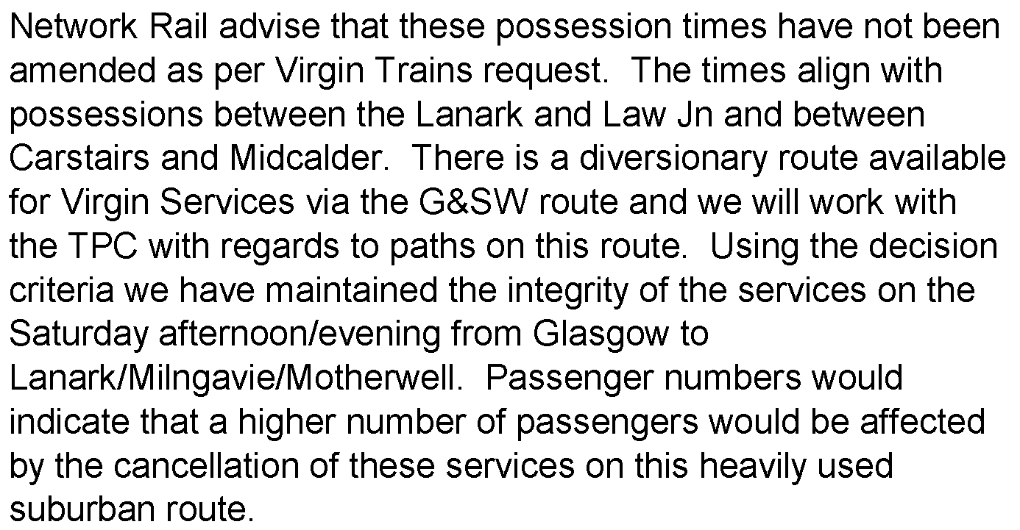
ANNEX “C”
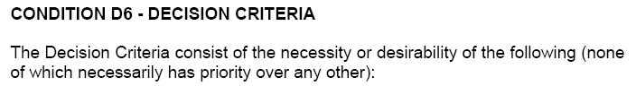
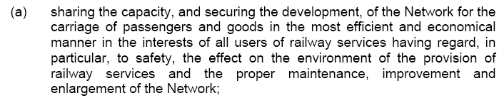
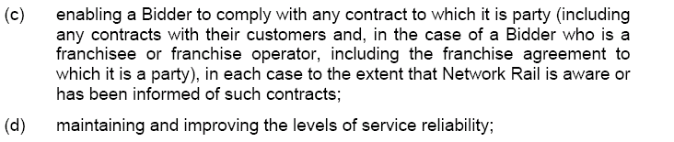
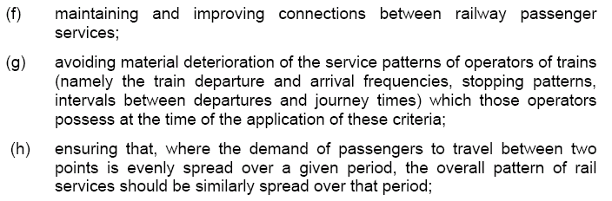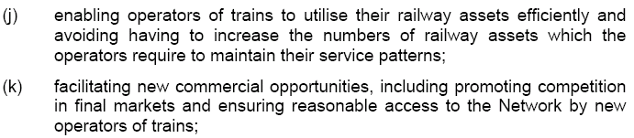

ANNEX “D”
Table 2.1: Passenger Train Slots
1 |  |  |  |  | 2
Service Group 6: London Euston to Preston, Lancaster and Glasgow Central
Service description |  |  |  |  | Passenger Train Slots
From | To | Via | Description | TSC | Weekday | Saturday | Sunday
London Euston | Glasgow Central | N/A | HF06.1 | 22112001 | 10 | 13 | 11
 |  |  | HF06.2 | 22112001 | 3¹ | N/A | N/A
 |  |  | HF06.3 | 22112001 | 1 | N/A | N/A
Glasgow Central | London Euston | N/A | HF06.4 | 22112001 | 9 | 10 | 9
 |  |  | HF06.5 | 22112001 | 2 | 4 | N/A
 |  |  | HF06.6 | 22112001 | 2 | N/A | N/A
London Euston | Lancaster | N/A | HF06.7 | 22112001 | 3 | N/A | N/A
 | Preston | N/A | HF06.8 | 22112001 | 2 | 2 | 2
Preston | London Euston | N/A | HF06.9 | 22112001 | 2 | N/A | 3
Lancaster | London Euston | N/A | HF06.10 | 22112001 | 3 | 1 | N/A
Lancaster | Crewe | N/A | HF06.11 | 22112001 | 1² | N/A | N/A
Notes to Table:

¹ Of these Services, one shall be Scheduled to terminate at Preston.

² This Service shall be Scheduled to couple at Crewe with the first Service of each Weekday originating from Holyhead in Service Group HF02.4 so as to form a through Service from each of Lancaster to London Euston and Holyhead to Euston.
ANNEX “D”
Table 2.1: Passenger Train Slots
1 |  |  |  |  | 2
Service Group 8: Birmingham New Street to Preston, Glasgow Central and Edinburgh; Rugby, Crewe and Preston to Glasgow Central; and Crewe to Preston
Service description |  |  |  |  | Passenger Train Slots
From | To | Via | Description | TSC | Weekday | Saturday | Sunday
Birmingham New Street | Glasgow Central | N/A | HF08.1 | 22114001 | 7 | 6 | 6
Glasgow Central | Birmingham New Street | N/A | HF08.2 | 22114001 | 7 | 8 | 4
Birmingham New Street | Edinburgh | N/A | HF08.3 | 22114001 | 7 | 6 | 5
Edinburgh | Birmingham New Street | N/A | HF08.4 | 22114001 | 7 | 7 | 5
Crewe | Glasgow Central | N/A | HF08.5 | 22114001 | 1 | 1 | 1³
Lancaster | Birmingham New Street | N/A | HF08.6 | 22114001 | 2¹ | 2¹ | 3⁴
Glasgow Central | Crewe | N/A | HF08.8 | 22114001 | 1 | N/A | 1
Birmingham New Street | Preston | N/A | HF08.7 | 22114001 | 2 | 3² | 3
Note to Table:

¹ Of these Services, one shall be Scheduled to start from Preston.
² Of these Services, the last one shall be Scheduled to terminate at Crewe.
³ This Service shall be Scheduled to terminate at Lancaster.
⁴ Of these Services, the first two shall be Scheduled to start at Preston.

ANNEX “E”
2.1.5 Rules of the Route/Plan Decision
(a) Network Rail shall, following consideration of any representations, objections and alternative proposals made by affected Bidders in accordance with Condition D2.1.4, review the Preliminary Rules of the Route/Plan Proposal or, as appropriate, the Subsidiary Rules Revision and, having due regard to the Decision Criteria, decide what amendments if any should be made to the applicable Rules of the Route and the applicable Rules of the Plan.
(b) Network Rail shall, no later than 4 weeks after the issue of the Preliminary Rules of the Route/Plan Proposal or, as appropriate, the Subsidiary Rules Revision, notify each Bidder which is likely to be affected by the applicable Rules of the Route or the applicable Rules of the Plan of the amendments it has decided to make pursuant to Condition D2.1.5(a) or, where no amendments are proposed, that fact.

2.1.6 Optimisation of the Draft Timetable
Notwithstanding the provisions of D2.1.4 and D2.1.5 Network Rail shall have the right having consulted with affected Bidders to make further modifications to the applicable Rules of the Route and the applicable Rules of the Plan, having due regard to the Decision Criteria, to facilitate optimisation of the Working Timetable; and Network Rail shall promptly notify the Bidders thus affected.

2.1.7 Referral to the relevant ADRR panel (See Note 1 below)
Following notification of Network Rail’s decisions in accordance with Condition D2.1.5(b) or 2.1.6 a Bidder may refer any aspect of those decisions (including any decision of Network Rail not to make an amendment or any decision by Network Rail as to whether or not a revision is a Subsidiary Rules Revision) for determination by the relevant ADRR panel under Condition D5, provided that such referral is made within the period specified in Condition D5.1.

3.2.4 Development of the Draft Timetable
(a) Following the Priority Date and at any time before the Capacity Request Deadline each Bidder shall have the right to notify to Network Rail new aspirations (if any) which amend, delete or add to those requests for changes which it notified in accordance with Condition D3.2.1.

(b) Network Rail shall, so far as reasonably practicable taking into account the complexity of the new aspirations, including any reasonably foreseeable consequential impact on the Working Timetable, and the available time before the Capacity Request Deadline, and having due regard to the Decision Criteria, incorporate each new aspiration into the Draft Timetable in accordance with the priorities set out in Condition D3.2.3.

3.2.6 Finalisation of the First Working Timetable offer
(a) Following the issue of the Draft Timetable in accordance with Condition D3.2.5 and up to the end of the Finalisation Period, each Bidder shall have the right to notify to Network Rail new aspirations (if any) which amend, delete or add to those Train Slots shown in the Draft Timetable.

(b) Network Rail shall, so far as reasonably practicable taking into account the complexity of the new aspirations, including any reasonably foreseeable consequential impact on the Working Timetable, and the available time before the end of the Finalisation Period, and having due regard to the Decision Criteria, incorporate each new aspiration into the First Working Timetable in accordance with the priorities set out in Condition D3.2.3.

CONDITION D5 -TIMETABLE APPEAL PROCEDURE
5.1 Right of appeal to relevant ADRR panel

5.1.1 Grounds for making an appeal

Without prejudice to Conditions D4.6.2, D4.7.1 and D4.8.6, if any Bidder is dissatisfied with any decision of Network Rail made under this Part D, including:
(a) the application by Network Rail of the Decision Criteria;
(b) the acceptance or rejection by Network Rail of any Bid;
(c) the exercise by Network Rail of a Flexing Right; and
(d) any decision of Network Rail which may be referred to the relevant ADRR panel under Condition D2.1.7, D2.1.11, D2.2.4 or D2.2.7,
it may refer the matter to the relevant ADRR panel for determination.

5.1.2 Timescales for making an appeal to the relevant ADRR panel
(a) A reference to the relevant ADRR panel under Condition D5.1.1 shall, save as shown in paragraph (b) or (c) below, be made within 7 days of receipt of the relevant decision from Network Rail. If Christmas Day occurs within such period of 7 days then the period shall be lengthened to 14 days.

¹ In view of the very late re-proposals from Network Rail Scotland Territory, and in conjunction with the immediacy of this dispute TTP271, it is envisaged that a continuation under D2.1.7 is more rational than changing to a dispute under D2.1.10.
ANNEX “E”

National Rules of the Plan (Extracts)

NETWORK RAIL National Rules of the Plan 2010 Version : 2.0
National Final Proposal for Principal Change Date : 27 February 2009
Timetable 2010 Page : 5 of 59

1.3. Rules of the Route/Plan

1.3.1. Network Rail presented its ideas for the future development of Rules of the Route at a meeting with Bidders on 9th September. Such was the nature of the feedback from that meeting that Network Rail has brought forward its proposals to apply from the 2010 timetable development period.

1.3.2. In summary, the intention is to reduce the number of versions of Rules of the Route from 3 per timetable to 2 per timetable. To reflect this, an increased period of time has been incorporated into the response periods. Line of Route meetings will be held, involving Bidders and Network Rail planners, to review Bidders responses and help inform the content of our Decision Documents. Recognising that using the formal disputes process remains important to our Bidders, extra time has been allowed for this in the programme.

1.3.3. Network Rail will hold discussions with Train Operators to establish their aspirations and any areas of concern. These factors will be taken into account in preparing a Preliminary Proposal.

1.3.4. Network Rail will issue their Preliminary Proposals to Train Operators at TT-56 weeks, flagging items which have changed since the previous agreed version of Rules of the Route/Plan.

1.3.5. Train Operators have 5 weeks to consider the Preliminary Proposal and make a formal response accepting or proposing alternatives. No response is deemed as acceptance.

1.3.6. Network Rail will consider responses from Train Operators over the following 10 weeks and determine whether any proposed alternatives should be accepted. Where a proposed alternative is not accepted, Network Rail will firstly seek; through Line of Route meetings to see what changes can be accommodated. At the end of this period, Network Rail will advise Bidders of their Decisions along with their reasons for the non-acceptance of counter-proposals. (Version 2)

1.3.7. Network Rail will issue a formal notification of its decision(s) to accept, reject or amend its preliminary prosals to Rules of the Plan (Version 2) and Rules of the Route, in the form of Network Rail Decision (Version 2), flagging items which have changed since the Preliminary Proposal.

ANNEX “E”

NETWORK RAIL National Rules of the Plan 2010 Version : 2.0
National Final Proposal for Principal Change Date : 27 February 2009
Timetable 2010 Page : 8 of 59

1.8. Preparation of the Draft Timetable

1.8.1 Following the Priority Date Declarations, Network Rail will prepare a project plan for the preparation of the Draft
Timetable, identifying tasks to be undertaken, including:

1.8.1.1. potential problem areas, NR Train Planning Centres/TOCs involved, process and timescales for resolution of
issues;
1.8.1.2. timescales for finalising key elements of the timetable such as the “standard hour” on key routes;
1.8.1.3. timescales for integration of key elements into a full timetable. Network Rail will publish the project plan to all
Train Operators within 5 Working Days following the Priority Date.

1.8.2. Network Rail will populate the Draft Timetable database from the Base Timetable, previous timetables,
development databases and from Train Operators ‘aspirational’ Bids as appropriate and will lead the
development of the Draft Timetable in consultation with Train Operators. Network Rail is working on the
introduction of a new Integrated Train Planning System [ITPS]. It is anticipated that it will be used for the
production of the Draft Timetable for the 2009 Subsidiary Timetable.

1.8.3. Network Rail will provide Train Operators with access to the evolving timetable plan. It is anticipated that there
will be frequent bilateral and multilateral dialogue during the drafting process to refine and clarify Train Operators’ declared aspirations. Where practicable, Network Rail will look for technology based solutions to allow on-line access to, or electronic publication of, the Draft Timetable.

1.8.4. Train Operators may introduce new or changed aspirations up to the Capacity Request Deadline, but inclusion
of those aspirations in the timetable will be subject to a test of practicability which will take into account the
complexity of the new aspirations, any knock-on effects on other services and the time available to undertake the work. This assessment will be the responsibility of the lead Train Planning Manager within Network Rail and decisions will be subject to appeal.

1.8.5. Where conflicts arise between the aspirations of different Train Operators or with Rules of the Route/Plan,
Network Rail will resolve those conflicts by agreement between the parties wherever possible, otherwise by according priority in accordance with the priority levels set out in Part D of the Network Code and by application of Decision Criteria.

1.8.6. Notwithstanding the provisions set out above, all Network Rail’s decisions during the timetable drafting process must be informed by consideration of the overall public interest as expressed in the Decision Criteria. For example, it may be appropriate for Network Rail, after consultation with affected Train Operators, to adjust paths to achieve pattern services, even spread of services, improved connections, efficient use of capacity, reservation of capacity for spot bids, and to optimise the balance between Rules of the Route/Plan and train slots.

1.8.7. Network Rail will need to establish an appropriate balance between accepting further bids after the Capacity Request Deadline and the demand for a published Draft Timetable. Network Rail will provide access to the Draft Timetable, in accordance with clause 1.7.2, at the intervals shown in the project plan, to allow Train Operators to comment in detail and to verify their resourcing.

1.8.8. So far as reasonably practicable, the Draft Timetable will comply with Rules of the Route/Plan, will be free from conflicts and will include all services and ancillary movements.

ANNEX “E”

1.8. Preparation of the Draft Timetable (Cont....)

1.8.9. Network Rail will use the 4 week period following the Capacity Request Deadline to complete the relevant
section of the Draft Timetable for the Principal timetable period or Subsidiary timetable period in time to allow its issue to Train Operators in accordance with the schedule set out in Appendix A. It is expected that dialogue with Train Operators will continue during this period, but inclusion of any further aspirations in the Draft Timetable will be at Network Rail’s absolute discretion.

NETWORK RAIL National Rules of the Plan 2010 Version : 2.0
National Final Proposal for Principal Change Date : 27 February 2009
Timetable 2010 Page : 9 of 59

1.9. Finalisation of the First Working Timetable

1.9.1. Network Rail will issue the relevant section of the Draft Timetable for the Principal and Subsidiary timetable
Periods respectively to Train Operators by 1700 hrs on the dates shown in Appendix A.
1.9.2. The Draft Timetable will be transmitted to Train Operators in one or more of the following formats:

1.9.2.1. a PIF file via the ‘B’ Plan system by electronic transfer or on CD;
1.9.2.2. hard copy timetable prints;
1.9.2.3. single train prints;
1.9.2.4. by Train Operator access to Trainplan.

The preferred method of data transfer must be agreed in advance between each Train Operator and lead Train
Planning Manager.

1.9.3. Draft Timetables, where it has been agreed that they will be transmitted via ‘B’ Plan, will include details of all Train Operators’ services over the relevant routes. Draft Timetables in single train print format will show the particular Train Operator’s services only. Draft Timetables in timetable print format may show all services or a particular Operator’s services only, by agreement between the lead Train Planning Manager and Train Operator.

1.9.4. Network Rail will provide Train Operators with access to the evolving timetable plan. It is anticipated that there will be frequent bilateral and multilateral dialogue during the finalisation process to eliminate errors, omissions and other undesirable features of the Draft Timetable.

1.9.5. Train Operators may introduce new or changed aspirations during the Finalisation Period, but inclusion of those aspirations in the timetable will be subject to a test of practicability which will take into account the complexity of the new aspirations, any knock-on effects on other services and the time available to undertake the work. This assessment will be the responsibility of the lead Train Planning Manager within Network Rail and decisions will be subject to appeal. This period of the timetabling process is intended to be used for error correction and fine tuning, so Train Operators should not expect to be able to introduce significant changes at this late stage.

1.9.6. Network Rail will continue to resolve conflicts within the timetable by agreement where possible and by use of Part D priority levels and by application of Decision Criteria. Network Rail has the right to determine the details of any train slot within the limits prescribed by the Track Access Agreement and Network Rail will exercise this right where necessary to resolve conflicts and to achieve a timetable which is in the overall public interest as expressed in the Decision Criteria. Any aspect of the timetable which is outside the contractual rights of a Train Operator’s Track Access Agreement must be agreed with the Train Operator concerned and the approval of the Office of Rail Regulation may need to be obtained for a formal amendment to the Agreement.
ANNEX “F”
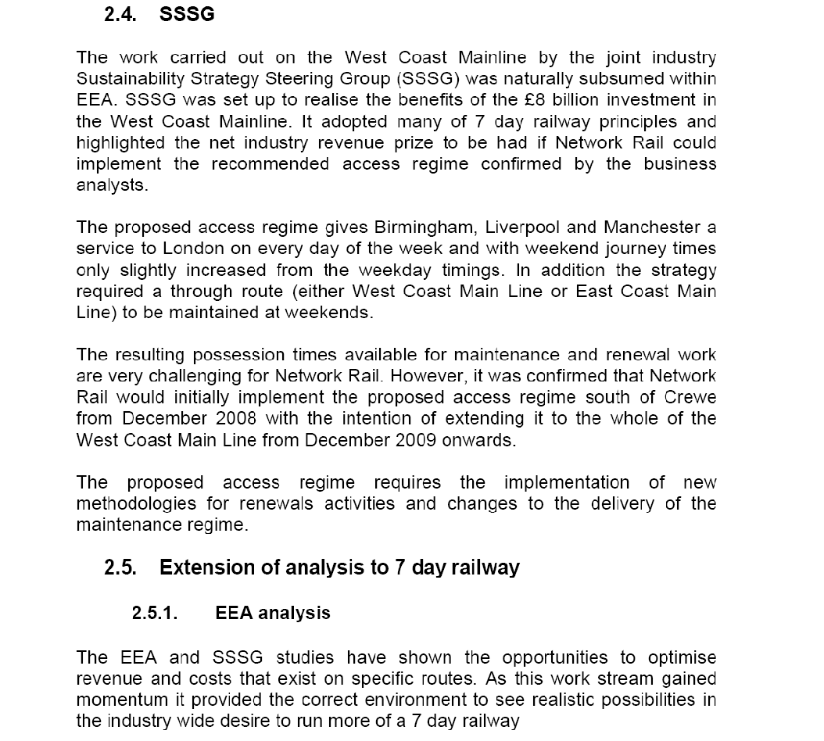

ANNEX “F”
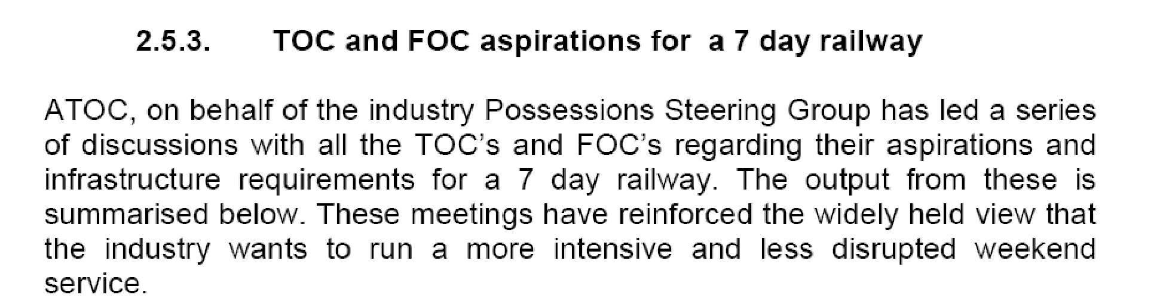
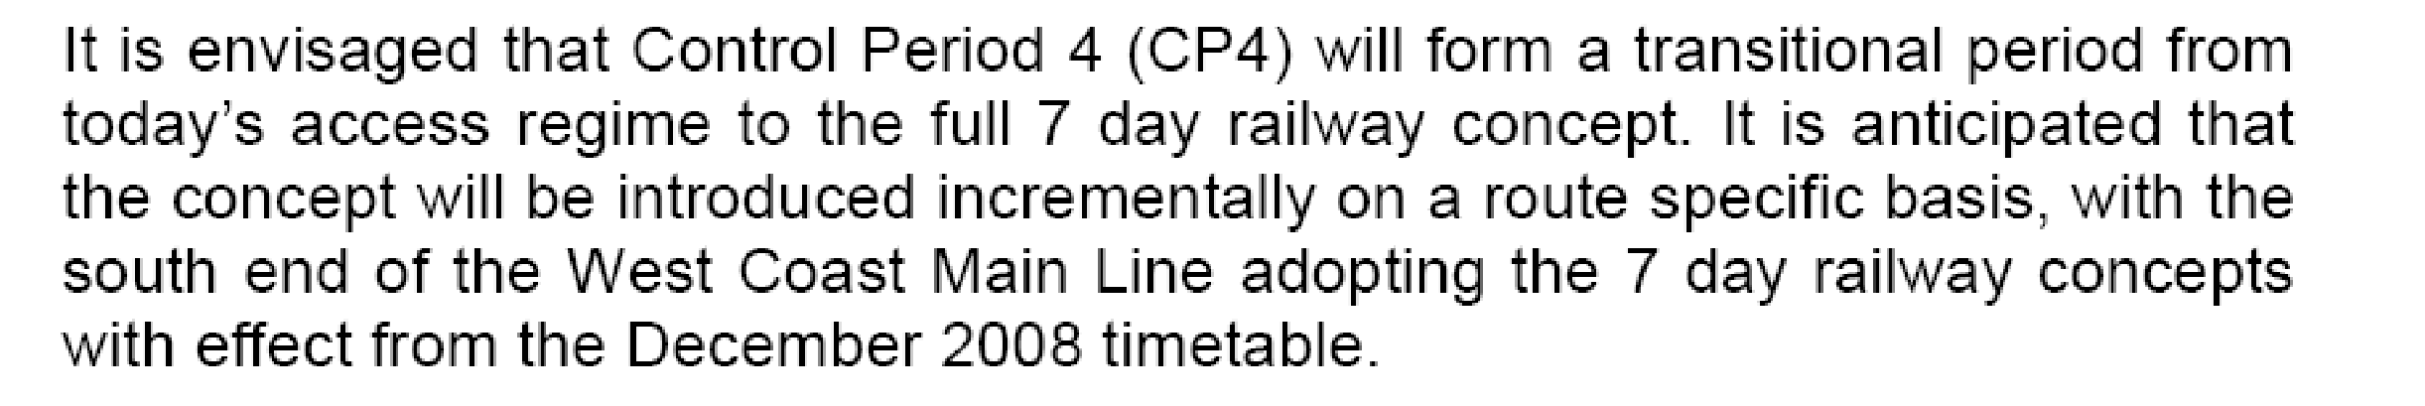
Demand
The following key conclusions have been reached from our analysis with operators of the potential demand:

• there is strong evidence of suppressed demand at weekends, especially on Sundays;

• weekend revenues affected by disrupted services (25-50% loss);

• there is additional demand late evening and on specialist flows such as airports traffic;

• TOCs (and passengers) do not like bus substitution (especially at weekends), and the costs of putting on a bus replacement service are high. Bus substitution is suppressing demand as passengers are deterred from using trains on the weekend from fear of being put on a bus for part of their journey;

ANNEX “F”
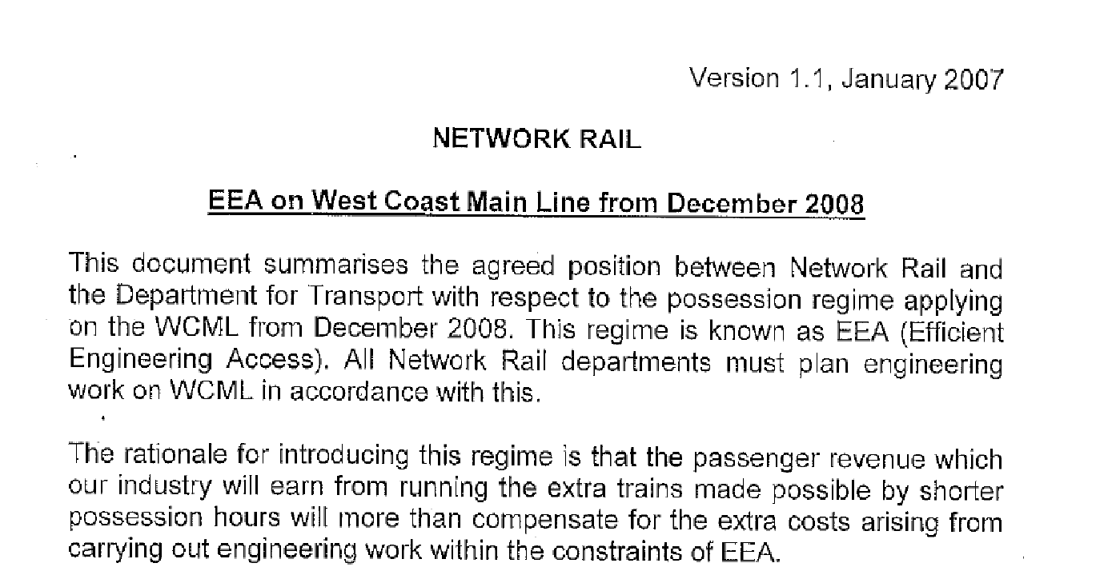
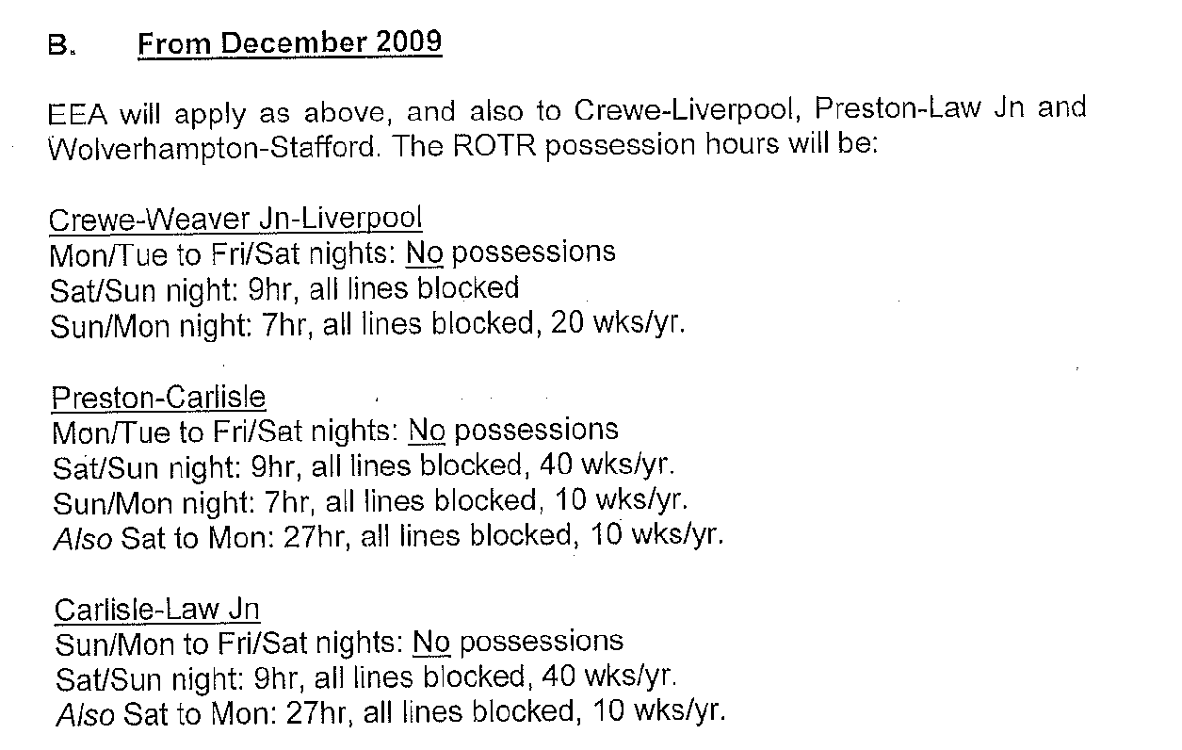

ANNEX “F”
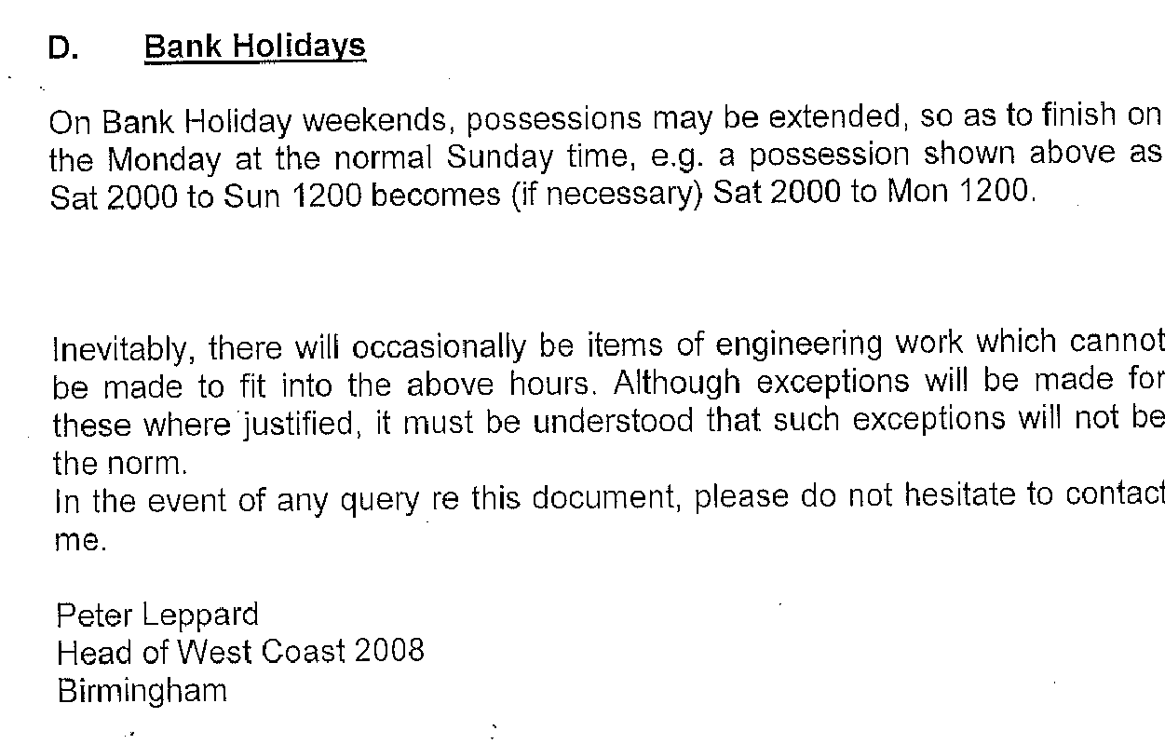
ANNEX “G”
From: [redacted]
To: Hassall Chris
Cc: [redacted]
Sent: Wednesday, April 01, 2009 11:00 AM
Subject: Fw: Motherwell Lanark Passenger Counts- Law junction possessions
Chris
Not withstanding the confidentiality provisions in the Track Access Agreement I am quite happy for Network Rail to disclose this information contained in this e.mail or forward it to other parties in pursuit of any dispute with a train operator who may wish to dispute the application of the decision criteria to your decision on the proposed possessions in weeks 1-4 of 2010/11 between Law Junction and Lanark.
Given the lines involved I must point out that all other operators have a diversionary route, which we do not. Those other operators were anxious during the upgrade of the WCML to ensure this route was available. For the avoidance of doubt we recognise that some alteration will be required to our G&SW trains to allow this to happen and providing it is done with due skill and care we will accept that.
You should also note that FSR will wish to be stated as an interested party and will vigorously defend the proposal as the right one. I can see no way in which the diversion of the small number of WCML trains on a Sunday Afternoon via the G&SW can be compared to the disruption caused to XXXXXXX journeys on a Saturday by the counter proposal. Add to that the security concerns we have associated with carrying the cXXXX people off the last 2 trains, many of whom will no doubt have consumed more alcohol than the Government would recommend, and I think it is an open and shut case and I would be very disappointed if anyone were to pursue what I regard as a
vexatious case to the timetable panel.
I have copied this e.mail to Tony Skilton as I wish him to be aware of our interest in the case, our willingness to have the passenger numbers used in defence of the decision and our desire to put our position directly to any panel.
MIKE PRICE
0141 335 4641 (04 54641)
First ScotRail Limited. Registered in Scotland Number SC185018. Registered
office: 395 King Street Aberdeen, AB24 5RP. My address for correspondence
is, Atrium Court, 50 Waterloo St, Glasgow G2 6HQ.
----- Forwarded by Mike Price/Scotrail on 01/04/2009 10:29 -----
[redacted] |
| cc: [redacted] |
| Subject: Motherwell Lanark Passenger Counts
Matt,
The table appended is a summary of passenger counts carried out on the
Argyle Line on Sat 28 Feb 09. For simplicity I have listed deps to/from
Motherwell to Lanark with pax usage either on arrival or departure as
appropriate. I have the full list of count data (raw and processed)
available should you wish further detail. Please get in touch should you require any further help.
ANNEX “G”
|------------------+------------------+------------------+------------------|
| Time departing | Number of | Time departing | Number of |
| Motherwell to | passengers on | Lanark | passengers on |
| Lanark | departure from | | arrival at |
| | Motherwell | | Motherwell |
|------------------+------------------+------------------+------------------|
| 1216 | XXX | 1153 | XXX |
|------------------+------------------+------------------+------------------|
| 1242 | XXX | 1223 | XXX |
|------------------+------------------+------------------+------------------|
| 1316 | XXX | 1253 | XXX |
|------------------+------------------+------------------+------------------|
| 1342 | XXX | 1323 | XXX |
|------------------+------------------+------------------+------------------|
| 1418 | XXX | 1353 | XXX |
|------------------+------------------+------------------+------------------|
| 1442 | XXX | 1423 | XXX |
|------------------+------------------+------------------+------------------|
| 1516 | XXX | 1453 | XXX |
|------------------+------------------+------------------+------------------|
| 1543 | XXX | 1523 | XXX |
|------------------+------------------+------------------+------------------|
| 1616 | XXX | 1553 | XXX |
|------------------+------------------+------------------+------------------|
| 1642 | XXX | 1623 | XXX |
|------------------+------------------+------------------+------------------|
| 1716 | XXX | 1653 | XXX |
|------------------+------------------+------------------+------------------|
| 1750 | XXX | 1723 | XXX |
|------------------+------------------+------------------+------------------|
| 1816 | XXX | 1753 | XXX |
|------------------+------------------+------------------+------------------|
| 1842 | XXX | 1823 | XXX |
|------------------+------------------+------------------+------------------|
| 1915 | XXX | 1853 | XXX |
|------------------+------------------+------------------+------------------|
| 1941 | XXX | 1923 | XXX |
|------------------+------------------+------------------+------------------|
| 2016 | XXX | 1953 | XXX |
|------------------+------------------+------------------+------------------|
| 2042 | 2XXX | 2023 | XXX |
|------------------+------------------+------------------+------------------|
| 2116 | XXX | 2053 | XXX |
|------------------+------------------+------------------+------------------|
| 2142 | XXX | 2123 | XXX |
|------------------+------------------+------------------+------------------|
| 2216 | XXX | 2153 | XXX |
|------------------+------------------+------------------+------------------|
| 2316 | XXX | 2223 | XXX |
|------------------+------------------+------------------+------------------|
| Total passengers | XXXX | | XXXX |
|------------------+------------------+------------------+------------------|
Best regards,
Dave Smith, Short Term Timetable Manager
Phone: 045 4308 / 0141 335 4308 Fax: 045 4095 / 0141 335 4095
Mobile: 0792 194 2149
First ScotRail, Atrium Court, 50 Waterloo Street, Glasgow G2 6HQ
ANNEX “H”

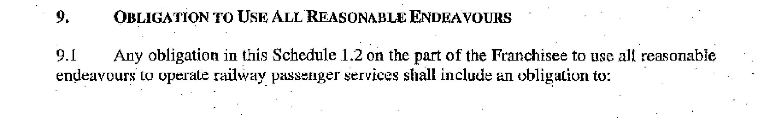
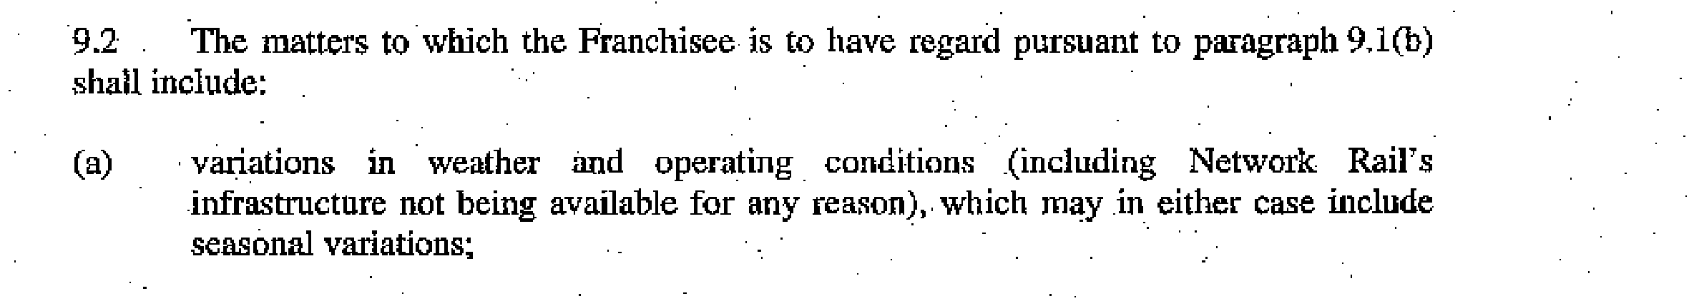
ANNEX “I”
From: Hodgkinson, Rob
Sent: 10 April 2009 16:01
To: McFarlane Pauline
Cc: [redacted]; Nichol, Susan; Sadler, Tony; Grimes, Alex; Steele, Gary; Thorpe, Steve
Subject: RE: Changes to SC001 WCML Period C and SC003

Importance: High

Dear Pauline,

In consideration of the attached possession (re)-proposals West Coast Trains Ltd. (WCTL) hereby respond, taking cognisant of our Dispute (TTP271) with Network Rail regarding the original weeks 1-4 inc (and as a result of these proposals now weeks 6 & 7), that are currently with the ADRC and set for a hearing on the 28th April 2009.

In view of the upcoming hearing, I am minded to draw to your attention that whatever we accept or reject herein, is completely reliant upon the outcome of the hearing in terms of weeks 6 or 7 specifically, and/or all the possessions outlined below, if determination(s) affect Period “C” as a whole.

On this basis and without prejudice to the outcome of the dispute proceedings, WCTL would be minded to accept the following:

Week 1 Lockerbie to Carstairs 1130 Sat – 1430 Sun : WCTL would accept an 1145 Sat to 1445 Sun times, to allow 1M11 SO, 1M15 SuO & 1M86 SuO to operate.

Weeks 3 & 4 Cove to Lockerbie 1130 Sat – 1430 Sun : WCTL would accept an 1145 Sat to 1445 Sun times, to allow 1M11 SO, 1M15 SuO & 1M86 SuO to operate.

Week 5 Lockerbie to Carstairs 0500 Sat – 0030 Sun : WCTL REJECT THIS PROPOSAL on the basis that we are currently disputing the LNW blockade between Oxenholme and Carlisle, and whilst this falls outside TTP271, this needs to be assessed in conjunction with such blockade.

Week 6 Lockerbie to Carstairs 2120 Sat – 0020 Mon : WCTL REJECT THIS PROPOSAL as this falls within the dispute principles contained within TTP271 We would be looking for a Saturday ‘pm’ to Sunday ‘am’ proposal, something akin to 1145 Sat and 1445 Sun.

Week 5 Law Jn to Lanark 0010 Sun – 0430 Mon : Whilst WCTL would be minded to accept this possession on the basis that it falls in bank holiday period, it is intrinsically linked to the other Week 5 possessions outlined above. It consequently goes into dispute pending resolution of the other items, but falls outside TTP271.

Weeks 6 & 7 Law Jn to Lanark 0010 Sun – 0430 Mon : WCTL REJECT THESE PROPOSALS as they fall within the dispute principles contained within TTP271. Once again we would be looking for a Saturday ‘pm’ to Sunday ‘am’ proposal, something akin to 1145 Sat and 1445 Sun.

Weeks 1-4 Midcalder to Carstairs 1030 Sat – 1430 Sun : WCTL would accept an 1040 Sat to 1340 Sun set of times, to allow 1S36 SO & 1S51SuO to operate, and for this route to come in line with 27 hour principles established elsewhere across the WCML, north of Preston.

I hope this brings some clarity to the current ‘fluid’ situation we all seem to be in at the moment regarding such Scottish possessions in Period “C”, which only goes to further highlight the continuing inconsistencies and risks with the planning of maintenance and renewal activities in Scotland in relation to overall National engineering planning & principles.

Kind regards

Robert Hodgkinson – Commercial Operations Manager
Virgin West Coast Trains, Room 15, North Wing Offices, Euston, London, NW1 2HS
t: 0207 391 8120 / [redacted]

ANNEX “J”
 |  | Sunday | 21/12/2008
 |  |  | FIRST | STANDARD
VTRoute | ExactTrainLabel | RetailServiceID | Count | Count2
VT1 | 1020 BHM EDB | VT102100 | XXX | XXX
VT1 | 1052 EDB BHM | VT151100 | XXX | XXX
VT1 | 1120 BHM GLC | VT103100 | XXX | XXX
VT1 | 1151 GLC BHM | VT154100 | XXX | XXX
VT1 | 1220 BHM EDB | VT105100 | XXX | XXX
VT1 | 1252 EDB BHM | VT155100 | XXX | XXX
VT1 | 1320 BHM GLC | VT106100 | XXX | XXX
VT1 | 1404 GLC BHM | VT159100 | XXX | XXX
VT1 | 1420 BHM EDB | VT107100 | XXX | XXX
VT1 | 1452 EDB BHM | VT161100 | XXX | XXX
VT1 | 1520 BHM GLC | VT109100 | XXX | XXX
VT1 | 1603 GLC BHM | VT163100 | XXX | XXX
VT1 | 1620 BHM EDB | VT111100 | XXX | XXX
VT1 | 1652 EDB BHM | VT165100 | XXX | XXX
VT1 | 1720 BHM GLC | VT112100 | XXX | XXX
VT1 | 1820 BHM EDB | VT114100 | XXX | XXX
VT1 | 1852 EDB BHM | VT169100 | XXX | XXX
VT1 | 2005 GLC CRE | VT172100 | XXX | XXX
VT6 | 0845 EUS CAR | VT602100 | XXX | XXX
VT6 | 0945 EUS GLC | VT604100 | XXX | XXX
VT6 | 1031 GLC EUS | VT653100 | XXX | XXX
VT6 | 1045 EUS GLC | VT607100 | XXX | XXX
VT6 | 1132 GLC EUS | VT658100 | XXX | XXX
VT6 | 1225 EUS GLC | VT609100 | XXX | XXX
VT6 | 1325 EUS GLC | VT612100 | XXX | XXX
VT6 | 1335 GLC EUS | VT663100 | XXX | XXX
VT6 | 1349 CAR EUS | VT661100 | XXX | XXX
VT6 | 1425 EUS GLC | VT615100 | XXX | XXX
VT6 | 1435 GLC EUS | VT667100 | XXX | XXX
VT6 | 1525 EUS GLC | VT618100 | XXX | XXX
VT6 | 1535 GLC EUS | VT672100 | XXX | XXX
VT6 | 1625 EUS GLC | VT620100 | XXX | XXX
VT6 | 1635 GLC EUS | VT675100 | XXX | XXX
VT6 | 1725 EUS GLC | VT623100 | XXX | XXX
VT6 | 1735 GLC EUS | VT677100 | XXX | XXX
VT6 | 1825 EUS GLC | VT626100 | XXX | XXX
VT6 | 1835 GLC BHM | VT679100 | XXX | XXX
VT6 | 1925 EUS GLC | VT629100 | XXX | XXX
VT6 | 2025 EUS PRE | VT630100 | XXX | XXX
VT6 | 2050 EUS PRE | VT633100 | XXX | XXX
 |  |  | XXX | XXX
ANNEX “K”
